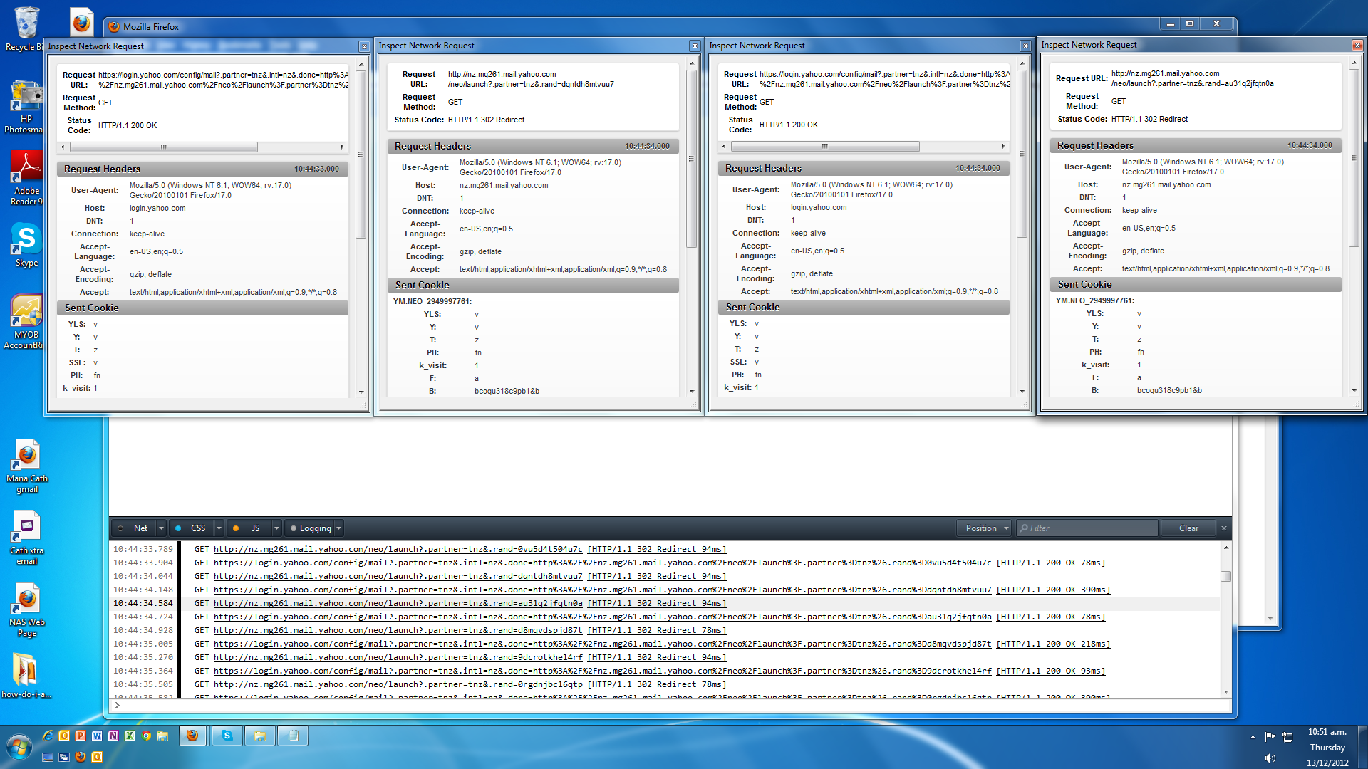
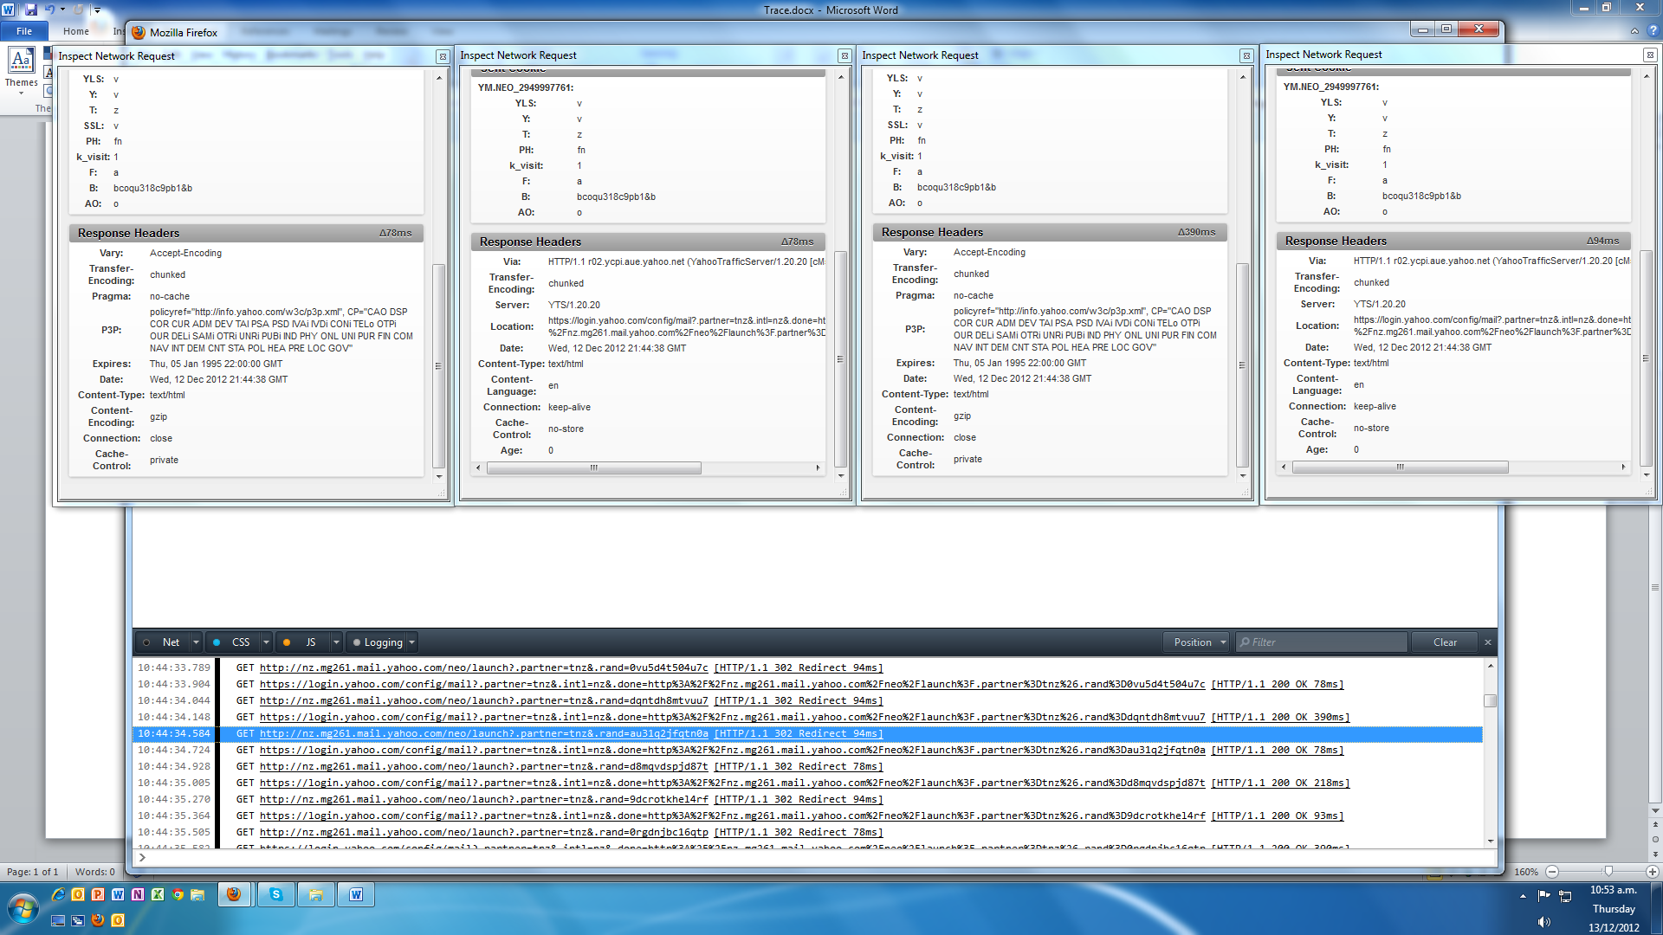

The code typically:
<html>
<head>
<meta http-equiv="Content-Type" content="text/html; charset=utf-8">
<script language="JavaScript">
<!--
window.location.replace("http://nz.mg261.mail.yahoo.com/neo/launch?.partner=tnz&.rand=2mg1mra6mevdd");
// -->
</script>
<meta http-equiv="Refresh" content="0; url=http://nz.mg261.mail.yahoo.com/neo/launch?.partner=tnz&.rand=2mg1mra6mevdd">
</head>
<body>
If you are seeing this page, your browser settings prevent you
from automatically redirecting to a new URL.
<p>
Please <a href="http://nz.mg261.mail.yahoo.com/neo/launch?.partner=tnz&.rand=2mg1mra6mevdd">click here</a> to continue.
</body>
</html>
[10:44:27.842] GET https://login.yahoo.com/config/mail?.partner=tnz&.intl=nz&.done=http%3A%2F%2Fnz.mg261.mail.yahoo.com%2Fneo%2Flaunch%3F.partner%3Dtnz%26.rand%3D8r8f3630f1d9l [HTTP/1.1 200 OK 359ms]
[10:44:28.297] GET http://nz.mg261.mail.yahoo.com/neo/launch?.partner=tnz&.rand=29k0memn6njn4 [HTTP/1.1 302 Redirect 93ms]

[10:44:28.406] GET https://login.yahoo.com/config/mail?.partner=tnz&.intl=nz&.done=http%3A%2F%2Fnz.mg261.mail.yahoo.com%2Fneo%2Flaunch%3F.partner%3Dtnz%26.rand%3D29k0memn6njn4 [HTTP/1.1 200 OK 94ms]
[10:44:28.780] GET http://nz.mg261.mail.yahoo.com/neo/launch?.partner=tnz&.rand=fk9jkend27l2m [HTTP/1.1 302 Redirect 78ms]

[10:44:29.310] GET https://login.yahoo.com/config/mail?.partner=tnz&.intl=nz&.done=http%3A%2F%2Fnz.mg261.mail.yahoo.com%2Fneo%2Flaunch%3F.partner%3Dtnz%26.rand%3Dfk9jkend27l2m [HTTP/1.1 200 OK 94ms]
[10:44:29.498] GET http://nz.mg261.mail.yahoo.com/neo/launch?.partner=tnz&.rand=7d6sk44ff7rqc [HTTP/1.1 302 Redirect 78ms]
[10:44:29.608] GET https://login.yahoo.com/config/mail?.partner=tnz&.intl=nz&.done=http%3A%2F%2Fnz.mg261.mail.yahoo.com%2Fneo%2Flaunch%3F.partner%3Dtnz%26.rand%3D7d6sk44ff7rqc [HTTP/1.1 200 OK 78ms]
[10:44:29.779] GET http://nz.mg261.mail.yahoo.com/neo/launch?.partner=tnz&.rand=e3seibvo2q78e [HTTP/1.1 302 Redirect 78ms]
[10:44:29.895] GET https://login.yahoo.com/config/mail?.partner=tnz&.intl=nz&.done=http%3A%2F%2Fnz.mg261.mail.yahoo.com%2Fneo%2Flaunch%3F.partner%3Dtnz%26.rand%3De3seibvo2q78e [HTTP/1.1 200 OK 78ms]
[10:44:30.076] GET http://nz.mg261.mail.yahoo.com/neo/launch?.partner=tnz&.rand=c4up2v2i4felf [HTTP/1.1 302 Redirect 93ms]
[10:44:30.192] GET https://login.yahoo.com/config/mail?.partner=tnz&.intl=nz&.done=http%3A%2F%2Fnz.mg261.mail.yahoo.com%2Fneo%2Flaunch%3F.partner%3Dtnz%26.rand%3Dc4up2v2i4felf [HTTP/1.1 200 OK 375ms]
[10:44:30.606] GET http://nz.mg261.mail.yahoo.com/neo/launch?.partner=tnz&.rand=3uufshulqsbou [HTTP/1.1 302 Redirect 93ms]
[10:44:30.716] GET https://login.yahoo.com/config/mail?.partner=tnz&.intl=nz&.done=http%3A%2F%2Fnz.mg261.mail.yahoo.com%2Fneo%2Flaunch%3F.partner%3Dtnz%26.rand%3D3uufshulqsbou [HTTP/1.1 200 OK 93ms]
[10:44:30.871] GET http://nz.mg261.mail.yahoo.com/neo/launch?.partner=tnz&.rand=5rmbca76r4uit [HTTP/1.1 302 Redirect 78ms]
[10:44:30.996] GET https://login.yahoo.com/config/mail?.partner=tnz&.intl=nz&.done=http%3A%2F%2Fnz.mg261.mail.yahoo.com%2Fneo%2Flaunch%3F.partner%3Dtnz%26.rand%3D5rmbca76r4uit [HTTP/1.1 200 OK 218ms]
[10:44:31.294] GET http://nz.mg261.mail.yahoo.com/neo/launch?.partner=tnz&.rand=4s7omie0qkl8g [HTTP/1.1 302 Redirect 78ms]
[10:44:31.392] GET https://login.yahoo.com/config/mail?.partner=tnz&.intl=nz&.done=http%3A%2F%2Fnz.mg261.mail.yahoo.com%2Fneo%2Flaunch%3F.partner%3Dtnz%26.rand%3D4s7omie0qkl8g [HTTP/1.1 200 OK 93ms]
[10:44:31.573] GET http://nz.mg261.mail.yahoo.com/neo/launch?.partner=tnz&.rand=1gc6ft52d1q70 [HTTP/1.1 302 Redirect 78ms]
[10:44:31.686] GET https://login.yahoo.com/config/mail?.partner=tnz&.intl=nz&.done=http%3A%2F%2Fnz.mg261.mail.yahoo.com%2Fneo%2Flaunch%3F.partner%3Dtnz%26.rand%3D1gc6ft52d1q70 [HTTP/1.1 200 OK 390ms]
[10:44:32.119] GET http://nz.mg261.mail.yahoo.com/neo/launch?.partner=tnz&.rand=0pm5qm3o7e1v1 [HTTP/1.1 302 Redirect 93ms]
[10:44:32.229] GET https://login.yahoo.com/config/mail?.partner=tnz&.intl=nz&.done=http%3A%2F%2Fnz.mg261.mail.yahoo.com%2Fneo%2Flaunch%3F.partner%3Dtnz%26.rand%3D0pm5qm3o7e1v1 [HTTP/1.1 200 OK 94ms]
[10:44:32.400] GET http://nz.mg261.mail.yahoo.com/neo/launch?.partner=tnz&.rand=5qv9pegcqck3b [HTTP/1.1 302 Redirect 78ms]
[10:44:32.540] GET https://login.yahoo.com/config/mail?.partner=tnz&.intl=nz&.done=http%3A%2F%2Fnz.mg261.mail.yahoo.com%2Fneo%2Flaunch%3F.partner%3Dtnz%26.rand%3D5qv9pegcqck3b [HTTP/1.1 200 OK 374ms]
[10:44:32.993] GET http://nz.mg261.mail.yahoo.com/neo/launch?.partner=tnz&.rand=38590j4mh7pjs [HTTP/1.1 302 Redirect 78ms]
[10:44:33.091] GET https://login.yahoo.com/config/mail?.partner=tnz&.intl=nz&.done=http%3A%2F%2Fnz.mg261.mail.yahoo.com%2Fneo%2Flaunch%3F.partner%3Dtnz%26.rand%3D38590j4mh7pjs [HTTP/1.1 200 OK 94ms]
[10:44:33.242] GET http://nz.mg261.mail.yahoo.com/neo/launch?.partner=tnz&.rand=fu935j48b6rul [HTTP/1.1 302 Redirect 78ms]
[10:44:33.355] GET https://login.yahoo.com/config/mail?.partner=tnz&.intl=nz&.done=http%3A%2F%2Fnz.mg261.mail.yahoo.com%2Fneo%2Flaunch%3F.partner%3Dtnz%26.rand%3Dfu935j48b6rul [HTTP/1.1 200 OK 374ms]
[10:44:33.789] GET http://nz.mg261.mail.yahoo.com/neo/launch?.partner=tnz&.rand=0vu5d4t504u7c [HTTP/1.1 302 Redirect 94ms]
[10:44:33.904] GET https://login.yahoo.com/config/mail?.partner=tnz&.intl=nz&.done=http%3A%2F%2Fnz.mg261.mail.yahoo.com%2Fneo%2Flaunch%3F.partner%3Dtnz%26.rand%3D0vu5d4t504u7c [HTTP/1.1 200 OK 78ms]
[10:44:34.044] GET http://nz.mg261.mail.yahoo.com/neo/launch?.partner=tnz&.rand=dqntdh8mtvuu7 [HTTP/1.1 302 Redirect 94ms]
[10:44:34.148] GET https://login.yahoo.com/config/mail?.partner=tnz&.intl=nz&.done=http%3A%2F%2Fnz.mg261.mail.yahoo.com%2Fneo%2Flaunch%3F.partner%3Dtnz%26.rand%3Ddqntdh8mtvuu7 [HTTP/1.1 200 OK 390ms]
[10:44:34.584] GET http://nz.mg261.mail.yahoo.com/neo/launch?.partner=tnz&.rand=au31q2jfqtn0a [HTTP/1.1 302 Redirect 94ms]
[10:44:34.724] GET https://login.yahoo.com/config/mail?.partner=tnz&.intl=nz&.done=http%3A%2F%2Fnz.mg261.mail.yahoo.com%2Fneo%2Flaunch%3F.partner%3Dtnz%26.rand%3Dau31q2jfqtn0a [HTTP/1.1 200 OK 78ms]
[10:44:34.928] GET http://nz.mg261.mail.yahoo.com/neo/launch?.partner=tnz&.rand=d8mqvdspjd87t [HTTP/1.1 302 Redirect 78ms]
[10:44:35.005] GET https://login.yahoo.com/config/mail?.partner=tnz&.intl=nz&.done=http%3A%2F%2Fnz.mg261.mail.yahoo.com%2Fneo%2Flaunch%3F.partner%3Dtnz%26.rand%3Dd8mqvdspjd87t [HTTP/1.1 200 OK 218ms]
[10:44:35.270] GET http://nz.mg261.mail.yahoo.com/neo/launch?.partner=tnz&.rand=9dcrotkhel4rf [HTTP/1.1 302 Redirect 94ms]
[10:44:35.364] GET https://login.yahoo.com/config/mail?.partner=tnz&.intl=nz&.done=http%3A%2F%2Fnz.mg261.mail.yahoo.com%2Fneo%2Flaunch%3F.partner%3Dtnz%26.rand%3D9dcrotkhel4rf [HTTP/1.1 200 OK 93ms]
[10:44:35.505] GET http://nz.mg261.mail.yahoo.com/neo/launch?.partner=tnz&.rand=0rgdnjbc16qtp [HTTP/1.1 302 Redirect 78ms]
[10:44:35.582] GET https://login.yahoo.com/config/mail?.partner=tnz&.intl=nz&.done=http%3A%2F%2Fnz.mg261.mail.yahoo.com%2Fneo%2Flaunch%3F.partner%3Dtnz%26.rand%3D0rgdnjbc16qtp [HTTP/1.1 200 OK 390ms]
[10:44:36.019] GET http://nz.mg261.mail.yahoo.com/neo/launch?.partner=tnz&.rand=7hgj1han1l230 [HTTP/1.1 302 Redirect 78ms]
[10:44:36.113] GET https://login.yahoo.com/config/mail?.partner=tnz&.intl=nz&.done=http%3A%2F%2Fnz.mg261.mail.yahoo.com%2Fneo%2Flaunch%3F.partner%3Dtnz%26.rand%3D7hgj1han1l230 [HTTP/1.1 200 OK 93ms]
[10:44:36.269] GET http://nz.mg261.mail.yahoo.com/neo/launch?.partner=tnz&.rand=f57s2il6s4nfe [HTTP/1.1 302 Redirect 93ms]
[10:44:36.435] GET https://login.yahoo.com/config/mail?.partner=tnz&.intl=nz&.done=http%3A%2F%2Fnz.mg261.mail.yahoo.com%2Fneo%2Flaunch%3F.partner%3Dtnz%26.rand%3Df57s2il6s4nfe [HTTP/1.1 200 OK 140ms]
[10:44:36.659] GET http://nz.mg261.mail.yahoo.com/neo/launch?.partner=tnz&.rand=1q70hc67u8l7q [HTTP/1.1 302 Redirect 93ms]
[10:44:36.731] GET https://login.yahoo.com/config/mail?.partner=tnz&.intl=nz&.done=http%3A%2F%2Fnz.mg261.mail.yahoo.com%2Fneo%2Flaunch%3F.partner%3Dtnz%26.rand%3D1q70hc67u8l7q [HTTP/1.1 200 OK 110ms]
[10:44:36.909] GET http://nz.mg261.mail.yahoo.com/neo/launch?.partner=tnz&.rand=9kboovss3shkv [HTTP/1.1 302 Redirect 94ms]
[10:44:37.002] GET https://login.yahoo.com/config/mail?.partner=tnz&.intl=nz&.done=http%3A%2F%2Fnz.mg261.mail.yahoo.com%2Fneo%2Flaunch%3F.partner%3Dtnz%26.rand%3D9kboovss3shkv [HTTP/1.1 200 OK 78ms]
[10:44:37.143] GET http://nz.mg261.mail.yahoo.com/neo/launch?.partner=tnz&.rand=cu1qmepkusbp2 [HTTP/1.1 302 Redirect 78ms]
[10:44:37.220] GET https://login.yahoo.com/config/mail?.partner=tnz&.intl=nz&.done=http%3A%2F%2Fnz.mg261.mail.yahoo.com%2Fneo%2Flaunch%3F.partner%3Dtnz%26.rand%3Dcu1qmepkusbp2 [HTTP/1.1 200 OK 94ms]
[10:44:37.345] GET http://nz.mg261.mail.yahoo.com/neo/launch?.partner=tnz&.rand=c8p3qc1frle9f [HTTP/1.1 302 Redirect 78ms]
[10:44:37.423] GET https://login.yahoo.com/config/mail?.partner=tnz&.intl=nz&.done=http%3A%2F%2Fnz.mg261.mail.yahoo.com%2Fneo%2Flaunch%3F.partner%3Dtnz%26.rand%3Dc8p3qc1frle9f [HTTP/1.1 200 OK 93ms]
[10:44:37.548] GET http://nz.mg261.mail.yahoo.com/neo/launch?.partner=tnz&.rand=8ebri1gtkjru2 [HTTP/1.1 302 Redirect 78ms]
[10:44:37.626] GET https://login.yahoo.com/config/mail?.partner=tnz&.intl=nz&.done=http%3A%2F%2Fnz.mg261.mail.yahoo.com%2Fneo%2Flaunch%3F.partner%3Dtnz%26.rand%3D8ebri1gtkjru2 [HTTP/1.1 200 OK 374ms]
[10:44:38.063] GET http://nz.mg261.mail.yahoo.com/neo/launch?.partner=tnz&.rand=2ii8md5184pi7 [HTTP/1.1 302 Redirect 78ms]
[10:44:38.143] GET https://login.yahoo.com/config/mail?.partner=tnz&.intl=nz&.done=http%3A%2F%2Fnz.mg261.mail.yahoo.com%2Fneo%2Flaunch%3F.partner%3Dtnz%26.rand%3D2ii8md5184pi7 [HTTP/1.1 200 OK 94ms]
[10:44:38.266] GET http://nz.mg261.mail.yahoo.com/neo/launch?.partner=tnz&.rand=ft687hmcrtnvf [HTTP/1.1 302 Redirect 78ms]
[10:44:38.344] GET https://login.yahoo.com/config/mail?.partner=tnz&.intl=nz&.done=http%3A%2F%2Fnz.mg261.mail.yahoo.com%2Fneo%2Flaunch%3F.partner%3Dtnz%26.rand%3Dft687hmcrtnvf [HTTP/1.1 200 OK 109ms]
[10:44:38.531] GET http://nz.mg261.mail.yahoo.com/neo/launch?.partner=tnz&.rand=aqfj4kq1d8iq4 [HTTP/1.1 302 Redirect 93ms]
[10:44:38.627] GET https://login.yahoo.com/config/mail?.partner=tnz&.intl=nz&.done=http%3A%2F%2Fnz.mg261.mail.yahoo.com%2Fneo%2Flaunch%3F.partner%3Dtnz%26.rand%3Daqfj4kq1d8iq4 [HTTP/1.1 200 OK 78ms]
[10:44:38.812] GET http://nz.mg261.mail.yahoo.com/neo/launch?.partner=tnz&.rand=2ia4ccdu80eqg [HTTP/1.1 302 Redirect 93ms]
[10:44:38.921] GET https://login.yahoo.com/config/mail?.partner=tnz&.intl=nz&.done=http%3A%2F%2Fnz.mg261.mail.yahoo.com%2Fneo%2Flaunch%3F.partner%3Dtnz%26.rand%3D2ia4ccdu80eqg [HTTP/1.1 200 OK 94ms]
[10:44:39.077] GET http://nz.mg261.mail.yahoo.com/neo/launch?.partner=tnz&.rand=ckqc95udc7jtj [HTTP/1.1 302 Redirect 94ms]
[10:44:39.173] GET https://login.yahoo.com/config/mail?.partner=tnz&.intl=nz&.done=http%3A%2F%2Fnz.mg261.mail.yahoo.com%2Fneo%2Flaunch%3F.partner%3Dtnz%26.rand%3Dckqc95udc7jtj [HTTP/1.1 200 OK 218ms]
[10:44:39.451] GET http://nz.mg261.mail.yahoo.com/neo/launch?.partner=tnz&.rand=0l7nbaushhg5b [HTTP/1.1 302 Redirect 78ms]
[10:44:39.545] GET https://login.yahoo.com/config/mail?.partner=tnz&.intl=nz&.done=http%3A%2F%2Fnz.mg261.mail.yahoo.com%2Fneo%2Flaunch%3F.partner%3Dtnz%26.rand%3D0l7nbaushhg5b [HTTP/1.1 200 OK 94ms]
[10:44:39.716] GET http://nz.mg261.mail.yahoo.com/neo/launch?.partner=tnz&.rand=c8n9m9c4dom9v [HTTP/1.1 302 Redirect 78ms]
[10:44:39.850] GET https://login.yahoo.com/config/mail?.partner=tnz&.intl=nz&.done=http%3A%2F%2Fnz.mg261.mail.yahoo.com%2Fneo%2Flaunch%3F.partner%3Dtnz%26.rand%3Dc8n9m9c4dom9v [HTTP/1.1 200 OK 94ms]
[10:44:39.997] GET http://nz.mg261.mail.yahoo.com/neo/launch?.partner=tnz&.rand=7silcdp9c75e6 [HTTP/1.1 302 Redirect 78ms]
[10:44:40.123] GET https://login.yahoo.com/config/mail?.partner=tnz&.intl=nz&.done=http%3A%2F%2Fnz.mg261.mail.yahoo.com%2Fneo%2Flaunch%3F.partner%3Dtnz%26.rand%3D7silcdp9c75e6 [HTTP/1.1 200 OK 78ms]
[10:44:40.294] GET http://nz.mg261.mail.yahoo.com/neo/launch?.partner=tnz&.rand=7gml0nsv5560u [HTTP/1.1 302 Redirect 78ms]
[10:44:40.387] GET https://login.yahoo.com/config/mail?.partner=tnz&.intl=nz&.done=http%3A%2F%2Fnz.mg261.mail.yahoo.com%2Fneo%2Flaunch%3F.partner%3Dtnz%26.rand%3D7gml0nsv5560u [HTTP/1.1 200 OK 78ms]
[10:44:40.590] GET http://nz.mg261.mail.yahoo.com/neo/launch?.partner=tnz&.rand=8344afkos0ed2 [HTTP/1.1 302 Redirect 94ms]
[10:44:40.684] GET https://login.yahoo.com/config/mail?.partner=tnz&.intl=nz&.done=http%3A%2F%2Fnz.mg261.mail.yahoo.com%2Fneo%2Flaunch%3F.partner%3Dtnz%26.rand%3D8344afkos0ed2 [HTTP/1.1 200 OK 94ms]
[10:44:40.871] GET http://nz.mg261.mail.yahoo.com/neo/launch?.partner=tnz&.rand=7jkr84oq98uv4 [HTTP/1.1 302 Redirect 93ms]
[10:44:40.980] GET https://login.yahoo.com/config/mail?.partner=tnz&.intl=nz&.done=http%3A%2F%2Fnz.mg261.mail.yahoo.com%2Fneo%2Flaunch%3F.partner%3Dtnz%26.rand%3D7jkr84oq98uv4 [HTTP/1.1 200 OK 93ms]

