General information about the CA’s associated organization
CA Company Name: Inera AB
Website URL: www.inera.se
Organizational type: Corporation established by the government
Primary Market / Customer Base: Swedish healtchare organizations, public and private
Impact to Mozilla Users Describe the types of Mozilla users who are likely to encounter your root certificate as relying parties Users who come into contact with swedish healthcare
CA Contact Information: sithspolicyauthority@inera.se

Technical information about each root certificate
Certificate Name: SITHS Root CA v1
Certificate Issuer Field: CN = SITHS Root CA v1
O = Inera AB
C = SE
Certificate Summary: This root CA issues certificate to subordinate issuing CAs. Subordinate issuing CAs issue certificates for persons and functions (e.g. applications, servers etc.)

Root Cert URL: http://aia.siths.se/sithsrootcav1.cer
SHA1 Fingerprint: 58 5f 78 75 be e7 43 3e b0 79 ea ab 7d 05 bb 0f 7a f2 bc cc
Valid From: 2012-03-29
Valid To: 2032-03-29
Certificate Version 1
Certificate Signature Algorithm sha1RSA
Signing key parameters RSA modulus length: RSA 4096
Test Website URL (SSL) https://v1.test.msoft.siths.se
CRL URL: http://crl1.siths.se/sithsrootcav1.crl
NextUpdate for CRLs of end-entity certs: 48 hours
Test:
OCSP URL OCSP URI in the AIA of end-entity: http://ocsp1.siths.se
Testing results
a) Browsing to test website with OCSP enforced in Firefox browser
b) If requesting EV: https://wiki.mozilla.org/PSM:EV_Testing_Easy_Version
SSL Validation Type: Domain validation

CA Hierarchy information for each root certificate
CA Hierarchy List, description, and/or diagram of all intermediate CAs signed by this root.

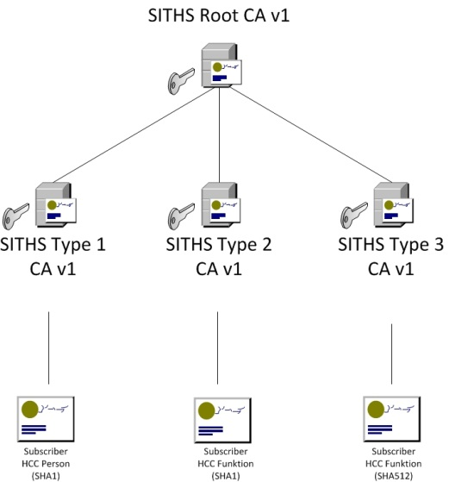

Verification Policies and Practices
Policy Documentation Language(s) that the documents are in:
CP: English
CPS: English
Relying Party Agreement: English
Audits Audit Type: Webtrust Audit for Certification Authorities
Auditor: Ernst & Young
Auditor Website: http://www.ey.com/
Multi-factor Authentication: Required for all RAs and CA-personell
Network Security: Applied accordin to requirements

