This is a screen shot of showing what is outlined in the unified in-box. Notice the timeline between 1:35PM and 1:42PM on 2/17:

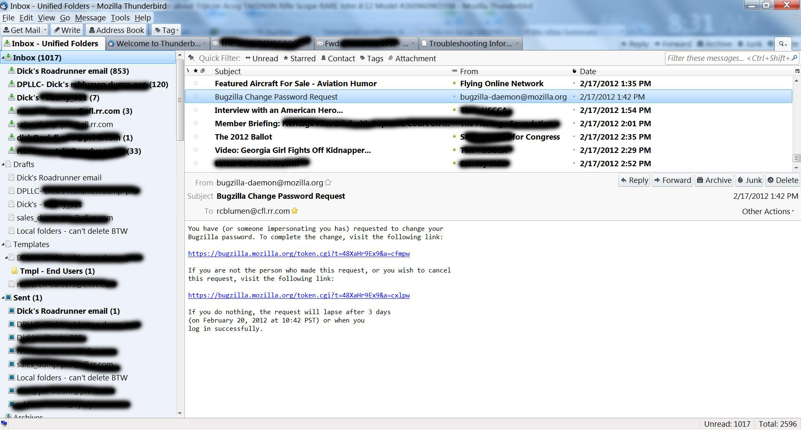

Now, here is the snapshot of the inbox from “DPLLC – Dick’s….”:
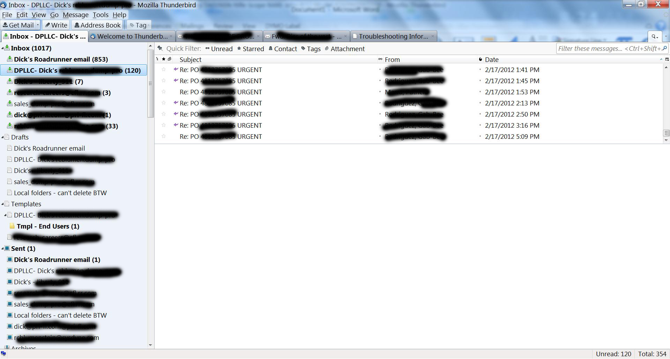

Notice all the missing URGENT messages that were not included in the unified box! Major issue, as I can’t believe in the unified in-box anymore.

