Installing Firefox on Windows

Step 1: Visit Mozilla.com in any browser (ie. Internet Explorer). Click the download button.
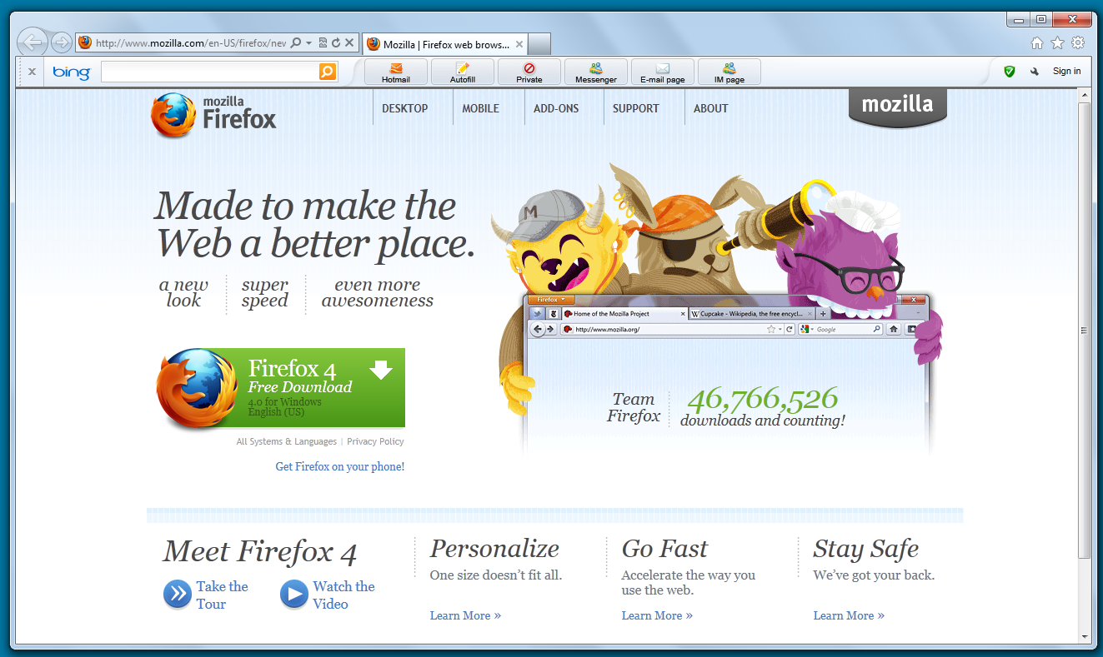
Step 2: Start the process by clicking Run
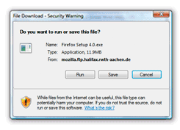

For Windows Vista / Windows 7: After it finishes downloading, a User Account Control message window will appear. Click Yes to continue the process.
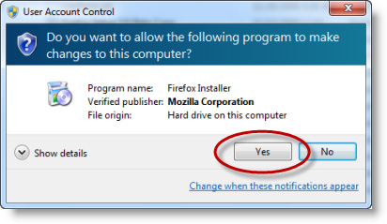
Step 4: You are almost there! Next, you will be greeted with a welcome screen. Click Next to continue.
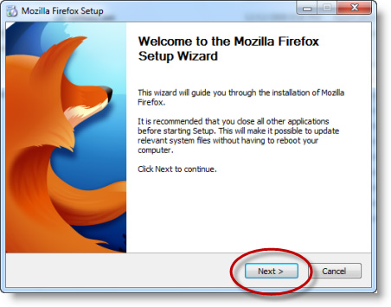
Step 5: This will bring you to the Setup Type screen. A standard setup is selected by default, which will install Firefox with a recommended configuration that will work for most users.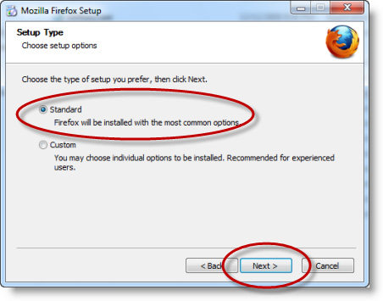

Step 6: Once the installation is complete, close the setup wizard by clicking Finish. If the "Launch Firefox now" checkbox is checked, Firefox will start for the first time immediately after you click Finish.
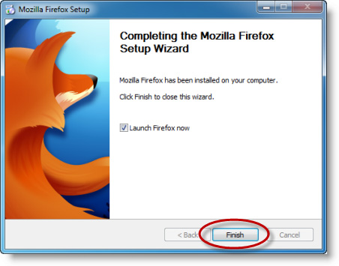
Congratulations! You are now ready to leap boldly into a new era of Web surfing. Double click on the Firefox icon whenever you want to go online.
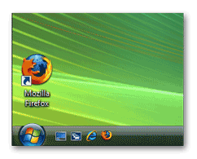
For more step by step instructions and useful tips and tricks to your Firefox Brower check out: firefox.com/tour

