Installing Firefox on Mac

Step 1: Visit Mozilla.com in any browser. (ie. Safari). Once you get to the page, click the download button to start the process.

Step 2: Your file should begin downloading automatically in a few seconds.

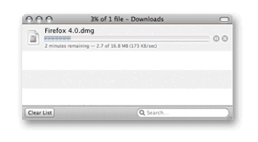
Step 3: Once the download has completed, the disk image may open by itself. If it does not open automatically, double-click the Firefox dmg icon to open it.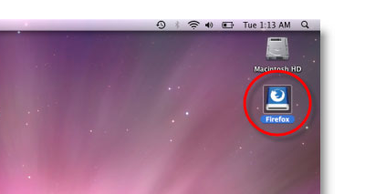
Step 4: A Finder window appears, containing the Firefox application. Drag the Firefox Icon into the Applications Folder. 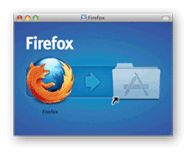

Step 5: Drag the Firefox icon from the Applications folder into the dock.
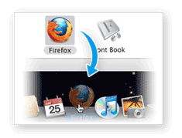
Step 6: Firefox is now ready for use. Just click on Firefox whenever you want to use the web!

For more step by step instructions and useful tips and tricks to your Firefox Brower check out: firefox.com/tour

