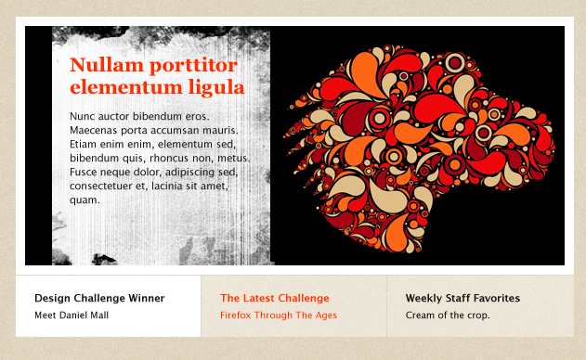
Artist Spotlight:

egirldesign
" Meet our featured artist from the UK, Tracie Andrews, who created an abstract, and beautiful, paisley inspired pattern in the shape of the Mozilla Dino. Be sure to check out her website for more awesome designs and inspiration.... or follow her on Twitter. "

Links:
Egirldesign: http://creative.mozilla.org/people/egirldesign
Twitter: @stuffwemake
Website: http://stuffwemake.tumblr.com/

Main challenge promo:
" Help create the official Firefox 4 launch t-shirt!"
link: http://creative.mozilla.org/challenges/7

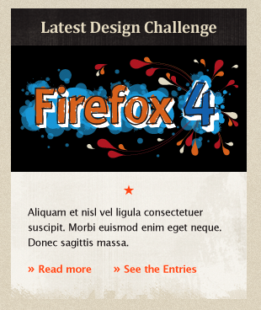

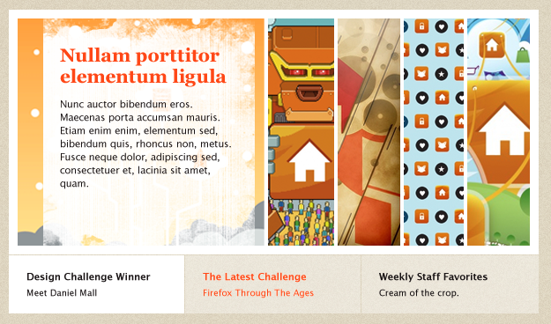

iphone skins!
“Check out these awesome iphone skins created by the Creative Collective design community. “
Link: http://www.infectious.com/iphone-skins

