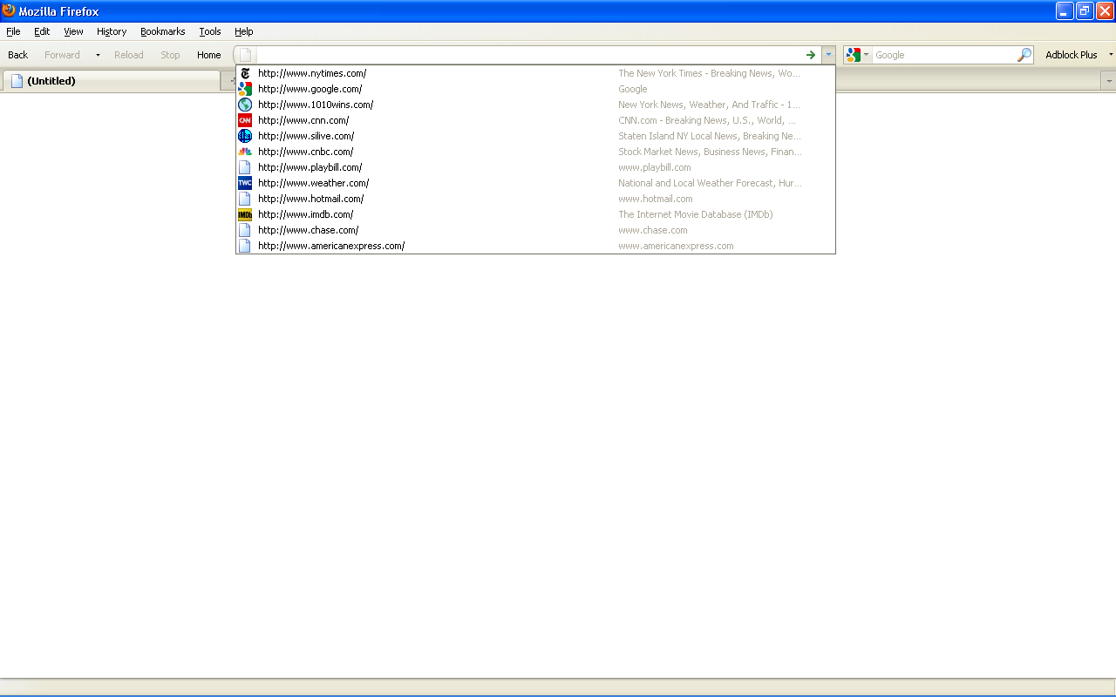

This shot is AFTER I took the steps to correct which you will find below.
Old tool bar working just fine. Also note that Norton tool bar is absent just as it should be

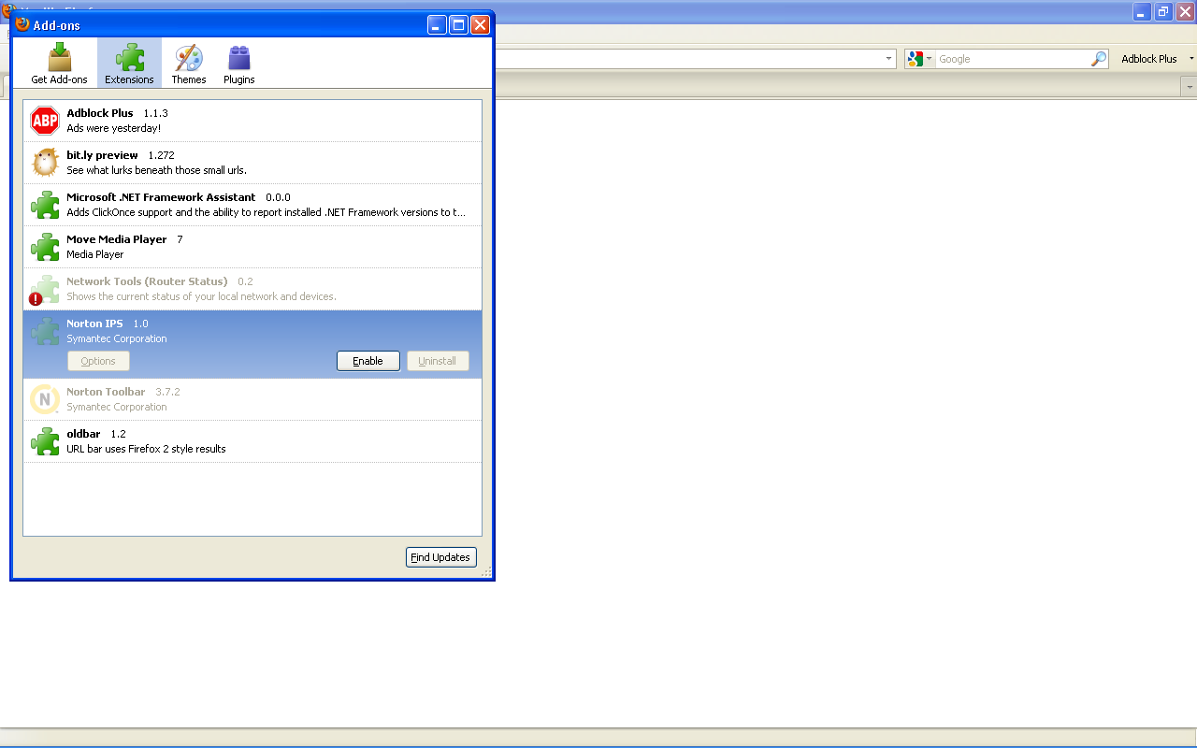

Add on dialogue box showing Norton disabled and oldbar installed and working

The following screen shots are after a system restart and for the first time firefox is opened after the restart.

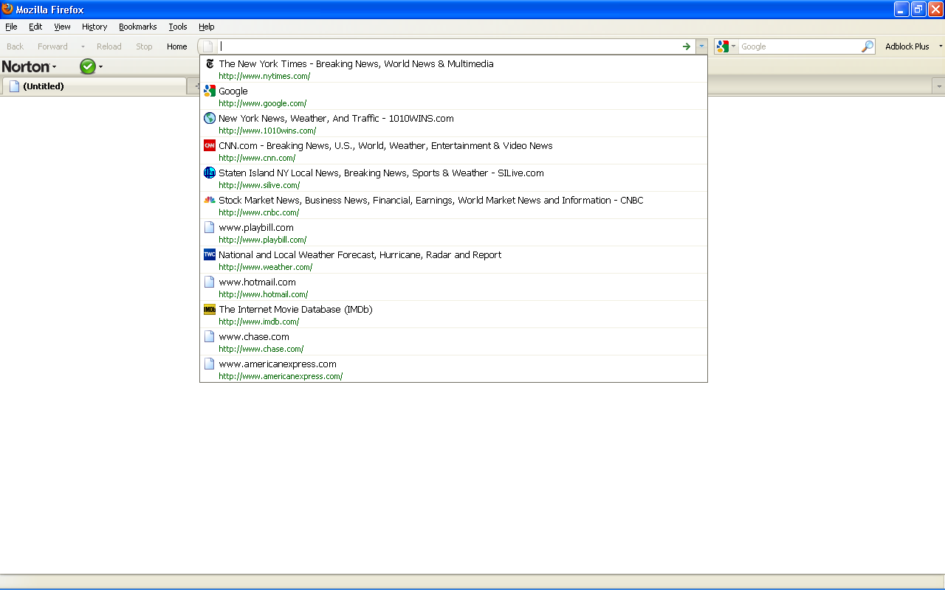

Norton bar and the hated location bar is now back

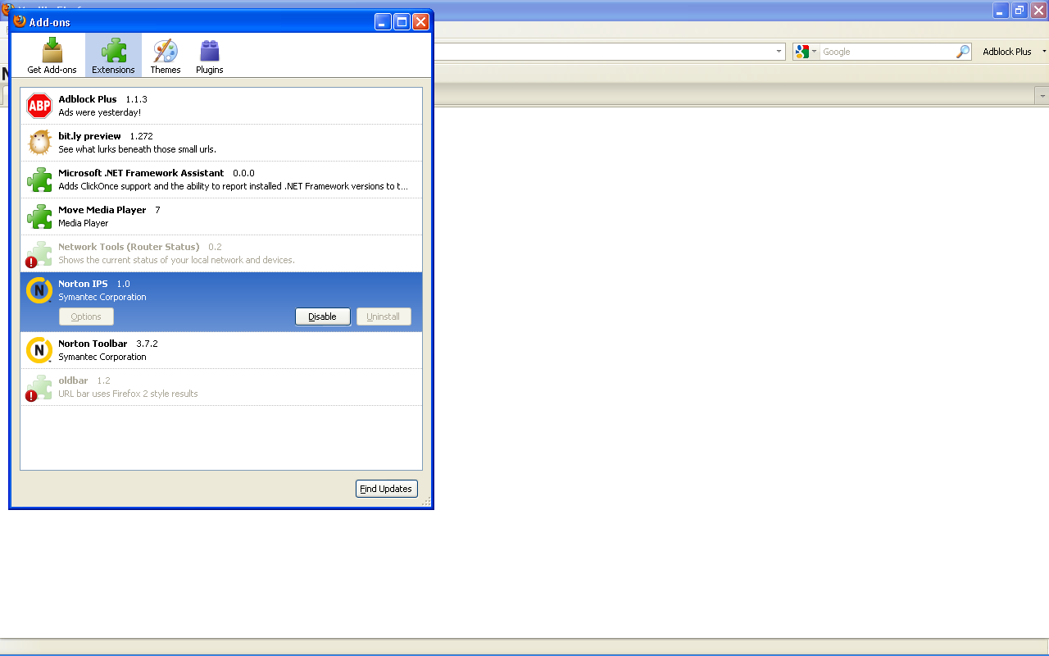

Add on dialog box showing Norton again enabled and….

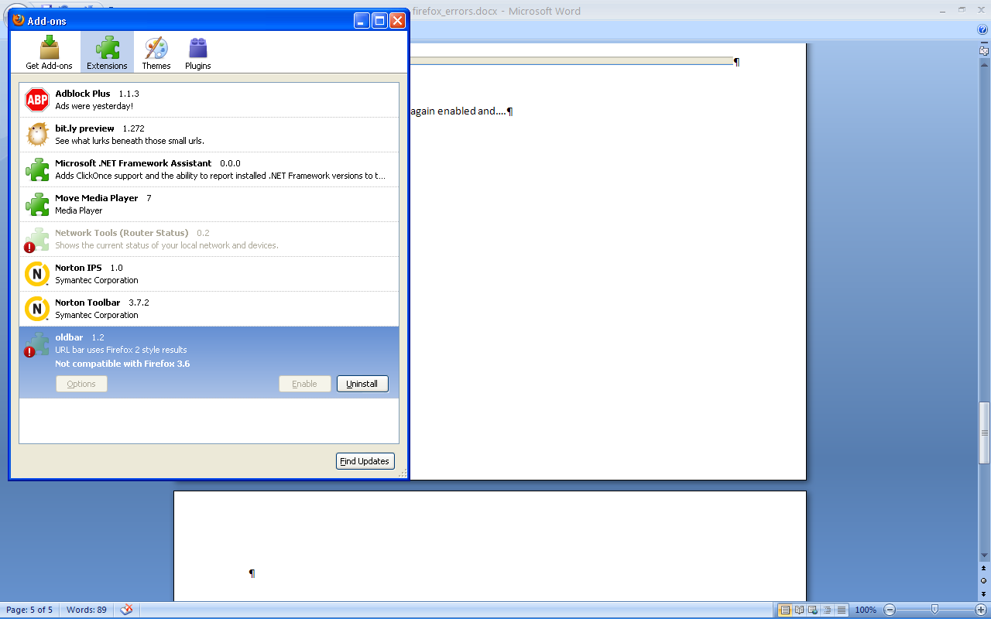

…oldbar telling me it is not compatible.. BUT it is because if I click Find updates, it updates and firefox restarts and it’s ok. I also have to manually disable Norton again:

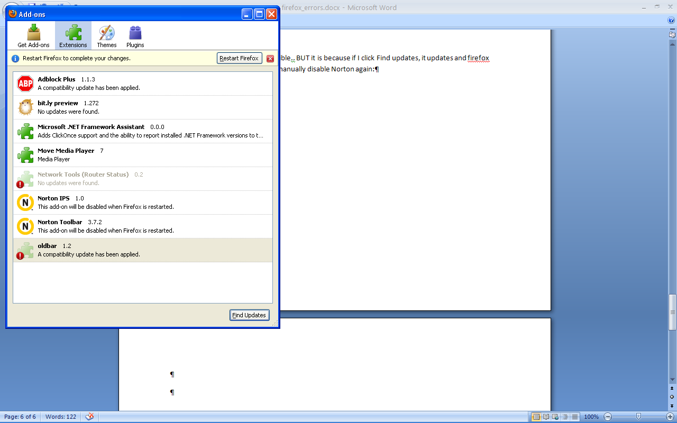

Add ons tell me a compatible update has been found and when I restart firefox, the oldbar works and Norton is gone.

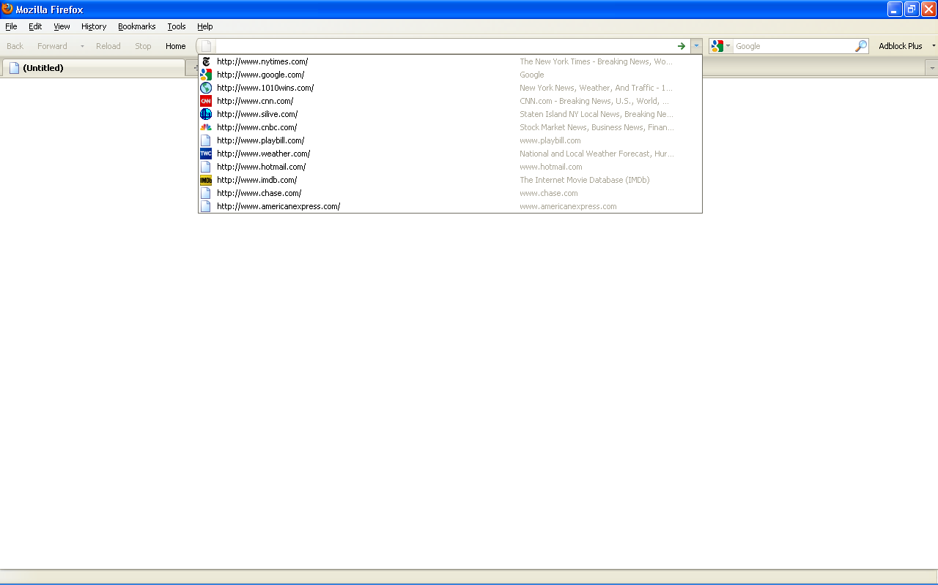

And now I am back to where I want to be. I can close / exit firefox an all the settings will remain as above.
However, a restart will bring everything back.

