Date: 14/08/2008
Bugzilla Mozilla Bug Report

- Certificates exported from IE and imported through Firefox are not being well displayed

Component: |  | Security
Hardware Platform: |  | PC
OS: |  | Windows XP
Build Identifier: |  | Mozilla/5.0 (Windows; U; Windows NT 5.1; en-GB; rv:1.9.0.1) Gecko/2008070208 Firefox/3.0.1
URL: |  | https://www.mygov.mt
Summary: |  | When a certificate previously created using IE browser (Version 6.0 on Windows XP) is imported into Firefox the certificate identification gets corrupted.
Details: |  | When selecting a certificate from a web portal, the User Identification Request window displays the certificate’s identification name as a string of characters, in which case the subject name is not being displayed as expected.  Through continues testing, this has been seen to occur whenever a certificate is being exported from an Internet Explorer browser and the same certificate is then being imported into Firefox browser under the same OS platform.  The image below shows the incorrect certificate identification which was exported from IE and imported through Firefox:
 | 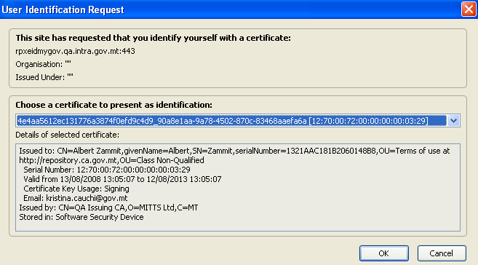
Reproducibility: |  | Happens every time
Steps to Reproduce: |  | From the URL provided above, a registered user can click on ‘Select Digital certificate’ to select the respective certificate to further secure the authentication session.
Actual Results: |  | The certificate identification name is not being displayed as expected when a certificate was exported from Internet Explorer and imported through Firefox.
Expected Results: |  | Ideally the certificate identification details should be well demonstrated for ease of identification.
Additional Information: |  | Such problem has been also tested under Windows Vista and Ubuntu.
Severity: |  | Normal

