Date: 14/08/2008
Bugzilla Mozilla Bug Report

- The Certificate Viewer does not show any information that a certificate has been revoked

Component: |  | Security
Hardware Platform: |  | PC
OS: |  | Windows XP
Build Identifier: |  | Mozilla/5.0 (Windows; U; Windows NT 5.1; en-GB; rv:1.9.0.1) Gecko/2008070208 Firefox/3.0.1
URL:
Summary: |  | The Certificate Viewer does not show any information that a certificate has been revoked.
Details: |  | After the CRL is imported into the browser, the browser does not show the certificates that have been revoked. Even once the CRL was forced to update, the certificates that had been revoked did not show as such.  For example the image below shows a certificate that has been revoked, however the information does not identify this:
 | 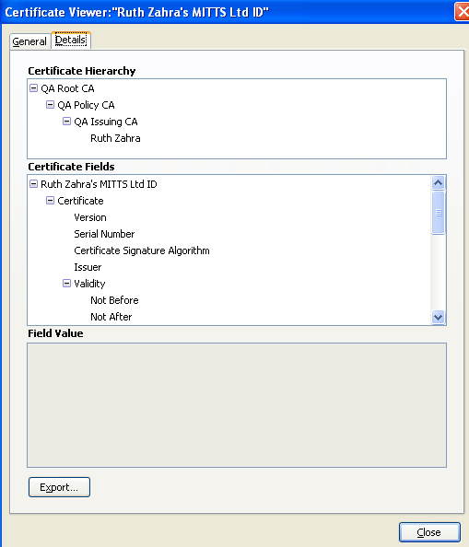
Reproducibility: |  | Happens every time
Steps to Reproduce: |  | To view certificate details:  - Tools | Options.  - Advanced | Encryption | View Certificates.  - Select certificate from ‘Your Certificates’ and click View.  - From the Certificate Viewer, go to Details tab.
Actual Results: |  | The window under Field Value does not prompt the user with a message that a certificate has been revoked.
Expected Results: |  | When viewing certificate details, the user should be notified that the certificate has been revoked.
Additional Information: |  | Such problem has been also tested under Ubuntu.
Severity: |  | Normal

