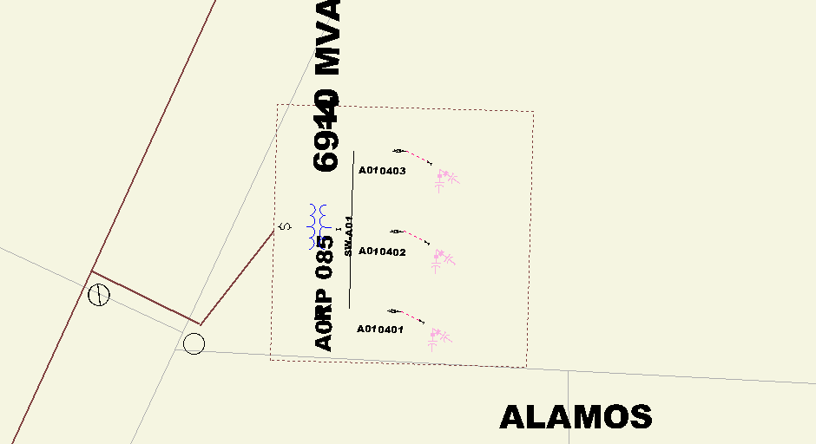
Sub ID Label
Sub Xfmr Name Label
This is a snapshot of OMS’s version of this Substation. (I think I was at 0.6 mile view and I cut the screen shot down to show just this part).
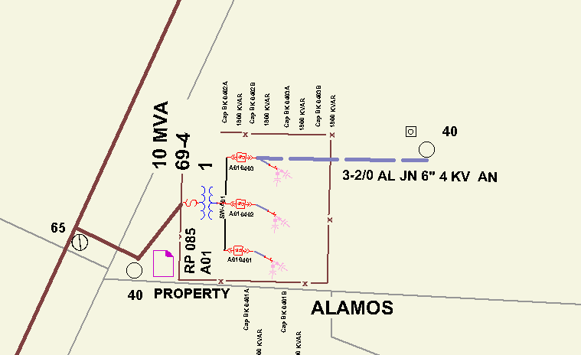
Note: Primary, pole & MH put on after extract.
This is 600 view in Gframme of same Substation.

