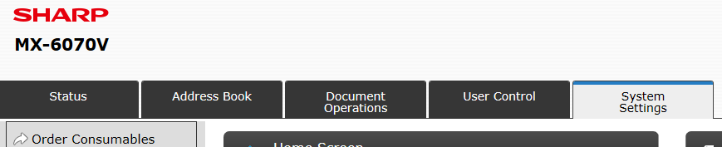
Screenshot 1

Screenshot 2

