- Display arrangement
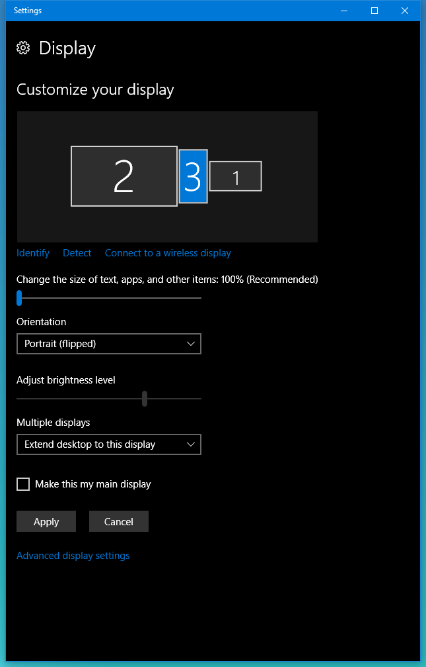
- Desktop
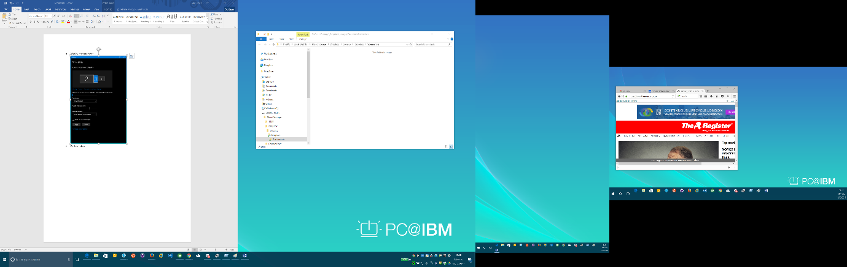
I’m about to move the “Register” Firefox window
- With Firefox window on right still visible
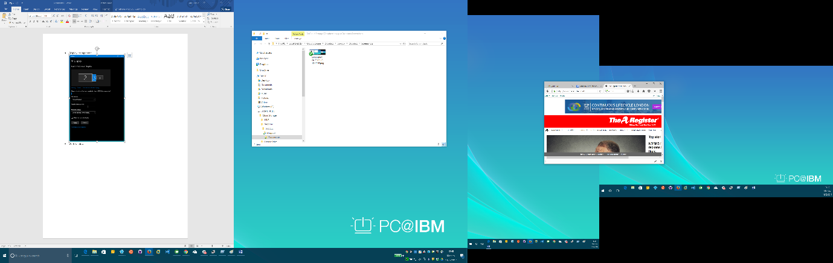
- With Firefox window dragged further left ….
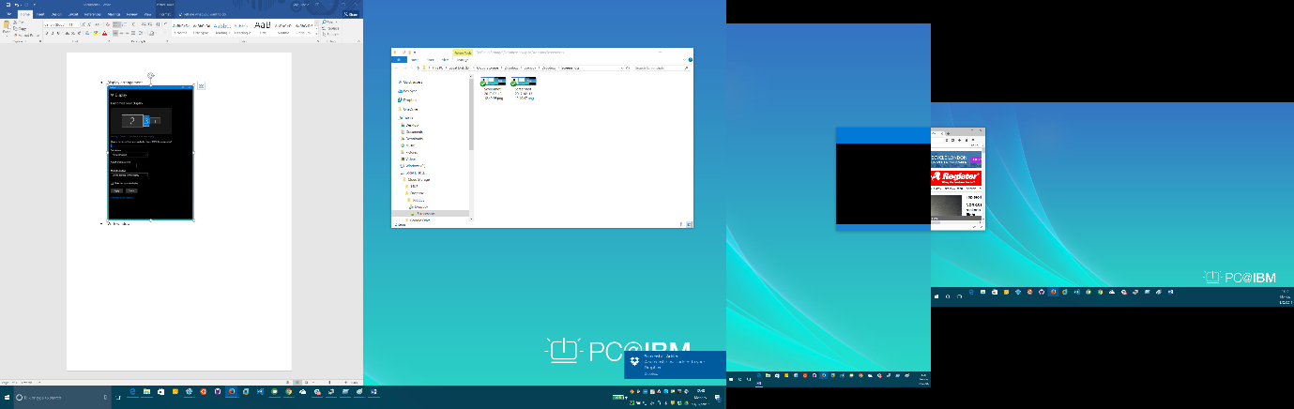
Notice that the left-hand side is now blank!
- The Firefox window now on the central screen and blank!
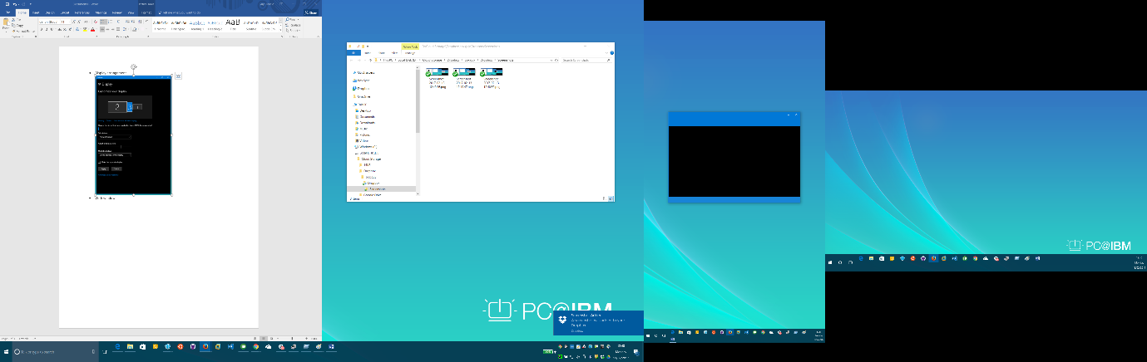
- Oddly, I can still drag tabs out!
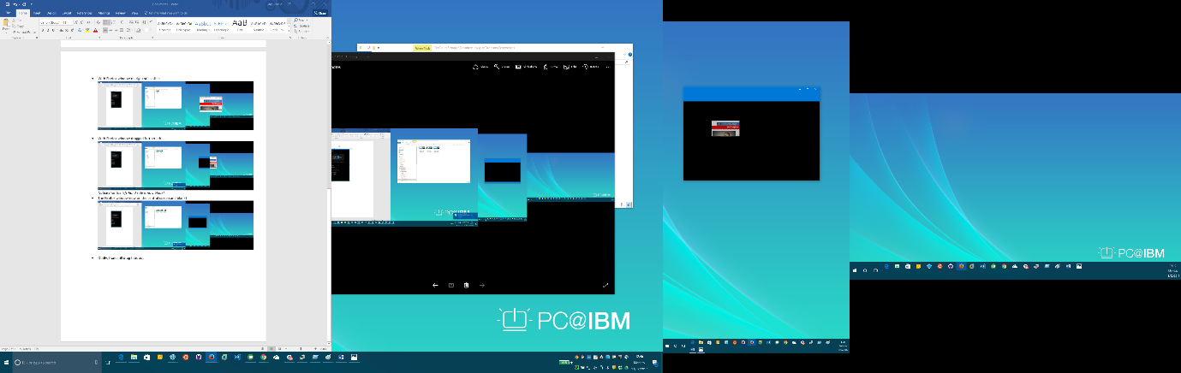
- And they become visible again!
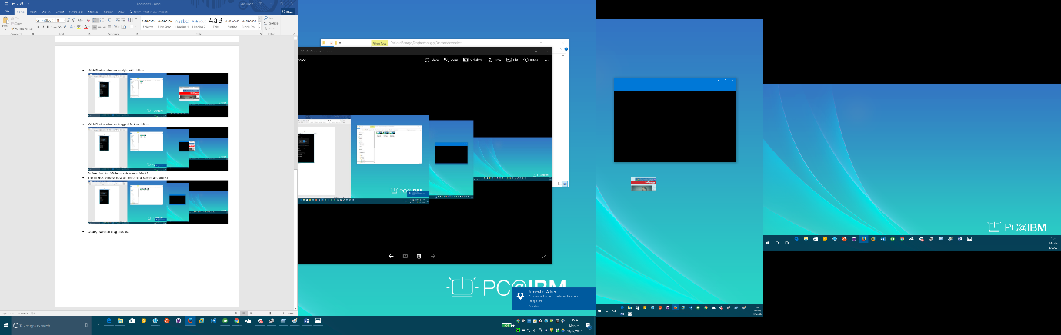
- Tada!
