Problem as seen from Firefox 51.0.1 (32 bits):
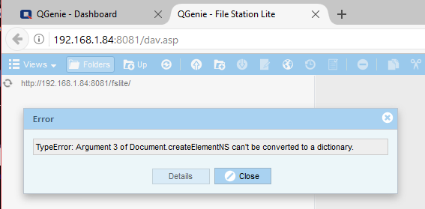
As seen on MS-Edge :
