Installing and Configuring Mac Print Driver

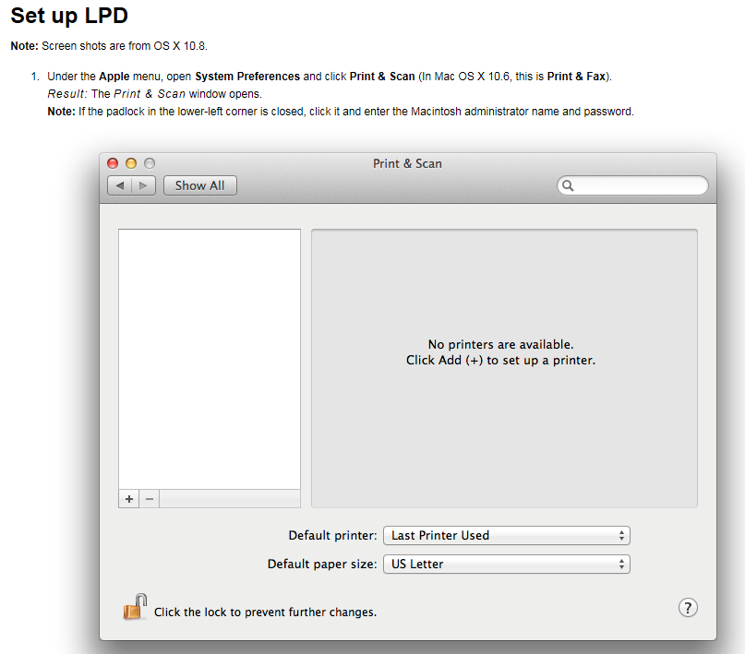
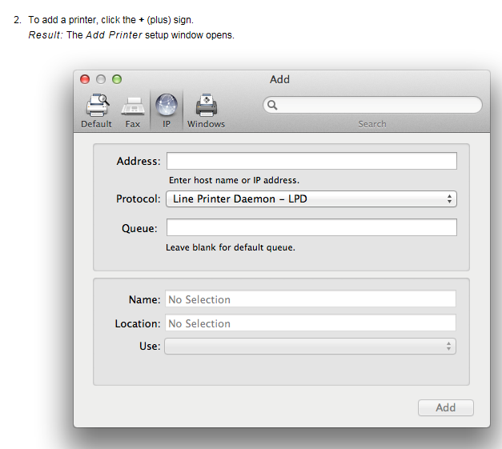
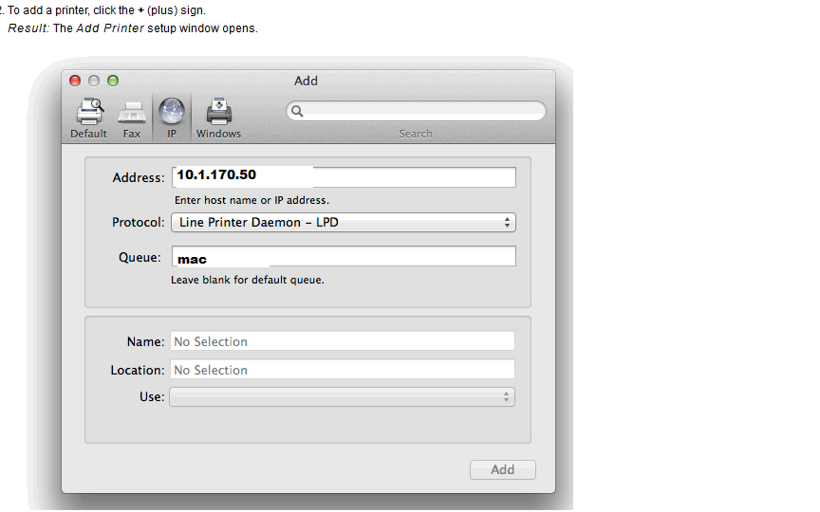
In the window you will enter 10.1.170.50 for the Address and in the Queue
You will enter lower case mac

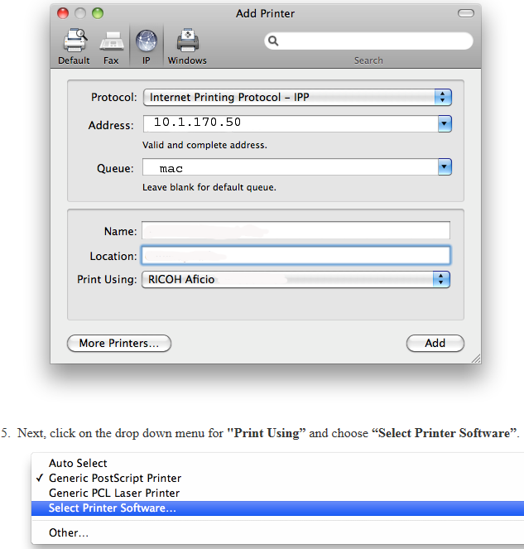

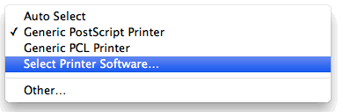
When you are prompted for the print driver Select Printer Software and go to the Ricoh printers and select the Ricoh PS C4000 PPD. Once installed you will need to configure the User ID setting as shown below.

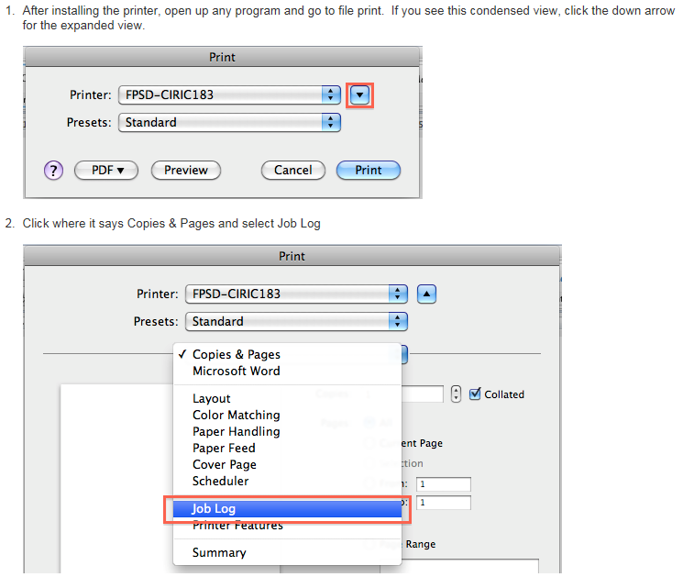
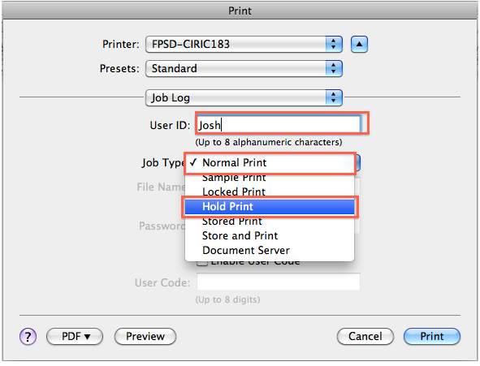
In the image above you will enter your LDAP ID in the User ID box. You can leave the Job Type on Normal Print. The LDAP ID is usually your first initial and first 5 or 6 characters of your last name.
Once this has been done you will need to save this configuration as you Default Preset.
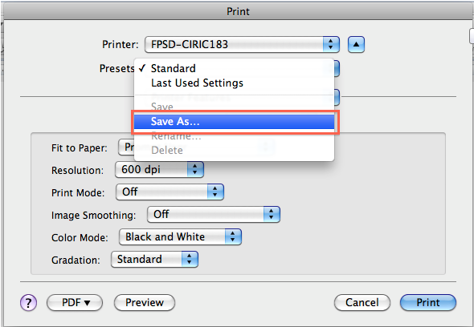
You are now ready to Print using the Mac Print Driver.

