We added some logs in the firefox soure code (version: 42) and built it.
It’s the modification below:
File : Rtp_sender_video.cc
Function: bool RTPSenderVideo::Send
Code:

bool RTPSenderVideo::Send(const RtpVideoCodecTypes videoType,
const FrameType frameType,
const int8_t payloadType,
const uint32_t captureTimeStamp,
int64_t capture_time_ms,
const uint8_t* payloadData,
const uint32_t payloadSize,
const RTPFragmentationHeader* fragmentation,
const RTPVideoTypeHeader* rtpTypeHdr) {
uint16_t rtp_header_length = _rtpSender.RTPHeaderLength();
int32_t payload_bytes_to_send = payloadSize;
const uint8_t* data = payloadData;
size_t max_payload_length = _rtpSender.MaxDataPayloadLength();

scoped_ptr<RtpPacketizer> packetizer(RtpPacketizer::Create(
videoType, max_payload_length, rtpTypeHdr, frameType));

// TODO(changbin): we currently don't support to configure the codec to
// output multiple partitions for VP8. Should remove below check after the
// issue is fixed.
const RTPFragmentationHeader* frag =
(videoType == kRtpVideoVp8 || videoType == kRtpVideoVp9) ? NULL : fragmentation;

packetizer->SetPayloadData(data, payload_bytes_to_send, frag);

bool last = false;
while (!last) {
uint8_t dataBuffer[IP_PACKET_SIZE] = {0};
size_t payload_bytes_in_packet = 0;
if (!packetizer->NextPacket(
&dataBuffer[rtp_header_length], &payload_bytes_in_packet, &last)) {
LOG(LS_WARNING) << "fail to get next package!";
return false;
}

// Write RTP header.
// Set marker bit true if this is the last packet in frame.
_rtpSender.BuildRTPheader(
dataBuffer, payloadType, last, captureTimeStamp, capture_time_ms);
if (SendVideoPacket(dataBuffer,
payload_bytes_in_packet,
rtp_header_length,
captureTimeStamp,
capture_time_ms,
packetizer->GetStorageType(_retransmissionSettings),
packetizer->GetProtectionType() == kProtectedPacket)) {
LOG(LS_WARNING) << packetizer->ToString()
<< " failed to send packet number "
<< _rtpSender.SequenceNumber();
}
LOG(LS_INFO) << packetizer->ToString() << " succeed to send packet number: " << _rtpSender.SequenceNumber()
<< " timestamp: " << _rtpSender.Timestamp()
<< " SSRC: " << _rtpSender.SSRC();
}

TRACE_EVENT_ASYNC_END1(
"webrtc", "Video", capture_time_ms, "timestamp", _rtpSender.Timestamp());
return true;
}

File:rtp_receiver_video.cc
Function: int32_t RTPReceiverVideo::ParseRtpPacket
Code：
int32_t RTPReceiverVideo::ParseRtpPacket(WebRtcRTPHeader* rtp_header,
const PayloadUnion& specific_payload,
bool is_red,
const uint8_t* payload,
uint16_t payload_length,
int64_t timestamp_ms,
bool is_first_packet) {
TRACE_EVENT2("webrtc_rtp",
"Video::ParseRtp",
"seqnum",
rtp_header->header.sequenceNumber,
"timestamp",
rtp_header->header.timestamp);
LOG(LS_INFO) << "Video Receive: seqnum : " << rtp_header->header.sequenceNumber << " timstamp: " << rtp_header->header.timestamp;
rtp_header->type.Video.codec = specific_payload.Video.videoCodecType;

const uint16_t payload_data_length =
payload_length - rtp_header->header.paddingLength;

if (payload == NULL || payload_data_length == 0) {
return data_callback_->OnReceivedPayloadData(NULL, 0, rtp_header) == 0 ? 0
: -1;
}

// We are not allowed to hold a critical section when calling below functions.
scoped_ptr<RtpDepacketizer> depacketizer(
RtpDepacketizer::Create(rtp_header->type.Video.codec));
if (depacketizer.get() == NULL) {
LOG(LS_ERROR) << "Failed to create depacketizer.";
return -1;
}

rtp_header->type.Video.isFirstPacket = is_first_packet;
RtpDepacketizer::ParsedPayload parsed_payload;
if (!depacketizer->Parse(&parsed_payload, payload, payload_data_length))
return -1;

rtp_header->frameType = parsed_payload.frame_type;
rtp_header->type = parsed_payload.type;
return data_callback_->OnReceivedPayloadData(parsed_payload.payload,
parsed_payload.payload_length,
rtp_header) == 0
? 0
: -1;
}

Result:
Send:
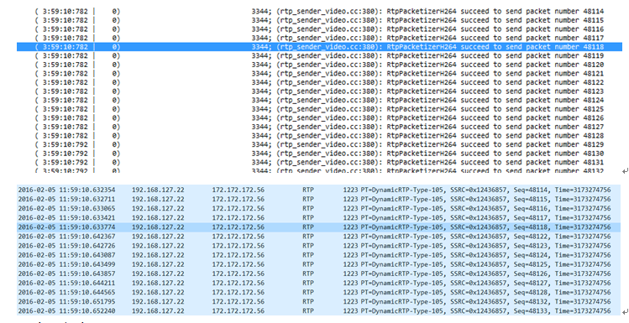
Receive:
