The PAC file host by IIS 7.
Step:
- Open Firefox, and change the proxy setting to use system proxy settings, close the Firefox.
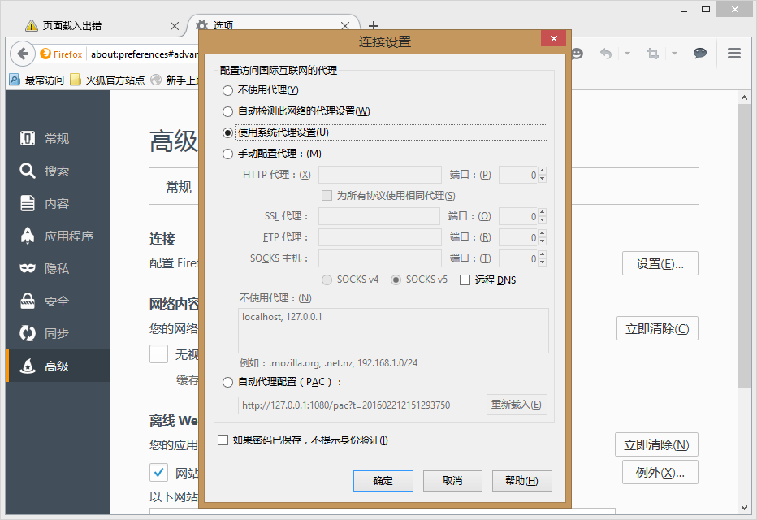
- Change the system proxy settings to http://172.165.1.5:8080/pac.txt?v=1
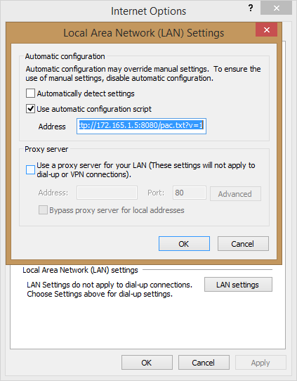
- Open the Firefox, and open the https://www.google.com/?gws_rd=ssl. The Proxy not work.
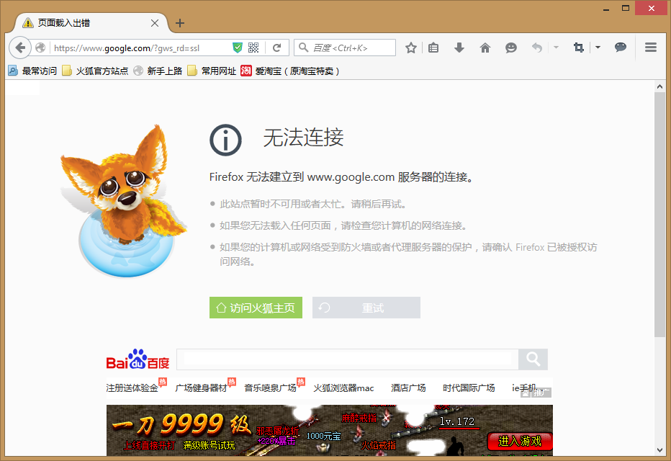
- Change the Firefox proxy settings as below screenshot.
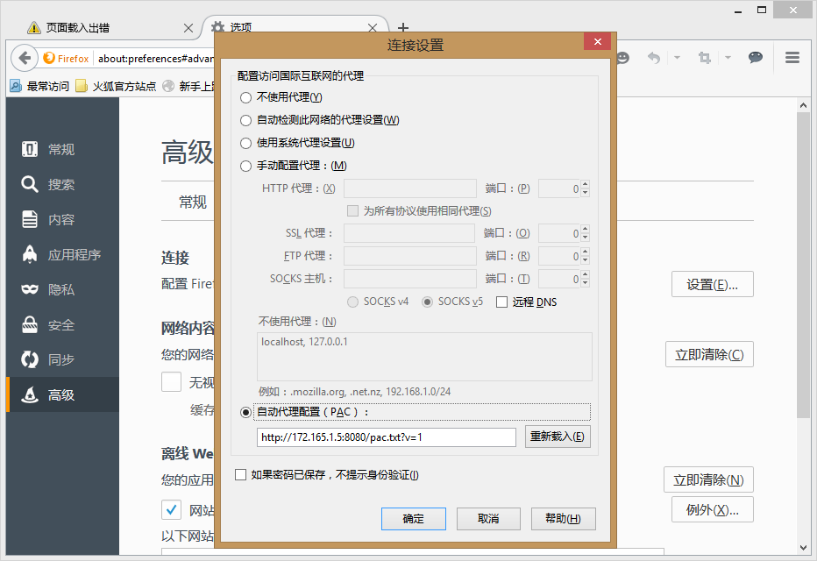
- Open the Firefox, and open the https://www.google.com/?gws_rd=ssl. The Proxy working.
