Name Firefox
Version 35.0.1
User Agent Mozilla/5.0 (Windows NT 6.1; WOW64; rv:35.0) Gecko/20100101 Firefox/35.0

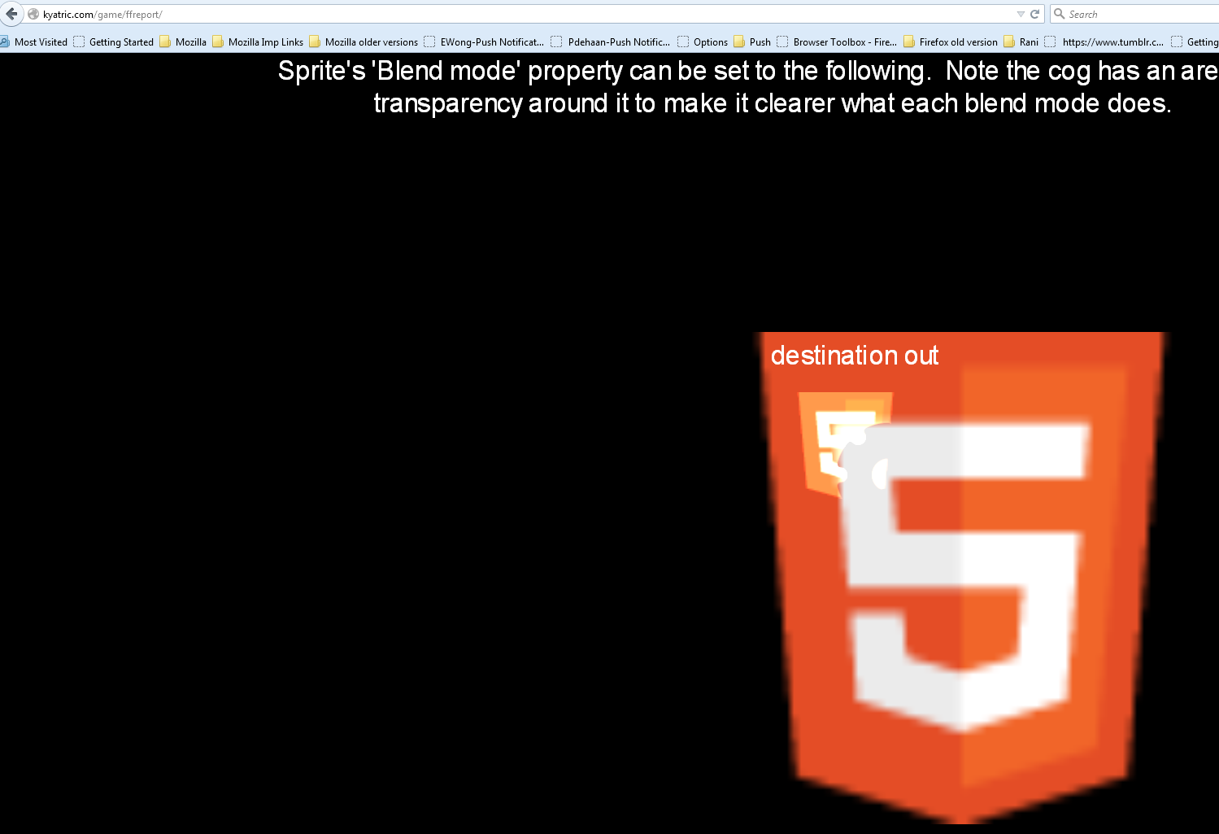

Google Chrome (Version 47.0.2526.106 m)
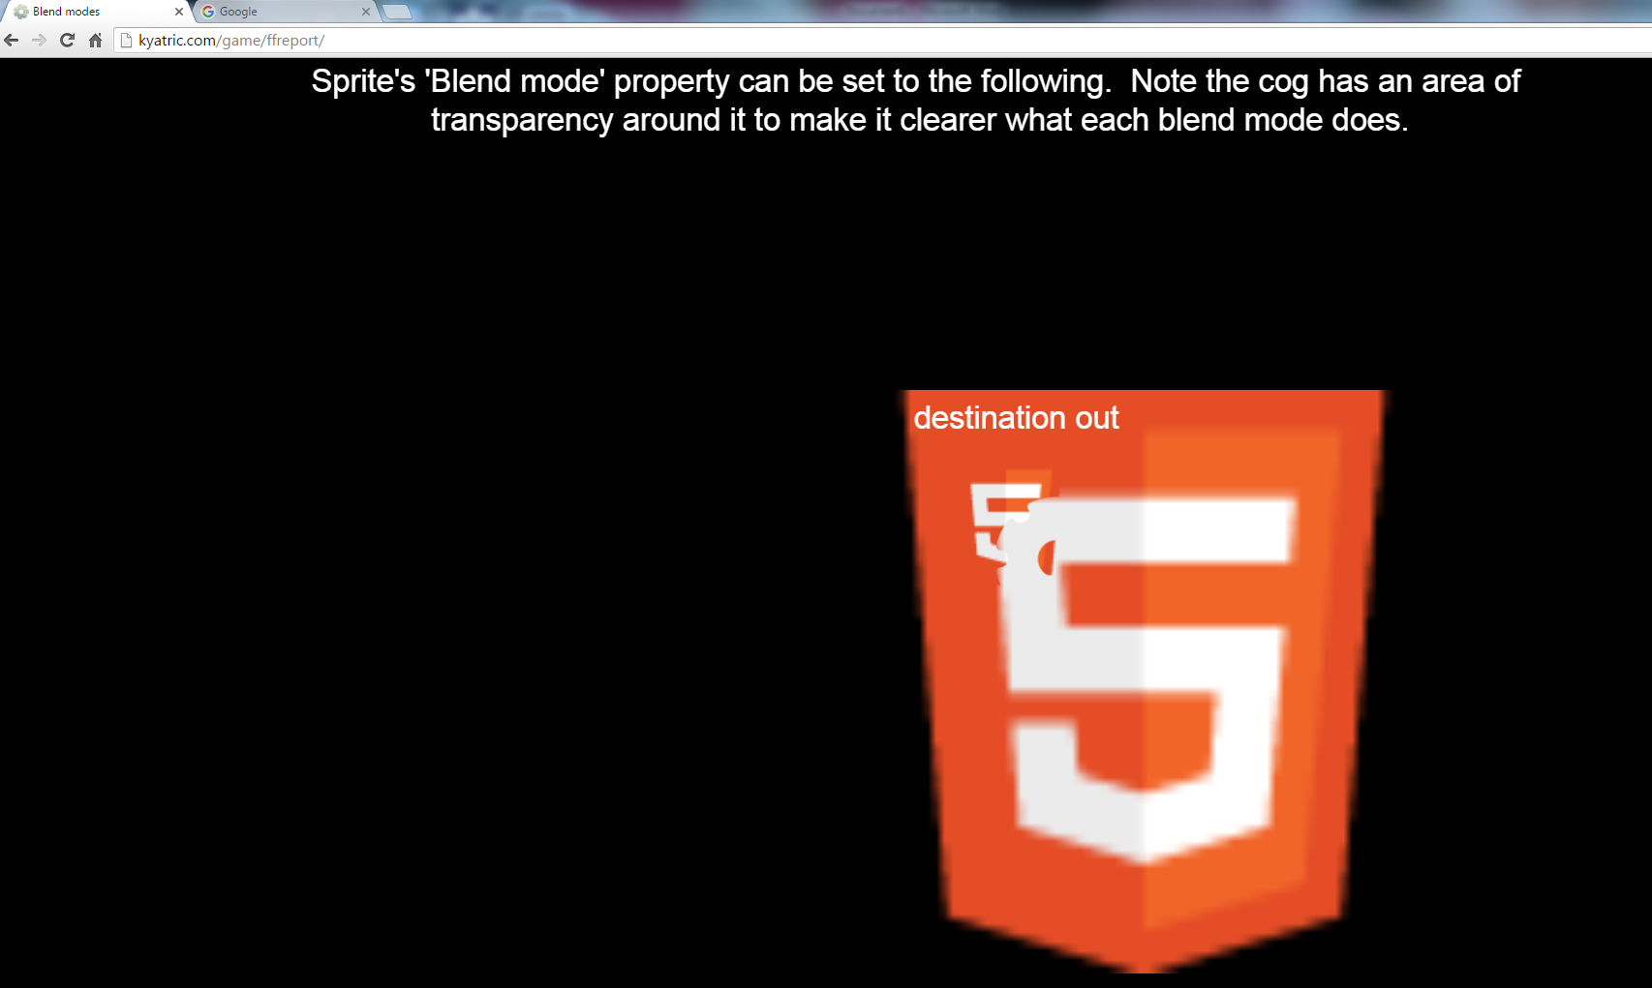

Name Firefox
Version 43.0.3
Build ID 20151223140742
Update Channel release
User Agent Mozilla/5.0 (Windows NT 6.1; WOW64; rv:43.0) Gecko/20100101 Firefox/43.0

