Portrait A4 full page
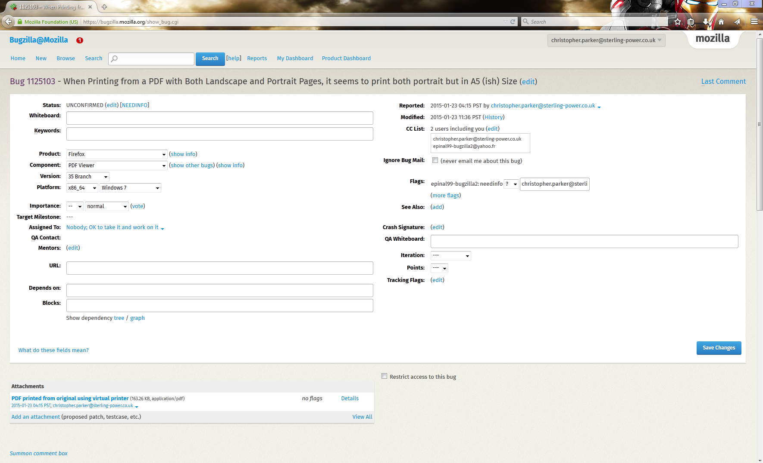

Landscape A4 full page

Portrait A4 full page

