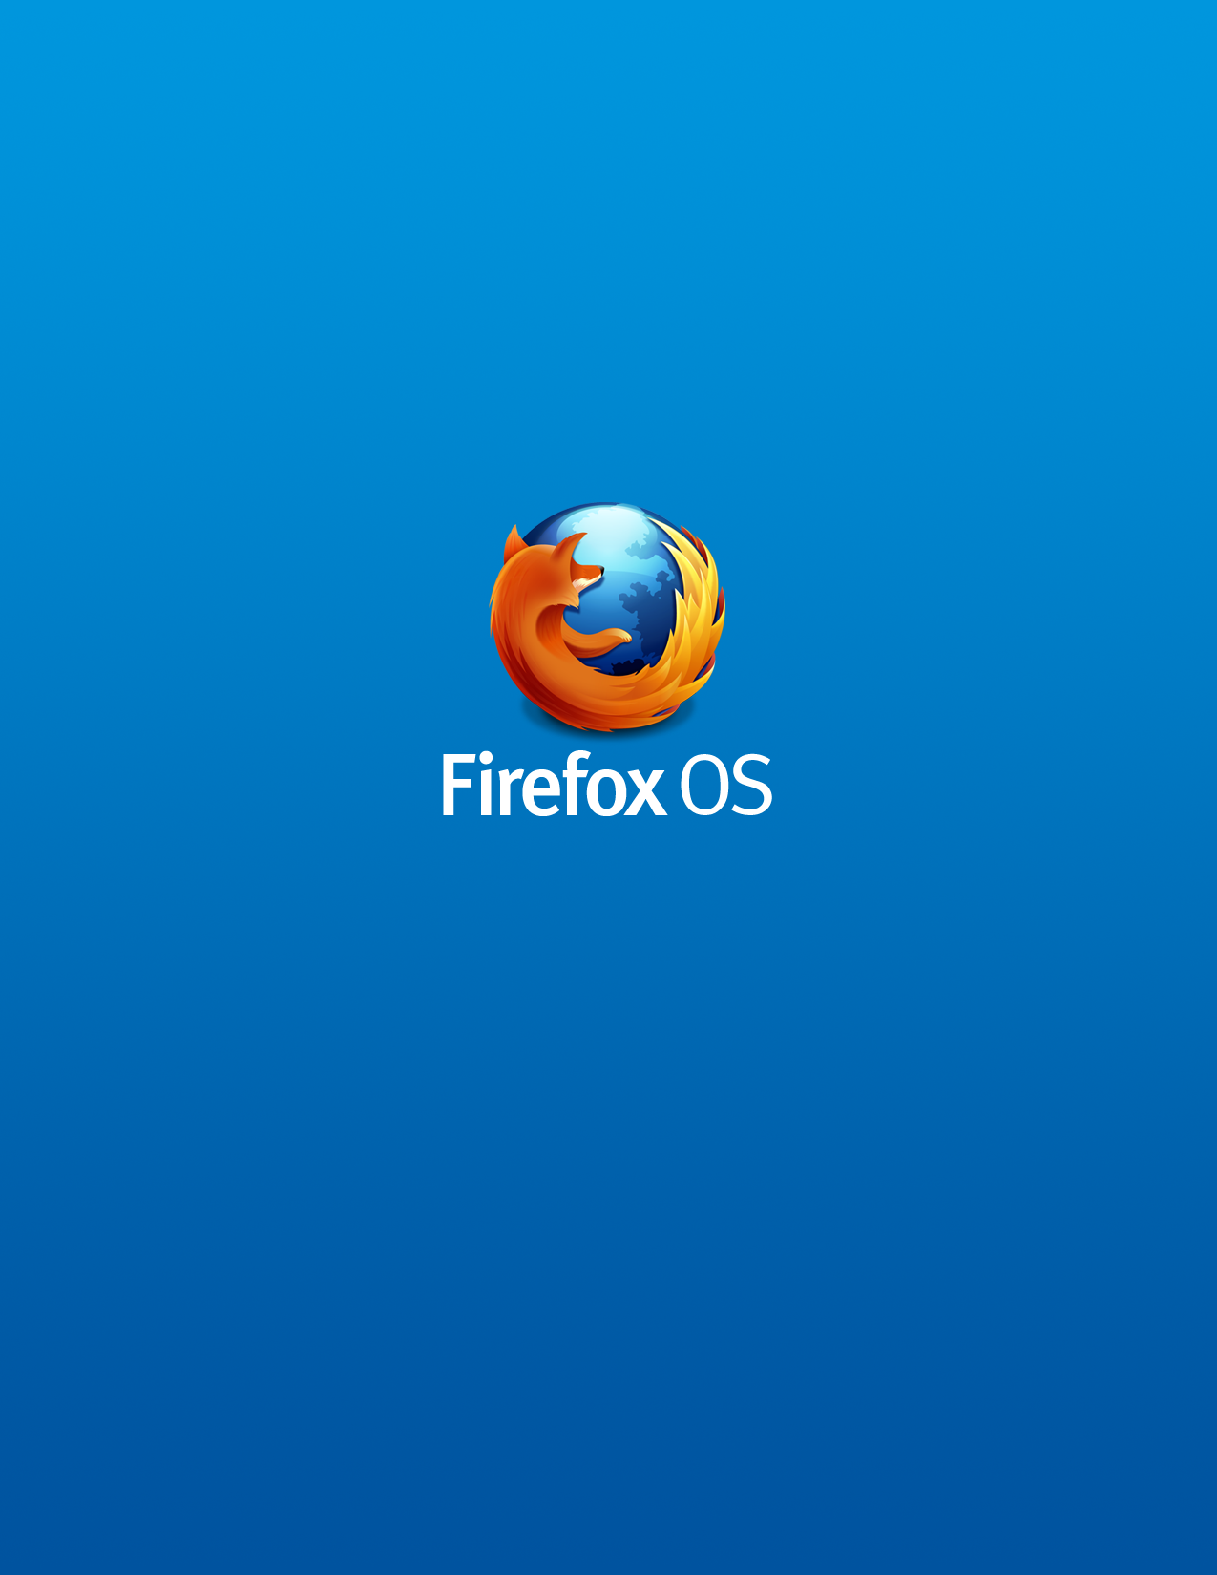
February 5, 2014
Firefox Marketplace
for Firefox OS v1.0 – v1.3

Portions of this content are ©2013 by individual mozilla.org contributors. Content available under a Creative Commons license.
Revision History (Internal Only)
Change Author | Date | Reason For Changes | Version
Kev Needham | 20-Feb-2013 | Final modifications, screenshot update | 1.0.1
David Bialer | 05-Feb-2014 | Revised and updated with screenshots | 1.5
David Almström | 14-Oct-2014 | Revised with Feeds and FxA | 1.6

Contents
Introduction 1
Firefox Marketplace 1
Exchange for Buyers and Sellers 2
Users 2
Developers 2
Mozilla 2
Firefox Marketplace Ecosystem 3
marketplace.firefox.com 3
Developer Hub 3
Admin Portal 4
Firefox Marketplace Architecture 4
Marketplace Services 5
Catalogs 5
Payments 5
Standard and Custom Services 5
Web Content 6
Web Apps 6
Providing Apps to the Marketplace 6
Obtaining Apps from the Firefox Marketplace 8
In-App Purchases 8
Getting the Latest App Update 9
Revenue Generation, Payments, and Billing 9
Agreements Among Marketplace Participants 9
Payments and Billing 10
Mozilla Persona 12
Resources 12

Introduction
Mozilla's Firefox OS brings the open web to mobile devices. This document describes the services that enable Firefox OS users to select, install, and maintain web content on their smart phones.
- Firefox Marketplace is an app preinstalled on Firefox OS devices where 3rd party apps for Firefox OS are published and purchased. Marketplace provides a secure, integrated framework for web app discovery and distribution.
- Mozilla Persona is a federated identity service for Firefox OS that provides users with a unique ID to manage their accounts (usernames & passwords) in the cloud. Persona is required for Marketplace and is used for user authentication and account management. However, Firefox Accounts will replace Persona during Q4 2014.
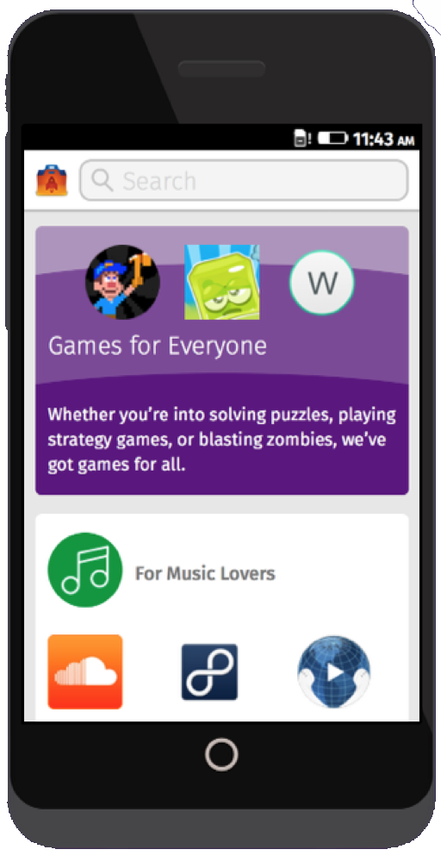
These services are external to mobile devices and are designed to interact seamlessly with the Firefox OS platform. Operators and OEMs provide these services to their customers. This document describes the basics of what Operators and OEMs need to know in order to plan, design, implement, and operate these services.

Firefox Marketplace
Mozilla's Firefox OS customers need a way to get web apps easily onto their mobile devices. They want to find and download web apps that are relevant to their needs and safe to use. Content providers need a way to promote and distribute their web apps to potential customers, and to collect revenue for their products. Operators and OEMs need a way to facilitate the exchange between consumers and developers.
Firefox Marketplace (https://marketplace.firefox.com/) provides an ecosystem for personalized web app discovery, simplified worldwide app distribution, easy payments, community and developer engagement, and operator/partner content and services. Firefox Marketplace enables open innovation, transparency, and user control.

Exchange for Buyers and Sellers
Firefox Marketplace is where developers and users come together.
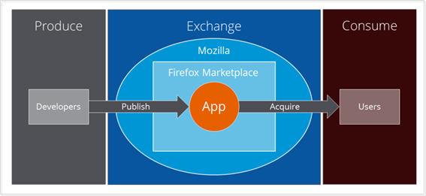

Users
For users, Firefox Marketplace is where they can easily discover, acquire, and install apps that use all the great features of their mobile device of their choice and that are relevant to their needs.

Developers
In this context, the term developer refers to any entity that publishes a web app in the Firefox Marketplace, including publishers, distributors, and individual developers. For developers, Firefox Marketplace is a large, established developer ecosystem that provides extensive support for cutting edge web technologies, and best-in-class tools and services to build, test, and deploy applications. It presents a powerful and scalable infrastructure for distributing apps and for getting input from the Mozilla community. It features strong support for payments and in-app payments (associated with a user’s Persona). Firefox Marketplace enables content providers to maintain a direct connection with their audience, own their content, and manage app release schedules.

Mozilla
Mozilla is responsible for Firefox Marketplace design, set-up, and operation. Operators may engage with a Payment Processor partner of Mozilla to manage Firefox Marketplace purchases and in-app payments.

Operators
The Firefox Marketplace provides a Operator partners with an Operator Shelf which allows for Operator to promote selected apps to their subscriber base.

Firefox Marketplace Ecosystem
The following figure shows the relationships among components and associated roles.
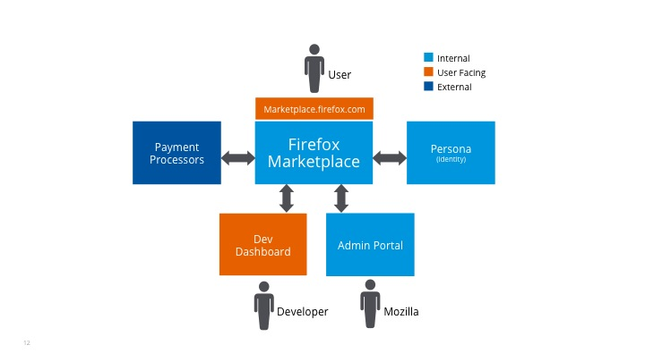
Firefox Marketplace uses role-based criteria when presenting content to logged in users.

marketplace.firefox.com
marketplace.firefox.com is the consumer interface to Firefox Marketplace. Web app that allows customers to interact with underlying Mozilla services. What users see can be filtered – for example, by region, carrier, or device.

Developer Hub
The Developer Hub (https://marketplace.firefox.com/developers/) is the where developers can learn about creating web apps, find resources, and download tools. It provides a means of submitting apps to the Firefox Marketplace.
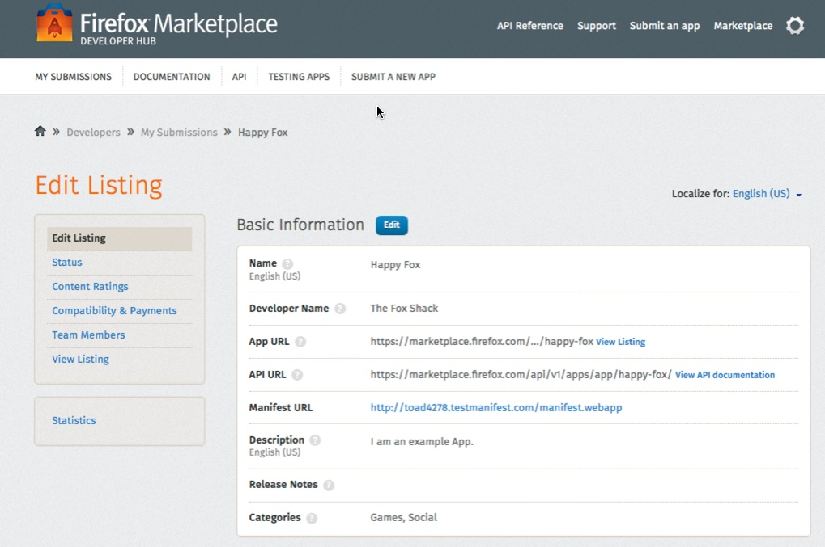
The Dev Dashboard is a console for developers to manage the publication of their app across many different countries. Developers can receive a content rating, manage payments, add team members, and to receive reports (such as the number of times an app has been downloaded).

Admin Portal
The Admin Portal is the administrator interface to Firefox Marketplace. It provides user-facing tools for app reviewers, administrators, support, and promotion. It also provides an access-controlled interface to analytical reports on Firefox Marketplace performance by region, Operator, platform, categories, and applications.

Firefox Marketplace Architecture

The Firefox Marketplace is built on Mozilla’s open-source Zamboni project using the Django web framework, python, and MySQL. Information on the Zamboni project is available at https://zamboni.readthedocs.org/en/latest/, and the APIs the Marketplace supports are documented at https://firefox-marketplace-api.readthedocs.org/en/latest/.

Marketplace Services
Firefox Marketplace delivers catalog, payment, and other services to customers. These services are implemented as web apps that access underlying Firefox Marketplace functionality via the Marketplace Core APIs.
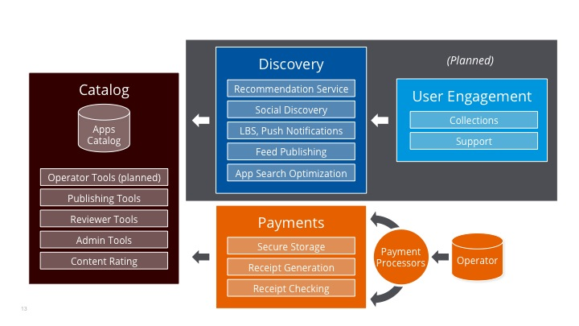

Catalogs
Catalogs provide access to available web content, including apps, ring tones, and so on. Mozilla is responsible for setting up and managing catalogs.

Payments
Payments in Marketplace are abstracted as a separate layer that can be implemented and managed by separate payment providers. Unlike proprietary app stores, in which users are bound to a single payment provider for purchases, Marketplace provides the flexibility of allowing developer to choose other payment options for in-app purchases, which gives users the freedom to select payment providers of their choosing. Marketplace integrates with operator billing providers in select regions.

Standard and Custom Services
Firefox Marketplace provides a set of standard, integrated services that enable core functionality. Standard services include personalization, metrics and statistics, localization, social integration, publishing, merchandising, and validation. In addition, the Firefox Marketplace can be extended with custom-built services.
All services are web apps that access underlying functionality via Marketplace Core APIs, which is secured via role-based Access Control. Mozilla can selectively expose specific operations and resources to specific roles. The Access Control model enforces these policies at run time.

Web Content
Firefox Marketplace is built for the purpose of distributing apps and app-delivered services. There are two main categories of apps:
- System apps are intrinsic to the Firefox OS platform, are certified for access to sensitive operations as appropriate, come preinstalled on the device as part of the system image, and are updated via platform patches and releases.
- Third-party apps are created by Developers and distributed and updated via the Firefox Marketplace.
The focus of this section is on third-party apps. For information about system apps, refer to
the Firefox OS Release Management white paper.

Web Apps
In Firefox OS, all applications are web apps – programs written using HTML5, JavaScript, and other open Web technologies – rather than native or compiled applications requiring an SDK. This approach makes the web the largest platform for app development to a broad community of developers. There are strictly no binary applications, which means that web apps are not restricted to a particular device or technology stack. Developers using standards-based technologies can build apps for multiple Web environments across devices. In fact, if a device has a modern browser, it can run content that users can get from Firefox Marketplace.

Providing Apps to the Marketplace
Developers create the apps and other content that consumers purchase in the Firefox Marketplace.
In order for an app to be published and made available to consumers, it needs to comply with Firefox Marketplace policies and practices in the code (https://developer.mozilla.org/en-US/Marketplace/Submission/Marketplace_review_criteria) including security, privacy, and appropriate usage requirements. For example, the app cannot have inappropriate access to sensitive operations and it must use good coding practices.

Content Ratings
All apps must receive a content rating that describes the age appropriateness for different regions of the world and use of interactive content. Mozilla has partnered with the International Age Rating Coalition (http://www.globalratings.com) which provides to developers a rating certificate for ESRB (North America), PEGI (Pan-Europe), USK (Germany), ClassInd (Brazil) and a generic rating for the rest of the world.

App Review / Approval Process
Apps undergo a rigorous review and approval process to ensure that the Firefox Marketplace catalog contains only trustworthy apps that are safe for customers to install and use.
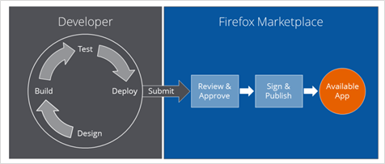
When a Developer submits an app in consideration for publication, Mozilla is responsible for validating the app, approving or rejecting it and, if approved, digitally signing it before making it available to consumers. Mozilla verifies its authenticity and integrity, ensures that requested permissions are used only for the purposes stated, verifies that the use of permissions is appropriate, and takes other measures to ensure that the web app will not behave maliciously with the permissions that it is granted.
As part of the app review process, Mozilla uses its own Reviewer Tools, a set of automated scripts that parse the app code and check for common coding issues (global variables, syntax, diction, and other requirements), and also identifies potential areas that require further investigation (such as invoking sensitive Web API operations). This information is for the benefit of the Developer as well as for the community editors who are conducting the review. If an app is found acceptable, it is published to the Marketplace. Mozilla uses a Signing tool to cryptographically sign the a packaged app's ZIP file with its private key, and then make the ZIP file available for mobile users to download and install on their device.

Publishing Apps
A developer chan choose whether the app is published in Firefox Marketplace as soon as it's approved by the review process or not, with options to keep it off listings and not visible for search but also keep it in a beta-mode and share with a define set of people to test before launching.
Choosing the Do not publish my app. enables a developer to:
- choose when to publish the app, which may be useful where, for example, you want to schedule the release to coincide with publicity.
- choose to make the app invisible or private, which may be useful where you're publishing a test version or an app for your organization.

Packaged and Hosted Apps
There are two types of apps that consumers can obtain from the Firefox Marketplace:
- A packaged app consists of a ZIP file containing application resources (HTML5, CSS, JavaScript, images, etc.), as well as a manifest that specifies an explicit list of assets as well as other details (such as requested privileges for API access). A packaged app that has undergone the rigorous review, approval, and signing process is called a privileged app, which means that it contains trusted content. An app must be signed in order to become privileged.
- A hosted app, on the other hand, is simply the manifest file, which contains a URI to content that is hosted remotely. Hosted apps undergo a review and approval process. However, because the content of the application is hosted and can change at any time, hosted apps are considered to be as untrusted apps with untrusted content.
Note: As ZIP files, packaged apps can be distributed without going through a Marketplace, but apps that are obtained outside the Marketplace are not signed and therefore cannot be trusted apps that use privileged WebAPIs.

Obtaining Apps from the Firefox Marketplace
Users go the Firefox Marketplace to discover, acquire, and install the third-party apps they want to use on their device.
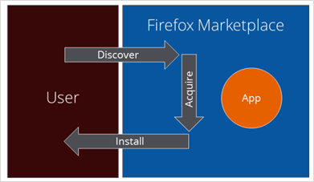
- Discover: The user searches through the catalog of apps that are available for free or purchase.
The Firefox Marketplace catalog provides a set of available apps, including signed (trusted) packaged apps and hosted (untrusted) apps. Apps presented to the user are filtered by the user’s region and device capabilities.
- Acquire: The user obtains an app (paid, freemium, or free). Depending on how payments are set up in the Firefox Marketplace, the user might pay with a credit or debit card, have it billed to their operator account, or some other method. Payments are described later in this document.
- Install: Once purchased, the user downloads and installs the app on their device.
If a user wants a hosted app, just the manifest is downloaded. If it is a packaged app, the user downloads the entire ZIP, and then the manifest is read from a known location inside the ZIP file, the signature is verified, app assets are verified, and the ZIP contents remain stored locally in the package.
Firefox Marketplace has a receipt generation service, which ties an app purchase to a user account so that the app may be re-downloaded or used on another device tied to that same account.

In-App Purchases
Developers may also use Firefox Marketplace to process in-app payments. Firefox Marketplace supports in-app payments by dynamically determining the user’s geographical location and allowing developers to present a payment option in the currency appropriate for that region, including mobile operator billing (where these billing relationships are in place with Operators). In this way, developers have access to the convenience of Operator billing for virtual goods that their app may offer.

Getting the Latest App Update
Developers use Firefox Marketplace to distribute updates (upgrades and patches) to customers who have installed their app. The Developer submits the update to Mozilla, where it undergoes the review and approval process. Once approved, the update is published and made available for users to download.
On consumer devices, Mozilla’s App Update Utility checks (automatically or manually) Firefox Marketplace for available updates.
If the App Update Utility discovers an app update, the user is notified that one is available, and is asked whether to install the update. If the user agrees to install, and if sufficient storage is available on the device, then the content is downloaded to a staging area, the signature is verified, and the update is installed (overwriting app files but not any user data).

Revenue Generation, Payments, and Billing
Marketplace supports both app and in-app purchases. Each time a customer purchases an app or makes an in-app purchase, the sale generates revenue. Revenue can be shared among various parties based on prior agreements. For example, the revenue might be divided up proportionally among the Developer, the Marketplace Administrator, the Operator, and other partners.

Payments and Billing
Firefox Marketplace offers consumers easy payment options, including credit card billing, built-in operator billing, and other billing and payment solutions. As mentioned previously, payments in Firefox Marketplace are abstracted as a separate layer that can be implemented and managed by an independent payment provider. For details about payments, see https://wiki.mozilla.org/Apps/ID_and_Payments. Currently, Operators can integrate payments with their billing back-end systems via the Payment Provider (Bango) API.

Mozilla Persona
Mozilla Persona is a federated identity service for Firefox OS that provides users with an account to manage their logins and data in the cloud. Persona is required for Firefox Marketplace and is currently used for:
- Web authentication. A user can sign into any supporting web app or site in two clicks. Users can choose which identity to present to any given web site or app. Persona is effectively a passport to web content.
- Account management. Persona is the basis for maintaining user purchases and licensed content.
Users set up Persona either opportunistically the first time they need to log in, or during the first-run of their Firefox OS device. When prompted, a user provides an email address, creates a password, receives an email confirmation, validates their email address, and then signs in using their account username and password.
Persona puts the user in charge. Users choose what data to share with which apps. Persona does not track the user across the Web, nor does it deliver any information to third parties.
Long range plans for the Marketplace are to use Firefox Accounts, a new Mozilla account system that uses Persona which supports other user services from Mozilla including syncing such information as contacts, app and history, and metadata.

Firefox Accounts
Firefox Accounts is a consumer account system, which provides access to services run by Mozilla, such as Firefox Marketplace and the next version of Firefox Sync. A user can sign in with a Firefox Account to all her "Foxes": Firefox on Desktop, Firefox for Android, and Firefox OS. Signing into a Firefox browser or device gives the user access to integrated Mozilla Services on that browser or device that requires authentication (e.g., Firefox Sync).

Resources
- Firefox Marketplace (actual)
http://marketplace.firefox.com
- About Firefox Marketplace
https://wiki.mozilla.org/Marketplace
- Web Apps:
https://wiki.mozilla.org/Apps
- Developers:
https://marketplace.firefox.com/developers/
- Mozilla Persona
www.mozilla.org/persona
- Mozilla Firefox Accounts
https://wiki.mozilla.org/Identity/Firefox_Accounts

