PARQUE EXPLORA
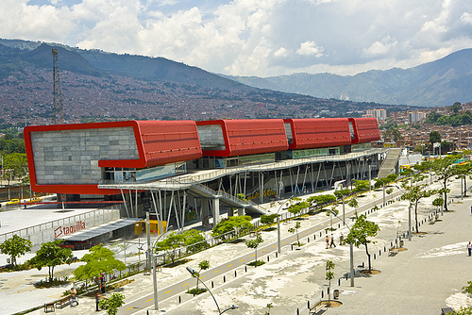
This attractive, interactive museum has a 3D room, children's playroom, and the largest freshwater aquarium in Latin America.

Getting there
Parque Explora is easily accessible by the metro. Just take the A line to Station Universidad. It is located between Parque Norte and the Jardin Botanico (Botanical Gardens).

Cost: $22,000 for full access to all attractions
Hours:

Monday to Friday from 8:00a.m. to 5:00 p.m.
Saturday, Sunday & holidays from 10:00 a.m. to 6:00 p.m.

JARDIN BOTANICO

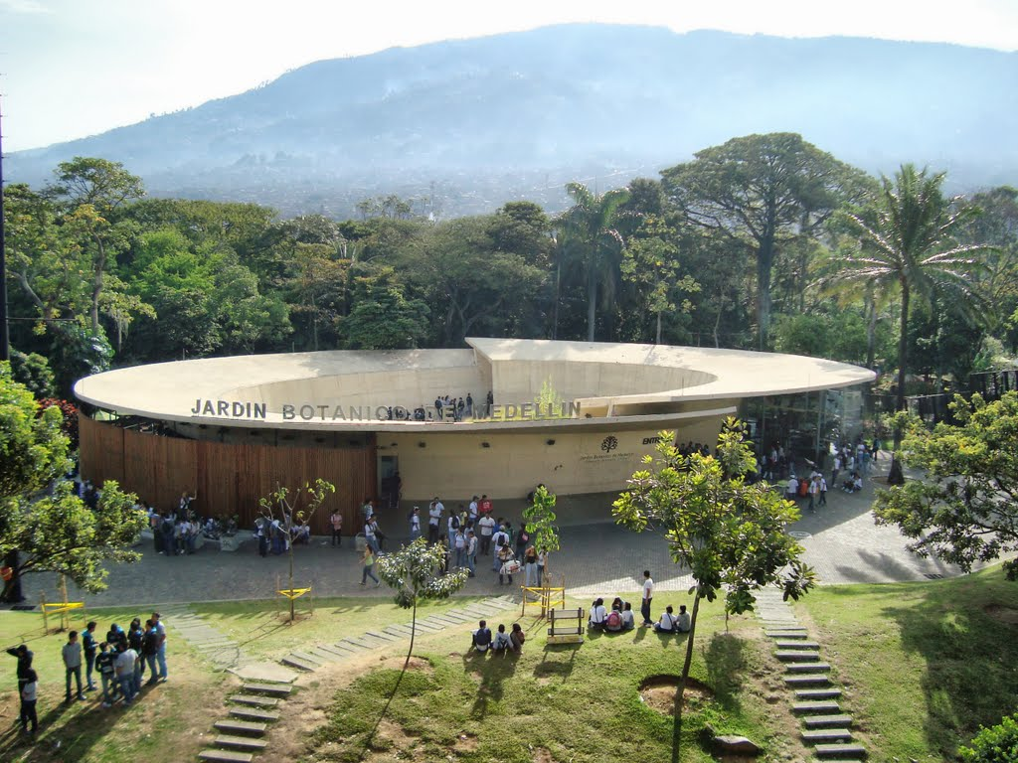.
Breathe some fresh air in this garden with 14 hectares of trees, a lagoon, an orchid tree and butterfly gardens.

How to get there:

To reach this beautiful place you can use the metro. Go to the Fatima Metroplus station and then switch to the metro. Simply go upstairs and take the pedestrian bridge to Industriales Station. Then take the metro towards Niquia and get off at Universidad Station.

Cost: FREE

Hours:

The park is open every day from 9 a.m. to 5 p.m., including weekends and holidays. Visitors may stay in the park until 5:30 pm.

Parque Lleras
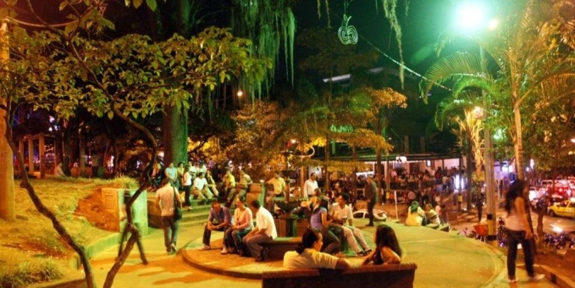
.
Parque Lleras is located in “El Poblado,” which is a safe and lively neighborhood in Medellin with a huge selection of restaurants, bars, and clubs. Parque Lleras is in the middle of it all, and it is a great place to have a beer, meet other travelers, and practice your Spanish with the locals. It is busiest from Thursday through Saturday, although it is still a nice place to relax and people-watch during the week.

Recommendations:
Discotechs/Clubs:
- La Ruana de Juana
- Blue

Restaurants:
- Pergamino (café), Velvet (café)
- Verdeo (vegetarian restaurant), Royal Thai, Natto

How to get there:

METRO: Take the metro to Poblado station. When you arrive at the station, exit to the East (go to the right) and walk uphill on Calle 10. You will pass Parque Poblado. Keep walking up the hill until Carrera 40, where you turn right. Walk one block, and you´re there! It’s a 5 to 10 minute walk from the station.
- *Spanish hint: ask someone “¿Donde está Parque Lleras?”*

TAXI: A taxi from IHM will cost around $8,000.

METROCABLE – Parque Arví
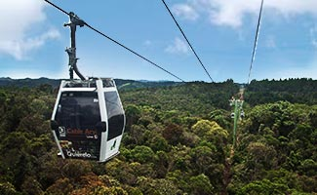

Arvi Park is an eco-tourism destination located in Santa Elena. After a trip in the metrocable with beautiful views, you arrive at the park where you can enjoy the outdoors. With abundant cloud forests, it is one of the most important natural resources of this territory. Arvi Park preserves the quality of the water that goes down to the valley of Aburrá and San Nicolás. It is also home to flowers, mosses, fungi, Sarros, frogs, birds, butterflies, and many other species that are of vital importance to the ecosystem.
How to get there:
To access Arvi Park via the Metrocable, you must go to Acevedo station in the north of the city. There you transfer to the K Cable Line toward Santo Domingo station, and then to the L Line Cable Arví. The journey lasts approximately 20 minutes.
Cost:

Entrance to the park is free. The trip by metrocable from Santo Domingo (station metro cable) is $ 4,600.

Hours:

The Cable L Line operates between 9:00 a.m. and 6:00 p.m. daily, except on the first working day of each week. That is, if Monday is a holiday, the cable does not work on Tuesday in order to allow for maintenance.

PUEBLITO PAISA
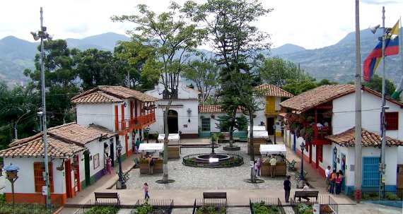
This is a replica of a typical Antioquia town and is located on top of Cerro Nutibara. The perimeter of the small square is decorated with the traditional buildings of a town, such as a church and town hall. It offers a spectacular view of the city day and night, restaurants with typical food, and various artisan shops. Pueblito Paisa, an emblem of the Antioquia capital, is accessible by car on a paved road, or by foot via the nature trails that surround I on all sides.

How to get there:
.
- To reach the entrance of Cerro Nutibara on 30th Street, you can take the bus routes toward Bethlehem University of Medellín or walk from the metro station Industriales. After arriving at the 30th Street entrance, you can climb to the top via the stairs built on the slopes of the hill or take a taxi. No public bus routes go to the top of the hill.
- To reach the entrance of Cerro Nutibara on 33rd Street, you can take bus routes Coonatra loop or Santra towards Bethlehem Park. On the 33rd Street entrance there are no stairs, but you can climb to the top via the streets.

Cost: FREE
Hours:

Open daily from 5:00 a.m. to midnight.

CENTRO DE MEDELLÍN
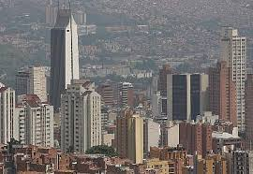.
The center is the ideal place for shopping. Here you can find clothes, shoes, and other miscellaneous items. There are plenty of stores that offer good prices. In Medellin, the center is commonly called “EL HUECO”. In the center, you can also find the Park of Lights, El Museo de Antioquia, and Barefoot Park.

How to get there:

You can take the subway and get off at stations San Antonio or Parque Berrio. From IHM you can also go by bus. Simply take bus 170 (it is yellow and blue) and get off at San Antonio.
Hours:
You can go to the center at any time, but if you want to go shopping, you should go between Monday and Saturday from 9:00 am to 6:00 pm when the shops are open. It can be a little dangerous to go on Sundays because the shops are closed and the streets are empty. It is also not recommended to go at night due to safety concerns.

MUSEO DE ANTIOQUIA
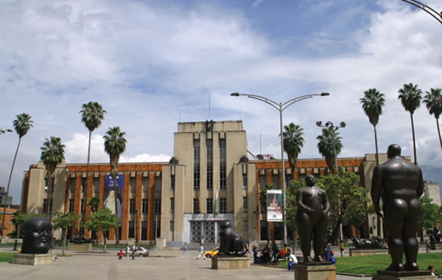
This is a beautiful place for art lovers, especially if you love Botero! This museum has various exhibitions, such as Botero, photography, and Antioquia artists, among many others. Outside the museum you will find Plaza Botero, where you can delight yourself with large bronze sculptures, perfect for photographs. Fun fact—each sculpture is worth 2 million dollars and each have been donated by Botero!

How to get there:

You can go by bus (170 Belen) and walk to the Parque Berrio station or you can take the subway and get off at Parque Berrio and walk one block to reach Plaza Botero.

Cost: $10,000 COP
Hours:
Monday to Saturday: 10:00 a.m. to 5:30 p.m.
Sundays & holidays: 10:00 a.m. to 4:30 p.m.

PARQUE DE LAS LUCES
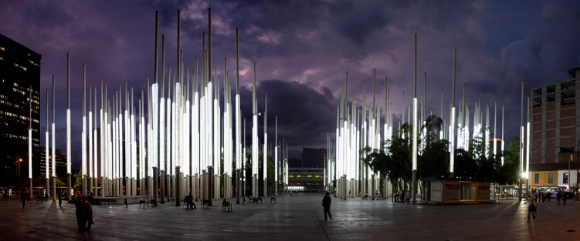
This park is part of a project to rejuvenate the downtown of Medellin. It is located in the old square of Cisneros, which is now the Parque de la Luz. The huge 300 light poles, 2,100 reflectors and 170 floor lamps make it a modern public space. It is a space in which various city activities take place, and where you can fine food vendors and little shopping stands.

How to get there:

You can take bus 170 or walk from the metro station San Antonio or Alpujarra.

Hours:
You can go at any time of the day, although you should be careful at night. At night, the lights are illuminated.

“REAL CITY” WALKING TOUR

The walking tour by Real City Tours may be the most popular tourist activity in Medellin, and is ranked #1 on TripAdvisor with more than 90% of its reviews as excellent. The walking tour takes you around the downtown area, and the guides explain the history of the Paisa-people, the recent history of the country, the transformation of the city, and many other interesting stories. The tour runs twice a day and due to its extremely high popularity, it is necessary to book your place in advance using the website www.realcitytours.com.

How to get there:

Meet at Alpujarra metro station (North ticket booth).

Cost:
It is a free walking tour but tipping is expected and highly recommended. Between 20,000 and 30,000 COP is appropriate.
Hours:
The tours leave at 9 a.m. and 2 p.m. daily.

GUATAPE
The majestic surroundings of the Embalse El Peñol - Guatapé, one of the country's largest lakes, were created in part by the construction of a hydroelectric dam that provides 30% of Colombia's electricity. It's hard to miss the region's most famous attraction, a 200+ meter high rock outcropping that towers over the surrounding area. It's officially named The Rock of Guatape, but more commonly referred to simply as La Piedra (The Stone). Over 600 stairs have been built into the side of this enormous geological marvel, allowing safe access to the top, where a viewpoint offers spectacular views of the lake and surrounding areas, as well as souvenirs and snacks.

How to get there:

Direct buses from Medellín leave from the North Terminal (directly connected to the Caribe Metro Station), passing through The Peñol and the entrance to La Piedra on the way to Guatapé (about two hours). Two companies provide transport service: Sotrasanvicente, (4) 861-0595, and Sotrapeñol, ( 4) 851-5912. Each company provides service approximately every hour starting from 6 a.m. The average fare is 12,000 COP (negotiable). Many buses continue to San Rafael. The last bus from Medellín to Guatapé is at 7:00 p.m. and the last bus from Guatapé to ​​Medellín is at 6:30 p.m. (7:45 p.m. on Sundays and Holiday Mondays). Return buses to Medellín quickly fill up on weekends – be sure to buy your ticket in advance.

Cost: $12,000 each way (negotiable)
Hours:
The following activities and tours can be arranged in and around Guatapé and El Peñol, with English-speaking guides upon request: Hiking, scenic boat tours, paddle boat rentals, kayaking, fishing, trips to hidden waterfalls and swimming holes, arts and crafts shopping, canopy zipline, mountain and road biking, horseback riding, rock climbing and free tours of the museum premises.
URBAN TRANSPORT YOU CAN USE FROM IHM

ROUTE BELEN (170 ) takes you towards the center and drops you right at the station SAN ANTONIO. From there you can walk a few blocks and find PARK BERRIO station, which is quite handy when going to ANTIOCH and the SQUARE MUSEUM BOTERO.

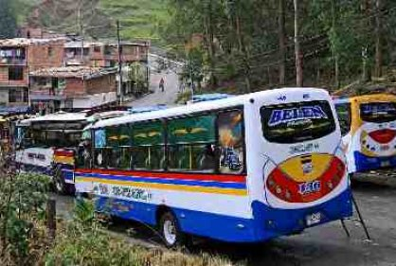
SCHEDULES AND RATES
A one way ticket costs 1,800 pesos and the bus operates from 6:00 a.m. to 10:00 p.m.

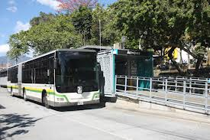
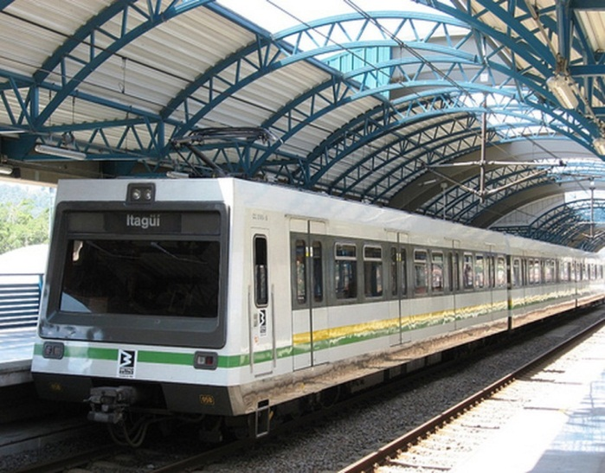
METRO PLUS DE MEDELLIN METRO DE MEDELLIN
An integrated bus system, which complements the system ferroviaro urban transport Medellin, is called METRO

SCHEDULES AND RATE

A one way trip (or “eventual” for tourists or potential users) costs $2,000 pesos and is valid for METRO, Metro cable and Bus Line 1. The complete system operates from Monday to Saturday, between 4:30 a.m. and 11:00 p.m.
On Sundays and holidays, Lines A and B of Metro and Bus Line 1 operates from 5:00 a.m. to 10:00 p.m. The K line service starts at 8:30 a.m., and the J line (Metro cable) starts at 9:00 a.m.; both run until 10:00 p.m.
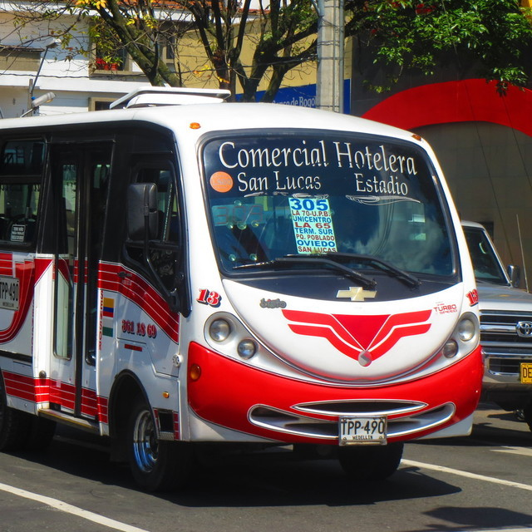
This bus called Commercial l Hotelera has a route to the south past the airport Herrea OLAYA. It reaches the village Bestacion, and if are going to the Parque Lleras you must walk toward Calle 10 and then turn right. This bus runs until 9:00 p.m. A one way ticket costs $1,800 pesos.
METRO CABLE
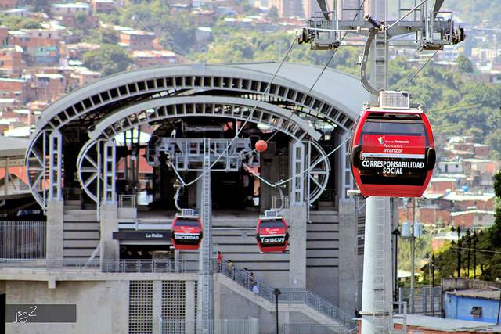
The Metro Cable is the cable car transport system of Medellin. It is composed of three service lines, and the line starts in the Commune No. 13 San Javier from the homonymous station and goes north to the Aurora station in the Commune No. 7 Robledo. The line crosses the Communes No. 2 Santa Cruz and No. 1 Popular from the exchange station Acevedo from Medellin Line subway to the transfer station Santo Domingo Savio, providing interchangeability with the line (Arvi Park).

SCHEDULES AND RATES

This service is complementary, and therefore does not have any cost for those entering from the subway platform. Otherwise, it costs $1,900 pesos, and the hours are Monday to Saturday from 4:30 a.m. to 11: 00 p.m., and Sundays and holidays from 9:00 a.m. to 10:00 p.m.
PLAZA MINORISTA
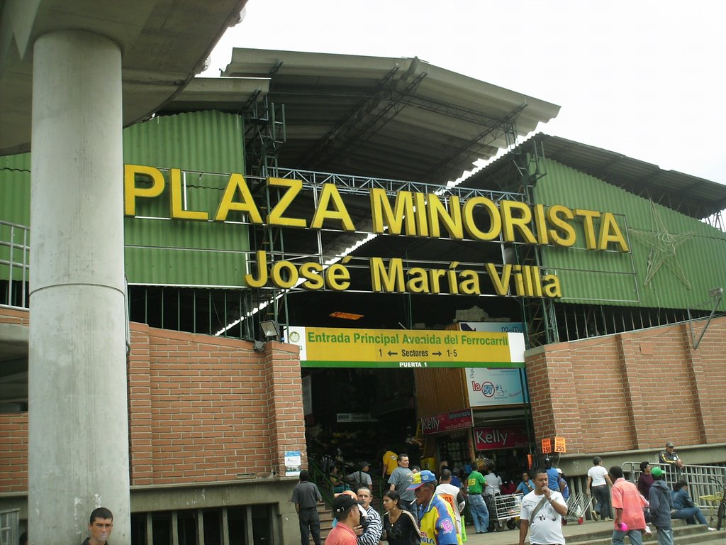
If you like fresh fruits and vegetables at a good price, this is the place to go! THE RETAILER OF MEDELLIN offers visitors a wide variety of quality products at economic prices. On the ground floor you can find Salas alimentarias, dairy products, cold meats, fresh fish, chicken eggs, drugstores, bakeries, arepas, plantains and bananas as well as parking. Upstairs you can find used clothing, beans, avocados, corn, potatoes, bars, cafes, restaurants, grocery stores and much more.

HOW TO GET THERE:

From IHM you can walk to the bus station and take Fatima Metro plus Line 1. Do not get off at Industriales.

HOURS:

The retailer is open every day from 4:00 a.m. to 5:00 p.m. To find more cool things, we recommend going in the mornings from Monday to Sunday.

UNICENTRO
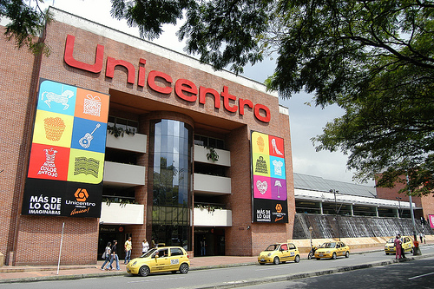
This mall is located in front of the Pontifical Bolivarian University and only 5 blocks from IHM. In this mall you can find currency exchange services, supermarkets, clothing, footwear, restaurants, photography stores, cafes, bakeries, cinemas and much more.

HOW TO GET THERE:

There is no need for transport. Go outside of IHM and face the sports park, then turn left and walk to the end of the street. At the corner take another left and walk five blocks. You'll see an Éxito supermarket on your right side; this is one of the entrances to Unicentro.

HOURS:

Unicentro is open Monday to Saturday from 10:00 a.m. to 9:00 p.m. and Sundays and holidays from 11:00 a.m. to 8:00 p.m.

ÉXITO
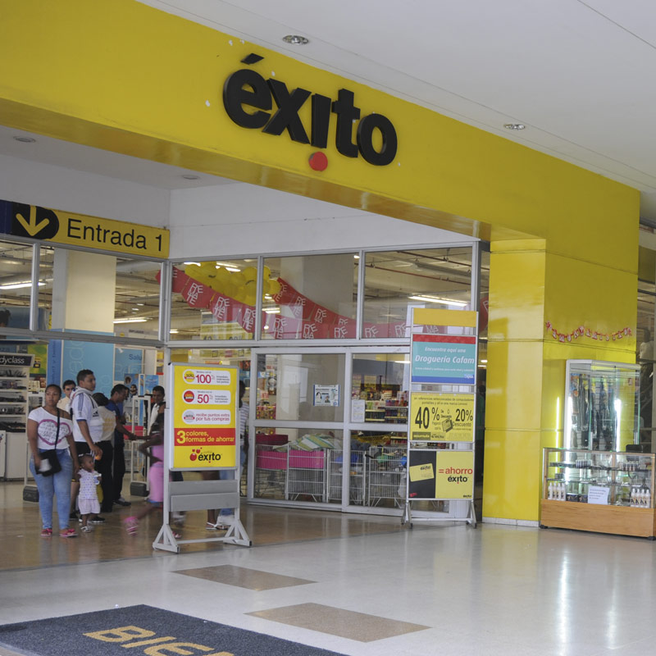
This supermarket is the closest to IHM. Here you can find a variety of fruits, vegetables, grains, liquor and personal care items. You can also find an ATM, a care center in prepaid health, fitness center, a fast food restaurant called The Corral, and a cafe called OMA.

HOW TO GET THERE:

Go outside of IHM and face the sports park, then turn left and walk to the end of the street. At the corner take another left and walk five blocks. You'll see the Éxito supermarket on your right side.

HOURS:

Monday through Friday from 9:00 a.m. to 7:00 p.m.
Sundays and holidays from 08:00 a.m. to :900 p.m.

SANTA FE DE ANTIOQUIA
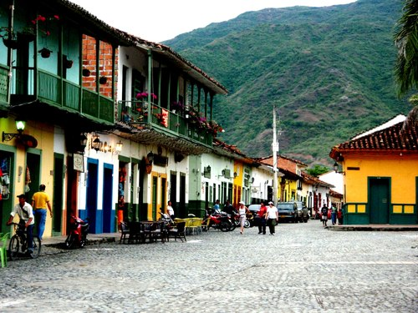
A picturesque village with a beautiful colonial architecture, Santa Fe is a national monument for its admirable and beautiful architecture of the colonial era. It has 8 churches and a lot of houses of the 16th, 17th and 18th centuries. It is located just outside of Medellin in western Antioquia (1 hour by bus).

HOW TO GET THERE:

You can go by bus from the North Terminal.

RATES:

By bus, the rates are between $7,000 and $8,500 pesos.

TERMINALES DE TRANSPORTE NORTE Y SUR

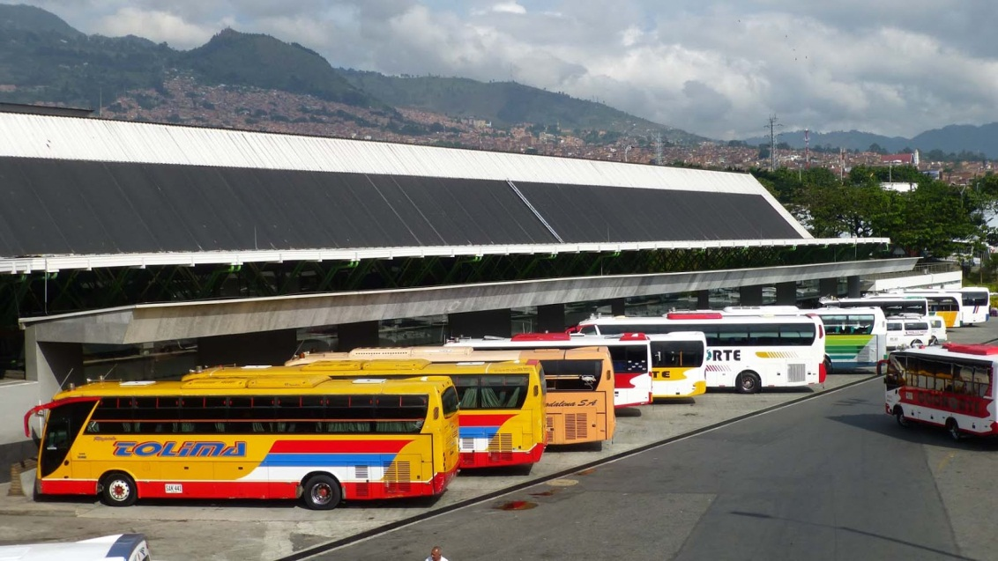
• Intermunicipal Transport Terminal North: Located in the northwestern part of the city, the Caribbean area (you can access it through the Caribe station of Metro Medellín), this terminal provides bus services to the areas in the east and north of the Antioquia region, such as Bogotá, Tunja, Santander, and the main cities of the North Coast of Colombia, mainly Cartagena, Barranquilla, Santa Marta, Sincelejo, Monteria, Magangué and others.

HOW TO GET THERE:
• From IHM walk to the Fatima station, take the bus to Industriales, then take the metro toward Niquia, and finally get off at Caribe station (the pedestrian bridge takes you inside the Terminal North).

• Inter-municipal Transport Terminal South: Located in the southwestern part of the city in the neighborhood Guayabal, this terminal provides bus services to the south of Antioquia, and also to the Antiochian East and to major cities of Coffee Country, such as Manizales, Pereira and Armenia, the Department of Tolima and major cities in southern Colombia, such as Cali, Ibague, Neiva, Popayan and Pasto.

HOW TO GET THERE:
From IHM walk down to the corner where the pools are located. From this corner, take the bus Comercial Hotelera, which will drop you very close to the terminal.

HOURS:
Hours may vary according to your destination. For further information please call the North Terminal at 520 65 40 or 444 80 20 ext. 150 (On the third floor, you will find a phone for local outgoing and incoming calls) or the South Terminal at 361 14 99 or 361 15 88.

Aeropuertos

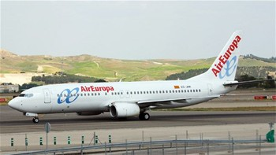

Medellin has two airports:

• The main international airport serving the city is the Jose Maria Cordoba International Airport, located outside the Aburrá Valley within the municipality of Rio Negro. From there you can take domestic flights to the major cities of Colombia and international flights to destinations in the United States, Europe, the Caribbean and Central and South America, plus catch links to multiple other air terminals in the world.

HOW TO GET THERE:

• You can catch a bus or a taxi at the Nutibara hotel, which is located downtown in the Plaza Botero or at San Diego metro station.

SCHEDULES AND RATES:

• Within the city of Medellin, the airport Olaya Herrera serves regional and domestic flights.

TARTARIFAS INTERMUNICIPALES
RUTA | TARIFA | TIPO DE VEHICULO
Rionegro Medellín and viceversa: | Collective transport $ 8.000 per person. | Shared taxi
Rionegro Medellín and viceversa: | Collective transport $ 6.500 per person. | Aerovan
Rionegro Medellín and viceversa: | Collective transport $ 5.500 per person. | Microbus
Aeropuerto – Medellín | Minimum rate  $ 54.000 | Individual taxi

HOURS:

To ensure that the bus leaves at your desired time you should call 511 40 23. This is the number of the bus company that runs from Medellin to José Maria Córdoba Airport. If you need a taxi you should call 261 16 16. This is only for private taxis that will pick you up at IHM.

OLAYA HERRERA AIRPORT

Inside the central perimeter of Medellin is Olaya Herrera Airport, which offers service for regional and domestic flights.

HOW TO GET THERE:

You can take a taxi for $7,000 pesos or a bus (305 Comercial Hotelera, which operates until 9:00 p.m.). You can use the phone on the 3rd floor to call 403 67 80 for more information.

RESTAURANTS NEAR INTERNATIONAL HOUSE

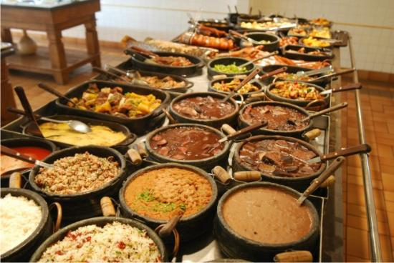

Walking from International House, take a left (the pools will be on your right) and go one block. Across the street, you will find the restaurant Caseritos, which offers typical Creole food of the Colombian region.

If you prefer fast food, you will enjoy El Corral, which serves sandwiches, hamburgers, wraps, and other foods of this style.

If you want more variety and better quality, walk to Calle 33 where you will encounter Chinese, Italian, and Creole food. At Unicentro, you are able to buy grilled food, Subway, Creole dishes, chicken, and much more.

If you want something cheaper, walk to Calle 33 and then climb up the strip where you will find brosty chicken, pizza, and more.

If you are vegetarian, near Unicentro you will find ANTONIO’S, which is a delicious vegetarian restaurant where you can eat healthy and wealthy!

