Introduction

Automatic Street Light Control System is a simple and powerful concept,

which uses transistor as a switch to switch ON and OFF the street light automatically.

By using this system manual works are removed. It automatically switches ON lights

when the sunlight goes below the visible region of our eyes. It automatically switches

OFF lights under illumination by sunlight. This is done by a sensor called Light

Dependant Resistor (LDR) which senses the light actually like our eyes.

By using this system energy consumption is also reduced because now-a-

days the manually operated street lights are not switched off properly even the

sunlight comes and also not switched on earlier before sunset. In sunny and rainy

days, ON time and OFF time differ significantly which is one of the major

disadvantage of using timer circuits or manual operation.

This project exploits the working of a transistor in saturation region and

cut-off region to switch ON and switch OFF the lights at appropriate time with the

help of an electromagnetically operated switch.

Automatic Streetlight needs no manual operation of switching ON and

OFF. The system itself detects whether there is need for light or not. When darkness

rises to a certain value then automatically streetlight is switched ON and when there is

other source of light, the street light gets OFF. The extent of darkness at which the

street light to be switched on can also be tailored using the potentiometer provided in

the circuit.

Moreover, the circuit is carefully designed to avoid common problems like
Over load ,relay chattering and indructive kick back in relay

Principle

The automatic streetlight control system operates on 12 V DC supply.

The automatic streetlight controller has a photoconductive device whose resistance

changes proportional to the extent of illumination, which switches ON or OFF the

LED with the use of transistor as a switch

.

Light dependent resistor, a photoconductive device has been used as the

transducer to convert light energy into electrical energy. The central dogma of the

circuit is that the change in voltage drop across the light dependent resistor on illumination
or darkness switches the transistor between cut-off region or saturation
regions and switches on or off the led

BLOCK DIAGRAM:-
Street light
ldr
Power supply
Switch
amplifier

Individual Block Explanation

Street light: Street light is the output of the circuit. In this circuit, it has been

replaced by LED

Power supply: AC power supply is stepped down, rectified and filtered to get

almost ripple-free DC output for the operation of the circuit .

Light dependent resistor: LDR senses the illumination level and gives the

input signal as voltage drop.

Amplifier: Darlington circuit amplifies the input current to get maximum

current gain.

Switch: Relay switch closes or opens electrically and automatically, which is

energized or de energized by the Darlington pair.

ON OFF control

The circuit is switched ON or OFF by the transistor in saturation region or cut off

region respectively, which is controlled by the signal from LDR. The collector current

from the transistor toggle between ON or OFF modes.

3.2 Circuit Diagram

The circuit diagram of automatic street light controller is given below:

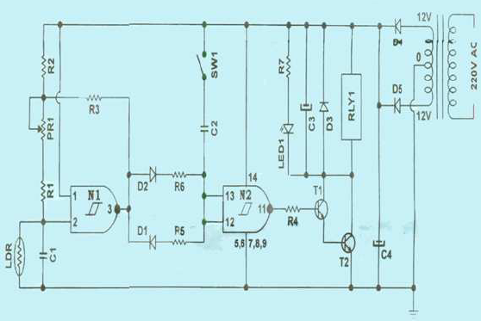

COMPONENTS USED IN THE CIRCUIT:-
S.No. | Component | Nos | Used
1 | 27K Resistor | 1 | To offer resistance
2 | 68K Resistor | 1 | To offer resistance
3 | 15K Resistor | 1 | To offer resistance
4 | 22K Resistor | 1 | To offer resistance
5 | 47K Resistor | 1 | To offer resistance
6 | 150K Resistor | 1 | To offer resistance
7 | 1K Resistor | 1 | To offer resistance
8 | 47K Variable Resistor | 1 | Switch ON point tuning
9 | LDR 10 mm | 1 | Photoconductor
10 | 0.1 µF Capacitor | 1 | To store charge
11 | 100 µF 25V Capacitor | 2 | To store charge
12 | 1000 µF 25V Capacitor | 1 | To store charge
13 | IN4148 Diode | 3 | To prevent inductive kick back  and for directional conductance
14 | IN4007 Diode | 2 | Rectifier
15 | 5mm Red LED | 1 | Indicator
16 | HCF4093 IC | 1 | NAND Gate
17 | BC 141 Transistor | 1 | Amplifier and switch
18 | BC 107 Transistor | 1 | Amplifier and switch
19 | Relay HRS 4H-12V 1C/O | 1 | Switch
20 | SPST ONSwitch | 1 | Switch
21 | 03A004 PCB | 1 | Circuit Board

Working:-

The alternating current voltage (220 V) is stepped down to (12 V) using a

suitable step down transformer. The stepped down AC voltage is rectified to direct

current Voltage using a full wave rectifier. To obtain a constant ripple-free DC

voltage, a capacitor filter is used across the circuit.

In dark, the resistance of light dependent resistor is high. So, the voltage

drop across the light dependent resistor is also high. Now the output of the NAND

gate N1 is low since both the input signals are high, which makes the switch SW1 to

remain open. And now the output from NAND gate N2 becomes high since both the

input signals are low. The high output signal from the N2 terminal drives transistor to

the saturation region, which makes the collector current I C very high. Finally, the high

collector current flowing through the relay, diode, LED and resistor makes the LED

glow.

When a light of suitable intensity is incident on the light dependent

resistor, the resistance decreases and the voltage drop across the light dependent

resistor is low. Now the output of the NAND gate N1 is high since one of the input

signal is low and the other one is high, which makes the switch SW1 to close. And

now the output from NAND gate N2 becomes low since both the input signals are

high. The low output signal from the N2 terminal drives transistor to the cut-off

region. In this case, the collector current is not high enough to make the LED glow,

since other circuit elements such as relay, diode, LED and resistor are connected in

parallel to each other.

Thus, by toggling the transistor between cut-off region and saturation

region it is possible to switch OFF or switch ON the LED. In this circuit, Darlington

pair is employed to increase the collector current. Relay switch is connected in parallel

to the LED to protect electrical circuits from overload. The extent of darkness or the

intensity of light at which the light should switch ON or OFF can also be tuned by

adjusting the potentiometer PR1. The capacitor C3 has been connected parallel to

relay to avoid the relay from chattering during twilight threshold levels.

APPLICATIONS:-

Application 1:

The above circuit can be powered from a battery, which can be charged during day

time by harvesting the solar energy through a solar cell as shown below:

Battery

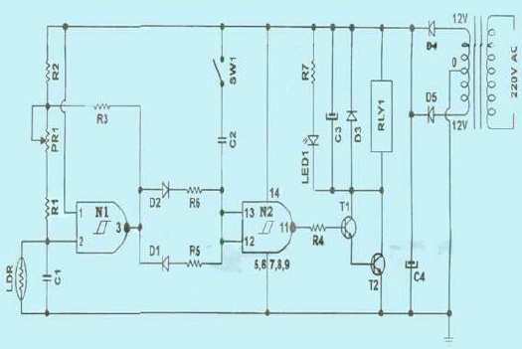

Application 2:

The solar energy harvested from sunlight can be stored, inverted from DC

voltage to AC voltage using sun tie converter. The AC voltage can be stepped up and

given to the electric grid.

Photovoltaic array

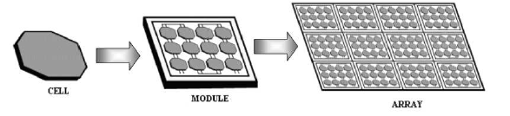
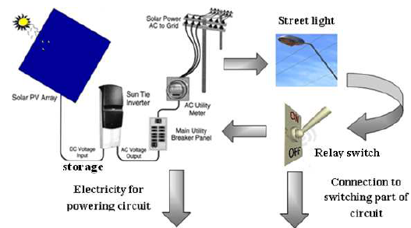
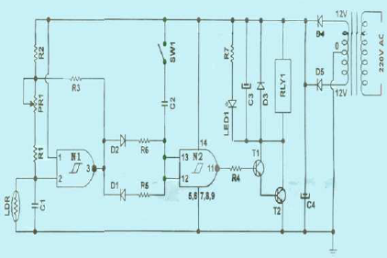

The AC voltage from the electric grid can be stepped down, rectified and

used for powering the circuit. Meanwhile, the street light can also be powered by the

A.C. voltage, which is controlled by a relay switch connected to the switching part of

the circuit. The above mentioned strategy will enable us to harvest solar energy in an

effective way for the operation of the circuit and for powering the street light also.

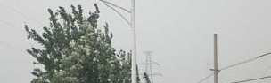

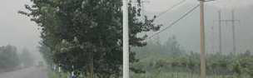

Solar Street light system with Automatic street light controller

A Future perspective

Results and discussion:-
The project aims were to reduce the side effects of the current street lighting system, and find a
solution to save power. In this project the first thing to do, is to prepare the inputs and outputs of the
system to control the lights of the street. The prototype has been implemented and works as expected
and will prove to be very useful and will fulfill all the present constraints if implemented on a large scale
Prototype of street light system Fig. 9 shows the street light system, from the figure it can be seen that,
all lighting column are OFF, because there is no any object passes through the street, even though the
weather is night. This is the idea of using the microcontroller to control each lighting column alone.
When any object passes in Mathematical Methods and Optimization Techniques in Engineering front
specific photoelectric sensor the lighting column which connected to it will be turn ON automatically.

Conclusion:-

The design and construction of automatic street control system circuit. Circuit works
properly to turn street lamp ON/OFF. After designing the circuit which controls the light of the street as
illustrated in the previous sections. LDR sensor and the photoelectric sensors are the two main conditions in
working the circuit. If the two conditions have been satisfied the circuit will do the desired work according to
specific program. Each sensor controls the turning ON or OFF the lighting column. The street lights has been
successfully controlled by microcontroller. With commands from the controller the lights will be ON in the
places of the movement when it's dark. furthermore the drawback of the street light system using timer
controller has been overcome, where the system depends on photoelectric sensor. Finally this control circuit can
be used in a long roadways between the cities

