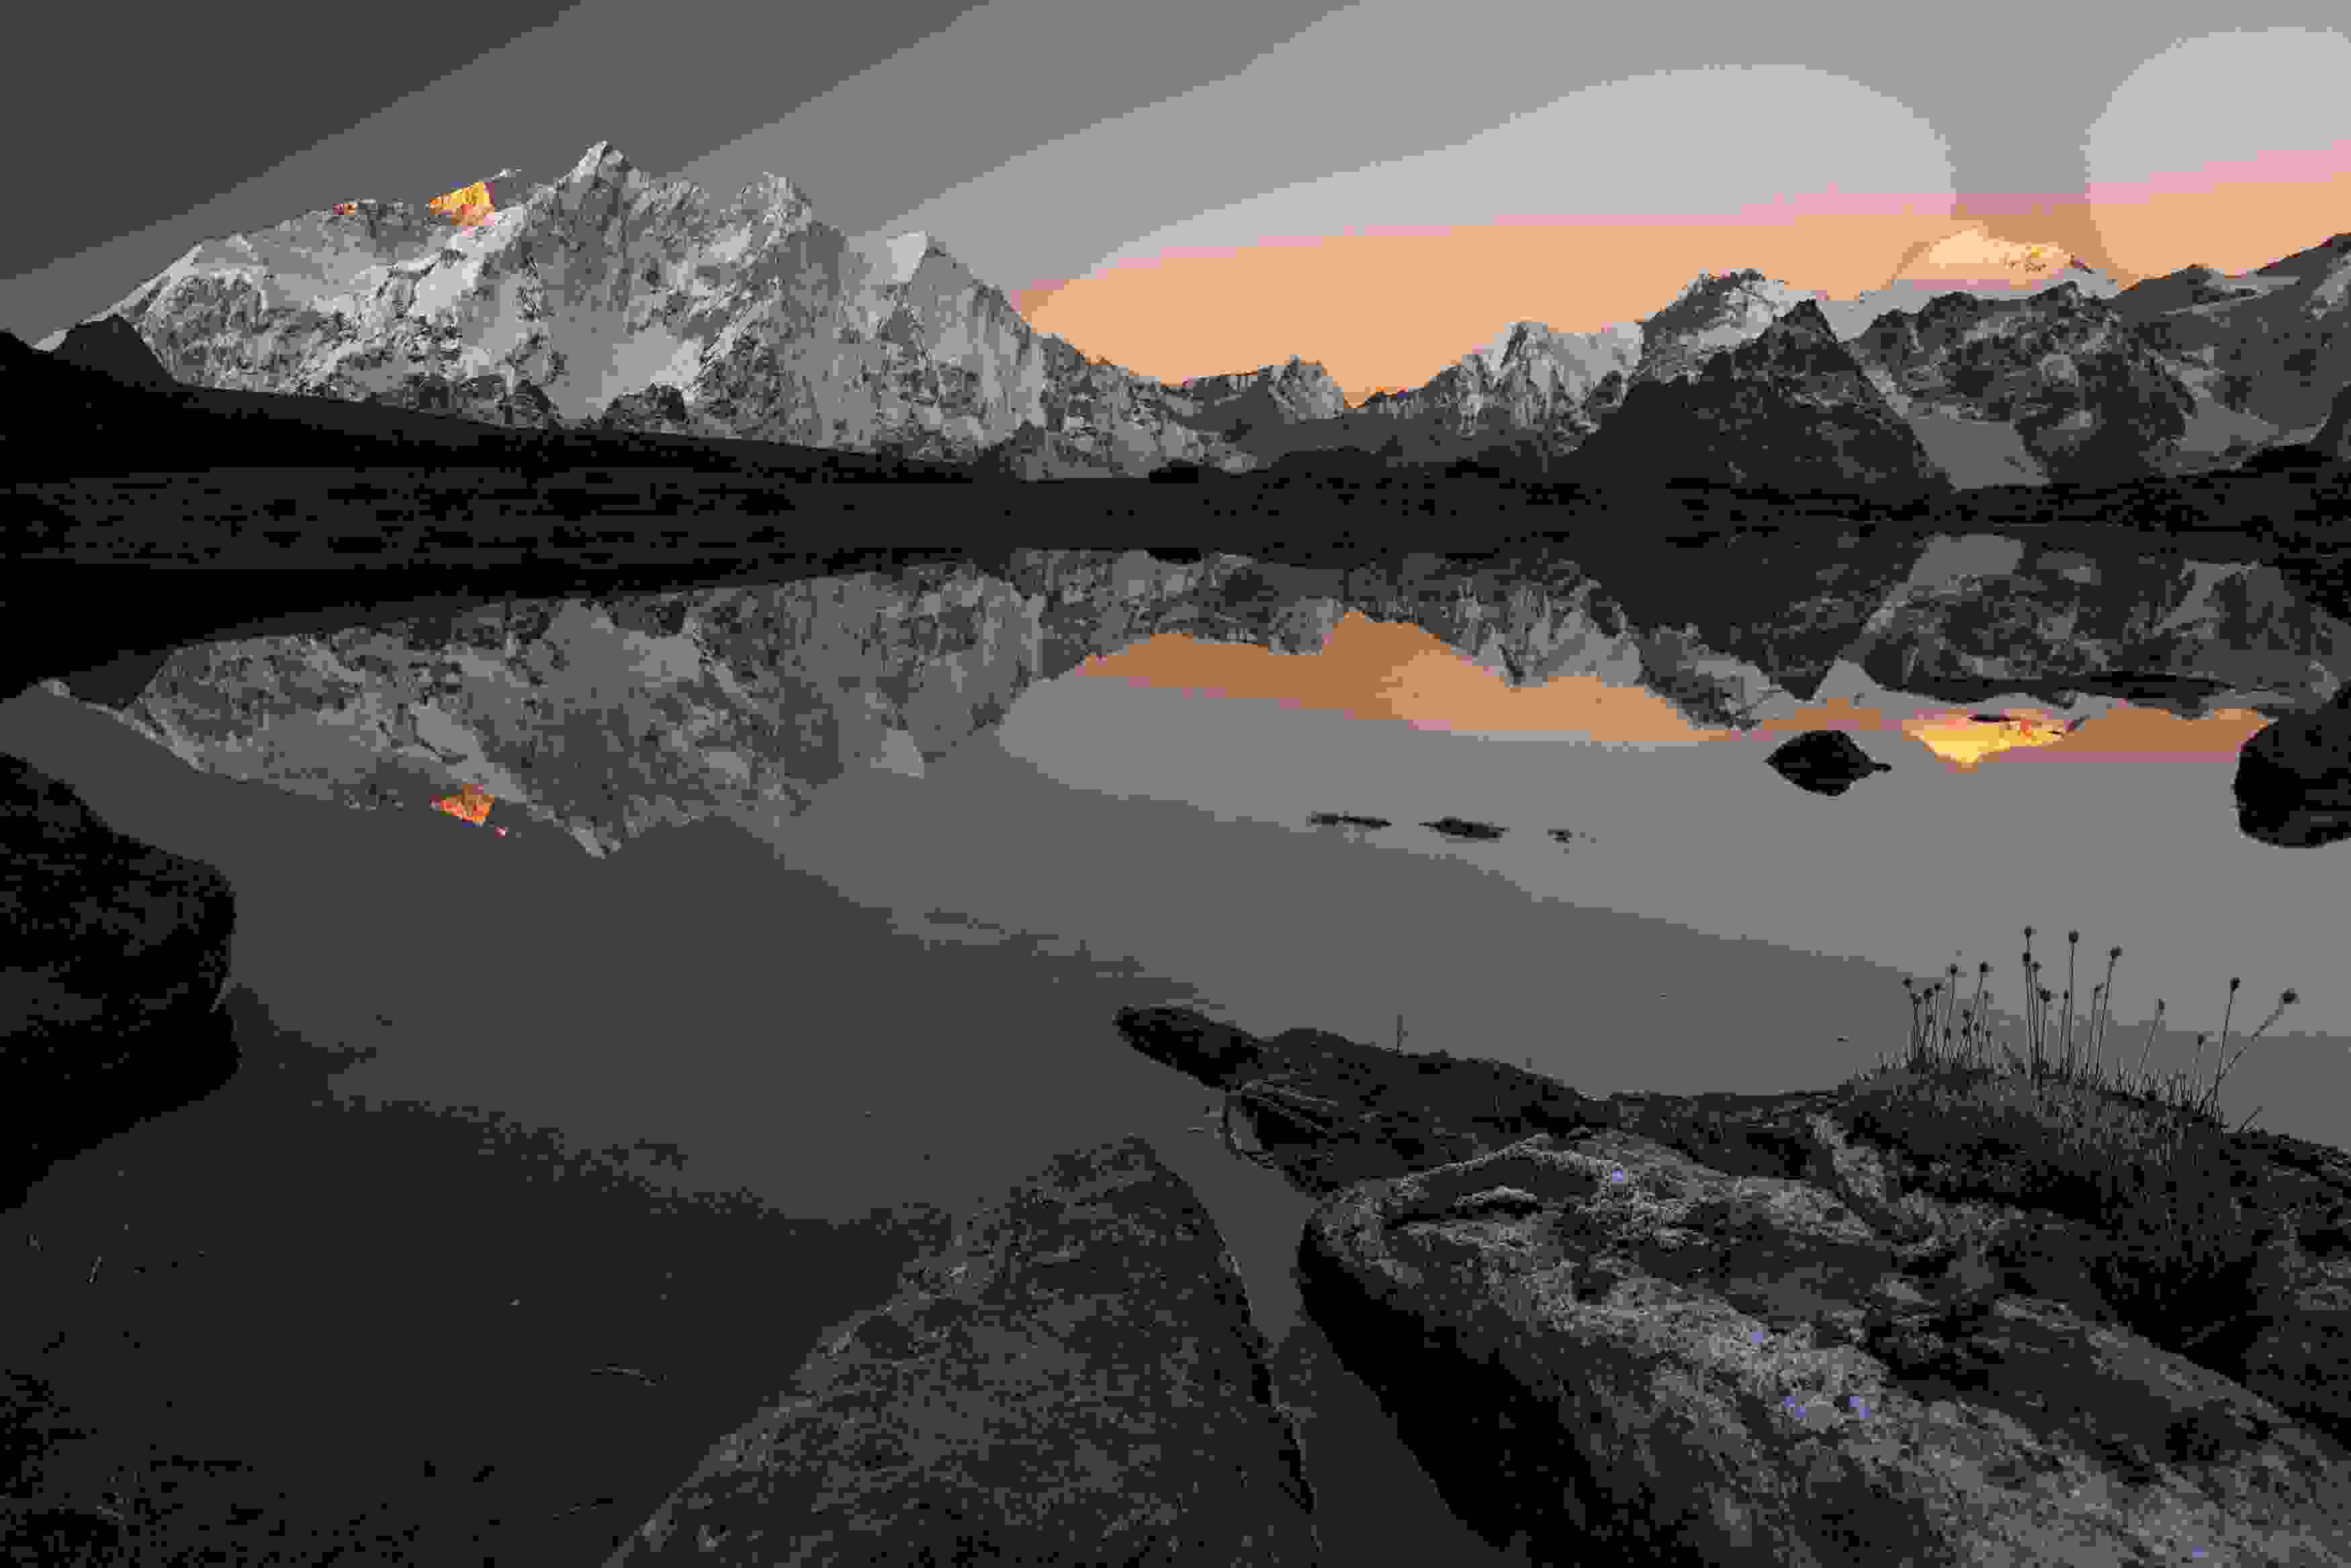
I am so comfortable and warm wrapped in my down cocoon, I’ve slept well, despite the high altitude, but I shrug aside any thoughts of lying there any longer. The very slightest hint of pre dawn light has started to permeate the tent and I know what I must do. At 5000m the brain doesn’t quite tick over as we’re used to, and I start to assemble a list of tasks that will get me from my lying position to fully dressed and out the tent; it’s an alarmingly long list! At this altitude, even turning over in your sleep can make you breathless, and the effort required to do the simplest things becomes such a daunting barrier to activity - I rely on pure bloody-minded stubbornness to get me through.

It’s only a few hundred meters from our tent village up to the alpine lake I have in mind for sunrise, but it takes a real battle of will to get there. Breaking journeys down to manageable bite-sized pieces, a pre-determined number of steps rewarded with so many seconds rest is the tried and tested method.

I’m grateful that my chosen composition is with the camera as low as it can be on the tripod, it allows me to lie down on the ground as a slight wave of nausea washes over me. I’m shooting with a manual focus 24mm tilt/shift lens to make a panoramic image, and this adds another little challenge to my very being there. With only 50% of the oxygen my body is used to from sea level the whole experience of being there is quite unusual: Imagine standing on your head, then spinning around until your dizzy, drinking a couple of shots and then trying to walk in a straight line - it’s a bit like that! Not entirely unpleasant, but it just doesn’t feel entirely real, a somewhat out of body experience we’re you’re aware of the surreality - or hyper-reality.

The physical symptoms of altitude are one thing, the magnitude of the landscape is another. From my reclining position by the lake I can see three of the world’s tallest mountains; Makalu, Lhotse and Chomolungma (Everest in English). Other summits, many of which are over 7000m are dwarfed, as am I nearly 3000m below them. The delicate light washes over the mountains, magenta, reds, the warm tones contrasting beautifully with the cool misty shadows in the deep valley below. This is the Kharta Valley Trek, a stunning hike across the Langma La into the east face of Everest, the heart of the Himalaya and a life-changing journey.

The word Tibet conjures up all sorts of images, from thin air to high mountains, monasteries and buddhism; it also sparks off other imagery like mysterious and secretive. It is a place like no other, enhanced somewhat by the trouble it takes to get there and the challenges to both body and mind to remain. It changes you and I know of no-one who has been and not reevaluated many of their life values and aspirations.

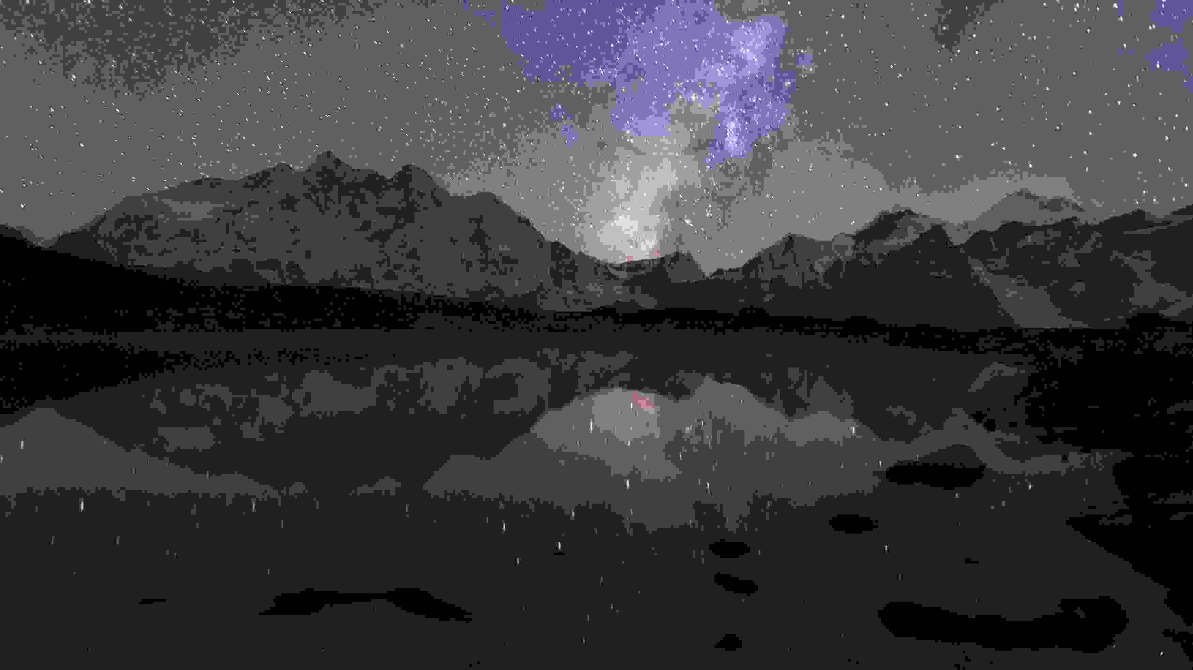
In the small hours of the day we’re supposed to start our trek, we’re woken by a huge storm; hail bounces off the tin roof of the hostel and the wind screams through the open atrium. Most of my Tibetan experiences have been typified by blue skies, insane dryness and skin-scorching sunshine. The prospect of a 10km road walk in the torrential downpour to the start of the trek is not appealing; the idea of climbing the Langma La in a blizzard seems insane. Thankfully by the time we’re forcing down some breakfast of rice porridge and white dough, the rain stops, the clouds part and normality is resumed. My wife Juanli even manages to organise a lift for us, and the 10km walk becomes a bouncy ride in the back of a flatbed truck.

Our Yak train had been brought up the day before and our large team of sherpa and guides were busy tying our stuff sacks to the backs of the animals in readiness for their portage. We’re part of a full scale expedition, with over a dozen Sherpas, Yaks, Kitchen tents and even tables and chairs - everything possible to make like as comfortable as we can. We shoulder our camera bags and tighten boot laces before leaving the trail head and starting up a gently rising valley. The weather is glorious and the hiking equally so; a good trail and an achievable goal for the day. As the sun sinks behind the ridge in front of us the temperature falls immediately and we rush to set up the tent among some massive boulders. The first few days at altitude can be a shock to the system, and everyone has mild symptoms to contend with; a touch of nausea or a mild headache, but we all sleep fine and ready ourself for the first serious challenge.

The Langma La is a formidable obstacle; due to a limited number of available days we have elected to miss out the eastern half of the traditional trekking route, and are now intending to climb up the exit from the Kharta Valley. They say that the toughest challenges in our lives make for the strongest and fondest memories, and I can attest to that here. The broken scree slopes above the camp are criss-crossed by a series of narrow paths and we begin the slog up them at our own pace. I can recall in minute detail various views, milestones of achievement and heart-crushing moments when the high point you’ve been fighting towards for a couple of hours turns into a false summit and you gaze skywards to some other seemingly unachievable climb. The mechanism of steps and breaths falls apart as I fail to hit my steps target time and again, I’m not as fit as I thought, and I’d foolishly underestimated the challenge of this ascent. On a couple of occasions waves of dizziness hit me so hard I think I’m going to pass out and I get swirling stars in front of my eyes - I come close to saying “enough” and packing it in, but I can’t, I just can’t.

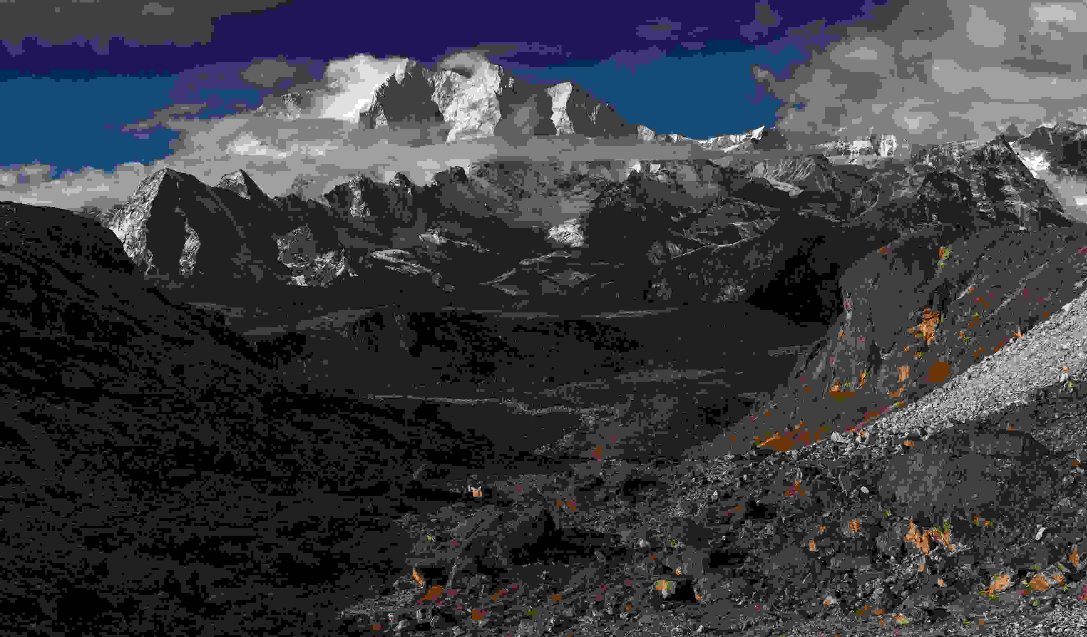
But then, just when the dizziness washes over me again, I see the typical mass of prayer flags blowing at the zenith, I know the summit is near and I urge myself to renewed effort. My body doesn’t respond, but I keep going, step by agonising step, breath by wheezing breath! I break out among the boulders and the world falls away below me across an unimaginable chasm towards Makalu. Everest is partly covered in cloud with it’s sister Lhotse, but the massiveness of the mountains is simply ridiculous. We hug each - emotions are raw, and we laugh and cry simultaneously, overcome with the pure beauty of being alive and being there. Words fail me!

From here, at the crest of the Langma La at 5332m/17,500ft the world falls away from you and gravity takes over. The hiking becomes easier, everything is fine, the pain of the ascent soon forgotten and the tents of camp 2 can be seen on a flat area beside a frozen lake. The thought that this area was once below sea level and has been pushed millimetre by millimetre up into the thin air is staggering. Fossils and even sea shells are common and the giant conch are used as ceremonial horns in the temples. Semi precious stones like red corral are also left over from the marine days.

Our trip was in early October, right at the end of the monsoon that forces moist air into Tibet from the Indian Ocean far to the south. By mid afternoon cloud had enveloped the mountains and mist was invading the camp site. We ate dinner and headed for our sleeping bags, ready for our first night sleeping at nearly 5000m. After a few hours one of our party shouted that it had cleared and we pilled out the tent to go searching for a composition to shoot the Milky Way over Makalu and Everest. With no moon to see by, it was absolutely pitch dark; our headlamps only making the darkness appear darker. In the gloom we were not entirely sure of which direction the lake lay, and we staggered around in a hypoxic state for about half an hour until we stumbled upon the river that we knew flowed from our target.

In all my years of shooting at high altitude, especially at night, I’ve learned one thing; the combination of darkness and high altitude create a challenging playground! As I alluded to earlier, with so little available oxygen, the brain doesn’t work to its full capacity and technical thinking about exposures and ISO’s is a real problem. My method has been to make sure I can run on auto-pilot and by doing this I was able to make some good exposures in the pitch darkness. Not surprisingly for an area so far from civilisation, the skies are among the darkest in the world and with no atmosphere to get in the way, you feel you can reach up and touch the stars. It’s no coincidence that most of the world’s biggest telescopes are perched on the top of high mountains.

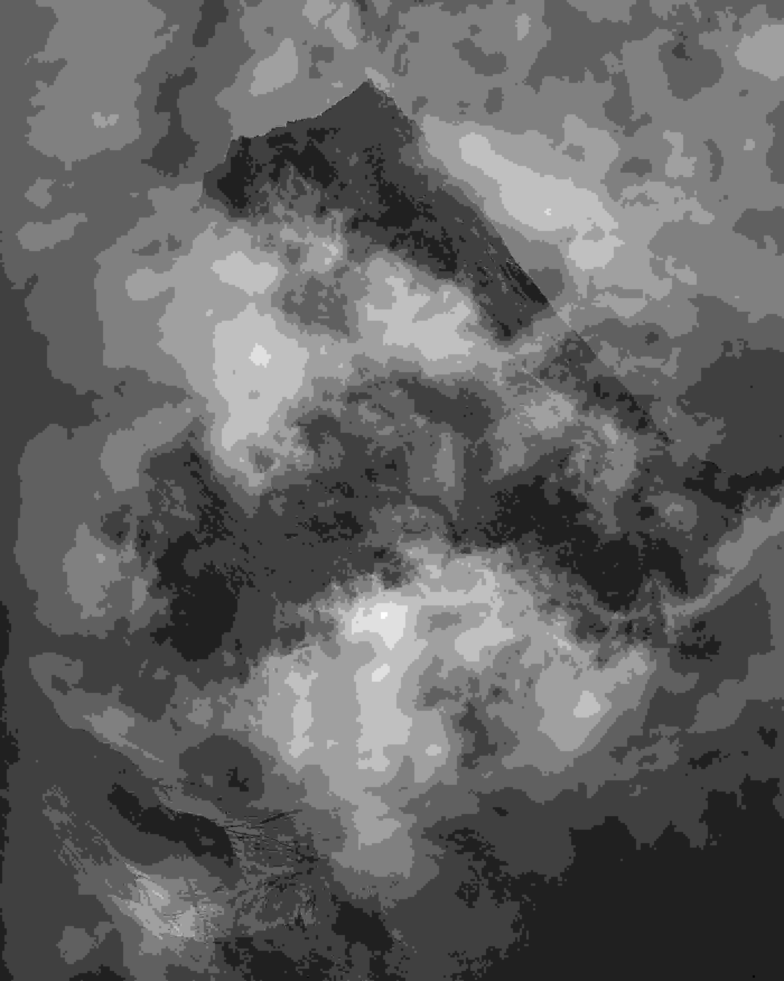
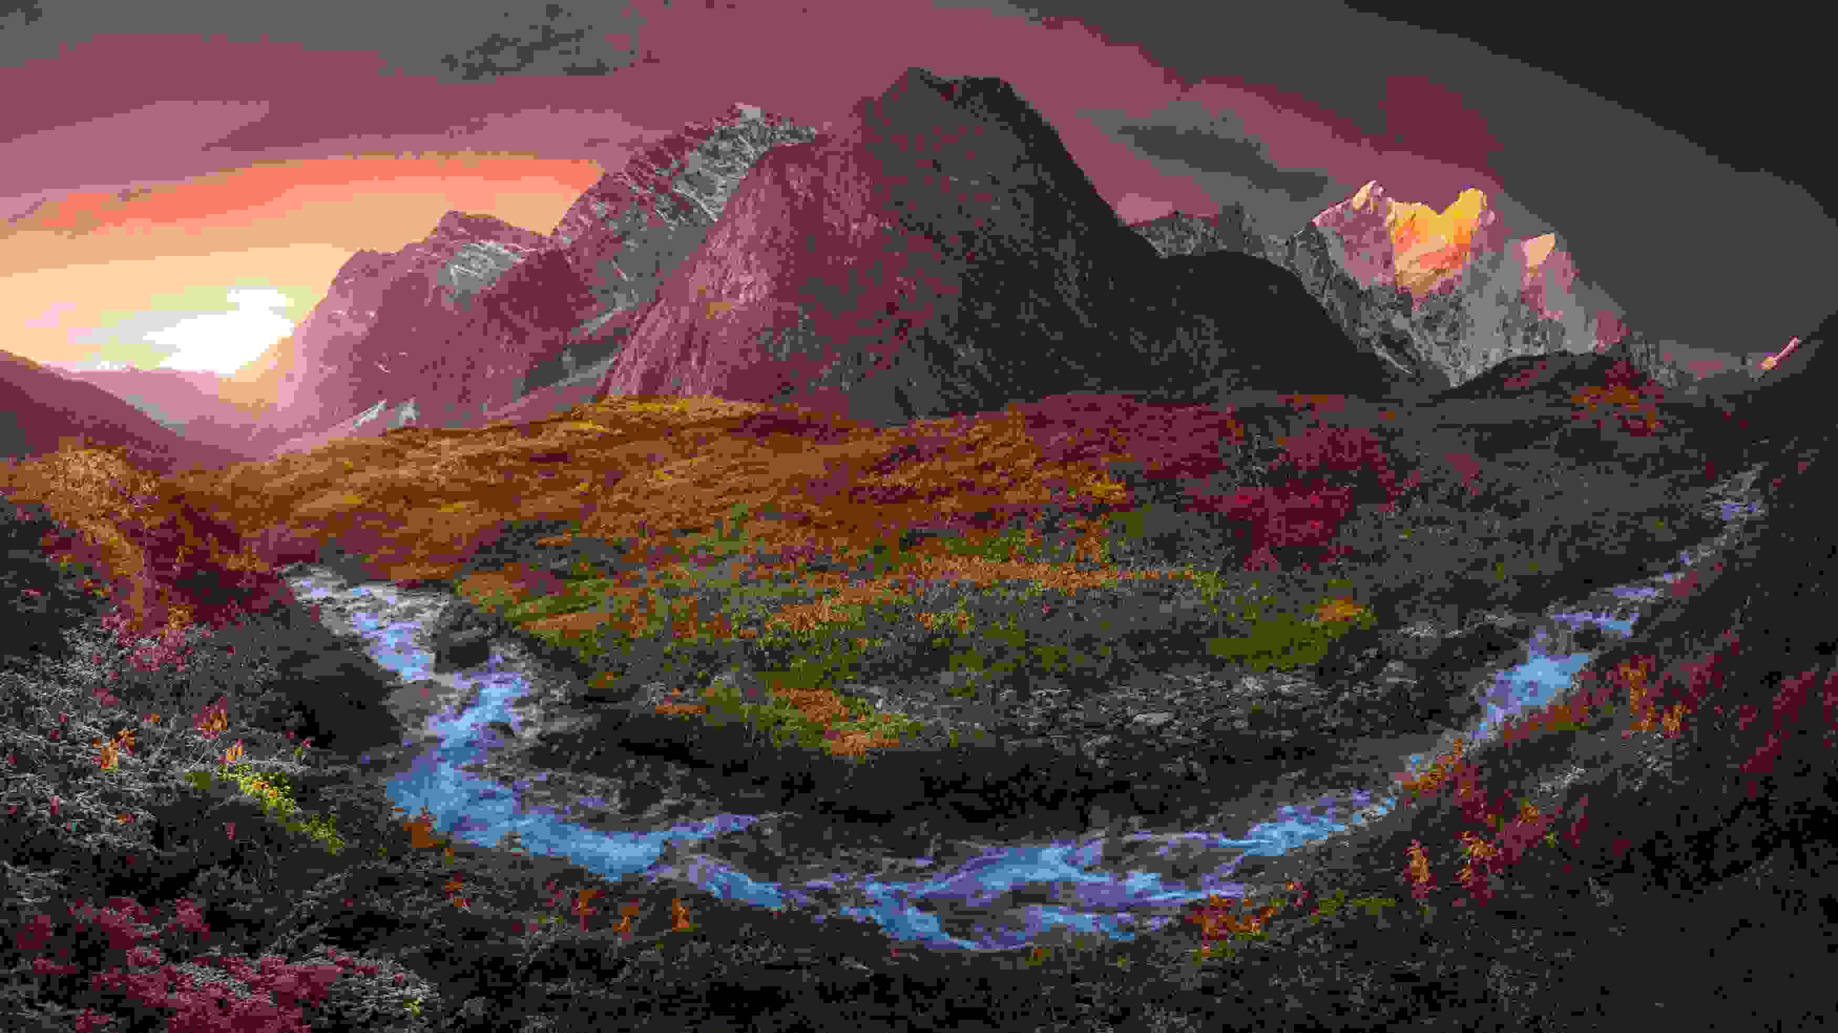
Gravity continued to pull us down hill the next day; mile after mile of easy strolling through staggering scenery. It seems trivial to mention it, but the Himalaya are just massive, they emit more than a physical presence, you feel them on a very subconscious level. Rational thoughts come to the front of your mind; the amazement that people climb them at all - especially without oxygen, or like Reinhold Messner in 1980, solo without oxygen.

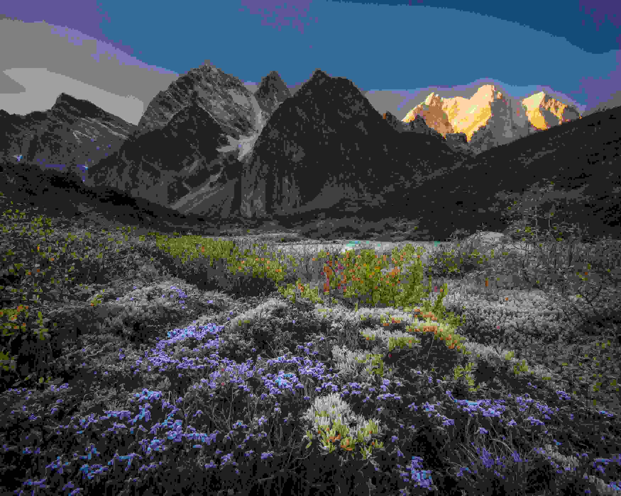
Our camp 3 nested at the bottom of a deep valley, utterly surrounded on all sides by massive mountains that glowed golden in the sunrise. The Azalea leaves had all turned red and the area was a riot of colour, and we settled in for three nights in this paradise. We’d drifted down to below 4000m again and the relatively thick air was an elixir, rejuvenating us and filling us with bags of energy. We ate well, drank endless cups of hot sweet tea and photographed as often as the urge took us. Each day we’d wander around the confluence of valleys to find interesting combinations of flow, balance and harmony. We’d climb up the ridges above to find elevated perches from which to soak up sunset over Everest. The cloud build up each afternoon held a ritualistic quality to it, and we’d dig out long lenses to create glacier and cloudscapes - intimate arrangements of water and rock.

Of course, our route out retraced our steps and what came down, must go up! The slog out the valley back up to the Langma La was as expected, tough going. But, even as the first snow of winter fell and we elevated our exertion levels to avoid getting stuck in there for 5 months, we soaked up the majesty of the place around us. I’ve spent a lot of my life in the Himalaya and the thing that drags me back year after year is the combination of overcoming seemingly insurmountable challenges in a place that is so awe-inspiring that it literally leaves you speechless. As gravity pulled us down off the high pass for the last time, the mixed emotions of success and loss are poignant counterparts to our very existence. An emptiness associated with losing site of the highest ridge line in the world is juxtaposed with the thought of a hot shower and a soft bed in the thicker air of 3800m.

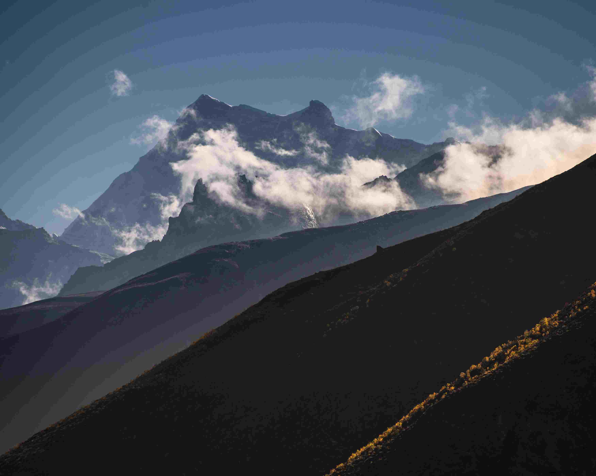
A few days later, we’re walking around Lhasa, watching the Tibetans on their daily peregrinations about the Jokhang Temple, a sense of achievement and serenity pervading our quiet minds. We smile at each other, sharing our little secret, a journey into one of the highest and remote valleys in the world, under the shadow of Chomolungma, Lhotse and Makalu. We raise a glass to each of us in turn, a few quiet words of companionship and mutual respect, then retreat into our inner thoughts once more to digest and elevate.

