3x3 table with floating position (horizontal 1,75 cm [page]and vertical 0,25):
A text under the table
The table borders are at -0,75 cm and 15,25 cm.
Cell margins are 0,5 cm left and right.

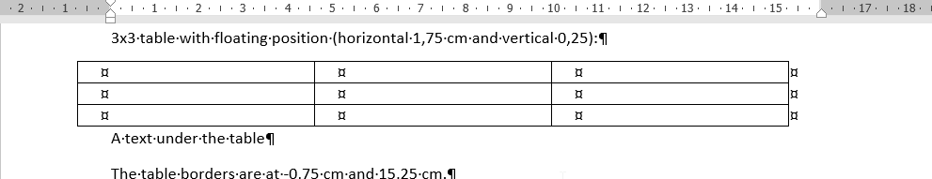
Word 365 (2017-04-22) screenshot:

