SMSCB CHILE REQUIREMENTS
Requirements:
The official requirements are:
- Pop up containing displaying the whole SMSCB content.
- Up to 90 characters at least
- Title “Alerta de Emergencia” with time and date on the header of the popup
- Automatic storage of all SMSCB messages, saving at least the last 10
- Sound notification different from any other notification. It MUST loop until interrupted by the user. User should not be able to disable the sound notification from profiles or any other menu. Tone is defined by ATIS/TIA J-STD 100, point 7.1
- Always vibrate with the sound notification. If the current profile is silent it should ALWAYS vibrate. Vibration pattern is defined by ATIS/TIA J-SDT 100, point 7.2
- Screen must light up as soon as the SMSCB is received and it should turn off 10 seconds later if no user interaction is performed. If the user presses any key the screen will light up again. This does not interfere with point 5 or 6, and sound/vibration should only stop when user disregards the popup message
- Default SMSCB channels 919 and 921 must be enabled and should not be customizable or editable in any way by the end user
Popup format required
Spanish English
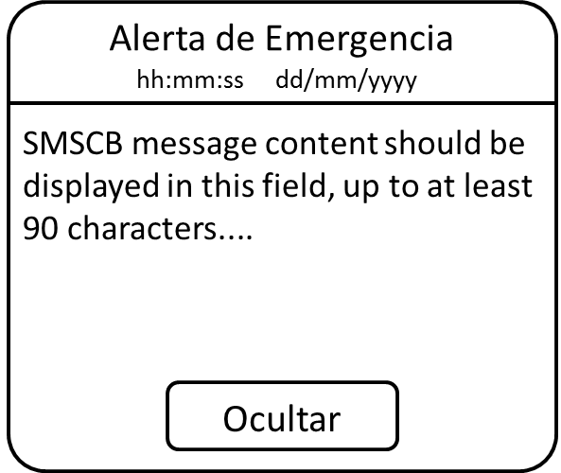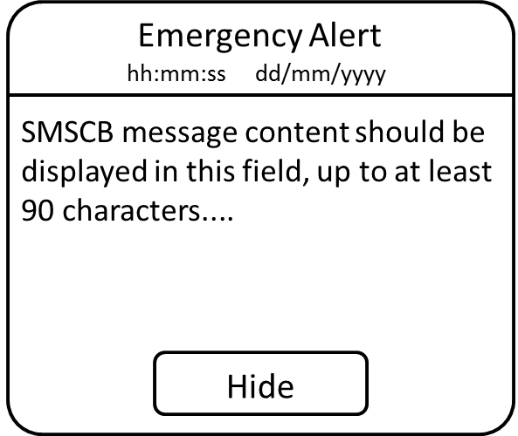
Sound notification tone required (as defined by ATIS/TIA J-SDT 100, point 7.1)
The tone must comply with the following requirements:
- Volume must be set to the loudest
- In polyphonic handsets, the tone should be composed by the 853 Hz and 960 Hz frequencies simultaneously.
- In monophonic handsets, the tone should be composed only by the 960 Hz frequency.
- Tone should loop forever until stopped by the user disregarding the popup.
- Timing should be as follows:

Vibration pattern required (as defined by ATIS/TIA J-SDT 100, point 7.2)
The vibrating notification must comply with the following requirements:
- Vibration should start synchronized with the sound tone.
- Vibration should loop forever until stopped by the user disregarding the popup.
- Vibration pattern/timing should be as follows:

Popup display with sound/vibration notification timing
- The timing/synchronization of the popup/sound/vibration should be according to the following diagram:

