Hi, the following message was sent as an email to another party just this week to see if they have experienced similar problems and found a solution. By coincidence you wrote to me a day later at 10.07hrs on 29/9/17 to “provide the requested information“. For your benefit, I have attached the spreadsheet relating to the screenshots below to help you as some of these issue relate in the same way as my assets worksheet that I sent an extract of to you before. I have not raised separate reports as requested in an earlier comment as I felt these may be related.

“It is a while since I last wrote to you, but as I am constantly correcting LibreOffice, I decided to ask if your team have come across my most frequent spreadsheet cell issues and found a solution:
- Entered text auto converts to a link, even when no @ or www is in the text, as well as when these are in a sentence, but not always
- Correcting this issue by cut and past special may work, but I suspect it auto reverts after leaving the cell or when the application or spreadsheet closes
- To make things worse, sometimes I correct the text spelling or wish to select a part of it to copy elsewhere and the wrong text is selected or the modification does some weird behaviours <so the correction is not actually made and the amended text reverts to what it was before I amended it>.
Examples are attached.

Regards,

John Hunt
+44 (0) 7952 11 6748
Note: if urgent, call, as emails are checked weekly or less often, not daily.” with the < > added since and the following was attached, all from the sheet labelled “Services”:

I save as a Microsoft file:

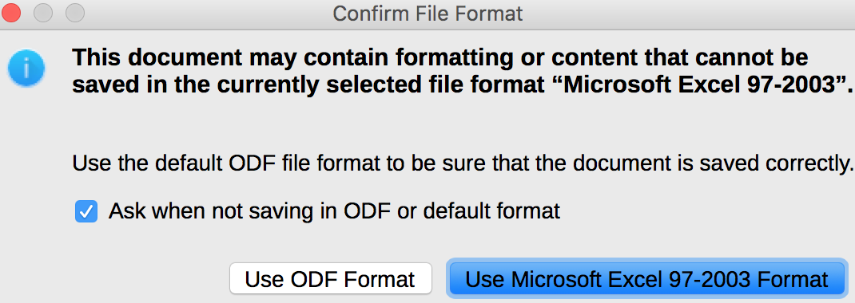

The following illustrates me selecting text in the equation bar <formulae bar> but what is actually selected is highlighted in the cell itself and copied to the clipboard:

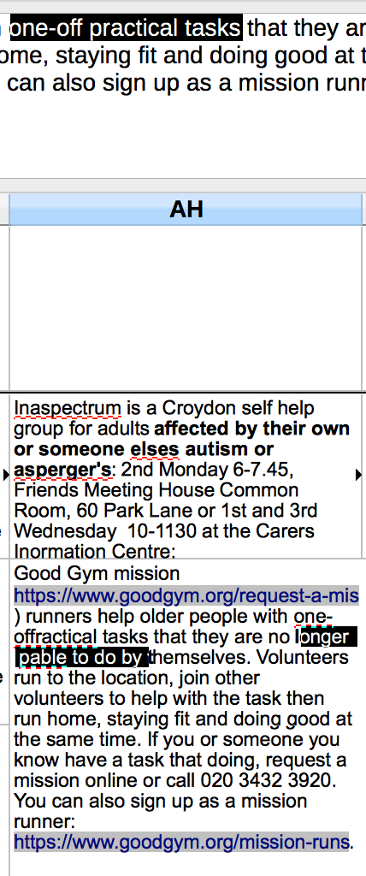

This illustrates where the equation bar has what appears to be a pile of text converted to a ‘link’, while the cell itself only has a piece of text that has correctly been converted to a real link. The equation bar entry cannot be edited:
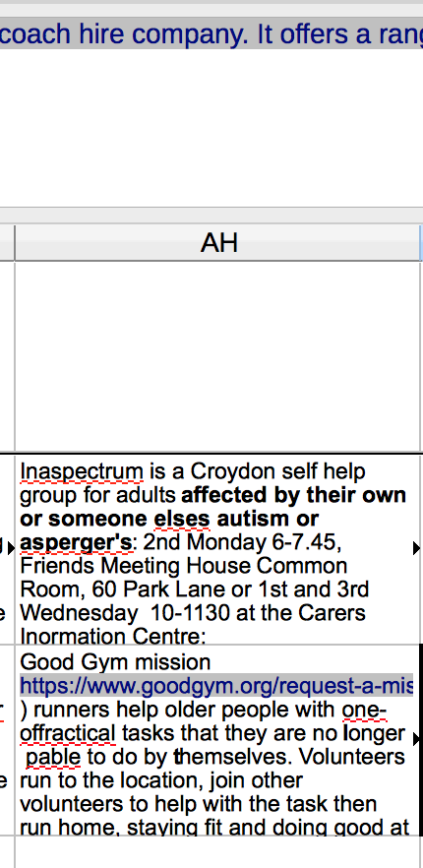

The following has examples of apparent links comprising whole paragraphs. The cell commencing helloa@softworks.com was the same but it was cut and pasted as unformatted text back into the cell to appear as it does:
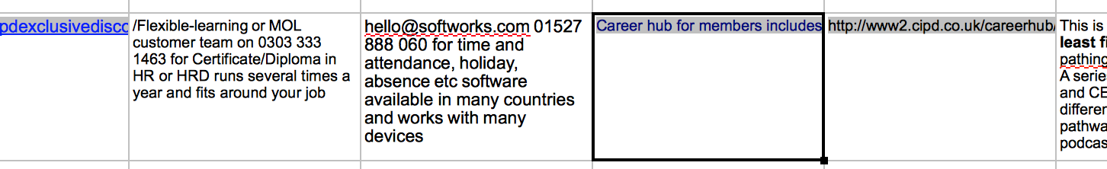
For this communication I can add that you have already described how to undo this auto generated link behaviour in Comment 9. However, I would like to prevent it occurring in the first place – how? This is essentially my Bug Description 1).

Regarding my ‘bug’ and your comments on my bug report:
- Bug Description 2) appears to be random. By tabbing to another cell and selecting ‘Undo’ the disappeared cell contents usually returns to re-populate the cell.
- Comment 2. “change it back to 'UNCONFIRMED'once the requested document is provided” has been done
- Comment 3. Apart from saying I can’t send my file due to the expected excessive hours in sanitising it, this listed more oddities which we will not go into here. They may or may not be re-occurring as I never check if entries made are still in the spreadsheet. I keep my fingers crossed!
- Comment 4. This was yet another oddity in my attempt to send you a file to work on. The file was of no use to you.
- Comment 5 & 6. This was about sending the useless file to you.
- Comment 7. You basically requested I raise separate reports for the following, where “links” refers to a paragraph taking the appearance of a hyperlink:
a) that text typed in a cell became a link (URL) without your consent. This is my bug description 1) and Comment 9 relates to this;
b) that links can not be changed to correct spelling mistakes. This is my bug description 2);
c) that removing a comma after an email address converts all text to a link. This is my bug description 3);
d) that the seemingly visually correct change is not maintained after switching to another sheet. This is my bug description 4)
This has not been done as they all relate to changing a cell content that has or will automatically take on the appearance of a link. I wish to stop this happening.
- Comment 7 & 8. These refer to the sample file I sent. The file when opened by you “asks if the user wants to update the content based on a link to an Excel 97/2003 file“. No link exists. The same occurred to the original file from which the sample was taken when I moved that file to a thumb drive, opened it in Microsoft Office on a PC, did not amend it, brought to back to my Apple MacBook Pro, and now every time I open the file it claims a link exists that did not exist before I put it on a thumb drive. This would be a new problem that I have not solved that you can solve for me:
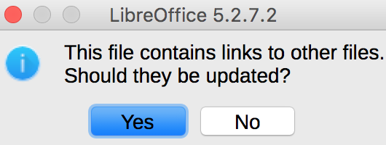

- Comment 10. Request for further information. As the same issues occur in my address book, I have submitted a partially sanitised version with this file by deleting a few sheets. This time doing so has not caused a problem and not resulted in the above link message when re-opened on my MacBook Pro. I have not yet transferred it to a thumb drive or passed it across to another PC to see if the link problem re-occurs. LibreOffice upgraded yesterday to Version: 5.2.7.2.

