In the North Atlantic prominent increases of freshwater fluxes and isotopic evidence of cooling from two foraminifera species were observed at 4.2K. Cooler SST in the North Atlantic could lead to changes in the AMOC and therefore in the ocean-atmosphere system at multidecadal scale (ref). These ice-melting effects observed in northern Atlantic for the 4.2K event are associated with weaker solar radiation called the Bond 3 event. According to speleothem records Bond events would lead to an enhanced SASM and wetter climate in tropical South America (ref).
So far none volcanic eruption dating back to this age was identified to test the volcanic hypothesis. Therefore we reconstructed the volcanic deposition at both poles from Electrical Conductivity Measurement (ECM) in ice core (Fig. 4). This method consists in measuring the conductivity of the ice along an ice surface between two electrodes a few centimeters appart (Wolff, 2000). ECM principally measures the acidity of the ice. In most cases, volcanic eruptions and associated volcanic aerosols create acidity spikes in ice core, and hence ECM spike, although this is not systematic (Wolff, 2000). ECM has been measured on the NorthGRIP (NGRIP) ice core in Greenland, and on the WAIS Divide (WD) ice core in Antarctica. Those two ice cores have been accurately dated by counting annual layers in various proxies (Svensson et al. 2008, Sigl et al. 2016). We could observe a high volcanism activity on both Greenland and Antarctica cores dated at 4220 yr BP (Fig. 4). According to Sigl et al (2016), this observation tells us that one strong volcanic eruption, e.g. with a Volcanic Explosivity Index (VEI) above 7, occurred within the tropical band with aerosols dispersed to both hemispheres after the eruption.
To better understand the effects of the different forcings on the distribution of precipitation and SASM variability in tropical South America we analysed the responses of the eruption of the Samalas, Indonesia (8.565°S 116.351°E), one of the largest eruption that occurred during the 13th century (Lavigne et al 2013).

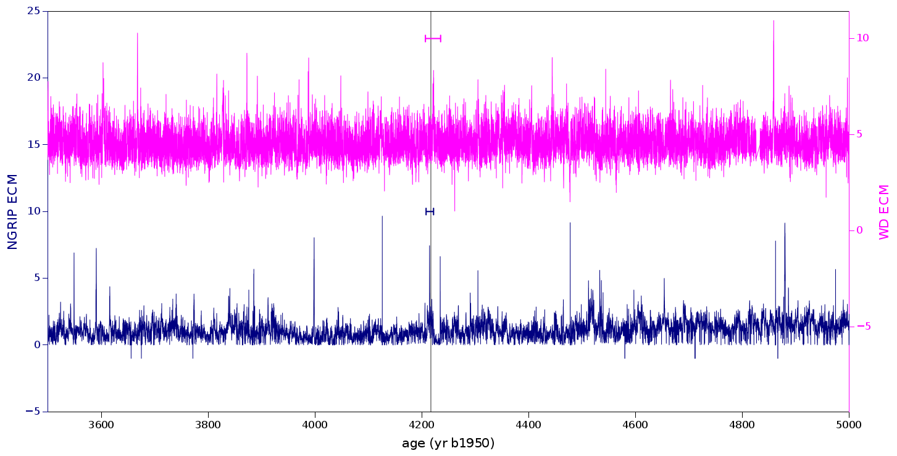
Figure 5 ECM records, a proxy for volcanic eruptions, in the NGRIP (blue, Greenland) and WD (pink, Antarctica) ice cores. Volcanic events show up as spikes. The blue (resp. pink) horizontal error bar represents the confidence interval of the NGRIP (resp. WD) chronology at the ~4217 yr B1950 volcanic event. The black vertical line at 4217 yr B1950 show that the NGRIP and WD chronologies are compatible with a common volcanic event at this date.

3 The AD 1257 Samalas eruption as a potential analog
Climatic effects of past volcanic eruptions have been detaily reconstructed for the last thousand years (Stoffel et al. 2015, Colose et al 2016a). However their inprints in sediment or in speleothem records have rarely been commented (Ridley et al 2015, Winter et al 2015). At Papallacta in Ecuador (fig. 1) the vegetation was drastically perturbated for several decades during the 14th century (Supplementary). The grassland (or Páramos) was replaced by a dry Asteraceae-dominant environment and the upslope convection of moist air abruptly stopped for almost 2 centuries (Ledru et al 2013). In the Guayaquil region, the Andean forest contracted during two centuries from ~1200 and 1400 AD indicating a short cooling and drier episode (Seillès et al 2015). The speleothem of Cascayunga shows an abrupt decrease in rainfall at AD 1260 that lasted until AD1300 and shows a progressive increase of the precipitation until AD 1450 (Reuter et al 2009). Due to the scarcity of the data for this time interval we decided to use climate models to control the different processes enhanced by the eruption of the Samalas (Table 1) as volcanic forcing is generally considered to be the most important forcing during this interval (Atwood et al. 2016).

