Internet

Sales/Customer Service

Web Servers 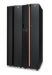
Web Server
Designers
Email Server Email Server Database Server
File Server
Admin System HR

File server
Production/ Printing Group

