SUMMARY

Presentation/Introduction
Claudia Mattos, Roberto Conduru

Keynotes

Between Rocks and Hard Places:
Indigenous Lands, Settler Art Histories, and the “Battle for the Woodlands”
Ruth B. Phillips
Carleton University

Transdisciplinary, Transcultural, and Transhistorical Challenges of World Art Historiography
Peter Krieger
Universidad Nacional Autónoma de México

1

The Global Dimension of Art History (after 1900)
Conflicts and Demarcations
Joseph Imorde
Universität Siegen

Perspectives on Institutional Critique
Lea Lublin and Julio Le Parc between South America and Europe
Isabel Plante
Universidad Nacional de San Martin

2

Historiography of Indian Art in Brazil and the Native Voice as Missing Perspective
Daniela Kern
Universidade Federal do Rio Grande do Sul

3

The Power of the Local Site: A Comparative Approach to Colonial Black Christs and Medieval Black Madonnas
Raphaèle Preisinger
University of Bern

4

Between Roman Models and African Realities:
Waterworks and Negotiation of Spaces in Colonial Rio de Janeiro
Jorun Poettering
École des Hautes Études en Sciences Sociales

Tropical Opulence: Rio de Janeiro’s Theater Competition of 1857
Michael Gnehm
Accademia di architettura in Mendrisio

5

The New Classicism Between New York and Bogotá in the 1960s
Ana M. Franco
Universidad de los Andes

Back and Forward: Considerations about Artistic Relations between Mexico and the United States (1988–2014)
Daniel Montero
Universidad Nacional Autónoma de México

6

Historiographies of the Contemporary: Modes of Translation in Conceptual Art and from Conceptualism
Michael Asbury
University of the Arts, London

Landscape Painting in the Americas: An Inquiry
Valeria Piccoli (Pinacoteca do Estado de São Paulo)
Georgiana Uhlyarik, (Art Gallery of Ontario, Canada)
Peter John Brownlee (Terra Foundation for American Art, USA)

7

From Ethno-Aesthetic to Socialist Realism, Aesthetic Practices in Africa and New Territories of Art History: The Role of Institutions
Romuald Tchibozo
Université d’Abomey-Calavi

Tonalá Ceramics in Seville
Alfredo J. Morales
Universidad de Sevilla

1492 in the Other Indies: Shifting Centers, Creating New Peripheries
Frederick Asher
University of Minnesota

European Architecture in Southeast Asia during the 18th Century: Between Tradition and Hybridization
Pedro Luengo
Universidad de Sevilla

8

Crafting Relational Activism:
Political Potentials of Communal Making in Contemporary Australia
Katve-Kaisa Kontturi
University of Melbourne

Transcultural Stories for Local Consumers: Screens and Rhizomatic Art Histories
Marco Musillo
Kunsthistorisches Institut in Florenz, Max-Planck Institut

Whose History? Why? When? Who Benefits, and Who Doesn’t?
Claire Farago
University of Colorado at Boulder

Between Roman Models and African Realities:
Waterworks and Negotiation of Spaces in Colonial Rio de Janeiro
Jorun Poettering

Introduction

In a book published in 1723, a friar of the Barefoot Augustinians, Agostinho de Santa Maria, describes a street scene a short distance outside of Rio de Janeiro as follows:

A street runs from the monastery Nossa Senhora da Ajuda toward the town, bordered by noble houses, and constantly frequented by many persons, both black- and white-skinned. The blacks come and go, fetching water from the Carioca River and bringing it into the city. The Carioca is a river rising out of the mountains, its water is superb [...] And those of fair skin seek out, for their amusement and relaxation, the fresh and enjoyable localities in the surrounding area.

The blacks and whites pursue their different tasks in apparent harmony, making joint use of the bustling street for work and recreation. Such an idyllic image of the utilization of a public space was extremely rare in the descriptions of Rio de Janeiro. In later accounts, a stark contrast between the protected domestic sphere and the hostile public streets and squares was predominant. In most depictions, these public spaces were characterized by a sense of disorder and threat caused by the ubiquitous presence of enslaved and freed blacks, from whom the whites sought to distance themselves as much as possible.

Who defines the spaces of a city, their configuration and functions, their utilization and value, their atmosphere, and thus their meaning and importance? And how do such processes come about? I wish to make these questions concrete by looking at the spaces constructed by and around the water supply infrastructure that transcended and structured the colonial city of Rio de Janeiro by means of a network of aqueducts, public fountains, and private water taps. At the fore of the inquiry are two central actors: the groups broadly termed “the white elites” and “the blacks.” I argue that these actors constructed the urban spaces of Rio in a continuous process of negotiation and renegotiation, imbuing those spaces with a specific identity. The white power elites, supported by technical experts, were active in the name of the Portuguese king or the municipal authorities, and identified themselves in large measure with the traditions stemming from their land of origin across the sea. They designed the water infrastructure and oversaw the construction of its facilities. The black slaves, on the other hand, who, most particularly in their function as carriers of water, were the direct users of the aqueducts and fountains, were indispensable for the actual supply of drinking water for the urban residents; they filled the facilities with the pulse of life, giving them their special atmosphere. The two groups had different ideas about the value and functionality of the waterworks. They never engaged in direct dialogue about the use and organization of the corresponding spaces; rather, they negotiated them through their respective behavior.

In reconstructing this process of negotiation, I have to make use of a highly asymmetrical array of source materials: while the attitudes, motivations, and actions of the Portuguese and their descendants are relatively well represented in the documentation they produced themselves—as well as directly in the waterworks—the actions of the blacks must be deduced from descriptions made by others, particularly from travel accounts written by foreign Europeans. Yet the authors of these descriptions were, by means of the accounts driven by their own interests and conceptions, likewise participant in the construction of the respective spaces. Thus the blacks tended to be highly underrepresented in the sources produced by the Portuguese, since as a rule they viewed Rio de Janeiro as a “normal” city along European lines. In contrast, the blacks were distortedly foregrounded in the accounts written by northern European travelers, because the slaves and their agency were considered a special feature of the exotic locality in the foreigners’ process of self-demarcation. This does not mean, however, that of interpreting elites and blacks as opposed actors in the process of negotiating the configuration of urban spacees is illicit. It only implies that we will learn less about the thoughts, motives, and intentions of the blacks than about those of the whites.

In the following, I will argue bearing in mind the spatial categories proposed by Henri Lefebvre. The Portuguese colonial masters and their descendants dominated the creation of the conceived space (espace conçu), a space that was materialized by architectonic set pieces of European origin, mirroring a specific program of dominion and civilization. The slaves and freed slaves created a lived space (espace vécu) around the aqueduct and fountains, which was shaped and defined by their own constraints and needs and had little in common with the conceived space of the Portuguese.

Roman Models
The notables of Rio de Janeiro were extraordinarily proud of their grand aqueduct with its two stories of arches, completed in 1723. It can be filed within a long tradition of aqueduct constructions in Portugal. In earlier times, the Romans had built a large number of impressive exemplars on the Iberian Peninsula that were renewed and expanded in many Portuguese towns in the sixteenth century. In particular, the humanistically oriented King João III (1521–1557) had a great interest in maintaining and restoring Roman culture and architecture, not least because he considered the Portuguese overseas empire to be the successor to the former Roman Empire. For this reason, he sent the Portuguese architect and painter Francisco de Holanda and other artists to the eternal city to study its Roman heritage as well as the urbanistic concepts of the Renaissance. In Rome, Holanda became acquainted with the renovatio Romae, a program by which the Renaissance popes sought to resurrect Rome as the center of Christendom, which included the restoration of its antique aqueducts. Many years later, he wrote a report in which he not only described his impressions from Rome but also proposed a program and draft plan for the urbanistic reconfiguration of Lisbon. One of his proposals was to build an aqueduct in Lisbon according to the Roman models. He not only argued that the city should offer its residents a level of comfort commensurate with its status as the capital of a world power, but also associated the architectonic renewal of the city with the purification of the souls of its residents and interpreted it as a way to civilize them. To strengthen his argument, he drew on a historic review of the conquest of Lisbon by the Romans, according to which on the heels of the victory over the local pagans, the Roman conquerors urbanized, embellished, and ennobled all their settlements with a system for water provision, including large arches and an extensive network of pipes.

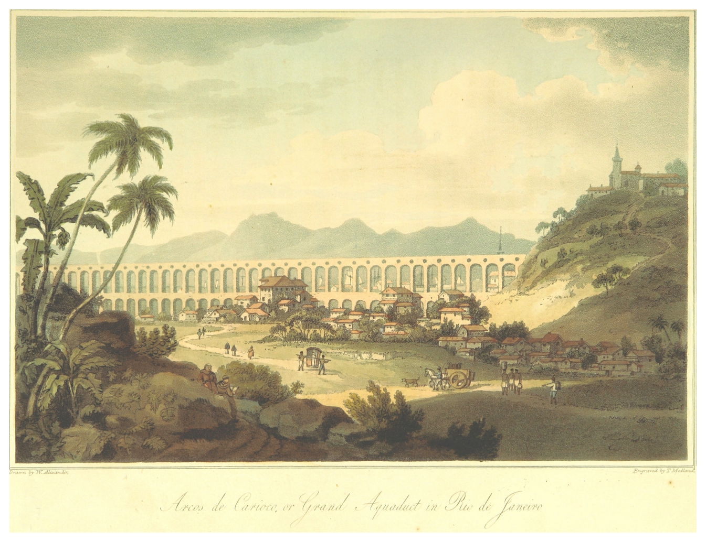
Fig. 1: John Barrow, Arcos de Carioco [sic] or Grand Aqueduct in Rio de Janeiro. Image extracted from: John Barrow, A Voyage to Cochin China, in the years 1792, and 1793 [...] (London: T. Cadell and W. Davies, 1806), 115. Original held and digitized by the British Library. Public domain.

Similar conceptions were adopted by the Portuguese regarding the establishment of cities in the early modern colonial world. Cities were seen as an expression of piety and civilization, as well as a means for the attainment of these. With their architectonic appearance as well as their structures of political organization, the cities formed a central part of the identity of European settlers in America. Just as the Roman conquerors had established cities in Portugal reflecting the model of their own cities, the Portuguese built cities with corresponding features in the areas they conquered and settled. The construction of the aqueduct in Rio de Janeiro, however, should also be viewed in relationship to the urban reconfigurations that reflected the increased royal interest in Brazil since the end of the seventeenth century. This applies especially to Rio de Janeiro, which would become the main export hub for the gold recently discovered in the interior. Through the constantly visible inscriptions on the aqueduct and fountains—almost all of them in Latin—the city’s inhabitants were constantly indoctrinated regarding a lasting connection between the material comforts of the city, the high degree of civilization of its inhabitants, and the representatives of the crown responsible for them.

African Realities
Innumerable travel accounts of the second half of the eighteenth and early nineteenth centuries, as well as many drawings done by foreign painters, captured scenes at Rio de Janeiro’s fountains. According to these descriptions, the spaces around the fountains were loud and chaotic, with many people conversing and arguing. Often the slaves and freedmen had to endure a long wait until they could fill their vessels, yet they would also deliberately take breaks at the fountains to smoke, eat, drink, or play, or occasionally even to take a bath. The areas around the fountains were spaces of community life where the blacks could pursue the social needs that the whites satisfied in the private sphere of their homes and gardens. Although they were freely accessible and observable, these places formed a kind of intimate space for the black population, in which, to a certain degree, their own rules and hierarchies held sway.

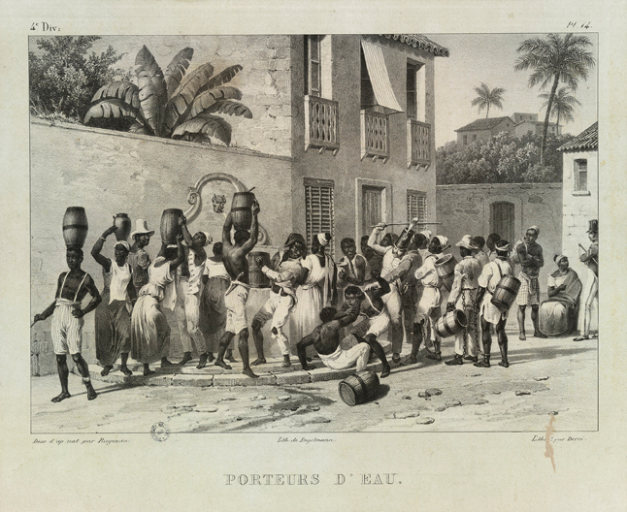
Fig. 2: Johann Moritz Rugendas. Porteurs d'eau (Paris: Engelmann, 1835). Original held and digitized by the Biblioteca Nacional, Rio de Janeiro. Public domain.

The white population felt uncomfortable with these scenes. To the whites, idle slaves seemed objectionable, if not downright dangerous. As the Jesuit Jorge Benci wrote in a tractate published in 1700 on how to deal correctly with slaves, a double threat emanated from them. On the one hand, idleness led to vice and a godless life of sin. Benci claimed that while this was also true for the whites, the blacks were much more prone to all manner of outrages. Yet idleness was not only an insult to the Lord, it also represented a concrete risk to the whites. According to Benci, it provoked slaves into being rebellious and recalcitrant; they even might try to shake off the yoke of slavery. For that reason, he warned slaveholders to make sure their slaves were constantly kept busy at work so that they would remain peaceable and tame. Only in that way could their masters lead a relaxed and quiet life. Likewise, the growing group of freed slaves posed a problem in the perspective of people of European origin. Socially marginalized and with few legal possibilities for work, they were considered lazy, vicious, and depraved. As did the slaves, the black freemen would also congregate at the fountains, and for the whites, this, too, constituted a threat to social order.

But it was not just black people’s presence at the fountains that disturbed the white population. Frequently, there were quarrels and fights between the slaves waiting at the fountains, with some being injured and even killed. Apart from that, slaves and freedmen were repeatedly accused of destroying the fountains as well as the aqueduct and its pipe system, either by negligence or on purpose. Unlike the white elites, the slaves were not interested in the functionality of the aqueduct, nor did the previously described image of urban culture and refinement going back to Roman antecedents have much meaning for them. Indeed, with their chaotic and sometimes violent behavior, they strongly disturbed that image. The blacks had, to a certain degree, appropriated the spaces created by the water supply infrastructure: their lived realities overlaid and submerged the urban identity postulated by the white elites.

The Counteractions

Despite this reality, the municipal administration nonetheless sought to enforce its conceptions. It installed sentinels who were to discipline the blacks, imposed penalties, and interfered materially by rendering the infrastructure particularly secure, undertaking repairs and relocating or remodeling structures.

The special role that the slaves played in the system of water distribution can be seen even in connection with the very construction of the aqueduct. When it was first planned in the early seventeenth century, it was far from obvious that it would actually be built, as the city had a white population of only between 3,500 and 7,500 and the distance to the Carioca River of some 2 to 3 kilometers was not a great challenge for the slaves. But with the aid of the aqueduct, it was easier to keep the slaves under surveillance. If they fetched water at a fountain in the city, they remained under the eye of the residents and the authorities, or at least had to fear being observed. Thus flight, aggression, and loitering in taverns could be hindered.

To restrict violent scenes, the white elites also tried to establish a certain functional and social segregation with respect to the fountains. Unlike the Carioca fountain, the first and main public fountain located at the periphery of the city, which was intended for the slaves, the second fountain had a much more representative function. A magnificent waterspout fountain, it was constructed in the very heart of the political center of Rio de Janeiro on the newly designed Carmo Square, which was open to the town’s harbor and flanked by the most important buildings of the city, including the governor’s palace and the town hall. In fact, it had been built where the pillory previously stood, thus marking the transition to an advanced stage of colonization: after having successfully established the justice system, symbolized by the pillory, the Portuguese had now turned toward the subtleties of dominion, demonstrating the city’s level of prosperity, symbolized by the new fountain.

The slaves, however, did not respect this symbolism and seem to have used the Carmo fountain like any other in the city. As we know from the reports of the expedition under James Cook, who landed in Rio de Janeiro in 1768, it was difficult for the palace guard to preserve order among the slaves waiting at the Carmo fountain, even though the guard members pursued their task with exceptional severity. Thus, if the foreigners wished to fill the water storage casks for their ships, they had to request from the viceroy their own especially assigned sentinel: he would clear their path to the fountain so that they could fill their containers there. Later, the Carmo fountain was replaced by a new one situated directly at the dock, making it possible for foreign ship captains to refill their water stores by employing hosepipes from the fountain.

Nonetheless, the foreigners continued to perceive the slaves much more intensively than they did the grand architectonic staging based on European paradigms. As the slaves were of such great importance for the daily provisioning of the city’s residents, they could hardly be banished from its public image. The omnipresent figure of the sentinel at the fountain, installed to ensure law and order, was ultimately nothing but the expression of an abiding sense of helplessness on the part of the authorities.

Conclusion
Returning to Lefebvre, it can be said that the maintenance of the difference between the space conceived by the white elites and the space actually lived by the slaves, instead of the absorption of the lived space by the conceived space, was an expression of the strength of the black population. However, due to their subjugated position, the slaves and freedmen never succeeded in conceiving an alternative conceived space that might have supplanted that of the white elite. This was because, unlike the whites, the blacks did not constitute a group with a shared past or common value system. Rather, their group included people who originally stemmed from a range of very different African nations with different languages and religions, as well as highly diverse social backgrounds. These differential features had, to be sure, largely been extinguished through the act of enslavement, which reduced the Africans to the status of subjugation and the external feature of their dark skin. But they encountered huge difficulties in constructing a new collective identity, one based on their role as slaves, though transcending it. This process took place under the watchful eyes of the whites, in the framework of religious fraternities, but also within locales of common socialization such as the fountains. Therefore, these spaces harbored a special meaning for the blacks and thus held the potential for a conceived space of their own. Yet at the same time, the slaves helped to consolidate the spaces conceived by the white elites, because it was they who built the aqueduct, the fountains, and the water supply channels, according to the instructions of the white engineers, and it was they who repaired these facilities when needed. What the blacks did succeed in doing was preventing the implementation of the conceived space of the white elites as perceived space (espace perçu), particularly in respect to foreign visitors, whose experience was deeply stamped by the image of the blacks.

---
Jorun Poettering

Jorun Poettering has a doctorate in Modern and Contemporary History from the University of Hamburg and has held postdoctoral positions at Ludwig-Maximilians-Universität Munich, Universidade Federal Fluminense, Harvard University, and the John Carter Brown Library. She published the book Handel, Nation und Religion. Kaufleute zwischen Hamburg und Portugal im 17. Jahrhundert (2013). Currently, she works as a Marie Skłodowska-Curie Fellow at École des Hautes Études en Sciences Sociales, preparing a social history of Rio de Janeiro, as observed through the perspective of its water supply.

The research for this article was enabled by generous grants from the Alexander von Humboldt Foundation and the European Union’s Horizon 2020 research and innovation programme program under the Marie Sklodowska-Curie grant agreement No 659520”. The text goes back partly to an earlier version translated by William Templer.
“Da mesma Casa, & Santuario de nossa Senhora da Ajuda […] corre hũa rua, que vay para a Cidade, toda povoada de casas nobres, & sempre frequentada de pretos, & brancos; os pretos vão, & vem a buscar, & trazer agoa da Carioca, que he hũa Ribeyra, que desce da serra de excellente agoa; [...]. E os brancos vaõ buscar no campo os lugares frescos, & deliciosos para o seu alivio, & divertimento;”; Agostinho de Santa Maria, Santuario mariano, e historia das imagens milagrosas de nossa senhora, vol. 10 (Lisbon: Antonio Pedrozo Galram, 1723), 20.
Cf. Sandra Lauderdale Graham, House and Street. The Domestic World of Servants and Masters in Nineteenth-Century Rio de Janeiro (Cambridge: Cambridge Univ. Press, 1988).
A more detailed version of the arguments will soon be published in Brasiliana - Journal for Brazilian Studies.
For literature on Rio de Janeiro's colonial water supply, cf. Magalhães Corrêa, “Terra Carioca. Fontes e chafarizes,” Revista do Instituto Histórico e Geográfico Brasileiro 170 (1935): 9–-214; Noronha Santos, “Aqueduto da Carioca,” Revista do Patrimônio Histórico e Artístico Nacional 4 (1940): 7–-53; idem, “Fontes e chafarizes do Rio de Janeiro,” Revista do Patrimônio Histórico e Artístico Nacional 10 (1946): 7–-133; José de Sousa Reis, “Arcuatum Opus. Arcos da Carioca,” Revista do Patrimônio Histórico e Artístico Nacional 12 (1955): 9–-108; Rosauro Mariano Silva, “A luta pela água,” in Rio de Janeiro em seus quatrocentos anos. Formação e desenvolvimento da cidade, [ed. Secretaria de Obras Públicas] (Rio de Janeiro: Distribuidora Record, 1965), 311–-37; Maurício de Almeida Abreu, “A cidade, a montanha e a floresta,” in Natureza e Sociedade no Rio de Janeiro, ed. Maurício de Almeida Abreu (Rio de Janeiro: Secretaria Municipal de Cultura, Turismo e Esportes, 1992), 54–-103.
Henri Lefebvre, La production de l'espace (Paris: Ed. Anthropos, 1974).
Walter Rossa, “Modern Age Aqueducts in Portugal,” in: Aqueducts, ed. Vittorio Gregotti (Bologna: CIPIA, 1994), 61–-62.
Katherine Wentworth Rinne, The Waters of Rome. Aqueducts, Fountains, and the Birth of the Baroque City (New Haven, CT: Yale University Press, 2010), 45; Ronald K. Delph, “Renovatio, Reformatio, and Humanist Ambition in Rome,” in Heresy, Cculture, and Rreligion in Eearly Mmodern Italy: Ccontexts and Ccontestations, ed. Idem, and Michelle M. Fontaine, and John Jeffries Martin (Kirksville, MO: Truman State University Press, 2006), 73–-92, here 85.
Francisco de Olanda, “Da Fabrica que Falece a Cidade de Lisboa,” ed. Vergilio Correia and Alberto Cortês, Archivo Español de Arte y Arqueología 5 (1929), 209–-224.
Cf. e.g. Giovanni Botero, On the Causes of the Greatness and Magnificence of the Cities, ed. Geoffrey Symcox (Toronto: Univ. of Toronto Press, [2012]), 10.
Nestor Goulart Reis Filho, Contribuição ao estudo da evolução urbana do Brasil: 1500-1720 (São Paulo: Livr. Pioneira Ed. / Ed. da Univ. de São Paulo, 1968).
For the inscriptions cf. José de Souza Azevedo Pizarro e Araújo, Memorias historicas do Rio de Janeiro e das provincias annexas à jurisdição do vice-rei do Estado do Brasil, vol. 7 (Rio de Janeiro: Silva Porto 1822), 47–-65; Santos, “Aqueduto da Carioca;”; Santos, “Fontes e chafarizes;”; Reis, “Arcuatum Opus.”.
Cf. e.g. the vivid discription in James Hardy Vaux, Memoirs of James Hardy Vaux, vol. 1 (London: W. Clowes, 1819), 219.
Jorge Benci, Economia cristã dos senhores no governo dos escravos (Livro brasileiro de 1700). Estudo preliminar de Pedro de Alcântara Figueira e Claudinei M. M. Mendes (São Paulo: Grijalbo, 1977), 175–-178.
Arquivo Nacional do Rio de Janeiro (ANRJ), Secretaria de Estado do Brasil, cód. 952, vol. 24, f. 303; vol. 27, f. 302.
ANRJ, Secretaria de Estado do Brasil, cód. 952, vol. 33, f. 335; Arquivo Histórico Ultramarino (AHU), ACL, CU, 017, cx. 34, doc. 3579; AHU, ACL, CU, 017-01, cx. 43, doc. 10397; cx. 44, doc. 10400.
Mauricio de Almeida Abreu, Geografia Histórica do Rio de Janeiro (1502-1700), vol. 1 (Rio de Janeiro: Andrea Jakobsson 2010), 20.
AHU, Lisboa, ACL, CU, 017, cx. 34, doc. 3579; Luiz de Almeida Portugal / Marquês do Lavradio, Cartas do Rio de Janeiro: 1769-1776 (Rio de Janeiro: Arquivo Nacional, 1978), 126.
Silvia Hunold Lara, Fragmentos setecentistas. Escravidão, cultura e poder na América portuguesa ([São Paulo]: Companhia das Letras, 2007), 47.
John Hawkesworth, An Account Of Theof the Voyages Undertaken By Theby the Order oOf His Present Majesty fFor Making Discoveries in the Southern Hemisphere, vol. 2 (London 1773), 27–-28; The Vvoyage of the Endeavour, 1768–-1771 (The Jjournals of Captain James Cook on Hhis Vvoyages of discoveryDiscovery), ed. John Cawte Beaglehole (Cambridge: Hakluyt Soc. at the Univ. Press, 1968), 29-–34.

