Love you to the moon and back
Clan Irwin Cousin Jen March always tells family members and very close friends, "Love you to the moon and back", well good news. She can officially say it by way of Clan Irwin, and here is why.
We have been to the moon and back.
Apollo 15 astronaut James B. Irwin, in 1971 was the eighth man to walk on the moon, quite a feat since only twelve have ever accomplished this amazing task.
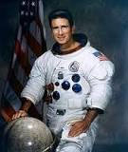
James Benson Irwin was born in a suburb of Pittsburgh March 17, 1930. (A true Celtic warrior,) at this venture I am going to digress and speak of another Irwin, my father James William Irwin, born the same year, in the same Pittsburgh suburb. J.B. Irwin entered the Air Force and eventually was strapped atop a rocket and sent to the moon, my father entered the Army and during the Korean action and normally had two or more tons of live munitions behind him that if ignited would also have sent him to the moon. OK, back to the story.
During Astronaut Irwin's career he accumulated more than 7,015 hours flying time, 5,300 hours in jet aircraft, he was also a developmental test pilot for the Lockheed YF-12, the Mach 3 interceptor which preceded the SR-71 Blackbird. Irwin had difficulties to overcome while trying to get to the moon, In 1961, a student pilot that he was training crashed the plane they were flying on a training mission. They both survived, but Irwin suffered compound fractures, amnesia, and nearly lost a leg. All this was overcome, maybe this goes back to "Flourish in sun and shade."
While on the moon, Irwin was one of the astronauts to operate the new lunar rover, and bring back moon rocks, one which carbon dated at 4 Billion years old- declared the genesis rock by scientists, it still is helping us discover Earth's and the solar system's origin.
While on the moon's surface Irwin said he had an epiphany, declaring, "I felt the power of God as I'd never felt it before." While LTC Irwin was serious and enthusiastic about his mission, he always showed a bit of the Irwin humor, as an example at the end of the first day exploring the rugged lunar highlands said he was reminded of "my favorite Biblical passage from Psalms." Speaking by radio to Mission Control in Houston, he began quoting the passage, "I'll look unto the hills from whence cometh my help," and added quickly, "but, of course, we get quite a bit from Houston, too."
Upon returning to Earth and leaving the military, and NASA, Irwin founded the High Flight Foundation, an interdenominational evangelical organization based in Colorado Springs, where he had settled with his family. It was through the foundation and his strong faith that he embarked on another journey, to find Noah's Ark. On two occasions he led expeditions to Mount Ararat in Turkey in search of evidence of Noah's Ark. In 1982, he reached the 16,946-foot summit but fell on the glacier, suffering severe leg and face lacerations. He had to be carried down on horseback.
A year later, he surveyed the summit by airplane, looking for possible remains of the ark, which, according to the Book of Genesis, came to rest on the "mountains of Ararat." "It's easier to walk on the moon," Mr. Irwin said. "I've done all I possibly can, but the ark continues to elude us."
On August the 8th 1991, he left the bonds of Earth one final time. Irwin was the first and the youngest of the moon walkers to die. Here is a tie in with education the Irwin's have, to honor the man and his accomplishments, the James Irwin Charter Schools were created in Colorado, and continue the education of our youth to this day.

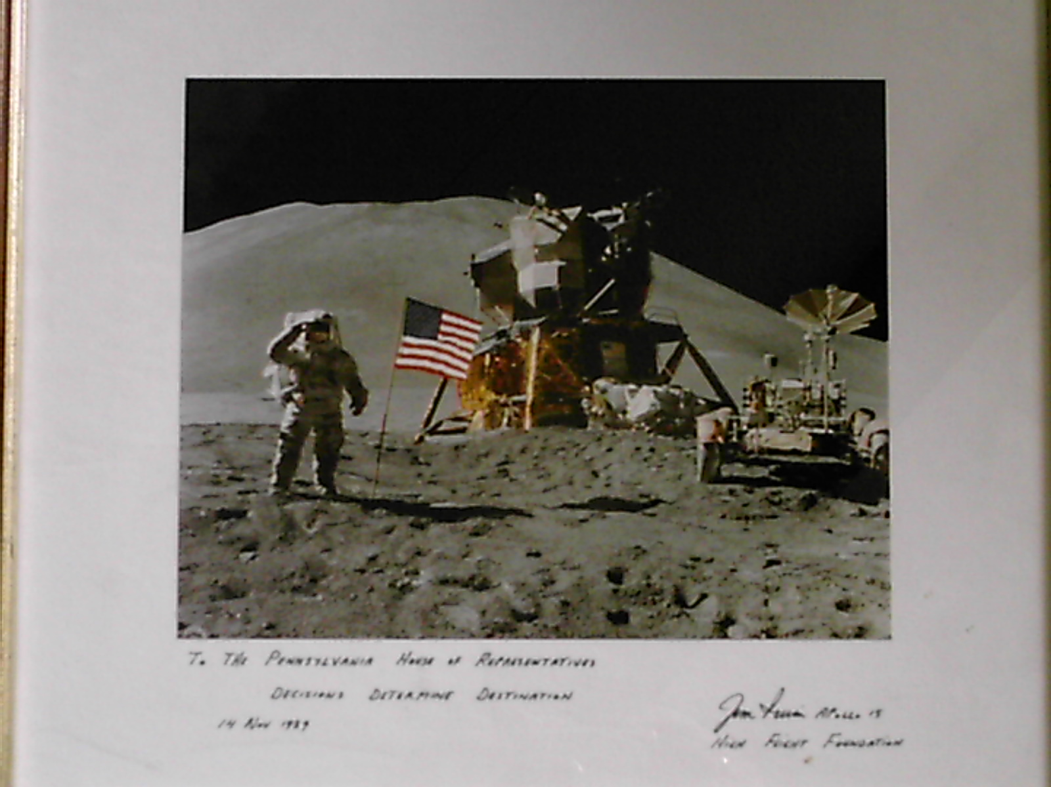
One final note: In 1989 Astronaut Irwin made a speech before the Pennsylvania House of Representatives, after the speech he presented the House with a photo of the Apollo 15 lunar landing site. My sister-in law Gini Rush was working as executive officer for a State Rep at the time. Well, after hanging in the halls of the State Capitol, during the refurbishment of the building, the photo was presented to my sister in law. Before she passed, also much too young, she wanted to make sure I received it. To this day I have it hanging in my office, this autographed photo of the lunar landing, and it reminds me of all of them, Gini, my Dad, and Col. Jim Irwin, who believed your decisions determine your destination.
Col Irwin is buried at Arlington National Cemetery, maybe next trip there we as a Clan will pay a visit.
Oh and by the way from Jen March, "Hey Clan Irwin Cousins, Love you to the moon and back."

Submitted by William J. Irwin

