Test document opened in MS PowerPoint
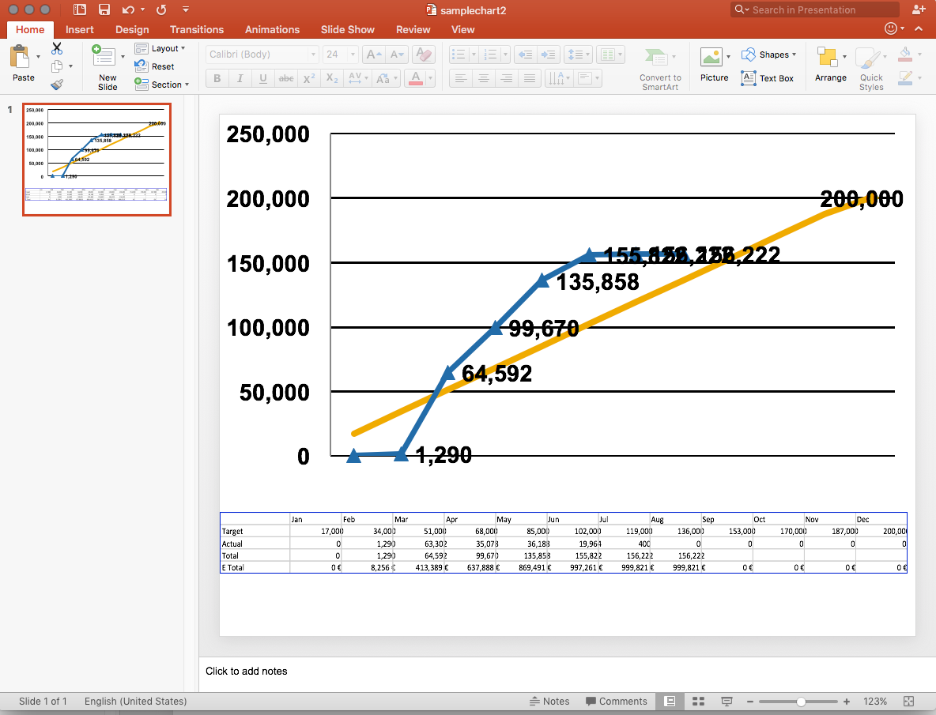

Same document opened in LibreOffice 5.1.0.3
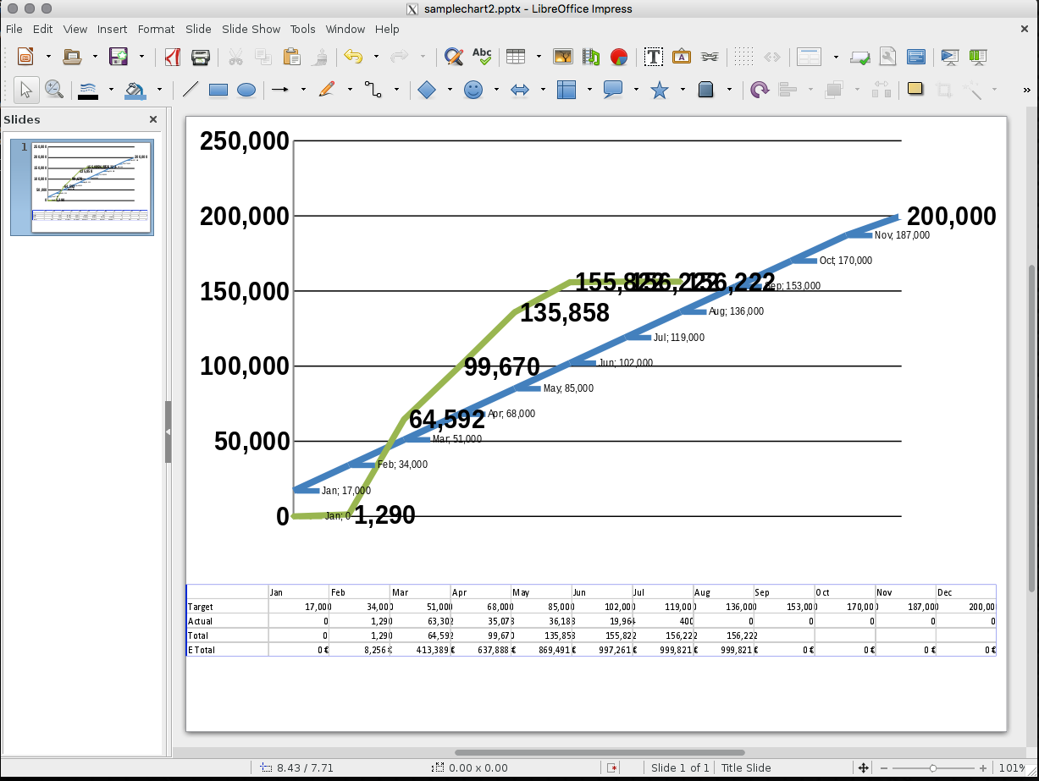

Data labels are displayed.
