Chapter
Text with image (see Figure 1.1).
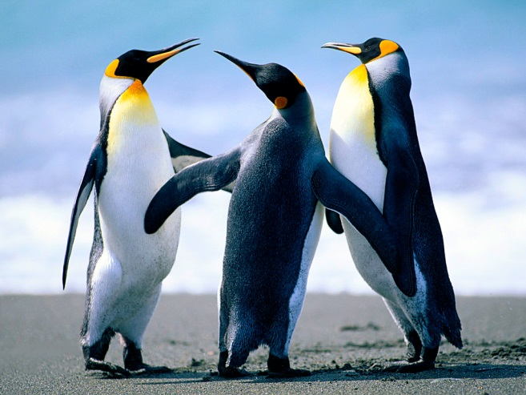
Figure 1.1 Penguins

Chapter
Text with table (see Table 2.1)

Table 2.1 caption

Chapter

