THE LOW COST TOURIST ACCOMMODATION SECTOR IN BARCELONA: AN ANALYSIS OF MARKET FORCES OPERATING IN THE LOW COST SEGMENT AND A STRATEGY FOR FUTURE DEVELOPMENT

A Capstone
Presented to the Faculty of European University
In Partial Fulfilment of the Requirements for
The Degree:
MBA in Tourism and Leisure Management
By: Aghasadikh Garaybayli

January 2016
FOREWORD
First of all, I would like to express my gratitude to my mentor, Mr. Anthony Lawson, for the guidance in this work, the scientific competence and criticism, corrections and suggestions.
Also, I would like to thank my parents from their support and love. For opportunities they gave me in my life and career without their sacrifice it would be hard to get here.
I take this opportunity to thank my brother for the patient, help and motivation, for real friendship and support.
I must also place on record my sense of gratitude to my fiancée and best friend, Kesha, for her endless love and support.
Finally, I want to thank all my friends for the support and friendship at all times and circumstances.

Barcelona, 1st October 2015

____________________________________
Aghasadikh Garaybayli
EXECUTIVE SUMMARY
It has been a long time already that low cost tourism strategy is rising in all over the world. Development of low cost carriers is affecting also the accommodation type of tourists in destination. It was affected not only because of financial scenario of the world but also high competition between tourism destinations. Even though most European cities already added a low cost model to their segmentation, Barcelona is facing several problems to do that. The reason could be already maximum inbound tourist numbers or no ability to apply this model to expand segmentation of incoming tourists. On the other hand the city is facing big social problems, started by the local communities and local neighbors of noisy and polluted touristic apartments. There are a lot of different protest especially during the summer against illegal tourist apartments. Also Barcelona is facing the problem of having lots of illegal tourist establishments such as hostals, hostels and tourist apartments. These illegal establishments are not only causing social problem with local communities but also financial damage to the budget of the region. For this reason it was decided to analyze the future of the low cost tourism accommodation as a business proposition in Barcelona, with the main objective of analyzing the feasibility of the future of the low cost tourism business in Barcelona and also hostal accommodation type being the solution of above stated social and economical problems.

The study consists of two main parts: the review of the literature and the business analysis of the low cost accommodation type with specifying on hostals. The data was collected regarding Barcelona as a touristic and industrial city and the low cost tourism in the world as a business area. Moreover, the research was made about the actual scenario of the low cost accommodation in Barceloa and it was compared with different cities around the world. The second phase, focuses on explaining the data of the first stage and developing a business analysis of the lodging industry. The analysis is made by using different data as well as special tools are TOWS analysis and Porter's Five Forces.
The result of the analysis clearly shows that there is a place for low cost accommodation in the lodging market of Barcelona. It is profitable business and investors should be gathered to develop this new kind of lodging. Opening a hostal in Barcelona has a positive impact and rapid turnover of the investment but also has positive impact on government budget and social aspects of the city.
The actual scenario of the hostal business is not favorable as there is an intense level of rivalry in industry and a number of establishments are continuing to grow. However, these issues could be easily solved with the government involving and regulation the accommodation industry in the city, as a result of analysis by Porter's Five Forces.

TABLE OF CONTENTS

FOREWORD…………………………………………………………………….
EXECUTIVE SUMMARY……………………………………………………...
LIST OF FIGURES……………………………………………………………...
LIST OF TABLES……………………………………………………………….
1. INTRODUCTION.……………………………………………………………

1.1STATEMENT OF THE PROBLEM……………………………………..

1.2 PURPOSE OF THE STUDY……………………………………………..

1.3 RESEARCH QUESTIONS………………………………………………

1.4 RESEARCH METHODOLOGY………………………………………..

1.5 RESEARCH LIMITATIONS…………………………………………….

1.6 THESIS ROADMAP……………………………………………………..

2. REVIEW OF THE LITERATURE

2.1 TOURISM AND BUDGET TOURISM: DEFINITION

2.1.1 HISTORY

2.2 BUDGET TOURISM IN BARCELONA

2.2.1 AS AN ACCOMMODATION TYPE

2.2.2 THE ROLE OF LOW COST CARRIERS IN THE

DEVELOPMENT OF TOURISM IN BARCELONA……………..

2.2.3 FOOD AND BEVERAGE OPPORTUNITIES IN BARCELONA

2.3 BARCELONA

2.3.1 AS A CITY

2.3.2 DEMOGRAPHY

2.3.3 ECONOMY

2.4 LOW COST ACCOMMODATION IN THE WORLD

2.4.1 HOSTELS

2.4.2 ONLINE ACCOMMODATION PLATFORMS: AIRBNB

2.4.3 HOSTALS

2.4.4 OTHER LOW COST ACCOMMODATION TYPES

2.5 BUDGET ACCOMMODATION TYPES IN BARCELONA

2.5.1. HOSTELS IN BARCELONA

2.5.2. AIRBNB

2.5.3. HOSTAL OF BARCELONA

2.5.4. LOW COST HOTELS
3. BUSINESS AND ENVIRONMENTAL ANALYSIS OF LOW COST ACCOMMODATION IN BARCELONA
3.1 INDUSTRY EVALUATION
3.1.1 ECONOMIC IMPACT OF TOURISM IN BARCELONA
3.1.2 SEASONALITY AND OCCUPANCY
3.1.3 MARKET ANALYSIS – POTENTIAL FIGURES
3.1.4 PORTER'S FIVER FORCES FOR INDUSTRY ANALYSIS
3.2 ECONOMIC EVALUATION
3.3 OPERATIONAL EVALUATION
3.3.1 VIABILITY OF LOW COST ACCOMMODATION
3.3.2 LENGTH OF STAY FOR LOW COST TOURISM
4. DISCUSSION AND ANALYSIS
4.1 ANALYSIS OF DATA
4.2 RECOMMENDATIONS
5. CONCLUSION
6. BIBLIOGRAPHY
7. APPENDIX

LIST OF FIGURES

Figure 1 – Demographic evolution, 1900 – 2007, according to the Spanish Instituto Nacional de Estadistica
Figure 2 – Barcelona Metropolitan Area Density in 2001
Figure 3 – Barcelona hostel maps for January 2016
Figure 4 – The evolution of hostels in Barcelona
Figure 5 – Beds(places) in tourist apartments in Barcelona, year 2011-2015
Figure 6 – Hotel beds (places) in Barcelona, year 2005-2015
Figure 7 – Evolution of inbound tourists and number of overnights
Figure 8 – Seasonality of tourists for year 2012,2013,2014
Figure 9 – Seasonality of hotel occupancy in BarcelonaFigure 10 – Evolution of room and bed occupancy
Figure 11 – Comparison of average stay between hotels, hostels and tourist apartments
Figure 12 – A graphical representation of Porter's Five Forces

LIST OF TABLES

Table 1 – The amount applicable as tourist tax for different types of establishment
Table 2 – Characteristics of the low-cost airline tourist's

INTRODUCTION

1.1 STATEMENT OF THE PROBLEM

The low cost accommodation in Barcelona has been suffering since the beginning of tourism era in Barcelona in 1992. After Olympic games Barcelona started to build an image of not cheap summer tourism destination as well as a destination of luxury business tourism. There more than 20 convention centers in Barcelona and in 2014 Barcelona received 1969 different events only in one year. It helped to the city to improve to be known as a tourism destination however in new era of low cost tourism Barcelona is still suffering.

The city has everything to add low cost tourism to the inbound tourism segment: being summer tourism destination for almost 5,000,000 people, availability to receive guests during all year long and also a price difference from other similar tourism destinations in Europe. Even though statistics show that 60% of tourists are coming for vacations and only 24% with business purposes government is showing an interest to this 24% more than 5,000,000 people coming to vacations. It could be a result of getting more profit from businessmen than leisure tourists however study shows that leisure tourists are staying an average 3,7 nights where in the case of businessmen it is 2,3.
Barcelona is a destination for a lot of low cost carrier companies in the past 5 years. This made Barcelona be reachable for tourists with a fixed, average or below average income. The prices for attractions, food and shopping are also admissible whether prices for accommodation are not.
There is a huge gap in establishment of accommodation types in Barcelona that makes a problem even bigger. From all hotels in Barcelona the most place in market is occupied by 4 and 5* hotels. Where numbers of 1, 2 and 3* hotels stayed the same during last decades. Being luxury is now a trend for Barcelona where prices are high for tourists with fixed budget. Here we are opening another problem of illegal accommodation or different platforms that allow tourists to find different low cost accommodation types. The problem here is more national where local public is against of these kinds of “apartments for tourists”. Local communities regularly taking part in protests against this kind of accommodation and government is losing money by not regulating this “apartments for tourist” and internet platforms.
Another big problem of Barcelona and Catalonia is that the government of Catalonia cannot regulate illegal established properties that are used as touristic accommodation types. Most of them are low cost lodging types and includes hostels, hostals, touristic apartments and 1 or 2 star hotels. According to Consell Comarcal Del Barcelones, for one official authorized accommodation in Barcelona there are two illegal functioning. Consell Comarcal Del Barcelona faces the problem of illegal establishments in the price application and tax regulation. As in high season prices could be raised up to 25 euros per bed in hostels. Besides that Generalitat de Catalonia wants to take over control of hostels and other low cost accommodation types to apply a taxation form on them. Government cannot apply a taxation to these properties as they are nor legally registered. As other legal establishments are paying 0,50 to 2,50 euros per night per person as a touristic tax. The price depends on the level of hotel, as if 1 star hotel or apartments are paying 0,50 euros per night per person, 5 star hotels are paying 2,50 euros. The price does not depend on the area of the room.
Consequently, these internal and external problems of socio-economic structure are barriers for development a low cost accommodation types in Barcelona.

1.2 PURPOSE OF THE STUDY
Accommodation is one of the biggest fixed cost travelers have. If the traveler manage to reduce lodging cost that leads to big savings. It is what many backpackers were doing for decades. By reducing accommodation cost they were able to travel for longer distance and for more cities and countries. In fact, even for not budget tourists, one of the best ways to take a cheap holiday is to cut down on accommodation expenses. Since a tourist have to stay somewhere every night, reducing this expense can save a lot of money off the total cost of the trip.
As stayed above, Barcelona does not seem to have favorable conditions to the practice of the low cost accommodation. Beside, the ratio of hotel types in Barcelona is very unbalanced, as the city wants to go follow with improving 4* and 5* hotels. For this reason it was decided to analyze the future of the low cost accommodation as a business proposition in Barcelona, with the main objective of the feasibility of the future of an accommodation business in Barcelona. The specific objectives of this work are:
- To evaluate the micro economic scenario of accommodation industry
- To compare the current situation of Barcelona with other destination in the world-class
- To ascertain the potential barriers and improvements to the opening of a hostal businesses
- To analyze success and failure cases in low cost accommodation types
- To suggest proposals to future development of low cost accommodate
- To recommend a possible solution for social problems of the city

1.3 RESEARCH QUESTIONS
In order to analyze the feasibility of the future of low cost accommodation business in Barcelona it is important to think about the questions that are related to the chosen country, such as:
- What is the actual scenario for the budget accommodation business?

- How does the financial scenario of Barcelona affects the market?

- Why is the budget accommodation different from another types of accommodation?

- What problems do new establishments face when entering the market

- What kind of problems do budget accommodation type faces?

- How can the government affect on budget accommodation?

- What are the future perspectives of the budget accommodation?
Answering these questions this study provides a useful business and environmental analysis guide to everyone who wants to start and who is interested in accommodation in Barcelona. Moreover, it delivers an interesting solution of the current scenario in the city and shows the strong strategy of hostal accommodation type, which is helpful for investor and for government perspective to analyze their current politics and to try to improve it.

1.4 RESEARCH METHODOLOGY

This work uses a mix between two different methods, which is a procedure for collecting, analyzing and mixing both the personal experience, internship that were made to understand better the current situation and collect data, and also analyze secondary data that was provided.

In the first phase, data was collected using not only a web-based research, but also the from the 2 internships that were made during 6 months period, in different level and type of accommodation in Barcelona. First internship was made in low cost hostal, the second experience was made in one of the 5 star hotels of the city. In both cases data was collected and analyzed from first person.

The second phase, focused on explaining the results of the first stage, trying to clarify all the issues founded and to develop a business analysis of the low cost market. Using all available documents, economic and financial data, case studies and journal articles, it will be conducted a business evolution to reach results that can answer the aim of this study.

1.5 RESEARCH LIMITATIONS
This study present some limitations mainly related with the lack of data about some low cost accommodation types, especially about hostals. As it is not officially recognized accommodation type by World Tourism Organization. Some of the data available were provided by the Barcelona Turisme and Ajuntament de Catalunya. However, most of the information and data are about other main accommodation types as different levels of hotels and touristic apartments. Other main limitations on research were the lack of literature available. Low cost tourism, and especially low cost accommodation is a new type of tourism, which is normal find little amount of literature about this topic. In order to solve these limitations, there were decided to combine some literature about general tourism, management of tourism and environment of the tourism. Also, traditional literature has been replaced with different kind of websites, platforms and articles about low cost tourism in the world.
Another big issue and a limitation for data is that most of the data provided in books or in internet is in Catalan. All main statistic and reports about the city are in Catalan language which is harder than Spanish to translate to English.
For those reasons, most parts of this thesis were made by my own investigation, experience and analysis of data available in the internet.

1.6 THESIS ROADMAP
The review of literature consists I five main chapters. In the first one it is possible to find some general information about the idea of low cost tourism, the history of tourism. The second chapter is dedicated to tourism and accommodation in Barcelona. The chapter number three is focused in Barcelona as a city, its history and some demographic, economic and financial data. The following chapter relates the two main concepts mentioned above: the low cost accommodation in Barcelona. It covers the actual scenario of the low cost accommodation in the city and all the issues found within it.
In the second part of this thesis it is possible to fin the business and environmental analysis of a hostal as a low cost accommodation type. It consists of different chapter where is it explained how different factors and analysis are affecting the existing scenario and what are the results for the future.
The last theme of the thesis is the conclusion, which finalizes the thesis providing some seasoned deductions based on the objectives of this study.

REVIEW OF LITERATURE

2. REVIEW OF LITERATURE
2.1 TOURISM AND BUDGET TOURISM
In the modern literature there are many different definitions of tourism. Most common of which is that tourism is a travel for pleasure. However this definition does not include the modern aspects and possible different kinds of tourism. Nowadays tourism is not only something defined as leisure but it also includes different reason for touring. Most famous from them are business tourism, study tourism, medical or recreational tourism, eco-tourism, religious tourism and etc. Types of tourism define themselves as a purpose of tourist to travel.

Literature is clearer about the definition of tourist as tourist is defined as a person who travel abroad or within the territory of the country for minimum 24 hours and maximum 1 year. However, there is an exception that says if the person travels for business purposes he or she should not get pay at the destination of the tour.

The budget tourism as being a part of types of tourism is a low cost independent international travel. This segment includes young generation demand to wilderness adventures, local travel and travel to nearby countries with the low, usually fixed budget. The segment of this type of tourism usually stays in hostels, touristic apartments or low cost hotels, travels choosing the cheapest way and visit free attractions and museums. Before budget tourism was struggling as a tourist could only travel only within the country or to nearby countries. Now new technology and development of low cost carriers tourist can travel a distance far as 4 hours which is maximum that low cost carrier does for now.
The tourism and hospitality industry, apart from being an economic sector in its own right, is also a driver of the other industries such as the land and air transport, energy and communications industries. The tourism and hospitality industry comprises three major area of activity: restaurant services, which involves all activities associated with the provision of food and beverages; accommodation, which includes overnight stays in large and small hotels, guesthouses, hostels, rural homes, etc.; and tourism planning, management and marketing, which includes tourism activities administrated though third parties and wholesale or retail travel agents.

2.1.1 HISTORY

Tourism, even if this word was not telling anything on those times stared in the 10th -13th century with traders who were traveling long distance with caravans to buy in one place and sell in another. As they traveled a long distances they needed a place to rest, to feed their animals and sleep. For this reason there were built small houses on the caravan ways, where traders could feed their animals and rest. Scientists are calling it the beginning of hospitality and accommodation in tourism.
However the first mass tour was managed by Thomas Cook, a big person in tourism history. On 9 June 1841 a 32-year old Thomas Cook organized a special train be engaged to carry temperance supporters of Leicester to a meeting in Loughborough about four weeks later. A train was subsequently arranged, and on 5 July 1841 about 500 passengers were conveyed in open carriages the enormous distance of 12 miles. That day was a great success and the beginning of mass tourism era.

The history of budget tourism goes back to seventeenth-century where Italian adventurer has been suggested as one of the first backpackers. The backpackers were first low cost travelers. Carrying only one back, tourists could tour weeks and months using the cheapest way to travel and stay. In late 1960s and ‘70s this activity experienced by hippie trail, which partly followed the concept of the Silk Road.

Technological developments and improvements have contributed to changes in backpacking. Traditionally, backpackers traveled with a backpack on their back and to close distance however this idea started to change in the seventies century when American domestic carrier Southwest started the concept of low cost airline. That also created a situation where already established carriers started losing significant amount of market share to these newly formed airlines.
After several decades the low cost concept was originated in the UK and Ireland which was based on the Southwest airline’s model with introduction of Ryanair and easyJet in 1995.

2.2. BUDGET TOURISM IN BARCELONA

2.2.1 AS AN ACCOMMODATION TYPE
This area includes the operation of facilities that enable tourists to stay in a place for a specific time. There are many types of accommodation, which can be grouped according to location (sea, mountain, etc.), additional services offered (spas, apartments, etc.) and the price paid for their use (hostels, hotels, etc.). Thus, there is a great variety of accommodation options such as hotels of different categories, guesthouses and inns, rural homes,spas, camping sites, hostels, mountain refuges, and tourist apartments, amongst others. It should be noted that, according to the Spanish Economically-Active Population Survey (EPA), the accommodation sub-sector employs 12.1% of all people working in the industry.
Seasonal famous destination Barcelona has an unequal accommodation types by ratings. It is famous for a variety of luxury hotels and a lack of budget hotels. According to web platforms such as booking.com, budgetplaces.com and hotelbeds.com in the city center of Barcelona there are only 50 hostels. Besides there are 36 1 star and 37 2 star hotels in the city. To compare to luxury accommodation type there 176 4 star hotels and 39 5 star hotels. By development of low cost carriers Barcelona is receiving more and more tourists with fixed budget. However lack of accommodation types for this segment shows a problem in an accommodation industry of the city.
A long time ago after Olympic Games Barcelona created an image of the city where world famous conventions and exhibitions are taking part. To do that there was a huge invest on the construction of luxury local and international hotel brands. As Barcelona was creating a luxury imagine in the world inbound tourists discovered a better segmentation part as a summer leisure destination. Starting from 1990s tourist flow to the city is growing. Last year Barcelona received almost 8 million, 7.874.941 million tourist from all over the world. 62,3% of which were leisure tourists. Professional tourists are only 24,1% of inbound tourism of Barcelona. Starting from 1990 when professional tourists were 69,1% tourists, the amount of business tourists are decreasing every year. However it does not affect the accommodation types the same way. In 2014 there are only 16 more 1 star hotel than it was In 1990. where at the same time 4 star hotels are now almost 5 times more than there were in 1990.
This inequality problem for Barcelona matters more with a development of low cost carriers past 5 years. As a result of lacking low cost accommodation types another problem is becoming a social issue: illegal accommodation. That includes apartments, rooms and beds for rent. When the demand of these kinds of accommodation types is high and a supply is low the city starting to suffer from illegal accommodation types. There are small possibility to count them and control them. These illegal accommodation types often causes social and financial problems. The main social problem of illegal accommodation in Barcelona is local people and neighbors. During the summer in the main touristic streets of Barcelona tourist can notice protesters and people who are not satisfied with the damage illegal accommodation causes. Beside that this kind of accommodation is financial problem for the city as there is no tax regulation for those apartments. Thousands of tourist are using this kind of accommodation for long and short stay, people are creating social platforms and applications to make it easy attract tourists. Until July 2014 world famous application AirBnB was helping thousand of people to find an efficient accommodation in Barcelona and other main touristic cities of the world. In July of the same year Spanish government decided to apply a taxation form for users of this application in Spain.

2.2.2. THE ROLE OF LOW COST CARRIERS IN THE DEVELOPMENT OF TOURISM IN BARCELONA
Spain is among the world's top three countries for receiving international tourism, European countries being the principal market. For its part, Catalonia is the Spanish autonomous region which receives most international tourism in recent years. One relatively recent phenomenon is the increase in what is known as low cost tourism, and in particular the type of tourism which uses this type of airline as a means of transportation. In 2005, a total of 15.3 million passenger arrived in Spain on low cost airlines from other countries, which represents 29.7% of the total number of passengers arriving by air (51.4 million), 30.8% more than previous year, continuing the strong growth observed since 2000. Catalonia is the autonomous region which receives the most low cost airline passengers, 24.6% (3.8 million passengers) of the total (IET, 2006c). The process of establishing and expanding low cost air travel is now becoming much more generalized throughout Spain, by means of both the secondary airport model which specialize in low cost airlines (as is the case with Girona-Costa Brava airport), and more established airports which have a tradition of operating flights with traditional/legacy airlines.
Barcelona is one of the accessible cities in the Europe. Situated on the coast of Mediterranean Sea, Barcelona can be accessed by airplanes, ships, cars, trains and buses. Nowadays the most famous transport that tourists use to arrive to Barcelona is by airplanes. The city can be reached by 3 airports. The biggest one is El Prat which is situated 25 minutes far from city center and it consist of 2 terminals. It is a destination and hub for lots of low cost carrier companies such as EasyJet, Vueling, WizzAir, GermanWings and etc. Eevery year El Prat airport recieves more than 35 million national and international passengers.
Another 2 airports, Girona and Reus, are an hour far from city center but it can be easily accessed by train. Girona airport is a hub for Europeans leader low cost carrier Ryanair. Even though these airports are not that accessible as El Prat, thousands of passengers are using these airports to find most economic way to travel. As statistics shows, most low cost carriers are not using main airports of the city as it is more costly to maintain the plain and has more additional fees. That helps them stay more economic as the biggest part of the cost are airport fees.
For more decades one of the most efficient transport type for budget tourist was a vehicle. Tourists were hitch-hiking to get free lifts by passing vehicles. By using this method, budget tourists could arrive to destination without spending anything from their budget. Nowadays, this method of travel is also used by a lot of tourists especially in North America and Europe. Following the technological boom and smart-phone decades, there are now a lot of applications that are developing hitch-hike system. As now, rather that spend time on the road in the different weather conditions, tourists can download an application or go to website that allows them arrange a road trip with vehicle driver. On of the well-known application of this kind is www.blablacar.com. This website and application has numbers of different driver profiles traveling and driving up tourist to destination by earning money. This is both side efficient deal as a driver makes his trip cost less, tourist is paying small amount of money to be delivered to the place he wants to go.
The less efficient by still a way to travel to Barcelona is bus and train. Unlike other travel methods these are more costly and takes a lot of time to be delivered. Barcelona has 2 main train and both stations connected with most of the national cities. Also there are international routes to nearby countries that allows tourists to travel internationally. Nevertheless, after analysis and personal experience in the budget traveling it is clear that the most efficient, both financially and from the time consumption way is a travel by using low cost carriers.

2.2.3 BUDGET FOOD AND BEVERAGE OPPORTUNITIES IN BARCELONA
Restaurant services comprise activities linked to the provision of food and beverages. Specifically, the services can be sorted according to variables such as the place where the service is offered and the number of people that us it. Thus, on the one the one hand, there are premises that offer individual service such as cafeterias, bars, restaurants or other less customary establishments such as casinos, theme parks, etc.;and, on the other hand, there are restaurant services for communities, offered at training centers, health centers, company dining-rooms, etc. It should be said that the restaurant services sub-sector is the largest employer of people within tourism and hospitality industry, accounting for 42% of the total.
Unlike other summer resort cities in Europe, Barcelona is on of the cheapest in the list. Even to comparison with Nice, France, prices for accommodation, food and entertainment are much lower. There is a huge opportunity for budget tourist to try local food, nice restaurants and bars.
Spanish cuisine is famous all over the world, which make a lot of people travel and try local cuisine. Barcelona has a combination of Spanish and Catalan food. As a lot of wealthy tourists are traveling to Barcelona to try local food in the world's the best restaurants, Barcelona is diverse enough to have the same opportunity for budget tourists. Thus, there are a lot of local bars and restaurants where tourist can try local food and be in surrounded by local culture. If in another cities a tourist has small choice and most probably cannot try local cultural food, Barcelona makes it easier for tourists of all kinds.
However, the city cannot give the same level of diversity in attractions and leisure. So, the price for many attractions and museums are much higher than the average level. This causes the problem as most of the budget tourists cannot observe all he monuments and attractions. On the other hand most architectural wonders of Gaudi and other famous architectures' monuments are open in the streets and do not require any fee unless a tourist want to enter and observe museums which are inside. In many famous touristic cities in the world the most efficient type of observation the city is still remaining the touristic buses. This type of transportation/observation is a growing business in different cities of the world. By using it a tourist pays for a day transportation in and around the city and moreover gets a broad information on different language about the city, history, culture and monuments. Barcelona provides this service with 2 different companies and each of them has 3 different routes around the city. An information is providing on more than 6 main languages of the world.

2.3 BARCELONA
2.3.1. AS A CITY
Barcelona is the second populated city in Spain with population of 1.6 million.¹ It is also the capital of autonomous community of Catalonia in Spain. The urban area of Barcelona limits with the population of around 4.7 million people and being the sixth most populous urban area in Europe. It is located on the coast of Mediterranean Sea and between mouths of the rivers Llobregat and Besos.
It founded as a Roman city and then in the Middle Ages it became the capital of the country Barcelona. Even after merging with the Kingdom Aragon, Barcelona continued to be and important city in the Crown as an economical and administrative center.
The city has a rich cultural heritage. Also, Barcelona today is an important cultural center and major touristic destination. The city is full of architectural works of Antoni Gaudi and Lluis Domenech which are in UNESCO World Heritage Sites list. Barcelona is famous for hosting the Olympic Games in 1992, wold-famous conferences and expositions and also a lot of international sport tourn aments.
Nowadays, Barcelona is one of the world's leading tourist, trade fair, economic and cultural centers. It is twelfth in the world by international tourist overnights with 7.63 million tourist a year.² In 2008 it was the fourth most economically powerful city by GDP in the European Union and thirty fifth in the world with GDP of €177 billion.³ Barcelona is leading Spain both employment rate and GDP per capita change.⁴

____________________________
¹ INE (1 January 2012). "Population of Barcelona". Instituto Nacional de Estadistica.
² http://www.cnbc.com/2015/06/03/most-popular-cities-for-tourists-in-2015.html
³ "Global city GDP rankings 2008–2025". Pricewaterhouse Coopers. Retrieved 16 December 2009.
⁴ Emilia Istrate; Carey Anne Nadeau (30 November 2012)."Brookings analysis of data from Oxford Economics, Moody’s Analytics, and the U.S. Census Bureau". Brookings Global MetroMonitor. Brookings Institution.
In 2009 the city was ranked Europe's fourth best city for business and fastest improving city, 17% growth per year.⁵ The city is a transport hub, Port of Barcelona is being one of Europe's main seaports and business passengers port,⁶ Barcelona-El Prat Airport that handles more than 35 million passengers a year⁷ and extensive motoway network and a high-speed rail line with a tie to France and the rest of Europe.⁸

2.3.2. DEMOGRAPHY
According to Barcelona's City Council, the city population for 2006 was 1,673,075 people.⁹ Yet, the population of urban area was 4,223,000 and metropolitan area, relies on a population of 5,083,000.¹⁰

____________________________
⁵ "Best European business cities". City Mayors. 28 October 2009.
⁶ "Port of Barcelona traffic statistics Accumulated data December 2013". Statistics Service. p. 6.
⁷ Ralph Tragale (1 April 2013). "2012 Annual Traffic Report". Annual Traffic Report of the Aviation Department. Port Authority of NY & NJ.
⁸ ."First commercial trips" (in Spanish). Europapress.es. 10 December 2010.
⁹ "Ajuntament de Barcelona: Estadística: Indicadors demogràfics. 2005". Web.archive.org. 21 December 2007.
^{10.} United Nations Department of Economic and Social Affairs, World Urbanization Prospects (2009 revision), (United Nations, 2010), Table A.12. Data for 2007

In late 1900 Barcelona had a population of 533,00 people. It grew rapidly until 1950 when the city started to gain a high numbers of people from other less-developed and less-industrialized cities of Spain. Barcelona reached the top number of population in 1979 with 1,906,998 people, yet then fell during 1980s and 1990s because people were leaving to obtain a higher quality of life in another cities. After dropping to 1,496,266 people in 2000, the city population began to rise again as younger population started to return to the city causing housing price increase.
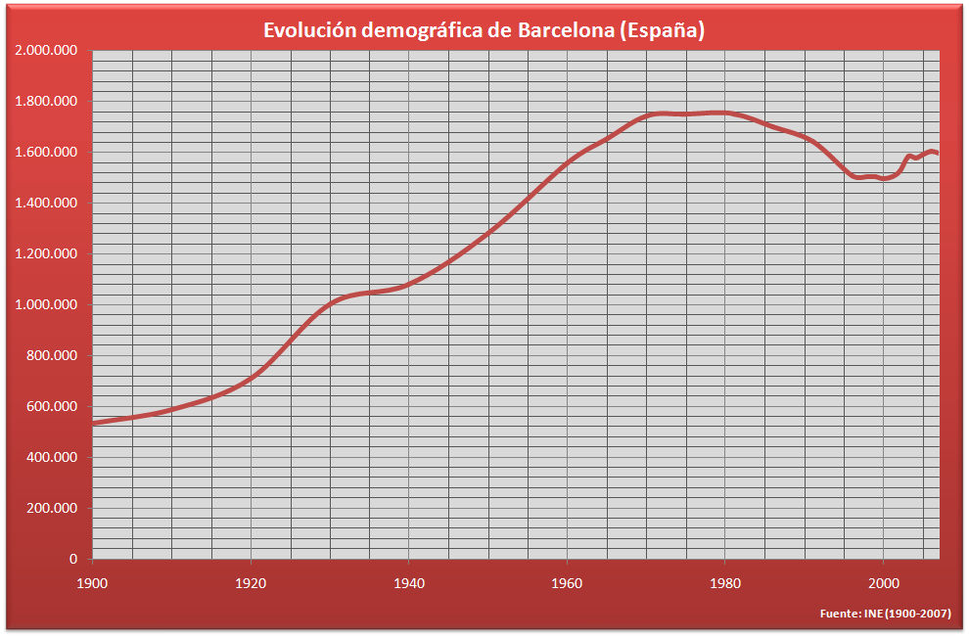

Figure 1 – Demographic evolution, 1900 – 2007, according to the Spanish Instituto Nacional de Estadistica
As Barcelona is the capital of Catalonia, 62% of inhabitants were born in Catalonia and 23,5% are from the rest of Spain. Other 14,5% are from other countries, the majority came from Pakistan, Italy, China and Morocco. For this reason the city has the largest community of Muslims, 322.698 Muslims leaving in Barcelona.
The most spoken language in the city is Spanish, even if Barcelona is the capital and largest city of Catalonia. After Spanish, the second most spoken language is Catalan and it is understood by 95% of the people while only 72,3% can speak it.¹¹

____________________________________________________
¹¹ Departament d'Estadística. Ajuntament de Barcelona (2011). "Coneixement del català: Evolució de les característiques de la població de Barcelona (Knowledge of Catalan in Barcelona)". Ajuntament de Barcelona (in Catalan). Retrieved 13 November 2015.

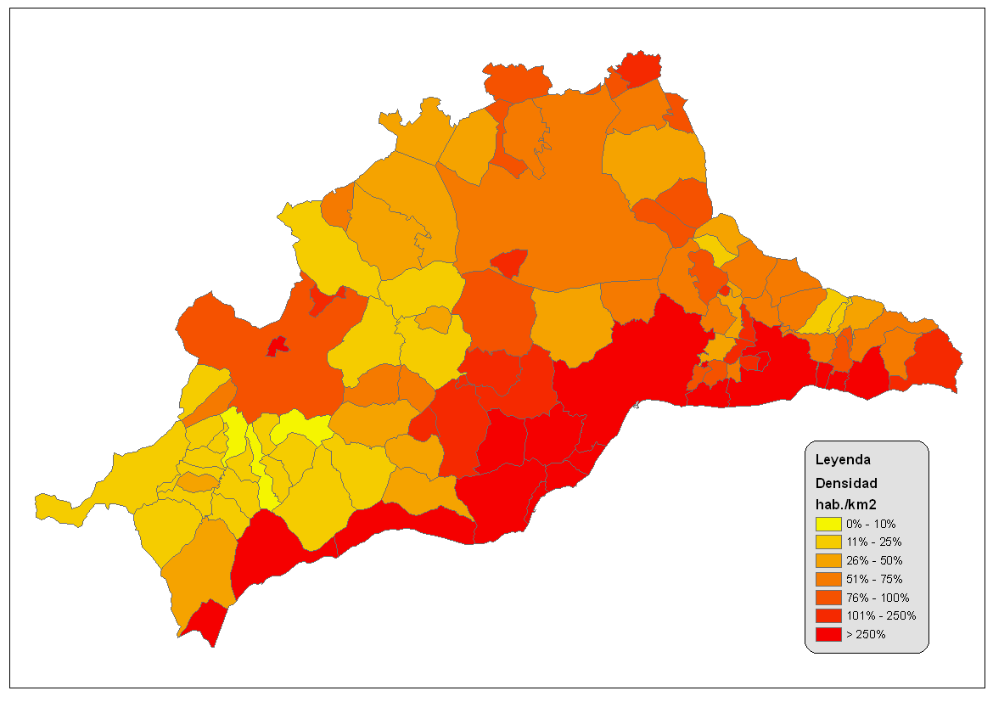
Figure 2 – Barcelona Metropolitan Area Density in 2001

Barcelona in fact is one of the most populated cities in Europe. It was calculated by city council in 2008 that in the 102,2 km² sized municipality there are 1,621,090 people living, that means an average population density of the city is 15,926 persons per square kilometer. The most densely populated neighborhoods contain 57,5% of the population however occupying only 22,7% of the city. Barcelona's most densely lived area is around Sagrada Familia. Here, city's most populated neighborhoods are located next to each other, which population density is higher than 50,000 persons per square meter.

2.3.3 ECONOMY
Catalonia is Europe's one of the richest regions and 66% of the people in Catalonia. Amount per capita in Barcelona is € 28,400 which is 16% more than EU average. According to Global city GDP rankings 2008-2025, Barcelona is 4th most economically powerful city by GDP in the European Union and 35th in the world. Besides, in 2009 Barcelona was Europe's fourth best business and fastest improving European city with growth of 17% per year.¹²
The main sectors of the emerging economy of Barcelona are tourism, fashion, power resources, manufacture and food. Furthermore, Barcelona is well-known for industrial design. It has a lot of trade fair and exhibition centers. The second biggest trade fair center in Europe is located in Barcelona. It hosts a huge number of national and international events each year. The city is known for hosting world-class trade conferences including “Exposicion Universal de Barcelona” in 1888 and Universal Forum of Cultures in 2004. Starting from 2006, Mobile World Congress takes place in Fira Gran Via conference center in Barcelona with attendance of 80,000-90,000 people.¹³
The city's tourism industry started with the 1992 Olympic Games. To host the games the city council had to improve the infrastructure of the city. In order to do that they cleaned the beaches built cruise ship docks, expanded its airport and rehabilitated its neglected Old City. Between 1990 and 2013 the number of annual tourists who stayed overnight exploded from 1.7 million to 7.6 million. The number of hotel rooms grew from 10,265 to 37,069. Now, Barcelona is 12th most visited cities in the world and the third in Europe after London and Paris. It receives 8 million tourists every year since 2012.¹⁴ Furthermore, in 2014 Barcelona was ranked as the most popular city in Spain.¹⁵ Today, about 14% of Barcelona's economy is accounted by tourism.
One of the main industries that generates 21% of the total gross domestic product (GDP) is manufacturing sector.¹⁶ Barcelona has 67% of the total number of industrial establishments in Catalonia. For a long time Barcelona has been one of the most important European automobile manufacturing center.
______________________
¹² "Best European business cities". City Mayors. 28 October 2009.
¹³ GSMA Mobile World Congress
¹⁴ Bremner, Caroline (2011). "Euromonitor International’s top city destinations ranking".Euromonitor International.
¹⁵ "Best Spanish Cities". Gospain.about.com. 25 March 2014.
^{16.} "Valor afegit brut a preus bàsics. Base 2000 Per sectors (%)" (en: "Gross value added at basic prices. Base by sector (%) - Idescat, 2008

The largest Spanish automobile manufacturer SEAT, has it headquarters located in Barcelona metropolitan area. There are also factory of Nissan and Derbi, a large manufacturer of motorcycles. Today, the manufacturing sector is overtaken by service sector, however it remains very important.
Barcelona is also a major fashion and textile center. The activity of the textile and clothing industry holds a prominent weight in the Catalan economy, accounting for 4,4% of Gross Value Added and 7,3% of the employment of Catalan Industry. Barcelona hosts a lot of world-famous fashion events one of which was Bread & Butter urban fashion fair. The fair brought €100 million to the city in just three days.¹⁷ According to the Global Language Monitor's annual ranking, in 2012, Barcelona was chosen as the third most important fashion capital of the world's top fifty fashion capitals.¹⁸

_________________________
¹⁷ Leticia Blanco (20 January 2009). "La feria de moda urbana Bread and Butter deja Barcelona". El Mundo.
¹⁸ The Top Global Fashion Capitals for 2012 – The Global Language Monitor, 2012
2.4. LOW COST ACCOMMODATION IN THE WORLD

2.4.1. HOSTELS
Hostels are the most well-known cheap accommodation type among budget tourists. Hostels provide budget-oriented, sociable accommodation where guest is renting a bad in a dormitory and with shared bathroom, lounge and kitchen. The dormitory can be mixed or single-sex. Sometimes hostels can provide the guest with private rooms. Most of the hostels in the world are self catering do not have the same formality level as hotels.
The independent hostel industry are growing very fast in the main touristic cities such as New York, Miami, Buenos Aires and Paris. The development of independent hostels in the world is count as a strong business model. A lot of hostels in the different cities of the world are reporting a higher average income per room that in hotels. The main idea in the hostels is running by occupancy numbers. The example of the city Honolulu, Hawaii shows that average hotel room cost is between $141 to $173, while an average hostel room in the same city in the same season reports $200 per night.¹⁹

___________________________
¹⁹ CNN Story

Even if hostels were considered as low-quality accommodation type for less-wealthy tourists, studies show that in average a guest in hostel is spending more than a guest of hotel due to his longer stay. According to Australian study, low cost tourists facilitate almost $3.4 billion and stay an average 34,2 nights.²⁰
Every year the association of Youth Travel Accommodation reveals a review of the business operations of the hostel sector. The study is made in partnership with Hostelling International and Web Reservations International. The study of 2010 includes:
- Average occupancy rate is 56%
- Occupancy level is higher in Asia
- The sale of beds is contributed for 70% of total revenue, and F&B sales 14% of revenue
- The average bed in hostel costs €21 in high season and €15 in low season.
- The main cost for hostel establishments are staff and premises, and together are accounted to 45% of total expenses
- Marketing cost is only 10% of the total budget

________________________
²⁰ International Backpacker Snapshot – Destination NSW
The study shows and confirms the strong model of hostel business. High occupancy rate and low level of expenses makes a big profit for hostel stakeholders

2.4.2. ONLINE ACCOMMODATION PLATFORMS: AIRBNB
Development of technology shows itself in every industry of world. It has a huge effect on tourism, as well on budget tourism. In our smart-phones we can easily access to different websites and download various applications. One of the most famous website of last decade in budget lodging is Airbnb. It is a website and also an aplication platform that helps travellers find accommodation. It is founded in 2008 in San Francisco, California.
Airbnb runs on the market place platform model where it helps to connect host with traveler. On its database it has more than 1,500,000 in 34,000 cities and 190 countries.
In every city that Airbnb is launched, it has a lot of positive impact on the economy of the city and country. In the las 2-3 years, Airbnb group accomplish different studies about the economic impact of the program activity in various cities of the world. One of the main ideas of the Airbnb, is not only connect hosts with travelers and provide them with lodging, but also give the travelers unique experience of being a tourist and living as local. Because, nowadays tourist does not want just visit touristic sights of the city, they want to see the city as a citizens and local. Study shows that 91% of the tourists wants to live as one more inhabitant of the city, and 79% of the travelers want to explore the specific neighborhood. Furthermore, Airbnb travelers accommodate longer than a normal guest in the hotel and they they spend more in different neighborhoods of the city. The duration of the Airbnb tourist staying and spending is 2,1 times more than a normal tourist. As a fact 74% of the tourists using Airbnb to accommodate are staying in out of the main touristic zones and 42% of them are spending money in the same neighborhood that they are staying.²¹
Besides that, Airbnb hosts in all over the world are getting a huge benefits from sharing their living places. The same study that was done on hosts of Airbnb shows that 52% of hosts have medium or low income. Also, 53% of hosts, by renting out their rooms could pay for their monthly rent and could stay in their apartments.²²
However, nowadays Airbnb is facing legal troubles in most of the cities of the world. Airbnb as an online platform allows individuals to rent out their homes or rooms. While this is not illegal, in many cases the rental that are advertised on this platform do not suit to local housing laws and regulations. In most of the cities, an owner cannot rent out the apartment for short periods unless he is leaving also in the property. Unsurprisingly, the hotel industry are also against Airbnb, as it makes it easy for travelers to find cheap accommodation. Economist reported that in 2016 Airbnb will take 10% of hotel takings and it is enough to send many businesses under.
__________________________
²¹ https://www.airbnb.es/economic-impact
²² https://www.airbnb.es/economic-impact
2.4.3. HOSTALS
Hostal is a new term that a lot of people most probably have not heard about it. However, tourist that travels to Spain or Hispanic America can face with this new term in tourism. Hostal is a type of lodging that is mostly found in Spain and Hispanic America. It is a concept of low cost hotel, without any level of stars. Normally, hostals have bar, restaurant of cafeteria where they serve food and beverages not only to guests of the hostal but also to locals.
This type of accommodation typically includes small private bedrooms, or in some cases apartments either for long or short time period. Sometimes, the bedrooms in hostals does not have private bathroom, so the guest should share the bathroom with other hostal clients. In some hostals there could be two or more different categories of rooms, some of which could have private bathroom in the bedroom. Linens and towels are usually provided by hostal, however not all hostals provide everyday cleaning and changing bedsheets and towels. If it is long stay, guest might be provided by cleaning after some period of staying in the hostal. Usually it is 3 or 4 days. Depending on the price and room type, some hostals might provide guests with small breakfast or half board.
Hostals are very common in Spain and also in Mexico, Central and South America and California. Often, they are family-run, independent businesses with a strong involvement with the local community.
Hostals are accommodation type between hostel and hotel. The main difference from the hostel is that, while hostels are providing shared accommodation type, usually in dormitory with 6 and more people, hostals are providing private bedrooms and in some cases bathrooms. In case of Mexico, for example, a hostal is just a spanish word for hostel, however in these hostals they can provide both dormitories and private rooms. This type of lodging is ideal for backpackers, youth and those travelers with little funds of accommodation.
Hostals are classified from one to three stars, unlike the hostels which are not classified under the star rating. It is also different from hotels, which have different stat classification from one to five stars.

2.4.4. OTHER CHEAP ACCOMMODATION TYPES
Besides of already mentioned above, there more different longing types that can help a traveler reduce the cost of the trip. One of the most common one is new trend in tourism sector, which is hospitality exchanges. It is one of the best ways to get free accommodation and to obtain that a traveler should find someone who lives where he or she is going. This kind of lodging are not only saving accommodation cost for 100%, but also gives a chance to tourist live a local life, meet new people and get information from the city locals.
When this kind of lodging started to be more famous among low cost travelers, there started to appear new website and applications that helps host find tourist and other way around. One of the biggest successful in this type of accommodation is couchsurfing. It is world-wide company that puts hosts and travelers together in one website, where travelers can achieve their goal: find free accommodation. The goal of the site is not only to help travelers to save money on accommodation but also learn about the culture by being able to stay and interact with a local.
Couchsurfing International Inc. was formerly a nonprofit organization registered in the U.S. Nevertheless, in August 2011, Couchsurfing announced its change of status to a for-profit corporation. Before site was functioning by volunteer investments which contributed $15 million. However, after its liquidation the company that its assets where sold start to apply an annual fee of $25. Explaining this with the safety, as by doing this they can verify the access to members credit card and other information.²³
One of the most common but least comfortable accommodation type is camping. Depending on the city and its camping facilities and season, tourist can set up a camp without any charges from the government in most cities of the world. It is an outdoor recreational activity. Generally held, it is more for nature and outdoor time spending to provide the enjoyment. Camping became popular among elites in the early 20th century. Tourist can use shelters, tent caravan or other primitive structure.
There are different forms of camping in the world. Even if the idea of camping was created as a nature recreational tourism type, nowadays there more than 25 different camping types. One and main of them is urban camping. Although, it is not comfortable and joy-giving accommodation type, it is one of the cheapest lodging type.
________________________
²³ "One Couch at a Time". Couchsurfing

Urban camping is very popular among budget travelers and backpackers. Campers have their own website, where they can get advice over which city to visit, the city's camping facilities and legal aspects of it. The definition of urban camping is “camping in an urban setting by sleeping on rooftops, under bushes and in public parks”.²⁴ One of the mainstreams of the urban camping nowadays is a card tent camping. Travelers are setting a car tent on the free parking places and spend night inside the tent. It is rather ingenious approach to urban camping. Instead of hiding in a park or making up excuses in a public location, car tent users can camouflage themselves right in plain view. These car tents are designed to look like a car cover, so travelers can go camping in the city without being disturbed. This type of camping is now popular in biggest cities in the world, like New Year, Los Angeles, Paris, Tokyo and etc.

____________________
²⁴ http://weburbanist.com/2007/09/28/urban-camping-subversive-city-living-from-times-square-to-the-car-tent/

2.5. LOW COST ACCOMMODATION TYPES OF BARCELONA
2.5.1. HOSTELS IN BARCELONA
Hostels in Barcelona are on of the most well-known budget accommodation type. However, in most cases hostels are confused with hostals in Spain. This causes because of the new Spanish low cost accommodation type of hostal, which is slightly different from usual hostels. According to the booking engine sites as booking.com, hostelworld.com and “Instituto Nacional de Estatistica” there are approximately 100 official registered hostels. They offer about 9.274 places. The main difference between Spanish hostels and normal hostel definition is that in most of Spanish hostels there are private rooms available. Hostels in Barcelona are famous among youth, students that are visiting the city for a short period of time. Nevertheless, generally taking, hostels in the city are less popular than hostals. And the reason is not only in price and establishments, also the benefits a traveler gets by staying in hostal. The medium stay in hostels of Catalunya is 2.34 nights per traveler.²⁵As in most of the cities in the world, hostels in Barcelona are located mostly in the city center and are accessible from public transport.

__________________________
²⁵ http://www.ine.es/daco/daco42/ocuptr/eoat0215.pdf
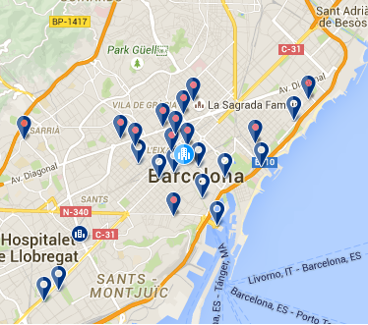

Figure 3 – Barcelona hostel maps for January 2016
Hostels are a type of accommodation that only five years ago had no hollow in Barcelona. And now due to the fall of other property uses such as residential property and offices, is and attractive outlet for local and international investors. This was a chance to flourish also for illegal operating hostels. It is now emerge situation in Barcelona as it is estimated that for every one legal hostels, there are two illegal.
The major growth in hostel development was produced between 2011 and 2012, when it was authorized of creation of 21 new hostels which were offering between 3.435 and 5.133 places, according to the data of “Concell Comarcal del Barcelones”. Although there are a lot of hostels functioning illegal, there are still more capacity in Barcelona to have more hostels. The same situation is happening with 1 or 2 star hotels. Where according to “Barcelona Turisme” only 9% of the places and rooms are corresponding to this segmentation which will be explain further in the article.

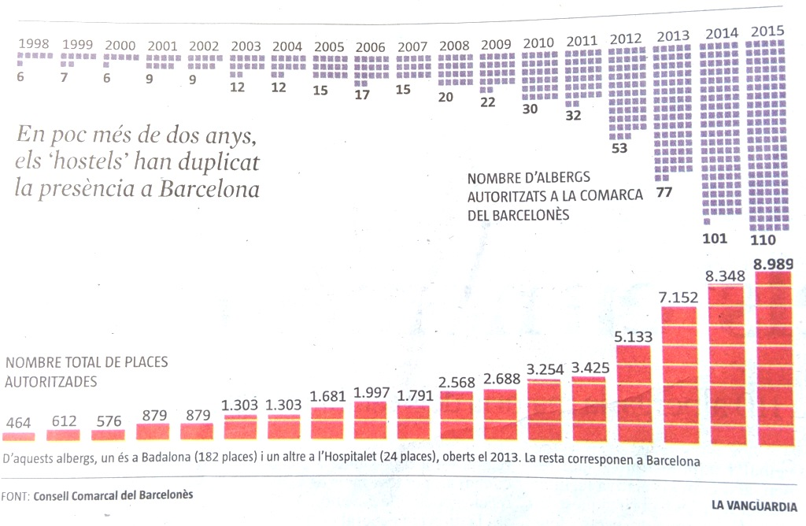

Figure 4 – The evolution of hostels in Barcelona

In future two years, Barcelona again doubled the number of hostels between 2012-2014. As we can see from the map above, most of the hostels are situated in Eixample. In total Barcelona is offering 9.000 places in those 110 hostels, from which 182 places are in Badalona and other 24 places in l'Hospitalet.
The rest is corresponding to Barcelona.²⁶
Barcelona, and generally speaking Catalonia has a big problem of regulation the authorization as well as the price management of the hostels. Although it is possible to find a bad in hostels for 9 euros a night in a low season, in a high season it is hard to control all prices as most of the hostels are not even registered as official hostels. For that reason, prices in high season, which in Catalonia is staring from May to September (both included), prices can rise up to 25 euros. Which is very expensive for a bed in 8 or 10 bed dormitory. To compare, it is possible to find a hostal with private room for 60-70 euros per double room.
The main reason for that could be that the hostels in the city are not regulated by the government of Catalonia. It is regulated by Consell Comarcal del Barcelones. Generalitat de Barcelona is looking forward to get the right and regulation on their hands to start applying a touristic tax. The idea of the government is to start hunting for illegal establishments and regulate price management of the city. Nevertheless, most hostel owners are not agree with this idea of taxation. As a fact, they are insisting to not be considered as touristic establishment and pay taxes. If a low cost hotel pays 0,50 euros per person per night, and there could be 2 people for the room, hostels owners are disagree by saying that for the same surface of the room they have 8-10 places which means more taxes per night per person. However, government is sure that this politics will help them regulate the market and also get some financial benefits from tax application.
_____________________
²⁶ http://infoturbarcelona.com/2015/06/01/barcelona-dobla-el-numero-de-hostels-en-dos-anos/
2.5.2 AIRBNB
Airbnb, the world-wide known accommodation platform is also famous in Barcelona. According to the company InAtlas, for november 2015 there are now 22.442 apartments that are registered in the website. These amount of apartments are offering 84.192 beds. The experiment that was held in the weekend of 17-18th of October2015 which is low season in Barcelona shows 14.510 active apartments or 54.942 beds active available for the weekend. The occupancy rate for selected weekend was 82,46%. This amount is very high for low season weekend.²⁷
We suppose it is very good index for Barcelona's tourism and economy however here Barcelona is facing the same problem as with other low cost lodging type – illegal. The analisys of all offers on Airbnb shows that 64% of all listed properties are illegal. Several years before when Government of Catalonia decided to starting regulating the amount of inbound tourists because of multiple meeting of protestors in the street. Locals are against illegal touristic apartments as tourist are disturbing locals. To somehow make the situation clear the government decided to apply a touristic tax for tourist apartments. This taxation form also affects Airbnb and other this kind of websites. According to Hostelsur, Generalitat de Catalunya is now opened the conversation with the Airbnb company. The main topic of this conversation is that the government wants the company to add an extra cost as a tax for staying in the city as it do all hotels in the city.
_____________________________________________
²⁷ http://www.inatlas.com/
In 2014 the Catalonia government has levied a €30,000 fine against Airbnb, claiming the popular international flat rental site that the site was advertising illegal rentals. While for US-based company it is not a big fine, Catalan government is threatening to block the site in Catalonia.²⁸ Which will definitely cause a huge problem.
Starting from december 2015 Barcelona city hall has started sanctions against Airbnb and HomeAway for publishing rentals without the registration number of Catalonia government. Government also applies sanctions against touristic apartments without proper license for use. In both cases the fine is €30.000. The district that is most famous for illegal apartments and most complains from local community is Ciutat Vella. There, Catalonia government found 300 apartments without license. Most of the apartments were registered on the Airbnb website. The other part that is against Airbnb are local hotels. 10.049 place of accommodation are equal to 54 hotels in Barcelona. To calculate it we divide touristic lodging to followings:
- Share rooms = 59
- Private rooms = 3.685
- Private apartment = 6.305

_____________________________________________
²⁸ http://www.spanishpropertyinsight.com/2014/07/07/catalonia-launches-attack-airbnb/

It is necessary to note that a hotel in Barcelona on average has 94,3 rooms, that corresponds for 185 places or beds according to “Gremio de Hoteles”. So, 10.049 beds that are registered in Airbnb are an equivalent to 54 hotels.
The average price of touristic apartment listed on Airbnb in Barcelona is similar to the reservation in the hotel of 4 starts category.²⁹ The medium price for the apartment on the platform is €99 per night. To rent a room, the price is from €15 to €25. According to travel portal GoEurope, Barcelona is ranked 45 on the list of most expensive cities in Airbnb. The leaders on this list are Boston €220, New York €185 and Dubai €181.
Besides all these bad stories happening to Airbnb in Barcelona, there are a lot of benefits that the company bring to the city.

In early 2014, Airbnb completed a study of the economic impact of its hosts and guests in Bacelona. This study found that Airbnb generated $175 million in economic activity in Barcelona in one year alone and supported more than 4,000 jobs.

_______________________________________________
²⁹ Informa La Vanguardia

As in any other city, Airbnb supports local resident and neighborhoods that do not benefit from tourism, boosts local economies and connects travelers to authentic experiences. Ninety-six percent of Airbnb guests are looking for a chance to live like a local. The same study also found that Airbnb is an important source of income for local resident who use the platform. 75% of all Airbnb hosts in Barcelona earn at or below Catalonia's average household income. The majority of hosts use this money to pay their ills and stay in their homes. Airbnb is also attracting new tourists to the city. 61% of the platform guests in Barcelona were visiting the city for the first time. The average Airbnb guest is staying 2.4 times longer and 2.3 times more money compared to typical tourists. As it was mentioned above, Airbnb is helping hosts to earn money to pay bills and stay in their houses. Host spend 60% of their Airbnb income on important household expenses. 53% of all hosts reported that the earning from Airbnb helped them to stay in their homes.³⁰

____________________________________________
³⁰ https://www.airbnb.co.uk/press/news/new-study-airbnb-community-contributes-175-million-to-barcelona-s-economy
In conclusion, Airbnb has both good and bad influence on the city. Airbnb definitely has a good influence on touristic economy of the city by generating more than $175 million in economic activity. On the other social side, most of the establishments listed on the platform are illegal, which causes the loss in economy point of few, and the biggest problem is protests of local neighbors to noisy, dirty touristic apartments.

2.5.3. HOSTALS
As it was mentioned before in previous chapter, hostals are typical Spanish countries creation. Although this type of accommodation is crossing the borders for other different touristic destinations in the world, the origin of this lodging type is coming from Spain. Basically speaking, hostals are very low cost lodging establishments that are offering private bedrooms with shared or private bathroom. In Barcelona, inbound tourist can easily notice hostal signs in the streets. Spain is using this kind of accommodation a lot. However, it is official type of lodging, there are no official records about amount of hostals in the city or other statistic information. Usually this type of lodging is mixed ether with hostels or with low cost hotels. Also the name hostal could be replaced hostel when hostel has some private rooms to offer. However the biggest difference is that normally hostals are offering only private accommodation. These hostals mostly have between 15 to 25 double rooms. They are much smaller than regular hotel room and has less facilities. The rooms could or could not have air condition. The design and the room furniture is simple. Rooms contain beds, clothed and a table with a chair.
Statistics of hostels, hostals and pensions are counted together in Barcelona. According to Ajuntament de Barcelona, starting from 2003, the number of places in these category started to decrease. Barcelona City hall explains it as a consequence of category changing. A lot of hostels and hostal were converted to superior category since 2003. Later starting from 2013 the number of hostel and hostals stared to raise again and currently stopped at the point of 268 establishments in september 2015. In total they offer 6.036 beds.³¹
Hostals are one of the most famous choices for low cost tourist in Barcelona. Although, all low cost accommodation types, hostel and hostals with 1 or 2 star hotels are only 9% of the all accommodation types in Barcelona. The price for double room in average is between 50-60 euros in low season, and between 60-75 euros in high season. The reason because this type of lodging is famous in the city, is the lack in cheap 1-2 star hotels. Especially in high season, even the prices for low category hotels are raised too high for the facilities and quality of service that they are offering.
Hostals can be one of the most efficient ways to develop low cost accommodation type and regulate establishment from the legal point of view. Of course, as it was mentioned before that there are two illegal hostels for one legal in the city.
_____________________________________________________
³¹ http://www.hosteltur.com/113808_radiografia-alojamiento-barcelona-hoteles-pisos-turisticos-albergues.html
And there are no doubts that there are also some illegal hostels functioning in the city. Of course affects the economy and quality of the service. The development of the hostals, and the recommendations will be provided in the section with research and future recommendation for provide better service and develop hostal sector.

2.5.4. TOURISTIC APARTMENTS
Touristic apartments, or apartments for touristic use is one of the most well-known accommodation type in Barcelona. During the last ten years number of places in hotels has been grown and in September 2015 reached 68.444 places. Nevertheless, the places that are offered by the touristic apartments has been grown with even faster rhythm. For September 2015 there were 41.000 official registered places. This rapid growth was noted since year 2004. This boom in growth of touristic apartments are not disturbing only hotel that are functioning in Barcelona, but also the local communities and neighborhood.
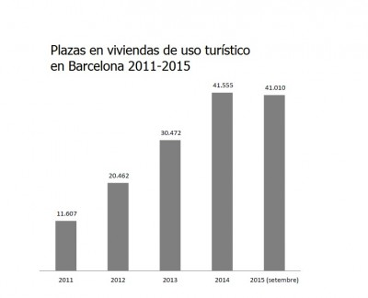

Figure 5 – Beds(places) in tourist apartments in Barcelona, year 2011-2015
As demand on tourist accommodation is raising every year it is normal to see a growth in hotel beds. But what is more surprising is the rapid growth in supply of touristic apartments. If we compare the evolution of growth of hotel beds and beds in touristic apartments we can easily notice that in four years the offer of beds in tourist apartments grew almost for 30.000 beds. In 2011 after financial crisis in the world, as well as in Spain which affected badly to Barcelona's tourism, the bed number in touristic apartments were 11.607 beds. For September 2015 this number is 41.010.

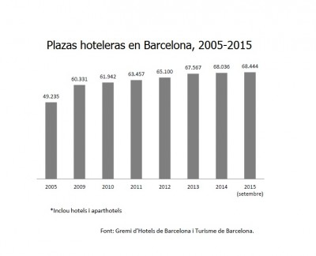

Figure 6 – Hotel beds (places) in Barcelona, year 2005-2015

Meanwhile in the evolution of hotel bed growth is slow. In the same four years the was increase in hotel bed number only about 5.000. Does it mean less demand to hotel beds, or less development and investment on this sector?
There is also an important thing noticeable from the chart. The difference between year 2014 and 2015, where in last year the number of beds of tourist apartments are decreasing. This is curious because logically the number should increase. The explanation to decrease of beds in touristic apartments is that since 2014, Barcelona city hall started to think about a slow down in inbound tourist amount. Their decision was encouraged from increase of illegal accommodation establishments, protests critical disagreement of locals and also some financial loss. While receiving almost 8 million guests last year, there was a lot of capital lost and the reason to that are illegal established touristic accommodations. Another main reason came from Barcelona City Hall was that the last two year the city is receiving much more tourists that it should receive. The amount of inbound tourists is now almost 8 million a year. Which is a lot for the city with 2 million inhabitant. So in order to somehow stop or slow down these negative actions tourism department of City Hall Barcelona decided to stop giving license that allows businessmen establish new tourist accommodation type. By doing this, government was planning to scan all establishments that already are in the market, and eliminate illegal establishments and check if all norms are followed in those tourist lodgings. In future 2 year Barcelona City Hall is planning to check all establishments and start giving out new licenses that allows investors open new tourist lodging.

2.5.5. LOW COST HOTELS
Barcelona is receiving millions of tourists every year from all over the world. As in most touristic destinations in the world, the main accommodation type for those tourists are hotels. Hotels of different level and service for different segmentation of the market. In Barcelona there are 373 establishments of hotels of different level. These all establishment offer 68.036 places or beds. These hotels are segmented for various segment of service they are providing. Star classification in Barcelona is the same international hotel rating from one to five star hotels.
However, the main problem of the hotel market in Barcelona is the main topic of this thesis. The hotel classification proportion is very unequal. Barcelona has an image of the business city, city that receives many conventions and international meetings. According to “Barcelona Turisme”s almost 40% of tourist that arrived to Barcelona in 2014 came for professional purpose. Even if the majority of the tourists are visiting Barcelona for leisure, most of the hotels are business related and luxury hotels.³²
From all of the 373 establishments in Barcelona only 9% are corresponding to 1 and 2 star hotels, which makes it difficult for low budget tourist. Most of these hotels are not providing professional work, and have wrong price management.
Together 1 and 2 star hotels are offering 3.273 places of beds. To understand how small this amount is we can see that only 5 star hotel segmentation has almost 5.000 beds. Often these kind of low cost hostels are confused with hostals. However, hostal does not have international star rating as hotels and should have less level of service and facilities.

__________________________________________________
³² Barcelona Turisme

To conclude, the segmentation of hotels is very poor developed in Barcelona. Main investments and attention is on luxury 4 and 5 star hotels, and low cost hotels are left without proper treatment. Further in this thesis, this problem will be discussed and will be proposed recommendations and solutions in order to change current situation in accommodation market in Barcelona.

3. BUSINESS AND ENVIRONMENTAL ANALYSIS OF LOW COST ACCOMMODATION IN BARCELONA
3.1. INDUSTRY EVALUATION
3.1.1 ECONOMIC IMPACT OF TOURISM IN BARCELONA
The tourism and hospitality industry is one of the main pillars on the Catalan economy. Specifically, in 2014 tourism in Catalonia accounted for 30.2% of GDP. Thus, Catalonia and especially Barcelona are tourist destination with a very diverse cultural heritage that attract millions of international and national tourists each year. Although sun and beach tourism had traditionally been promoted in Barcelona, the appearance of new international destinations that are competitive not only in costs, but also in tourism offer such as the Adriatic Coast in Croatia, which offers identical climate and coastal tourism services, has promoted a diversification of the Catalan tourism offer. In the regard, the promotion of the cultural, natural and gourmet heritage of Catalonia brings with it a rise in urban and business tourism, rural and Eco-tourism, all of which have became more important within Spanish and Catalan tourism sector.
Statistics shows that Barcelona city was visited by 7.874.941 person in 2014.³³ It is 4% more than the tourist number arrived in 2013. It is also approximately 4 million more people than in year 2000. Barcelona has received 79.5% of international tourist and only 20.5% of Spanish tourist. As was mentioned above tourism has a great influence on the city especially from financial point of view. Barcelona was gaining €25 million every day from tourism.³⁴
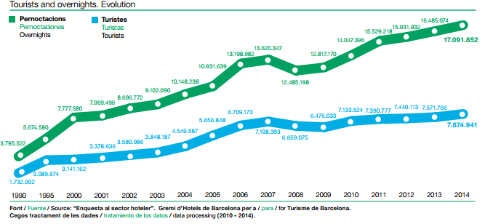
Figure 7 – Evolution of inbound tourists and number of overnights
_____________________________
^{33 “}Enquesta a sector hoteler” Gremi d'hotels de Barcelona
³⁴ NSETUR (Universitat de Girona) for Barcelona City Council (2012 and 2013) and AQR (Universitat de Barcelona) for the Pla Estratègic de Turisme de la Ciutat de Barcelona (2007)
From the graph above, it is noticeable that Barcelona is living its growth period as a destination product in the product life cycle. Tourist numbers are growing every year since the time when Barcelona was introduced to the tourism market as a destination for leisure. We can also see slight decrease between 2007 and 2009. These period is corresponding to global financial crisis which affected Spain badly, and only in the beginning of the 2015, Spain officially announced that it totally recovered. However, after 2009 we can see already a growth in tourism flow which is growing every year after 2009.

3.2.1 SEASONALITY AND OCCUPANCY
An important feature of tourism in the Mediterranean coast is its strong seasonality. Most tourists travel during August and less than 40% of all arrivals are registered in the peak months of July, August and September. Such a strong seasonality dictated by weather, gives rise to main problem:.The need to optimize the use of tourism infrastructure such as roads to accommodate high flows during the summer, and redistribute tourist flows to reduce the risk of high unemployment during the rest of the year.
These issues are well-known in Barcelona, as being one of the most famous summer tourism destination on Mediterranean coast. The season of massive tourist flow in Barcelona starts in the end of April and in the beginning of May. However, as the weather is a dictator in this role, everything depends on weather. Thus, every year weather is good enough to tourist flow begin in May. Occupancy rate of accommodation types is increasing, city streets are getting busier and more crowded.
The chart beyond shows the seasonality of tourists in past 3 years. It is noticeable that the seasonality of all three years is almost equal. Starting from October tourist flow is decreasing sharply. This continues until the end of February. Starting from March the number of inbound tourist is starting increasing slightly. As the weather is getting warmer and better, tourist amount arriving to Barcelona is increasing also. From that we can note that the weather and inbound tourist number are in direct relationship.

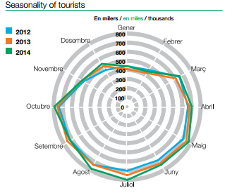
Figure 8 – Seasonality of tourists for year 2012,2013,2014
It was mention above that Barcelona is a destination of beach, sea season. Which in Spain is summer months. Even if Barcelona is now trying more or less to equalize their occupancy and tourist flow with other events, still the most tourist flow to the city begins in the summer.

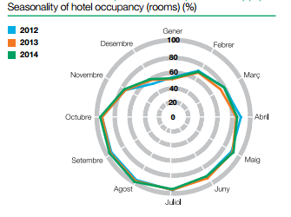

Figure 9 – Seasonality of hotel occupancy in Barcelona
As it is shown on the chart for last 3 years the occupancy of the hotels are less than 60% starting from November until beginning of February. It is really hard period for most of the hotels as it is a period when all touristic related industries suffer from lack of revenue and profit. However, most of the hotels
Of course the global financial crisis affected not only tourism flow to Barcelona but also occupancy rate in hotels.
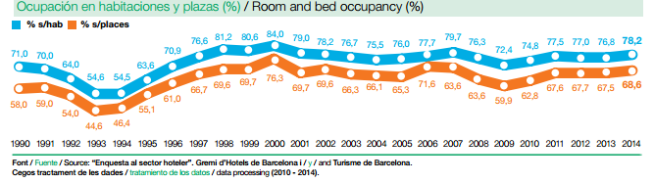

Figure 10 – Evolution of room and bed occupancy
As in previous chart, here it should be noticed the decrease in occupancy in hotels in the period of global financial crisis, Thus, most interesting fact on this chart is that after crisis occupancy rate cannot recover and cannot reach even 80%. This could be easily explained with a development of other accommodation types in the city as hostels, hostals and especially touristic apartments.
Statistic shows that the average hotel stay in 2014 is 2.7, and it is a smooth decrease after 2.18 in 2013. The most occupancy rate is shown in 3 star hotels and also the average hotel stay in hotels of different category shows 3 star hotels being on top. The average stay in hotels is also in direct relationship with seasonality. As in summer months average hotel stay is approximately 0.6 more than in non-seasonal months of the year.³⁵
______________________________
³⁵ http://professional.barcelonaturisme.com/imgfiles/estad/Est2014b.pdf
Despite this, the statistic for apartments and guesthouses is totally different from the statistics of the hotels. It was a decrease in tourist numbers accommodating in hostals and guesthouses, -2.5% in compare with year 2013. This could be explained not as a reason of less interest for hostals and guesthouses, but opposite, actual overnights for hostals and guesthouses are 10% more than previous year. The decrease in tourists numbers lodging in those accommodation types can be explain with a decrease in numbers of establishments in these category. As Catalan government and Barcelona city hall started strong and strict policy against low cost accommodation types, government is checking all licenses and establishments if they response to the rules that are presented by government. Yet, the average stay in hostals and guesthouses is more that in hotels, 2.78 nights.
The same policy was applied for touristic apartments are there were enormous number of touristic apartments growing every year. But, it did not affect touristic apartments the same it affected hostals and guesthouses. There was an increase in tourist staying in touristic apartments by 0.6%, and also 5.9% increase in overnights.³⁶ The strict regulation by Barcelona City Hall did not affect also the occupancy rate of the touristic apartments. The occupancy rate of the apartments is very close to occupancy rate of hotel rooms, 74.5. It is very high index for touristic apartments, especially when more than half of them are illegal.

___________________________________________________
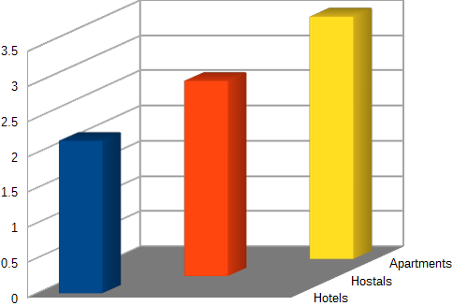
³⁶ INE a partir de la “Enquesta d'ocupacio en apartaments turistics”

Figure 11 – Comparison of average stay between hotels, hostels and tourist apartments
Despite all of this in compare the average accommodation stay in different lodging types it is quiet noticeable that the average stay in touristic apartments is much higher than in hotel,
3.45 when the average stay in hotels is only 2.17. The result of these statistics provided by annual touristic report of “Barcelona Tursime”, it confirms the study made by Airbnb Co. where researcher discovered that tourists staying in apartments are staying longer and spends more money rather than a tourist staying in the hotel. Hostals are in the middle and average stay in hostals is 2.78 which is much higher that in hotels. The future analysis and development of hostal type of accommodation will be the result of increasing the average hostal stay and the financial profit for the government.

3.1.3. MARKET ANALYSIS – POTENTIAL IN FIGURES
In order to make a market analysis of the hostal accommodation type in Barcelona will be used 2 different ways for analysis already existing and potential market in case of further development of this accommodation type. First tool for analyze the market will be TOWS analysis. By using this tool issues in existing hostal market will be more clear. The next tool to analyze the market will be Porter's Five Forces. Porter's Five Forces are better and developed market and business analysis tool that helps to examine the market more deeply.
TOWS
This well-know classic business tool helps to analyze the external environment (threats and opportunities) and internal environment (weaknesses and strengths). These techniques can be a good tool to think about the strategy of whole organization or business. It can also be used as a process, a marketing campaign. TOWS analysis will help to understand better the strategic choices that the business is facing. The original and more well-know variant of this analysis is SWOT analysis. However, after a small research and studies of professors in university it has been decided that focusing on threat and opportunities first helps lead to productive discussion about what is going on in the external environment rather than getting bogged down in abstract discussions about what a company is good or bad at. Following this advice for development and analysis of market in hostal accommodation type external factor of the market should be analyzed first. Existing market nature and competitiveness of the market and other external factor should be examined. To do that analysis should start with point out factor of threats and opportunities of the existing market. After accurately checking external factor, internal weaknesses and strengths could be analyzed.
THREATS.
In the external environment of Barcelona's touristic accommodation, for accommodation type as hostal there are different kind of threats that might affect the development of hostal business. The first and one f the main threats of the hostal business is the rising competitiveness of different kinds of accommodation types in Barcelona. There are a lot of different legal and illegal accommodation types which stand in competition against hostals. One of the most famous and technologically developed accommodation type is a touristic flats that regular tourist can book through various internet platforms and websites. In modern society and technology development it is one of the easiest and comfortable ways to accommodate in any destination. Websites as Airbnb or HomeAway are direct rivals for hostals. Also for now well-know touristic flats, even if most of them are illegal rented. Besides, being illegal gives the opportunity to tourist as well as to landlord to avoid the taxes and documentation which is beneficial for both sides as the price is satisfactory. Also, the factor that hostals are not famous in non-Spanish destination. As it was mentioned before, hostals are new accommodation type mostly known in Spain and Latin America. People usually confuse hostal with hostel, thinking that it is other type or the name hostel in Spanish. However, there are a lot of differences between hostals and hostels. Recognition of the difference between hostel and hostals by tourists might take a long time. In order to do that, promotion of this kind of accommodation, benefits and main differences between hostel and hostal should take place widely on international websites and tourist portals.

OPPORTUNITIES.
Despite all threats that were listed above, there are more opportunities in external environment of Barcelona's accommodation market. Hostals could be Barcelona's main substitute for illegal touristic apartments. Investment and development of hostals will show their legality. Besides that, as the government is now more strict against touristic apartments it could be a chance for hostals to get more market share in local accommodation market. It might be slightly more expensive than touristic apartments, however, there will be more services provided. One of the main opportunities for the government will be the financial benefit from hostals. The legalization and tax application for this accommodation type will reflect on the budget of the government. Development of hostal accommodation type will be also a solution for one of the main social problem of the city. Thousands of people are protesting every summer against illegal touristic apartments. Neighbors are complaining about the noise of drunk tourist, increase in pollution in different neighborhoods which is disturbing local community. By investing and developing hostals, government would be able to control the percentage of accommodation types in different neighborhoods, control the establishments of this accommodation type. By normalizing the amount of tourist establishments in various establishments and spreading the same amount to each neighborhood, government could obtain a satisfaction of local communities.

WEAKNESSES.
The weakness of hostals as an accommodation type could be a lot of shared territory. Even if, it depends on the each establishment, most hostals have shared bathrooms, kitchens and common areas. Which might be a weakness for tourists who want more private space which local apartments could give them. Not being popular between inbound tourist might be another weakness for hostel, nevertheless, this weakness could be solved by time and promotion of this type of accommodation. Another weakness of this accommodation type is that hostals as well as hostels are known to be more for young generation. However, this statement could be doubted as hostals have hotel like private rooms not only youngsters but also adults are accommodating in hostals. The image behind hostals might be considered as it was with low cost carriers. As a lot of people were thinking that this time of transportation is more for young generation however there are different sources that confirm that bookings by businessmen is increasing. From year 2013 to 2014 there was 17% increase in bookings made by businessmen. So applying the same strategy is a low cost carriers hostals can avoid the above mentioned weakness.
STRENGTHS.
There are a lot of strengths that hostal has as an accommodation type. One of which is control of the quality of the service. As those establishments will be control by several rules and direction from the government, it would be possible to control the quality of the service provided in hostals. Unlike in other accommodation types, for example in touristic apartments there is no chance and possibility to control or somehow affect on the quality of the service provided to the tourists of the city. Especially this problem gets on its critic stage when touristic apartments are illegally rented. There will be also an opportunity of new employments. More and more people would be brought to the business and it will reduce the number of unemployment in the city and the region. Government should also control the legality of the hostal. By doing that government will not only control the taxation system and get more profit from the tourism, but also government will get a chance of somehow control the price management of different establishments. This possibility will also stabilize the critical increase in the price, and a huge gap in price perspectives between season and non seasonal time. Talking about the price, hostals are known to be budget friendly, so by promoting the idea of saving cost on accommodation and the get the chance to socialize in hostals will help to promote and increase the amount of tourists accommodating in hostals.

3.1.4. PORTER'S FIVE FORCES FOR INDUSTRY ANALYSIS
Porter's five forces is a framework that helps to analyze the level of competition within an industry and other 4 main components developed by Michael Porter. The main goal of the forces are to determine the attractiveness that refers to the overall industry profitability. These forces are referred to the micro environment of the company that affects its ability to serve its customer and make a profit.

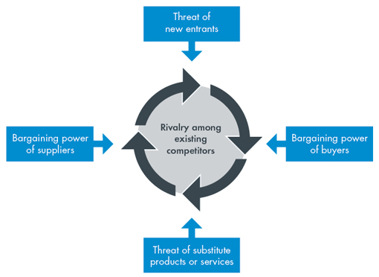
Figure 12 – A graphical representation of Porter's Five Forces
In modern industry of lodging the analysis by these five forces shows non profitability of the accommodation industry. The barriers for entrance is very low. Everybody with investment can build or rent establish new hotel. No matter if it is low cost hostal or five star hotel. As soon as there is investment and government permit any hotel could be established. So it is bad for industry as there dozens of new entrances in the industry.
Nowadays buyers of the lodging industry are very price sensitive. Most customer now are not loyal and they witch between accommodation types depending who is more convenient and who has best price offer. With the development of new technologies, customer can scan all existing price, offer and comments about the accommodation type. There are more information about any establishment now, simply entering the internet. There are a lot offers with a huge variability of the price. These all factor are making the industry less profitable as customers have more bargaining power.
Suppliers also have a big bargaining power. As there are thousands of different kind of establishments supplier can choose the best offer between different buyers and can choose to whom to sell. On the other hand there are a lot of different substitution for supplier which makes them have medium bargaining power.
In the modern accommodation industry there are lots of different substitutes. Buyer can choose between various numbers of lodging establishments such as hotels, hostels, motels, touristic apartments, modern platforms that makes to accommodate anywhere in the world. The process is slightly easier and has less substitutes in low cost lodging types because as the buyer is very sensitive, they have a choice between hostal, hostels or apartments. Depending on the need of each customer, they make a choice.
All these indicators are a result of intense rivalry in the industry. Barriers of entrance is very low so there lots of different lodging types, buyer is price sensitive and can choose between all these different lodging types in the market. Besides, as there a lot of lodgings establishments suppliers can be price sensitive and choose who to work with between different lodging types. And as there lots of different types and levels of the accommodation, there various choices of substitutes for any accommodation type. All above mentioned factor are the result of a compete between different companies in the industry. Companies are now taking care and compete against by focusing on the price rather than on brand image and reputation.
Nevertheless, this kind of low profit industry can be transformed to very high profit industry simply adding sixth element which is a main element in all industries and businesses. Government, it is a factor that can easily affect on these industry and change it from really low profitable to high profitable industry. The government can affect on price policy of the industry and make it fixed cost industry. By controlling taxation and yield management in different seasons. Government is also the main aspect in creating and amount of new accommodation establishments. Government is the last but most important step for new companies before entering the market. If the company will not be able to get a license or permit to start functioning as accommodation establishment then he barriers to enter the market will be very high so not every establishment will be able to enter the industry. It is a big indicator and controller. This will lead to fixed amount of establishments and decrease in the number of existing lodging types as the indicator will be more strict. As the number of establishments will decrease that means there will be more suppliers than demand, which makes the situation even better as supplier will not have bargaining power any more. There still will be substitution for different kinds of lodging but it will not decrease the profitability of the industry. As the government entries the industry it makes cardinal changes to the industry profitability, and non profitable or low profitable industry becomes very high profitable. It is important factor to use in modern business as government has more power than shareholders, and government can dictate the rules in order to change the profitability of the industry. In our case with hostals and other low cost accommodation types in Barcelona government is able to play a big role and can totally change the existing situation in lodging market of Barcelona that will be shown and proven later.

3.2. ECONOMIC EVALUATION
The situation that appeared now in Catalonia and especially in Barcelona as being the most visited place in the region is that there are more illegal lodging establishments rather than legal. It does not affect 3,4 and 5 star hotels as it is hard and almost impossible to get illegal with those big establishments. However, it strongly affects small establishments which correspond to low cost accommodation types. 1 and 2 star hotels, hostals, hostels and touristic apartments are the establishments where for each one legal establishment there are 2 illegal. Catalan government and Barcelona city hall started worrying about it recently, 2 years ago, when there was an increase among protesters against illegal accommodation and touristic apartments in quiet and peaceful neighborhoods of Barcelona. Then the government also started to think about the financial part of this question. Where thousands or maybe millions euros that government is losing by not controlling the establishments. So as a result government stopped to give new licenses to new tourist lodging establishment and started investigating each of existing establishment in order to count and verify the amount of legal establishments there are.
In order to maximize the profit, government should apply taxation on existing low cost accommodation types. However, as the was of maximize the income for government, city hall should invest to hostal type of accommodation type. By giving chance to stakeholders and businessmen invest in new establishments, government could apply the corporate tax which is 30%. ³⁷
______________________________________________
³⁷ Form 220, Form 303 for VAT and Form 111 for withholding tax.
This percentage could be applied after deduction all expenses for the property, including utilities, renovation work, management fees and property taxes. By applying taxes for corporate property owners 30% of profit is a goes to tax coffers of Barcelona.³⁸ Corporate income tax is one of the main direct tax applicable in Spain. Also if the company is big then the tax rises to 35%. However in case of hostals as it is small business the small size company size is applicable.
Calculation: Incomes – Expenses = Profit Before Taxes
Profit Before Taxes x 35% / 30% = Net Profit
There is a system of tax incentives for small-sized enterprises, exclusively applicable to companies whose net turnover in the tax period immediately prior thereto is less than 8 million euros:
- A tax rate of 30%, applicable to the first 120,000 euros of taxable income
- Accelerated depreciation if the asses unit value does not exceed 601.01 euros.
- Deduction in repayment of 10% of the investments or expenses: Access to Internet, Presence on Internet, E-commerce and etc

______________________________________________
³⁸ http://www.strongabogados.com/taxes.php#PropCorpTaxes
Beside the direct tax of 30%, there is also an indirect taxes in Spain. One of the main is VAT (Value Added Tax; Spanish: IVA), this tax is normally 21%, however besides the standard rate it also has a reduce rate of 10% and 4%. In Spain, hotel or hostel accommodation is counted as reduced rate of 10% VAT for the general price. This 10% rate applies to certain goods and services, such as purchase of a newly built properties, hotels and restaurants, health products and entertainment and sport activities. Applying VAT tax rate of 10% to hostel rooms price, government generate another financial profit which can be used as a help for investment of new establishments and infrastructure.
Unlike other regions of Spain, Catalonia started levy a tourist tax on November 1,2012. The Catalonia Tourist Tax applies to any facility where tourist stay overnight – from campgrounds and youth hostal to hostel and cruise ships. Tourist apartments and private houses rented to tourists are subject to the charges as well. Under the terms of a bill approved in March 2012, the tax fees are used to finance the newly founded Tourism Development Fund, which produces promotion campaigns for tourism in Catalonia. In additional the tax is used for “tourism-related infrastructure” - which includes anything from the upkeep of seaside boulevards or the rebuilding of beaches after they have been damaged in storms, to payment of salaries for extra policeman hours during some famous events or festivals. When it was introduced, the Catalan Government expected the tax to raise €50 million per yer. In 2014, €41 million was raised – bringing the total revenue raised since the introduction of the fees to €82.3 million. The income is split between The Catalan Tourism agency and local tourism boards and town halls.

Type of Establishment | Barcelona | Rest of Catalonia
Cruise ships,  5-star, Luxury Hotels | € 2.25 | € 2.25
4-star, 4-star superior Hotels | € 1.10 | € 0.90
Campings,  Apartments  Villas, Others | € 0.65 | € 0.45

Table 1 – The amount applicable as tourist tax for different types of establishment

It is important to mention that the tourist tax is also a subject to a 10% VAT charge.³⁹ The main reason of introducing tourist tax in Catalonia was because as tourism industry is a booming industry in Barcelona and the rest of Catalonia and the Government of Catalonia plans to use some of the revenue generated by the new tax to assist the region's economic recovery. That being said, Generalitat has stated a large percentage of the newly imposed tax will be poured back to the tourism industry.
__________________________________________
³⁹ Catalonia Tax Information http://www.catalonia.com/en/businessguide/taxsystem.jsp

Tourist tax is and additional tax that government could get profit from applying it to hostels. In conclusion, the total amount of direct and ancillary taxes will be following:
Corporate income tax 30% + 10%VAT of accommodation price + (€0.65 tourist tax + VAT)

3.3 OPERATIONAL EVOLUTION
3.3.1. VIABILITY OF HOSTAL: LOW COST ACCOMMODATION
Hostal, as being one the main low cost accommodation type and one of the most profitable. Hostals usually have fixed cost and chosen target segment with distinct needs. These type of accommodation does not need big investment to start up. There are several main reasons of hostal being cheap but at the time very profitable business. Hostals usually avoid unnecessary services. They work with the same strategy and principle that low cost airlines do. It is one of the most efficient and profit bringing businesses in the world. What hostals also do, they avoid wasted spaces. So there are only basic need that guest might need. Amount of investment per room in hostal business is low, and management achieve it by carefully managing purchasing and construction costs.
In order to hostal to be the efficient business, cost should be the part of the company culture. Hostals also have low managing cost are most of the hosstals are managing by a familiy. In any other case, hostals always have family, warm and friendly employees who consider to be loyal employees. This also reduces expensive turnover. Hostals are not providing extra services, they are working with the strategy to provide for each guest personalized attention and provide a private space for each guest.
To be viable business, hostals choose specific target of tourists with distinct, and low needs. Hostals' main objective is to satisfy person's main need for minimum cost possible. They do not broaden their service strategy as it will lead to losing money, and they will have to substitute it with high room rate.
The main rival for hostals in Barcelona are touristic apartments. However, unlike tourist apartments hostals are providing 24 hour message services and personal attention and service to each guest. It is strong modern business model, with most of it strategies being directed to reducing all kinds of costs.
3.3.2. LENGTH OF STAY FOR LOW COST TOURISM
As far as a profile of foreign tourists arriving in Spain on low cost airlines is concerned, practically the only type of information available is descriptive, and therefore the effect of different variables on length of stay is unknown. The Institute for Tourism Studies ( Instituto de Estudios Turisticos) publishes information relating to all low cost airline tourists in Spain in general, without offering more disaggregated data (e.g. by the tourist's airport of entry or tourist destination). Despite this limitations on the data available, overview of some characteristics of low cost airline tourist is providing below.
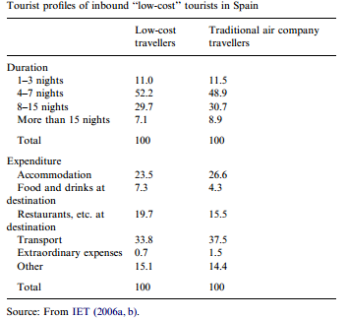
Table 2 – Characteristics of the low-cost airline tourist's
According to the Institute, and using data ( Instituto de Estudios Turisticos, 2006b), the low cost airline tourist is much more accustomed than those who use traditional airlines to using new information and communications technologies for researching, reserving and paying for their trip; they are also more autonomous with regard to organizing the trip, and are greater users of free accommodation. The principal reason for the trip is holiday/leisure (as it is for the majority of tourists) and they reserve their means of transportation further in advance. Most are loyal to their destination and are highly satisfied with their trips. As far as expenditure is concerned, the main difference with tourists who use traditional airlines is that they spend proportionately less on transportation, but more on some expenses at their destination, such as shopping. With regard to length of stay (Table 2), most tourists are at their destination for a period of between four and seven nights, which is the same as the traditional airline tourist, although a greater proportion of the shortest trips is found among low cost airline travellers.
As shown on the Table 2, low budget tourist is more likely to stay more at the destination. Regular stay of low cost tourist is between four and seven days. This is one of the trends of hostal establishments. The main income of hostals is running on occupancy rate. Even if hostal can be and accommodation type for both long and short stay, they main income of the hostal is high occupancy rate throughout the year. This could be achieved by price policy or different kind of methods that help to boost occupancy rate. The example of occupancy rate of one of the hostals of Barcelona will be shown in Appendix 1 and Appendix 2.

4. DISCUSSION AND ANALYSIS
4.1 ANALYSIS OF DATA
Drawing on information and data provided in other chapters it can be confirmed that hostal type of accommodation is actually beneficial from both perspectives. From one hand it is financially profitable for government. Government could get profit by applying taxation on these kinds of establishment. Government will get 30% of corporate tax from the profit of the company after deducting all expenses including managerial costs, besides government will also obtain 10% VAT on each bought and sold room in the hostal and finally touristic tax which is approximately €0.72 per person per night. As the occupancy and length of the tourists in low cost accommodation is high it is actually reasonable amount for new investments and developing infrastructure of the region.
Also by analyzing industry with Porter's Fiver Forces, we can notice that, even if hospitality business is not high profitable, situation can change by adding government as a sixth force in this industry. The examples of occupation rate in on of the hostals of Barcelona is provided in Apendix 1 which supports and proofs the above mentioned information and statements.
Investment and improvement of hostal business will also positive affect on social issuas that appear to be in the current scenario of the city.

4.2 RECOMMENDATIONS
After careful examine all the data there could be given some recommendations from government perspective as well as from investor and businessmen perspective. Government perspective recommendations are:
- Strictly control touristic establishments
- Avoid to give tourist licenses for tourist apartments in several districts
- Promote hostal type of accommodation and gather investors for developments
- Control the price management and amount of touristic establishments
- Applying strict Corporate, VAT and touristic taxes
Recommendation for businessmen and management point of view:
- Invest to hostal type of accommodations
- Control the costs, fixed and additional costs
- Avoid unnecessary extra services
- Provide basic accommodation service to guests
- Choose target segment with lower needs
- Invest only where needed
- Make a cost part of the company culture

5. CONCLUSION
In order to analyze the future of low cost accommodation as a business proposition in Barcelona, it was performed a study with a review of literature collecting information about the city and the low cost accommodation in Barcelona and it was developed a business and environmental analysis of the low cost tourism area. Thus, despite the constraints inherent in this study, it is possible to draw the following conclusions:
- The Spanish economy is recovering from the financial crisis started in 2008 in the line with other European countries, and tourism sector of the region is developing, which is stimulating the job creation and is offering the population the possibility to recover financially.
- The actual scenario of the touristic accommodation in Barcelona is not favorable as the is lack of government control with causes a lot of illegal establishments, and more competition and less margins, while the market is not growing.
- Local communities are disturbed by these kind of illegal establishments and tourist apartments, which cause social problem between government and local community, resulting with protests and etc.
- Hostal type of accommodation is lacking investments and good managerial strategy. Also there is lack of support from the government, and market share is obtaining by illegal establishments.
- Government is losing millions of euros every year on taxes that could possible be applied on those establishments that are functioning illegaly. Beside, the unemployment in tourism sector could get better with new legal establishments and job opportunities

The hostal type of accommodation as it is now is not sustainable, so the owners of those businesses should change the strategy and create a sustainable competitive advantage to have higher market share.

6. BIBLIOGRAPHY
C. Michael Hall (Ed.) Pro-Poor Tourism: Who Benefits? Clevedon, Channelvie Publications,2007, ISBN 13: 978-1-84541-075-9 (hb)

Ashley, C.,Roe, D. & Goodwin, H. (2001) Pro-poor Tourism and Strategies: Making tourism work for the poor (London: IIED)

Scheyvens,R. (2002) Tourism for Developmet: Empowering Communities (Harlow: Prentice Hall)

Scheyvens, R. (2005) Growth of beach fale tourism in Samoa: the high value of low-cost tourism, in: C.M. Hall & S.W. Boyd (Eds) Nature Based Tourism in Peripheral Areas: Development or Disaster?, pp. 188-202 (Clevedon: Channelview Press).

Mason R. McWatters (2009) Residental Tourism: (De) Constructing Paradise Bristol, Vhanel View Publications, 2009, ISBN 978-1-84541-090-2

Sven Gross & Alexander Schroder (Eds) Handbook of Low Cost Airlines: Strategies, Business Process, and Market Environment Gorringen, Hubert and Co.,2007 ISBN 978 3 503 10081 1

World Tourism Organization (WTO)
http://www.unwto.org/index_s.php

Institute of Tourism Studies (IET)
http://www.iet.tourspain.es

Exceltur. Spanish Alliance for Tourism Excellence
http://www.exceltur.org

Institute of Spanish Tourism Quality (ICTE)
http://www.icte.es

Tourism Round Table
http://www.mesadelturismo.com

Spanish Confederation of Hotels and Tourist Accommodation (CEHAT)
http://cehat.com

Spanish Association of Hospitality and Restaurants (FEHR)
http://www.fehr.es

Spanish Confederation of Travel Agency Associations (CEAV) http://www.ceav.info/publico/constitucion.htm

Gremi d’Hotels de Barcelona
http://www.barcelonahotels.es

Barcelona Turisme
http://www.barcelonaturisme.com/

Feria Internacional de Turismo, FITUR (International Tourism Trade Fair) http://www.ifema.es/ferias/fitur/default.html

International Tourism Show in Catalonia (SITC)
http://www.salotourism.com

HOSTELCO (International Restaurant, Hotel and Community Equipment Exhibition) http://www.hostelco.com
European Cities Marketing
http://www.europeancitiesmarketing.com/

Destinet. Sustainable Tourism Information Portal
http://destinet.ew.eea.europa.eu

Global Code of Ethics for Tourism
http://turismo-sostenible.net/documentos/codigo-etico-mundial-para-el-turismo/

European Charter for Sustainable Tourism in Protected Areas
http://www.european-charter.org/home/

Development Assistance Network for Tourism Enhancement & Investment (DANTEI) http://www.dantei.org

Portal Comunicatur. Informació turística professional
http://www.comunicatur.info/

Hosteltur Portal
http://www.hosteltur.com Nexotur (daily e-newsletter) http://www.nexotur.com
Armstrong, G., Adam, S., Denize, S. & Kotler, P. (2014). Principles of marketing.
Melbourne: Pearson.

Berta Ferrer Rosell “Tourism demand in Spain: Trip duration and budget structure, a comparison of low cost and legacy airline users”

The price policy of Airbnb in Barcelona
http://infoturbarcelona.com/2015/01/07/el-precio-medio-de-airbnb-en-barcelona-99-euros-por-noche/

Use of illegal touristic apartments
http://infoturbarcelona.com/2015/08/07/multas-de-15-000-euros-de-media-a-300-pisos-turisticos-ilegales-en-ciutat-vella-de-barcelona/

Accommodation platforms being penalized in Barcelona
http://infoturbarcelona.com/2015/12/22/airbnb-y-homeaway-multadas-por-el-ayuntamiento-de-barcelona/

Barcelona City hall is negotiating the touristic tax application on website users
http://infoturbarcelona.com/2015/09/08/la-generalitat-negocia-con-airbnb-el-cobro-del-impuesto-turistico-en-barcelona/

Airbnb released the number of apartments
http://infoturbarcelona.com/2015/02/03/airbnb-comercializa-en-barcelona-en-plazas-de-alojamiento-el-equivalente-a-54-hoteles/

Penalization applied for landlord of illegal touristic apartments
http://infoturbarcelona.com/2015/08/07/multas-de-15-000-euros-de-media-a-300-pisos-turisticos-ilegales-en-ciutat-vella-de-barcelona/

The impact of Airbnb on the city
http://blog.airbnb.com/economic-impact-airbnb/?_ga=1.84723484.420372837.1450263736#barcelona

The contribution of Airbnb for economy of Barcelona
https://www.airbnb.co.uk/press/news/new-study-airbnb-community-contributes-175-million-to-barcelona-s-economy

Generalitat de Catalunya
http://www.parlament.cat/documentacio/estatut/recursos-constitucional/index.html

European Tax Rate
http://www.vatlive.com/vat-rates/european-vat-rates/eu-vat-rates/

7. APPENDIX
7.1. APPENDIX 1 ( The occupancy of one of the hostals of Barcelona)
