**Mission of the African Great Lakes Initiative**

The African Great Lakes Initiative (AGLI) of the Friends Peace Teams strengthens, supports, and promotes peace activities at the grassroots level in the Great Lakes region of Africa (Burundi, Congo, Kenya, Rwanda, Tanzania, and Uganda). To this end, AGLI responds to requests from local religious and non-governmental organizations that focus on conflict management, peace building, trauma healing, and reconciliation. AGLI sponsors Peace Teams composed of members from local partners and the international community. AGLI, as an initiative of Friends Peace Teams, is a 501(c)3 not-for-profit organization.

**History of the African Great Lakes Initiative (one page)**

**​​**The African Great Lakes Initiative (AGLI) is a program created by Friends Peace Teams, an organization consisting of sixteen Quaker Yearly Meetings in the United States ​and Australia Yearly Meeting. These have united to support the traditional emphasis of Quakers in promoting a more peaceful world. In March 1998, the Friends Peace Teams realized that Quakers in the Great Lakes region of Africa, numbering almost half of the Quakers in the world, were in countries with a great deal of violence, social unrest, genocide, and civil war.

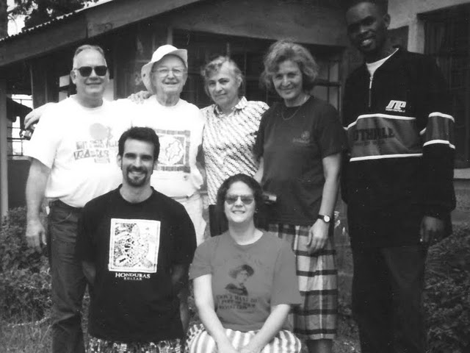

Members of the 1999 AGLI delegation. Front row from left, Carl Stauffer, Jill Sternberg, Back row from left, David Zarembka, Bill McMechan, Rosemarie McMechan, Ute Caspers, Derrick Kayongo.

In January 1999, an international delegation of seven team members visited Kenya, Uganda, Rwanda, and Burundi. The purposes of the trip were as follows:

1. Visit Quakers and other peacemakers in Rwanda, Burundi, eastern Congo, Kenya, and Uganda to determine how they were being affected by the violence in the region.

2. Find out what peace making programs they were doing.

3. See if the Quakers wished to partner with the African Great Lakes Initiative in further peacemaking activities.

​The delegation learned that Quakers in the region were (1) heavily impacted b​y the violence, (2) in Rwanda and Burundi, in particular, they were doing a significant amount of peacemaking work, mentored mostly by the Mennonite Central Committee, and (3) would be more than willing to partner with AGLI if further work. From this visit and subsequent discussions, the Friends Peace Teams decided to create the African Great Lakes Initiative to support peacemaking activities at the grassroots level in east and central Africa.

​AGLI's first activities were to introduce the Alternative to Violence Project (AVP) to Rwanda (2001), Burundi (2002), Kenya (2003), North and South Kivu (2005), and Tanzania (2006). AGLI also sponsored workcamps in Burundi, Uganda, Rwanda, and Kenya and placed Extended Service Volunteers with our partnering organizations in east and central Africa. In 2003 AGLI helped support the launching of the Friends Women's Association (FWA) and its Kamenge Clinic in Bujumbura, Burundi.

From the time of the initial delegation, the African Quakers indicated that trauma healing at both the individual and societal level were of primary concern. In ​October 1999, AGLI sent two Americans and two Burundians to South Africa for a three month training in trauma healing through the Quaker Peace Centre in Capetown, SA. When they returned they began the Trauma Healing and Reconciliation Services (THARS) under the leadership of David Niyonzima, then Legal Representative of Burundi Yearly Meeting.

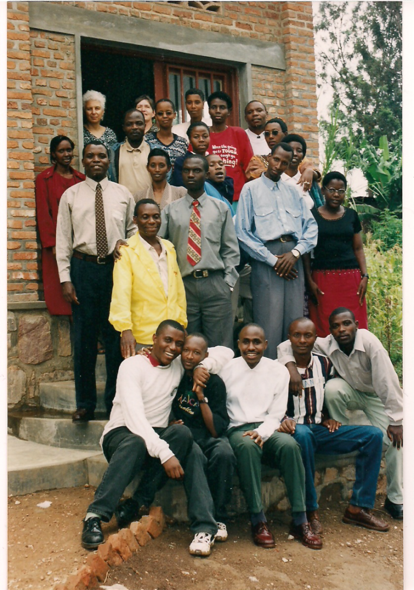

Members of the first HROC Training in 2003.

In January 2003, with financial assistance from the American Friends Service Committee, AGLI sponsored a four week trauma healing seminar in Kigali, Rwanda. From this seminar, the participants developed the program, Healing and Rebuilding Our Communities (HROC), based on the model of AVP. They then conducted 25 basic workshops to refine the program. Later the HROC program developed follow-up days, community celebrations, and healing companion trainings to further the program. After this development in Rwanda and Burundi, in 2007/2008 HROC expanded to North Kivu of the Democratic Republic of the Congo and western Kenya.

Beginning in 2011, AGLI has sponsored three week HROC International Trainings in Rwanda for people from various countries to train to lead basic HROC workshops. In addition to the east and central Africans, participants have come from the United States, England, and Nigeria.

In 2014 Catholic Relief Services has introduced HROC to the Central African Republic and in 2015 to Orientale Province of the Democratic Republic of the Congo (DRC). In 2014, the Mennonite Central Committee began supporting HROC in North and South Kivu of the DRC. Also in 2014 the Mennonite Central Committee in Nigeria and the Nigerian Church of the Brethren began conducting HROC workshop in Northern Nigeria in areas affected by Boko Harum violence.

In 2005 AGLI launched PeaceWays-AGLI, a magazine published two or three times per year, reporting on AGLI’s peacemaking work in Africa. In 2007, a weekly blog on the internet, Reports from Kenya, was initiated to cover peace developments in the region. Since 2002 AGLI has sponsored two or three speaking tours per year to the United States, England, and Canada for its African partners.

**AGLI Team Members**  
**Working Group**

**​​**  
Laura Shipler Chico  
Anna Crumley-Effinger  
Rosalie Dance (recording clerk)   
Rachel Madenyika  
Sue Nowelsky (clerk)

Parfaite Ntahuba (staff representative)  
Tom Paxson (treasurer)   
Andrew Peterson

Laurie Woodell   
  
  
**Staff**  
David Bucura, (Coordinator--Central Africa)  
Dawn Rubbert (Program Manager)  
John Kintree (FPT Administrator)   
David Zarembka (Coordinator)  
  
**Burundi**  
Marcelline Girukwishaka   
Elie Nahimana  
Nadine Ndayizeye  
Alexia Nibona  
Parfaite Ntahuba  
Desire Nzeyimana  
  
**Kenya**  
Getry Agizah   
Gladys Kamonya

Ezra Kigondu

Peter Serete

**Rwanda**

Herbert Hirwa  
Solange Maniraguha

**Uganda**  
George Katosi

Grace Kiconco

Emmanual Ocayotoo  
Barbara Wybar

**AGLI Budget for 2016 Fiscal Year**

**General Funds**

|  |  |  |  |  |  |  |  |
| --- | --- | --- | --- | --- | --- | --- | --- |
|  |  |  | General **Funds** | |  | 2016 |  |
| AGLI Income | | | | |  |  | $ 111,950 |
|  | AGLI General funds | | | |  | $ 103,950 |  |
|  |  | Fall Appeal | | | $ 55,500 |  |  |
|  |  | Spring Appeal | | | $ 29,500 |  |  |
|  |  | Meetings, AGLI | | | $ 18,500 |  |  |
|  |  | Honorarium | | | $ 200 |  |  |
|  |  | Sale of Materials | | | $ 250 |  |  |
|  | Tours by Africans | | | | $ 1,000 | $ 1,000 |  |
|  | Burundi | | | |  | $ 3,500 |  |
|  |  | Friends Women Association | | | $ 2,000 |  |  |
|  |  | HROC | | | $ 1,500 |  |  |
|  | Kenya | |  | | $ 1,000 | $ 1,000 |  |
|  | Rwanda | | | |  | $ 1,500 |  |
|  |  | HROCprogram | | | $ 1,500 |  |  |
|  | Extended Service Volunteers | | | | $ 1,000 | $ 1,000 |  |
|  |  |  |  | |  |  |  |
| Expenses | | |  | |  |  | $ 111,940 |
|  | AGLI in US | | | |  | $ 18,150 |  |
|  |  | Fundraising | | |  |  |  |
|  |  |  | Postage | | $ 2,000 |  |  |
|  |  |  | Printing | | $ 2,500 |  |  |
|  |  | Postage | | | $ 2,200 |  |  |
|  |  | Printing | | | $ 6,000 |  |  |
|  |  | Office Supplies | | | $ 50 |  |  |
|  |  | Telephone/internet | | | $ 150 |  |  |
|  |  | Banking | | |  |  |  |
|  |  |  | Donation fees | | $ 250 |  |  |
|  |  |  | Wire transfer/banking fees | | $ 1,000 |  |  |
|  |  | Conferences and Travel | | | $ 1,000 |  |  |
|  |  | International Travel | | | $ 3,000 |  |  |
|  | AGLI in Kenya | | | |  | $ 6,600 |  |
|  |  | Travel in Kenya | | | $ 500 |  |  |
|  |  | Coordinator | | | $ 4,800 |  |  |
|  |  | Health | | | $ 200 |  |  |
|  |  | Phone & Internet | | | $ 350 |  |  |
|  |  | Office Eqpt & Supplies | | | $ 50 |  |  |
|  |  | Int'l Travel in Africa | | | $ 700 |  |  |
|  | AGLI in Central Africa | | | |  | $ 4,190 |  |
|  |  | Coordinator--Central Africa | | | $ 3,000 |  |  |
|  |  | Health | | | $ 200 |  |  |
|  |  | Fringe benefits | | | $ 490 |  |  |
|  |  | Administrative Expenses | | | $ 500 |  |  |
|  | Tours by Africans | | | | $ 2,000 | $ 2,000 |  |
|  | Reserve for special projects | | | | $ 5,000 | $ 5,000 |  |
|  | Burundi | | | |  | $ 38,600 |  |
|  |  | Friends Women Association | | | $ 18,000 |  |  |
|  |  | HROC | | |  |  |  |
|  |  |  | | Program | $ 20,000 |  |  |
|  |  |  | | Health | $ 600 |  |  |
|  | Kenya | | |  |  | $ 17,500 |  |
|  |  | Program | | | $ 17,500 |  |  |
|  | Rwanda | | | |  | $ 19,900 |  |
|  |  | HROC | | | $ 17,500 |  |  |
|  |  |  | Health | | $ 400 |  |  |
|  |  |  | HROC center | |  |  |  |
|  |  | AVP-Africa Gathering | | | $ 2,000 |  |  |
|  |  |  |  | |  |  |  |
| Net Surplus for General Funds | | | | |  |  | $ 10 |

**Budget for designated funds**

