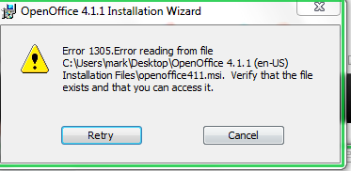

1305 Error reading from file

C:\Users\mark\Desktop\OpenOffice 4.1.1 (en-US) Installation Files\openoffice411.msi. verify the file exists and that you can access it. Tab box “ retry” “cancel”

Nothing allows me by to continue install.

I have downloaded 3 times and I cannot understand any fixes described in the data base

Click run

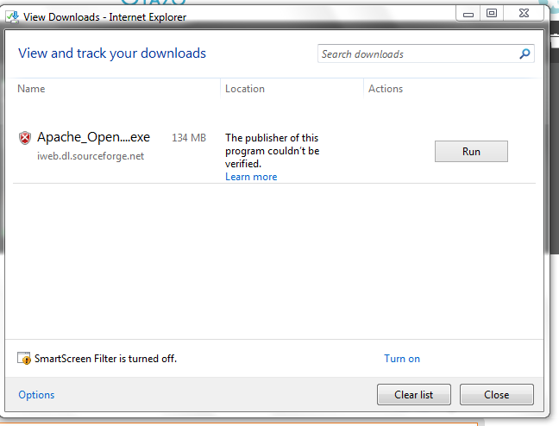
Click run then ask for administratior privilages which there is only one user and administrator on this computer
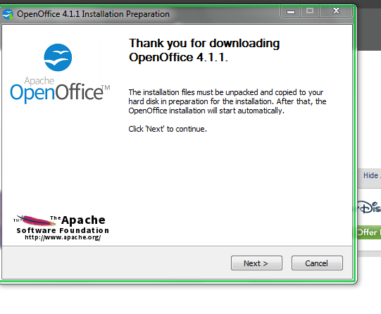

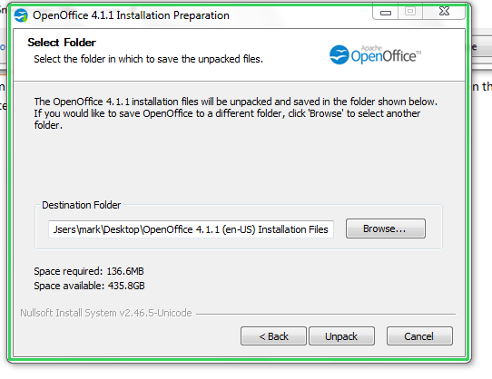
Click unpack

Then get the follow message see below.

Click try again get the 1305 error message after that hit retry it doesn’t go anywhere just gives same error message, if hit cancel losses the whole download
