# PRELAB EXERCISE

## Preview 0

1. What do you think you will learn from this course?
2. What should you prepare before the classes?
3. Why are you asked to accomplish PRELAB before classes? If you don’t, what kinds of punishment are expected?
4. Why are you asked to finish the theoretical analysis before classes? If you don’t, what kinds of disadvantage or punishment are expected?
5. What are the advantages of wiring with a breadboard?
6. Read the table of content of microelectronic text book and syllabus of this course. Try to find the correspondent chapter of each laboratory.

## Preview 1: Read the Resistance

Read the nominal resistance value and error of the carbon composition resistor shown below.



## Preview 2: Understand the Operation of Power Supply and Current Limit

1. Why do we have to limit the upper current when using a power supply? What might happen if we don’t? Please give an example.
2. Each single panel of power supply in the lab can provide 30V voltage at most. If a 50V-DC voltage is required, what will you do? Refer the handout and reference book, and write down your operating procedures.
3. Referring to the handout and the reference books, explain how to use a power supply to provide +5V, 0, and -5V voltage simultaneously. The upper current is 0.5A. Write down your operating procedures and draw the connections in the figure below.



## Preview 3: Resistance Measurement with a Multimeter

1. Assuming that V=5V, R1=30KΩ, and R2=10KΩ in the figure below, please find out the voltages (V1 and V2) across R1 and R2 respectively.



1. Take the internal resistance of multimeter into consideration and explain how to measure an unknown resistor’s resistance with a power supply and two multimeters. Moreover, indicate the range of resistance that can be measured with your design (you have to consider the internal resistor of multimeter). (Optional)

HINT:

## Preview 4: Concepts of Grounding of the Power Supply

Assume that the panel of a power supply is showing 10V output voltage.

1. Use a multimeter to measure the voltage between “+” and “GND” of the power supply as fig.1. Predict the value the multimeter shows.
2. Use a multimeter to measure the voltage between “-” and “GND” of the power supply as fig.2. Predict the value the multimeter shows.
3. Use a multimeter to measure the voltage between “+” and “-” of the power supply as fig.3. Predict the value the multimeter shows.
4. Use two multimeters to measure the voltage between “+” and “GND” and the voltage between “GND” and “-” of the power supply simultaneously as fig.4. Predict the values the multimeters show. (Let two multimeters have same internal resistance)

|  |  |
| --- | --- |
| Fig.1 | Fig.2 |
| Fig.3 | Fig.4 |

## Preview 5: AC voltage measurement with a multimeter (Optional)

1. What dose “RMS value” mean?(Hint: refer your Fundamental Physics textbook) Assuming that the power signal that power companies offer is a sine wave with amplitude 156V and frequency 60Hz, please calculate its RMS value.
2. Continuously, if we want to use a multimeter to measure this AC signal, which mode and magnification of the knob should be turned to?

## Preview 6: Use a Breadboard to Build an Electric Circuit (Optional)

Calculate the resistance between A and G, A and C, and A and D, respectively (Let R = 1000 ohm).

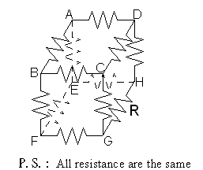

|  |  |
| --- | --- |
|  | Resistance(Ω) |
| Between A and G |  |
| Between A and D |  |
| Between A and C |  |

Hint:

* Resistance between AG
  + Find the Equivalent-Voltage Points!
* Resistance between AD

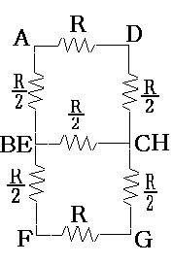

* Resistance between AC