**Bug#94267**

Win 7 LO 5.0.1.2 release



Desired graph before saving

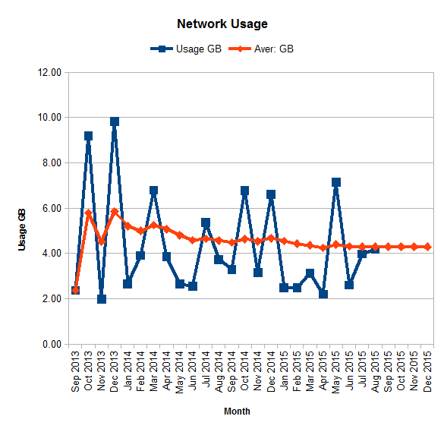

Graph reproduced after re-opening

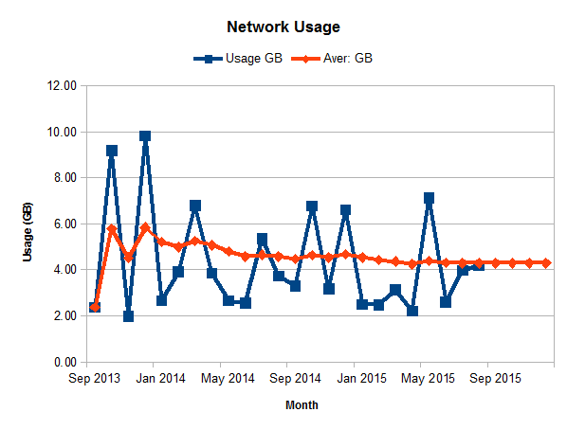 **Thoughts:**

It appears that the graph somehow resets from the desired Format axis / Scale / Date - Major interval 1, Minor interval 1 to the Automatic scale [which gives the 4month intervals]. It similarly alters the Format axis / Label from the required 90deg to the Default 0deg giving the horizontal text.