**The Law**

In Britain, Illegal drugs are called “controlled substances”. They are split into three groups (A,B and C).

Class A are considered the most harmful and/or most addictive. Different penalties are given for possession of these drugs and dealing the drugs.

**IT IS A CRIMINAL OFFENSE TO:**

* possess a controlled substance unlawfully
* possess a controlled substance with intent to supply
* supply, or offer to supply a controlled drug
* Allow your property to be used for drug taking

**Gateway Drugs**

Gateway drugs are drugs that lead you to getting into “harder” drugs. They’re not particularly harmful, although they are addictive, which is the reason behind a person getting into other harder drugs. When/if the human body becomes “immune” to the drug, as it is weak; it is going to want a more effective drug. Examples are marijuana and tobacco.

A GUIDE FOR TEENAGERS

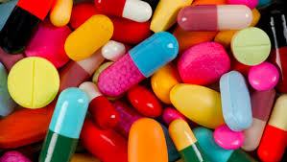

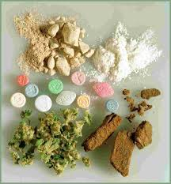

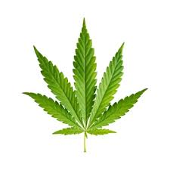

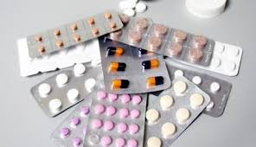

D

R

U

G

S

**Top 10 most commonly used illegal drugs**

1. **Heroin**
   * Taken through and injection
   * Gives feeling of wellbeing
2. **Crack Cocaine**
   * Creates sense of euphoria and hallucinations
3. **Methamphetamine**
   * Popularly referred to as “meth”
   * Can cause depression, anxiety and drug craving
4. **Cocaine**
   * A stimulant
   * Increases energy levels, pulse rate and heartbeat
5. **Marijuana**
   * Usually smoked
   * A gateway drug
6. **Opium**
   * Conatins morphine
   * Morphine is an addictive painkiller
7. **Ecstasy**
   * Increases self awareness
8. **LSD**
   * Causes hallucinations
9. **PCP**
   * “Phencyclidine” gives hallucinations
10. **Psilocybin Mushrooms**
    * Aka “Magic Mushrooms”
    * Creates severe hallucinations

**What is a Drug?**

A drug is anything that affects the way the body works, e.g., raising the heartbeat or blurred vision.

An estimated one in three adults (around **12 million** people) will take an illegal drug in their lifetime

Some examples of illegal drugs are **LSD, Cannabis, Speed, Ecstasy and Heroin**

As well as illegal drugs, there are also legal drugs, most of which are used for a medicinal purpose. Some examples are **antibiotics, paracetamol, nicotine** (cigarettes)and **caffeine** (coffee)

**Stimulants and Depressants**

Stimulants give a person a feeling of **boundless energy** and can be very **addictive**. It can also change a person’s behavior and personality. Some examples of stimulants are **amphetamine** (Speed), **cocaine, coffee** and **methedrine**.

Depressants are usually **barbiturates**, which means that they have a kind of **sedative, or sleep inducing drug** in it. Depressants can **slow down a person’s body** and can be **dangerous**. An example of a depressant is **alcohol.**

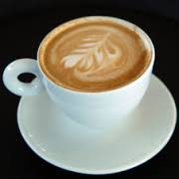 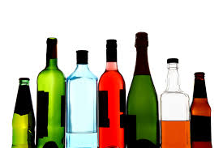

**Effects of Drugs**

Some drugs have a positive effect and can heal people with certain conditions. These drugs are usually legal.

However other drugs can have bad effects, for example some illegal drugs can cause **hallucinations** and a **feeling of boundless energy**. Some can also lead to **dehydration** and **overheating** which could result in **death.**

Another symptom is that most illegal drugs are quite **addictive**, which could mean serious damage if someone is quite addicted to the drug.

Pain killers can also affect the human body, although they are legal, as they are very addictive a and can cause degeneration of a person’s life.