Sample Doc

Some changes i’ve made, but want to 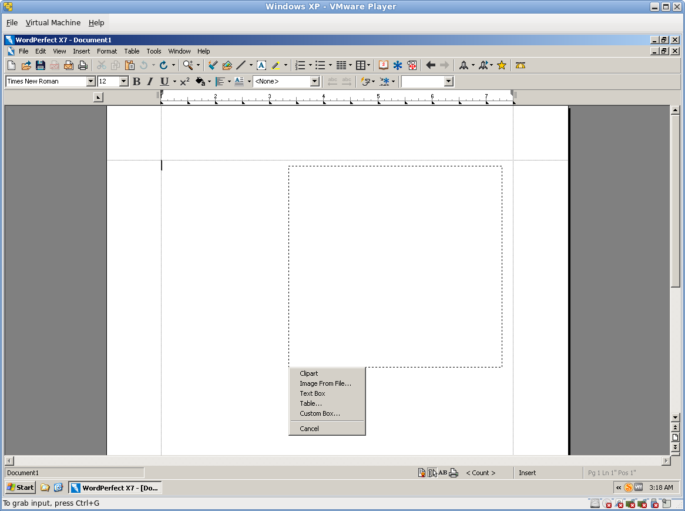save the revision without these words.

