
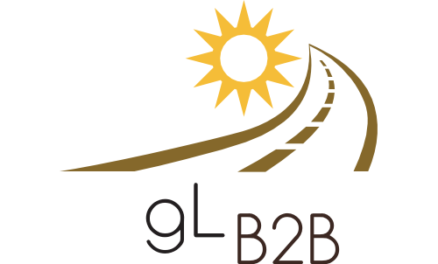
Regional Airports:
Need to Attract More Business?

5 Marketing Tips You May Not Have Considered

Regional Airports:
Need to Attract More Business?

5 Marketing Tips You May Not Have Considered
Regional Airports:
Need to Attract More Business?

5 Marketing Tips You May Not Have Considered
Regional Airports:
Need to Attract More Business?

5 Marketing Tips You May Not Have Considered
Regional Airports:
Need to Attract More Business?

5 Marketing Tips You May Not Have Considered
Regional Airports:
Need to Attract More Business?

5 Marketing Tips You May Not Have Considered

