Title
kjsdf klsd9uwer mnvo9ew9u dnv sfsjfoekj
kjsdf sdkljf p9owe vkj vkjsdofu wehjkdgj
Illustration 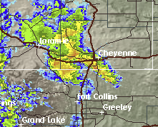1: Weather - satellite from NWS

