Kaspersky LAB Update Servers
Provider
Client 1

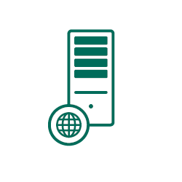
Inbound connection:
TCP 13000, 14000

Internet

Master KSC

Inbound connection:
TCP 13000, 14000
TCP 17000

Slave KSC

Client 2
More information about network ports - http://support.kaspersky.com/9297
Average it should be 20 000 – 30 000 clients (workstations, mobile devices) per single Administrative Server.
Network capacity requirements depend on the amount of events the client will send to the Master KSC:
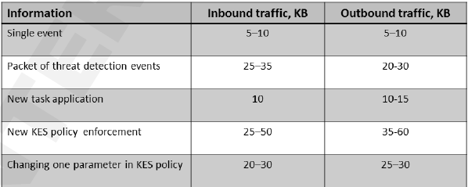
Connection between Kaspersky Security Center and client’s workstation
Connection between Master Kaspersky Security Center and Slave Kaspersky Security Center

Scenario Client 1:
- Only workstations on client side
- Use virtual KSC for each client
- Protection Settings for the client’s workstation at the virtual KSC could be done by provider or client’s administrator, for instance over mmc console or over web-console

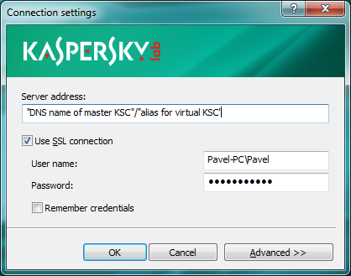

- Protection setting could be distributed from KSC in two ways:
- Directly within synchronization process – every 15 minutes by default client’s workstation should synchronize his settings
- Over dedicated computer (known as Update Agent) - on the client side choose one computer that will consolidate information from other workstations and send it to Master KSC. Also at this scenario it could be when Update Agent always keep active connection to Master KSC and receive actual protection settings which will spread to the client’s workstations inside LAN. IT IS NOT REQUIRED waiting for synchronization time period. It could be provided remote installation.
- Database Update in client’s workstations should be done from the Kaspersky Lab servers for optimization network resource in the provider’s side.
- License type subscription

Scenario Client 2:
- Kaspersky Security Center with Slave role on the client side. All information about events, installed software etc. stores on client side.
- Use separate Slave KSC for each client (it could be more than one).
- Client’s Workstations are connected to the Slave KSC.
- The same functionality as at the Master KSC.
- License type subscription:

- A partner asks for activation codes for Kaspersky Endpoint Security 10 SP1 (one activation key per managed customer). For process automation Partner can integrate their services platforms with KORM via its API, which is given by KL if there is an agreement between KL and that Partner.
- Partner provides activation codes to their customers.
- One key can be used to activate several computers.
- KL can calculate the number of activations and invoice partner. Billing period of subscription – one month or one quarter (normally based on conditions of partner agreement), but for B2B products it’s 1 month or 1 quarter.
- After entering activation code product (Kaspersky EndPoint Security 10 for Windows SP1) switches licensing mode from traditional (if there was a traditional license installed) to subscription.
- Partner can stop subscription.

