Computer studies lesson notes
Information security

What is access control?
Access control limits access to a resource using a physical or a logical limitation, that authorize a person or a group of people and disallow other people from accessing a resource.

Examples of physical controls include a padlock, whilst examples of logical access control include a logon – consisting of a username and password to access a computer for school use. Nowadays access control is quite advanced and includes security cameras which are manned by security guards trained to control access, such as security guards guarding banks.
Sourced from http://en.wikipedia.org/wiki/Access_control.

Why do you think we need access control? (class discussion)

Personal security such as not allowing people who are not my friends to access the school.

Logical security such as protecting valuable assets such as money kept in the vaults of a bank.

Data can be stolen, and, data is worth a lot of money.

Pharming i.e. the mischievous hacker throw large amounts of useless data over a network to a website and slow traffic down or deface a website.
Phishing e.g. asking for information such as a stranger asking you to provide your credit card information. Watch out and ask who they are first and foremost, then ask the credit card holder for authorization.

Spamming i.e. sending confusing messages which are misleading advertising to fool you in buying something.

Drive by hacking and stealing information from WiFi. One can protect the network by using a strong password, and, using WPA/WEP to protect your wireless network. A cabled network might be more secure and faster and does not allow external access.

Don't try these at home, but do watch some videos on YouTube if you have some free time to read up.

Keeping doors locked and why?

Keeping your computer locked after you login, and, a short demo on how to login to a computer, and, lock a computer, knowing your user name and password.

NOTES

________________________________________________________________________________________________________________________________________________________________________________________________________________________________________________________________________________________________________________________________________________________________________________________________________________________________________________________________________________________________________________________________________________________________________________________________________________________________________________________________________________________

Log on to the computer (Windows-based)
1. Switch on your computer and wait for the computer to boot up (which means it is loading information to its memory from the slow hard disk). If the hard disk makes strange noises call the teacher, it means the computer may be faulty.

NOTE: When you need help, just raise your hand and ask and don't do anything else, please.

2. Check that everything is connected and ask your teacher if you hear any beeps or the lights are not green where they should be.

3. Select Ctrl + Alt + Del (at one go) keys on your keyboard and enter your logon and password.

Other operating systems such as unix-based computers use a similar process to logon. In order to lock your computer, select Ctrl + Alt + Del (at one go) on your keyboard and selected the option to lock your computer.

Then you can go for your break feeling safe because only the person who knows the logon and password is able to access this computer again.

Remember to save any documents, while you are working, we shall cover this in detail in other lessons, meanwhile you can read through the further reading section if you want to find out before the teacher does.

Browsing online
1. Use a popular browser, because they are recommended, I would suggest using Google Chrome, Opera (or Opera Mini on your mobile phones), Firefox, or Safari (if you have an Apple computer such as an iMac).
2.
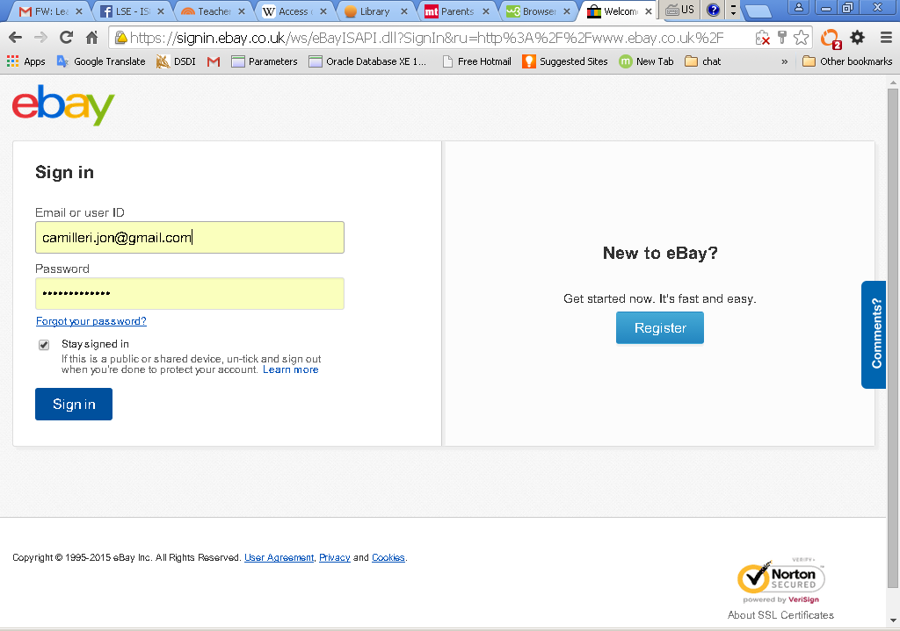
Illustration 1: Logon page with security features

NOTE: Firewall and parental control software may prevent you from accessing websites, just browse somewhere else if you are blocked and feel free to ask questions on safe websites.

Further reading
Computer architecture – see http://en.wikipedia.org/wiki/Computer_architecture.
How to use Microsoft Word – see http://digitalunite.com/guides/creating-documents/microsoft-word. The same website includes useful step-by-step information on how to carry out common tasks such as checking your email, connecting to a wifi, and, browsing.

