Sample Doc

- Some changes i’ve made, but want to
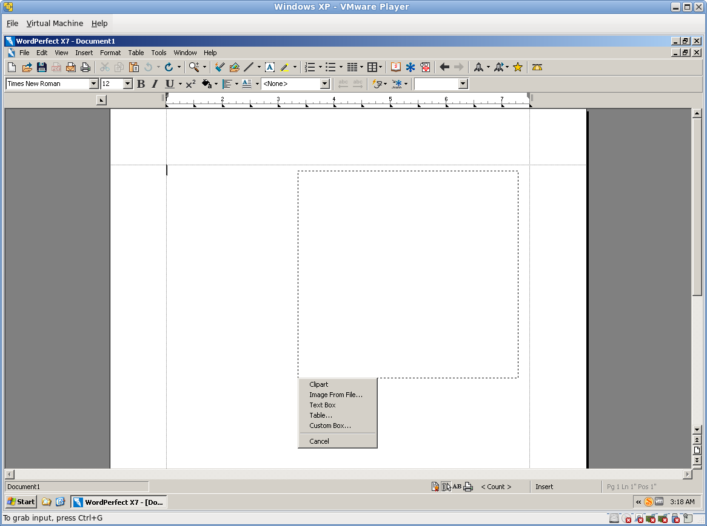save the revision without these words.

