User Interface and Experience Priority List

Goals: The UX should be optimized to reduce the number of clicks/steps a user has to make in order to achieve a completed action with a UI that is not intimidating for casual users and not stripped of its advanced features for advanced users.

Constraints: The default UI for each application will fit and be optimized for a screen resolution of 1280x768 (WXGA).

Guidelines: In order to standardize the use of controls and workflow, we’ve begun working on some UI Guidelines.

Taken from previous google+ hangout about Human Interface Guidelines (HIG)
+ LibreOffice uses the GNOME HIG's (Kendy)
+ but which ones? - there are 2 different ones ;-) (Heiko)
+ https://developer.gnome.org/hig-book/3.2/design-window.html.en (Kendy)
+ "This version of the Human Interface Guidelines was written
for designers and developers of GNOME 2 applications....")
+ HIG for Gtk3:
http://blogs.gnome.org/aday/2014/08/21/new-human-interface-guidelines-for-gnome-and-gtk/
not finished, AFAIK, (Heiko)

I’m listing the various UI and UX features that i think are important, so that others who want to contribute to the improvement of LibreOffice’s design and usability can find it all in one place.

Persona
Toolbar
Tooltips
Format
Descriptive Tooltips
Icons
Tango
Sifr
Oxygen
Breeze
Toolbars
Writer
Theming
Future Plans
Split / Group Buttons
Duplicating Existing Buttons
All Apps
Writer
Calc
Improve Existing Buttons
Toolbar Layouts
Sidebar
Existing Tabs
New Tabs
Sections
Additions to Sections
Styles / Colors
Styles Drop Down
Context Menu
Sidebar
Others
Context Menu
Dialogs
Comments
Previously Suggested (tdf#89232)
New Suggestions
Dictionary
Writer
Sidebar
Calc
Document Interface
Sidebar
Impress
Normal View
Master View
Sidebar
Tab Bar
Properties Tab
Custom Animations Tab
Slide Transitions Tab
Slide Pane
Google Summer of Code (GSoC Ideas and GeneralIdeas)
Universal Search Toolbar Field
Ways to Contribute

Persona
Libreoffice users needs to be described by one or a few personas. It would be good to have it based on real data, e.g. from past surveys and life observation.

Toolbar

Tooltips

Tooltip Format
  - Three versions/formats of a tooltip need to be stored, while presently LibreOffice only store one by default and has a second in the help files.
  - Version one is what LO currently uses, which has a word or two like Open, New, Save, and Print. The benefit of retaining this version is that this text can be used as the label shown next to or below a button icon, and old users can enable this version. (aka simple tooltip and icon label)
  - Version two needs to follow a naming convention similar to “verb followed by a noun or adverb” like Insert Image, Align Left, Increase Indent, Show Grid. It is not mandatory that each button have this version. (aka descriptive tooltip)
  - Version three is an extended tooltip which is a sentence or two to further explain the function. This text will also contain details of button behaviour like double-click actions as well as different behaviours of the function. The text for this version is already present in LO’s ‘extended tips’ feature which pulls this text from the help files. (aka extended tooltip)
  - The tooltip the user will see is a combination of tooltip version 1 or 2 in bold, followed by version 3.
Example: Image, Insert Image, Inserts a picture in the current document
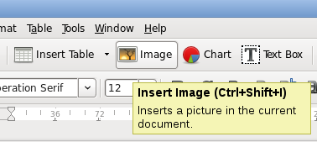
How it looks in MS Office 2010 (they also sometimes have an image)
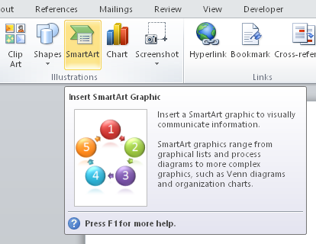
  - Tooltips which also contain explanations of the variations of the buttons action based on holding down a key (e.g. double clicking the clone formatting button causes it to stay active), then that explanation needs to be put in brackets - e.g. Clone Formatting (Double click for multi-selection)

Descriptive Tooltips
  - Work is in progress to create these tooltips in this Spreadsheet.

Icons

Tango
  - Many of the recently added icons in 4.4 were created in GIMP by me and vector versions need to be created for them (e.g. all buttons in the track changes toolbar, insert page break, insert footnote, insert and delete rows and columns)
  - Calc needs new icons for format as currency and format as number.
  - The sort icons in Calc need to be redone as they are not easily understood. Other icon sets use A to Z metaphor as a means of showing this.
  - https://redmine.documentfoundation.org/boards/1/topics/333
https://redmine.documentfoundation.org/boards/1/topics/313
https://redmine.documentfoundation.org/boards/1/topics/186
https://redmine.documentfoundation.org/boards/1/topics/152

Sifr
  - A number of the icons need to be improved on (format painter, textbox, number format: number) and some need to be recreated as vector versions (e.g. insert image)
  - Likely need to use a darker color for the icons, as they dont look so great on Mac on the second row. Google docs uses #000000 when an icon is highlighted but the icons are at 70% opacity when they are not selected, Breeze uses #4d4d4d, while Sifr uses #555753
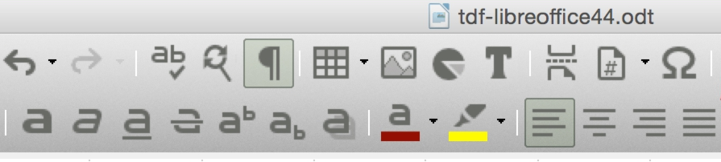
  - I was discussing with Mattias (Papamatti in the IRC) about the various icons that needed to be completed or redesigned in a Redmine thread
  - Metaphors for new icons can be taken from Breeze, Google’s Material Icons, and Google Docs toolbar icons.
  - Bug report: Meta bug report for Sifr being incomplete

Oxygen
  - Icons are mostly complete in Writer except for insert page break. New icons are likely needed for format painter (aka clone formatting), insert page break, insert footnote, and non-printing characters.
  - In Calc there are alot of older styled icons that need to replaced (e.g. pivot table, number formatting, decimal places, vertical alignment, borders) and new icons are needed for wrap text, conditional formatting, and formula.
  - In Impress there are also a few old styled icons like arrange, arrow style, interaction.

Breeze
  - The theme is currently under development by the Breeze creator Uri and is being tracked in a github issue and it has design guides.
  - There is also an effort to map the existing Breeze icons to libreoffice, though it can only go so far, which is why Uri’s efforts are crucial https://community.kde.org/KDE_Visual_Design_Group/LibreOffice_Breeze
  - Jonathan Riddell (Riddell on #libreoffice-design IRC) is assisting with this work and better integrate libreoffice in KDE.
https://redmine.documentfoundation.org/boards/1/topics/478

Default Base Icons
  - Calc’s number formatting - A good set of default icons are needed for these number formatting and decimal places icons to be the base for all themes.

Toolbars

Writer
  - New Image Toolbar - Writer enables both the frame and image toolbar when an image is clicked, but only the image toolbar needs to be shown if the useful buttons from the frame toolbar are copied to the image toolbar - tdf#87362
Proposal: https://bug-attachments.documentfoundation.org/attachment.cgi?id=111097
  - Automatic Activation of Track Changes Toolbar - tdf#83958
  - Missing Lines and Arrows Button - Writer is missing the lines and arrows split/group button that would be useful in the standard toolbar - tdf#89646

Theming
  - Mac Theming - The Mac toolbar background needs more work, especially with 10.10 having a different theme/gradient - tdf#69358
  - Proper Theming - I’ve proposed an approach to make LibreOffice themeable and its been placed as a Google Summer of Code

Future Plans
  - Resizable toolbars - the ability for the toolbar to show/hide icons depending on the size of the window. mentioned in the UI Guidelines and is available in MS Office.

Split / Group Buttons
In order to extend the toolbar without cramming in too many buttons into the toolbar, buttons can be grouped together in split buttons with the main button having one action and the drop down arrow providing additional actions. Many of these group buttons were conceived in my toolbar proposal (though they were limited to just writer) as shown below.
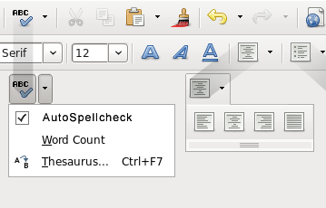
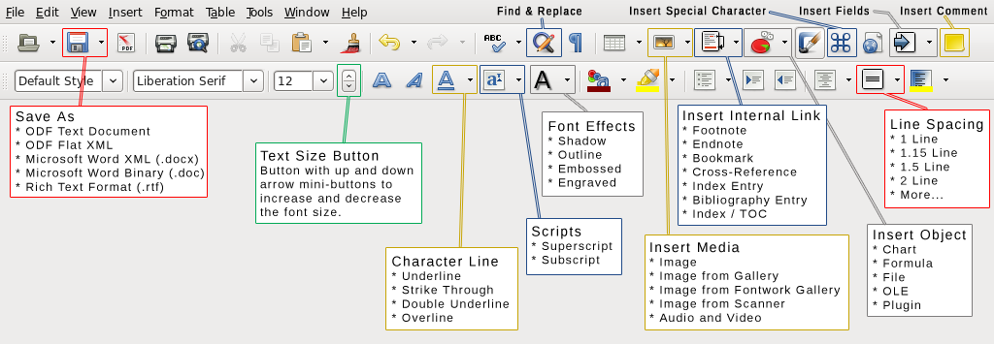

Duplicating Existing Buttons
  - Basic Shapes with main button being square rather than diamond
  - Lines and Arrows with main button being a line rather than arrow

All Apps
  - Save As - main button open dialog and drop down shows list of common formats
  - Character Line - main button is underline and drop down shows strikethrough, double underline, overline
  - Font Effects - main button shadow and drop down shows outline, embossed, engraved, and possibly character font effects (capitals, lowercase, etc)
  - Change Case - no main button, it drops down to provide change case options
  - Insert Media - main button is insert image and drop down shows image from gallery, image from scanner, audio and video
  - Insert Object - main button is insert chart and drop down shows formula, file, ole, and plugin
  - Insert Internal Link - main button is footnote and drop down shows endnote, bookmark, cross-reference, separator, index entry, bibliography entry, index or TOC
  - Word Functions - main button is spellcheck and drop down shows autospellcheck, thesaurus, word count - tdf#87079
  - Shapes - Combining all the non-line related shapes from the Drawing toolbar tdf#84350
  - Horizontal Alignment - Two versions of this need to be created as Calc has different uno commands for these functions
  - Vertical Alignment
  - Special Character - Contains the most used symbols in it [MS Word]

Writer
  - Columns - tdf#86946

Calc
  - Conditional Formating - tdf#86567
  - Sum - tdf#86091
  - Format as Currency - tdf#82641
  - Column and Row - likely Insert and Delete might be a better option tdf#86083

Improve Existing Buttons
  - Line Spacing - Already done by Kendy but it still needs tweaking like the current line spacing that is available in a button should be pressed, so from a glance you can see what is active without having to look at the line spacing drop down, and the line spacing drop down needs 1.15 added to it (tdf#85949)
  - Insert Field Submenus - tdf#85350

Toolbar Layouts
This will be activatable through the view menu similar to Inkscape
- Default View - Two or three row toolbars
- Single Toolbar View - Similar to Google Docs
https://redmine.documentfoundation.org/boards/1/topics/529
mockup: https://redmine.documentfoundation.org/attachments/download/435/image01.png
- Sidebar View - Similar to IBM Symphony, Calligra, and iWork
https://redmine.documentfoundation.org/boards/1/topics/163

Sidebar
- All tabs need to have a minimum size, so content isnt being cropped off - tdf#79758
- Sidebar collapse button should be more easily seen - tdf#83527

Existing Tabs
  - Reorganize Properties tab - tdf#86299
https://redmine.documentfoundation.org/boards/1/topics/69
  - Reorganize Navigator tab - tdf#89566
mockup: https://bugs.documentfoundation.org/attachment.cgi?id=113625

New Tabs
  - Page tab - tdf#83830
https://redmine.documentfoundation.org/boards/1/topics/97
https://redmine.documentfoundation.org/boards/1/topics/235
  - Style related tabs - Style gallery and table style
  - Shapes tab - tdf#87643

Sections
  - Shrink Line section - https://bugs.documentfoundation.org/show_bug.cgi?id=89543

Additions to Sections
  - Shadow properties - tdf#87702
- Sidebar by Module
  - In Writer
  - In Impress

Styles / Colors
Though LO wants to move users away from using direct formatting, LO doesnt make it easy for them with a good set of predefined ones for them to choose from.

Styles Drop Down
  - Not available in the Sidebar - tdf#73071
Note: This is the number one requested feature for users who want to exclusively use the sidebar and disable the formatting toolbar.
  - Easy access to create new styles - tdf#85415
  - Show unused custom styles in drop down - tdf#85930
  - Need a character style drop down - tdf#88512

Context Menu
  - More shape style entries in Impress - tdf#89155
  - Styles in the context menu - tdf#85940

Sidebar
  - Easy access to duplicate a style - tdf#87711
  - Table style tab - tdf#86177
https://redmine.documentfoundation.org/boards/1/topics/444
  - Styles gallery sidebar tab - tdf#86039
mockup: https://bug-attachments.documentfoundation.org/attachment.cgi?id=109138
https://redmine.documentfoundation.org/boards/1/topics/418

Others
  - Calc needs a good set of default styles
https://redmine.documentfoundation.org/boards/1/topics/493
Cell Styles in MS Office 2013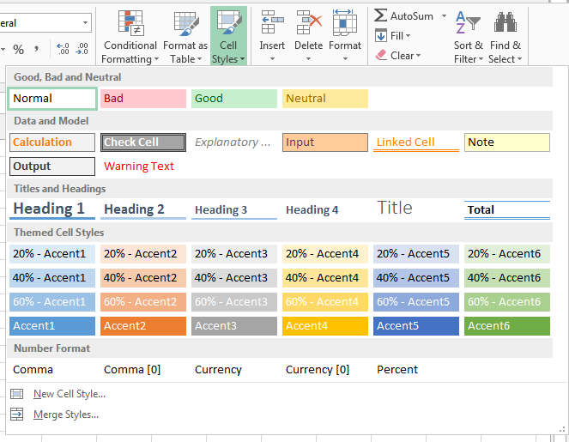
  - Impress/Draw needs a good set of default shape styles as it only has 2
Shape Styles in MS Office 2010
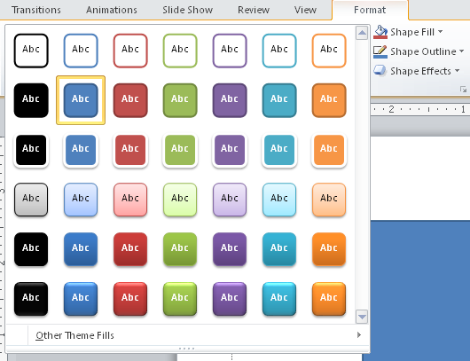
  - Calc’s conditional formatting requires a good set of preset colors - tdf#86508

Context Menu
- Copy, Cut, Paste should always be visible - tdf#86850
- Calc: Change Paste Only to Paste Special and move Paste Special into the submenu as More Options and add Unformatted Text to the submenu

Dialogs
- Apply Button - Apply button in all dialogs so users dont have to leave the dialog when they want to test how their change will look, rather than pressing okay and having to reopen the dialog again and again until they get it right.
- Customize Dialog - Heiko worked on a new toolbar customization dialog tdf#88896
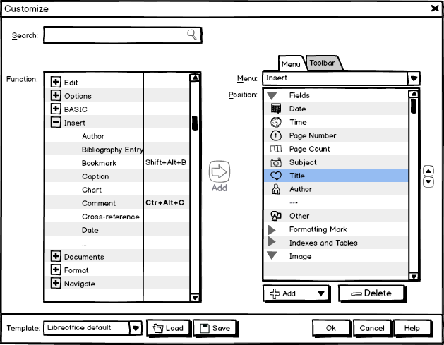
  - http://user-prompt.com/how-to-make-libreoffice-customization-usable/ (Google Docs)
  - Cor suggested to extend the dialog, someone else to make it as simple as in Firefox
- TOC Dialog - I worked on a new Entries tab for the Table of Contents dialog - tdf#89608
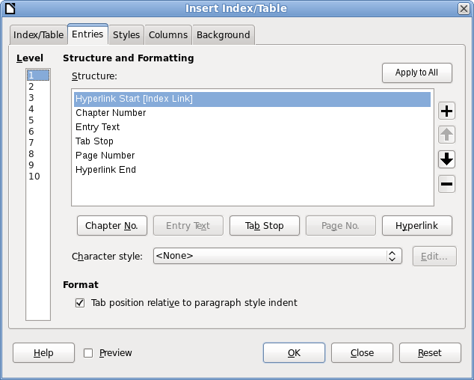

Comments

Previously Suggested (tdf#89232)
  - Make comments a plain color rather than a gradient, as the page is plain and so is the comment column.
  - Minimum height of a comment needs to be smaller
  - Comments column needs to be wider by 10 to 15 percent (approx. 300px at 100% zoom).
  - Padding should be around the comment text as well the author and time lines should be padded as well.
  - Two additional buttons are needed along with the drop down button. One for delete and one for reply (both being available in the context menu).
  - It would be nice to have a slightly darker background color for the information part of the comment, so that its easier to see what part isnt the comment text.

New Suggestions
  - User should be able to reply to their own comment (available in Docs and Word)
  - Commenter’s name and comment date can be put on one line
  - Three buttons can be added to the commenter detail’s area for delete, reply, show/hide (only shown when comment exceeds 5 lines), and the down arrow for others
  - Commenter detail’s area should be moved to the top (this is how its in all office suites)

Dictionaries
- The English dictionaries i believe havent been touched since LibreOffice has been created and it would be good to do something about it (i’m assuming the one in LibreOffice was brought over from OOo in this bug report). tdf#89695
  - Spoke with Kevin Atkinson about it and he’s working on a new compiled English hunspell and aspell dictionary at wordlist.aspell.net and he said the new words can be submitted to as a github issue.
  - Spoke with Andras Timar about it as well and he mentioned that LO is using an aspell -> hunspell converted dictionary by Laszlo Nemeth and suggested that “TDF could start a "Libre Dictionary" project and become upstream for at least English dictionaries (Mozilla, Linux distros, etc. would take them from TDF).”

Writer
- Background color should fill the cell and not paragraph - tdf#82504
- Improve Index/TOC dialog - tdf#89608 (mockup above)

Sidebar
  - Improve Track Change tab - tdf#87695
  - Table section - https://redmine.documentfoundation.org/boards/1/topics/121
mockup: https://redmine.documentfoundation.org/attachments/download/217/proposal%20-%20table.png

More usability issues can be found in Crucial Features Missing in Writer.

Calc

Document Interface
  - You can put the visual column/row style entry here Adolfo

Sidebar
  - You can add your sidebar suggestion here Pedro

Impress

Normal View
- Slide Pane: Default Width: 200px, Max Width: 300px
Default Width: Powerpoint 195px (141px thumb), WPS 216px (168px thumb), LO 208px (152px thumb)
Maximum Width: Powerpoint 279px, WPS 283px
Note: Sizes above exclude the draggable resize section of the pane
- Impress should open with a template gallery (tdf#89664) as not everyone opens Impress through the start center and even in the start center, if a user goes to the template gallery, you have tiny thumbnails (tdf#89095).
Note: Very crucial feature that needs to be implemented so users have the correct workflow.

Master View
- Hide Presentation Toolbar - tdf#87822
- Different Color - tdf#87905
- Pane Should be Correctly Titled - tdf#87638
- Presentation toolbar should be hidden - tdf#87822

Sidebar

Tab Bar
  - Reorder tabs in Impress - tdf#87904
  - Hide Master Pages tab by default as user has already used the template gallery

Properties Tab
  - Add Background and Presentation sections - tdf#89466
  - Add Interaction section - tdf#89667
  - Add Master Pages section - pull the ‘Used in This Presentation’ section from the Master Pages tab
  - Add more outline buttons - tdf#89457
  - Bullet commands - tdf#87651
  - Media Playback section - tdf#87794
  - Shadow options - tdf#87702

Custom Animations Tab
  - Fit Content in Size - tdf#87809
Current: https://bug-attachments.documentfoundation.org/attachment.cgi?id=111441
  - Add Effects List and Reorganize - tdf#87813
Mockup: https://bug-attachments.documentfoundation.org/attachment.cgi?id=111598
  - Show More Info - tdf#87812
  - Copy and Paste Style - tdf#88938

Slide Transitions Tab
  - Improve It tdf#87862

Slide Pane
- Move view tabs to slide pane - tdf#87672
posted it on twitter to get people’s view - https://twitter.com/jphilipz/status/570738831793659904
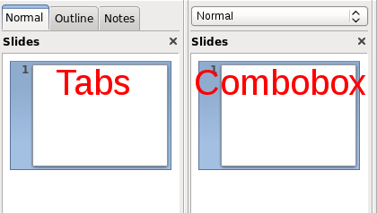
- Move slide management to slide pane - tdf#89668
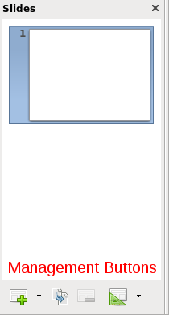

Proposals

Google Summer of Code (GSoC Ideas and GeneralIdeas)
- Improve Integration with the Cloud (CMIS, Google Docs, OneDrive)
- Integrate Template website into Start Center - tdf#85420
- Being able to fully theme LibreOffice (my proposal)
- Revamp gallery sidebar to be able to search it, sort by tag, and connection with online clipart services.
- Revamp Tools > Customizations (Heiko’s proposal)
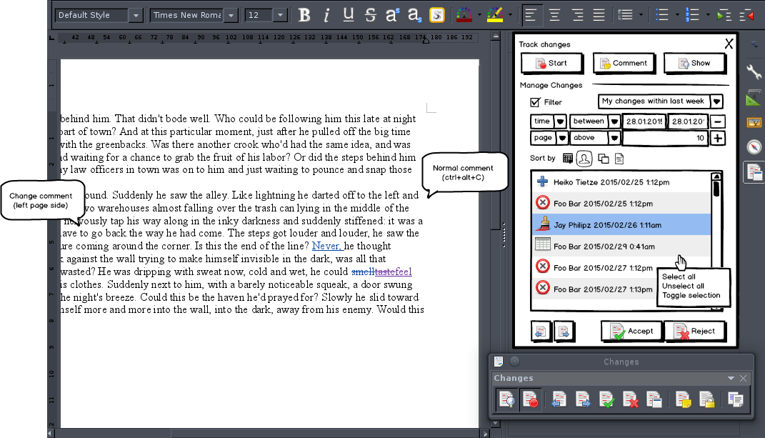
- Implement document themes, like what is found in MSO

Universal Search Toolbar Field
- Search field that will have the power to search through menus (similar to ubuntu’s HUD), provide links to other related menu items (e.g. user types ‘header’ and related shows ‘footer’), list help results (pulled from the help search if its installed) and link to youtube videos related to topics (each feature will have associate video links associated with it explaining more about the function and how it works - e.g. TheFrugalComputerGuy vids).
- MS Office 2007: The Story of the Ribbon (9 of 10) (05:18 - 07:14) : Stated they tried implementing search in the ribbon UI revamp, but that most users dont know the correct command name so then they werent able to find what they were looking for. Also stated that it was difficult to get it to work in multiple languages, but that they were going to look into the possibility of having it in later versions.
- A user had suggested we have a similar type of menu only search as they indicated that it was present in Google Docs.

Ways to Contribute

- Design icons
Create 16x16 and 24x24 for tango/gnome and sifr themes in Inkscape
- Create mockup of better organized dialogs
I use GIMP, while Heiko uses Balsamiq
- Reorganize toolbars and menus
You can easily reorganized them in Tools > Customize… and send in the customized xml or even just a screenshot

More technical details about these type of contributions can be found in my Knowledge Gained document.

