Soliber Net Ltd.
Suite 408, The Edges 1
Beacon South Quarter
Sandyford, D18 · Ireland
US phone: +1 310-425-3762
UK phone: +44 870-495-3905
IE phone: +353 85-142-9772
Email: contact@soliber.net
March, 2013
Marketing Automation
White Paper
Jobin Jose

Copyright Statement
This white paper on Marketing Automation is subject to copyright. Soliber Net Ltd. owns the full copyright of this white paper. Any form of reproduction, replication and unauthorised circulation of this document, in full or partial, without the prior written permission from the publisher is illegal and subject to legal action.

Table of Contents
Copyright Statement 2
Table of Tables 4
Table of Figures 4
Marketing Automation 5
Benefits of marketing automation 5
Impact on revenue 6
Impact on efficiency 6
Impact on visibility 7
Impact on sales team performance 7
The business Concepts and requirements 9
Acts As a Listening Post 9
Right Information at Right Time 11
The preconditions of provider selection 12
Marketing Campaign Analysis 14
Content Optimisation 14
Customise Content for an Individual Prospect 15
Prospect Segmentation 18
Market Segment Type 19
Content Tactics 20
Barriers 21
Campaign Testing and Analysis 22
Marketing Metrics 23
Key Metrics and Difficulty Level 24
Impact of Duration of Purchase Cycle and Workflow 26
Automated Customer Focused Sales Process 28
The Marketing Funnel 29
The Vitality of Marketing Automation in the Sales Process 30
Marketing Automation Helps the CRM ROI 32
Result from Marketing Automation 32
The Importance of Adhering to Marketing Automation Best Practices 33
The product market share 33
Reference 35

Table of Tables
Table 1: Email marketing industry standard 12
Table 2: Data collection and use by marketers (in %) 20
Table 3: Key metrics and its difficulty level 23
Table 4: Marketing automation implementation time requirement (in months) 32
Table 5: Estimated Revenue of B2B Marketing Automation Specialists in 2012 34

Table of Figures
Figure 1: Benefits of Marketing Automation (in%) 8
Figure 2: Database Integration 16
Figure 3: Industry based email open rate (in %) 21
Figure 4: CEOs grade marketing 24
Figure 5: Productivity of marketers based on automation level 29

Marketing Automation
Marketing automation is the process of managing the target, time, and content of a business’s marketing messages automatically as response to potential clients for their inward actions and for their online conduct (Oracle Eloqua, 2012).

It has a well defined focus of filtering marketing inquiries or purchase interest of prospects to sales ready leads. The process of marketing automation starts from watching prospect’s online behaviour.
The prospects are then presented with series of campaign messages through email or social media or other means thereby nurturing their ‘interest’ towards a sale. This process is common among Business to Business (B2B) and Business to Customer (B2C). In marketing automation, marketing technology is intertwined with integrated sales process.

Benefits of marketing automation
The marketing automation tool implementation in a company affects revenue, efficiency, visibility and performance of the sales process. The decision makers provide utmost importance for these four areas while doing buy/build analysis. The benefits are given below.

Impact on revenue
- Marketing Automation Strengthens the collaboration of sales and marketing departments. Marketers can fully prepare for sales dialogue thereby increases sales, revenue, and productivity of the company.
- It clearly benefits the sales funnel. Chances are high for prospects become clients. The marketers can timely track the online activities and movements of prospects and nurture them with accurate information. However, prompt availability of the thoughtfully carved content and quality information to the prospect are the decisive factor of sales.
- The marketing automation considerably reduces timecycle the sales process. The speed increases the sales procedure thereby increases chances of client retention.

Impact on efficiency
- According to Randy Shattuck, the marketing automation process helps the companies to send out accurate content and data through emails, articles, webinars, demos, newsletters, landing pages etc. (Shattuck, 2012).
- Marketers can create and send out series of emails with regular interval or predefined schedule to potential clients. It helps the prospects to contemplate and come to an ‘informed’ choice. It really increases the chance of sales.
- Analytical data availability increases the efficiency of marketing work force. The analytical data – web traffic, webinar attempts, email reading etc. - availability in dashboard really reduces the timing for identifying hot prospects.
- Marketing automation increases the efficiency of list management.

Impact on visibility
- Marketing automation helps easy monitoring of leads. Marketers can easily track and follow the online activities –digital footprint- of prospects.
- It allows the marketers to ‘score’ the prospects from ‘amateur visitor’ to ‘hot prospects’.

Impact on sales team performance
- The study of Aberdeen Group reveals that the marketing automation tools increases the lead conversion rate up to 107% when compared with manual lead conversion (Aberdeen Group).
- It helps the sales team to achieve up to 17% forecast accuracy.
- Team sales achievement can be up to 20%
- Average deal size is up by as much as 40%.
Figure 1: Benefits of Marketing Automation (in%)
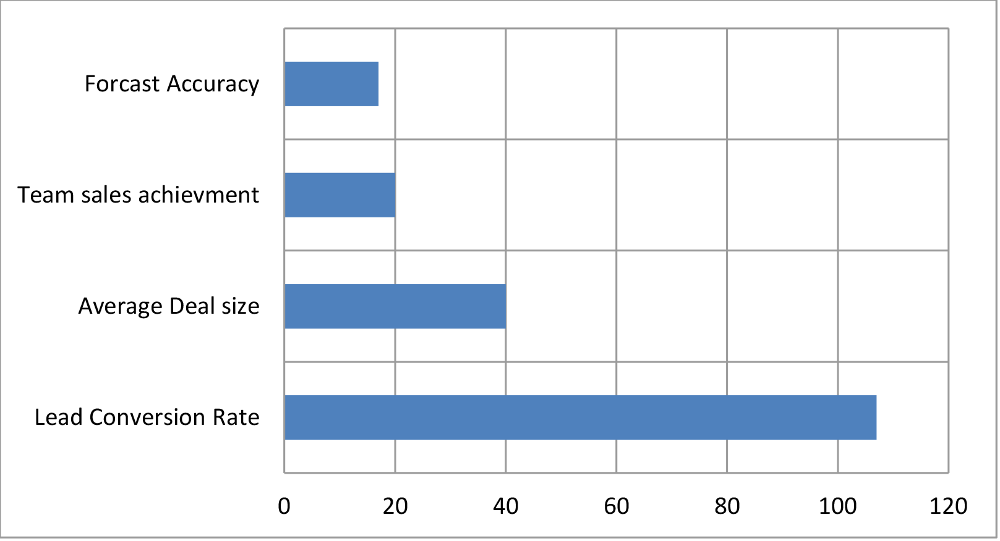
Source: Aberdeen Group

The business Concepts and requirements
Marketing automation tools are designed based on few business concepts and requirements. The technology literally accelerates the business process through meeting business concepts.
The marketing automation really leverages the sales process in four areas. They are:
- Enable listening to prospects
- Customised content for individuals
- Provides right information at right time
- Qualitative analysis of different market campaigns

Acts As a Listening Post
One of the basic concepts of marketing automation is that it should act as a listening post. It helps the marketers to listen prospect’s requirement.
It is not mandatory that the prospects ‘tell’ the marketers about their requirement, but their activities – digital footprint – help the marketers to identify prospect’s requirements (Econsultancy, 2011).
Marketing automation always depends on factually correct data. It is achieved through proper back end data management strategy. The marketers should be able to aggregate, extract and analyse all basic data of the prospects from company database therefore the primary responsibility of a marketing automation tool is nothing but capturing correct and precise prospect data.
The digital marketers consider collection of prospect information as listening. They store the data with more structured manner for future retraction through marketing automation tools. Social network activities, past purchase data, web analytics, data collection forms, surveys or any other feasible methodologies are used by data marketers in collecting user information and they store this data in the master database. It is mandatory to have back end software for capture and structure those data consistently.
Companies follow following methods for ensuring effective data collection (Econsultancy, 2011) during test cycle:
- They set quantitative and qualitative business goals.
- There should be a communication plan in place for achieving business objectives.
- Have a clear control line between pre-set communication plan and automated communication plan.
- Identify data requirement for effective communication plan
- Find out missing data that is vital for communication plan and find a way to close the gap.

Right Information at Right Time
Marketing automation tools should aid the marketers to feed prospects with right information at right time. The tool should be able to provide enough data analytics for analysing which information is relevant for the time.
Providing information, that is relevant for a specific segment of prospects, through emails and landing pages engages prospects thereby increase the chance of sales close. Marketers customise the images, text, criteria, location, industry, and title of job and many more data for prospects based on their requirement (Miller, Rothman, & Roberson, 2013). Marketing automation helps marketers to develop and execute campaigns where sales team can add leads. They can even propagate targeted campaigns.
Many seasoned marketers believe that providing relevant message or informing the prospects with current offers, which are relevant to them, at right time, significantly increases the chance of conversion. According to Gartner, “marketers can expect a 600% lift in performance over outbound campaigns by leveraging event-triggered tactics and innovative brands like Travelocity and IHG are already seeing between 5X and 15X lifts in performance from their right-time email marketing programs. These statistics are too compelling to ignore” (Strongmail, 2012).
Table 1: Email marketing industry standard
Industry Benchmark | “Cold” Performance | “Warm” Performance
9.53% Open Rate | 7.5% Open Rate | 13% Open Rate
2.87% CTR | 0.28% CTR | 1.5% CTR
N/A | 3.8% Engagement | 11.7% Engagement
Source: Martin, 2010

The preconditions of provider selection
The decision makers of the company are advised to conduct a thorough requirement analysis before selecting a marketing automation vendor. According to Henao, it is vital to have a ‘Scope’ document before listing all functional requirements (Henao, 2012).
Consider following facts while selecting a marketing automation vendor or service provider.
Analyse whether the marketing automation software of a vendor really helps the company’s marketing team to manage multiple products. If the company is selling single product, then it requires comparatively simple and small automation tool. Remember the size of the company does not matter when selecting marketing automation tools.

Identify and list out the sales and marketing work flow of the company because the marketing automation tool should comply with company’s workflow, not vice versa.

Analyse whether the company can devote full time employees for marketing automation or the company can assign only part time employees.
Analyse which are the roles – Content developers, PR executives, Business managers, Sales staff, advertisers etc.- that need to be signed in to the tool on behalf of company’s marketing life cycle. Ensure that the tool supports this.
Know the price of the tool. Purchasing a product may not be enough. Its implementation is crucial.
Ensure that the service provider will effectively provide after sales technical support.

Marketing Campaign Analysis
The marketing automation tool should enable marketers to analyse the performance of their different marketing campaigns. The tool should facilitate the marketers to conduct critical budget analysis on the expense for generating each lead. It would help the marketers to have greater control over marketing strategies, campaigns and budgets.
Many marketers fail to measure the impact of marketing campaign on revenue. A study report of Eloqua identified that the marketers shows proficiency in tracking tactical metrics whereas they provide less importance for revenue impact (Eloqua, 2012).
Sales intelligence helps marketers to identify the requirement of prospects. They can identify what a prospect expects from a sales call. Many marketing automation tools have the capability of providing information on which email has read by the prospect at what time. This type of information helps the team to analyse the marketing campaign cost.

Content Optimisation
Marketing automation tools help marketers to serve individual and optimised content to the prospects. A well structured database integrated with an automation tool helps marketers to provide dynamic, optimised, and information rich content to the prospects in real time manner (Econsultancy, 2011).
This ensures the prospect receive most relevant and up to date information.
Many marketing automation tools have the capability of keeping unlimited communication loop, thereby increases the efficiency of marketers.
The dynamic content capability of marketing automation tools help marketers to plan and execute various campaigns targeting various client segmentation. The marketers optimise content for individual prospects for increasing sales possibility.

Customise Content for an Individual Prospect
The marketing automation tools should facilitate marketers to provide customised content for prospects based on their sales funnel position. It helps them to create well structured communication strategy.
Marketers require adequate data for preparing content that is customised for individuals. Email surveys, static data forms, online surveys, and preference centres facilitate data marketers to aggregate relevant data. The data collected through these different methods are fed in to a master database for future use.
Marketers use the collected data for writing exceptionally good private messages. Marketing automation tools helps them to start the email with prospects name. In many cases, companies that do not have implemented marketing automation tools, can not address the prospects name but write simply “Dear Sir”. In this case, companies send out bulk emails with blind guess. This type of email marketing campaign produces a little, or sometimes any result. A normal prospect marks those emails as spam without reading.
The individual content customisation depends up on the availability and structure of data. If a marketer has access to adequate data through marketing automation tools, they can create more private messages.
Figure 2: Database Integration
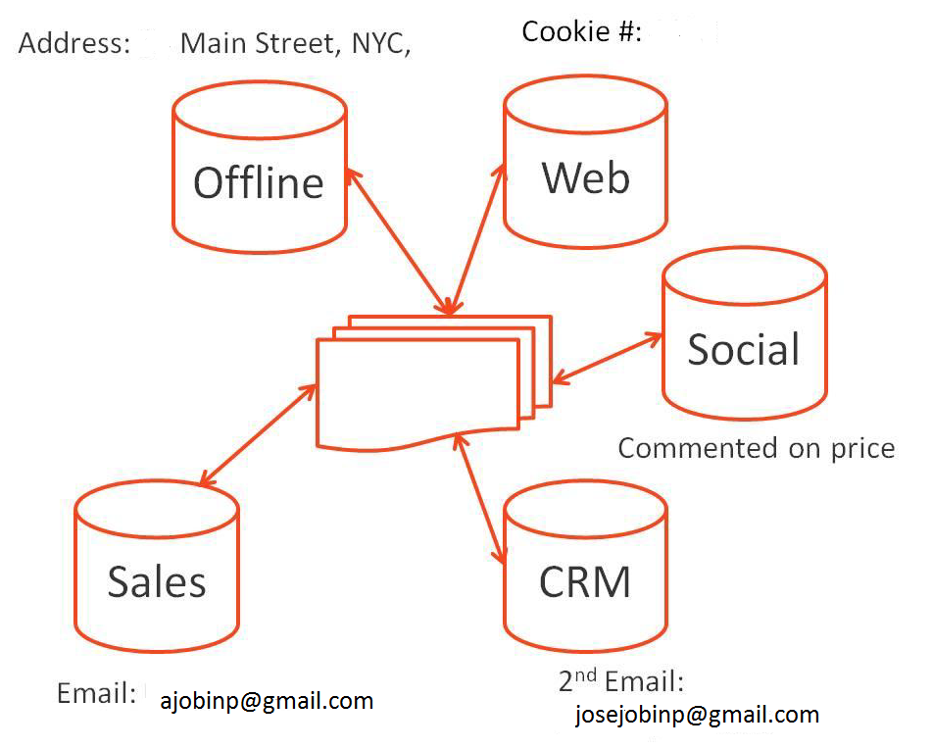
Source: Econsultancy, 2011
Marketers practice different Individual content tactics for effective marketing automation. Segmentation, an individual content tactics, stands at the top of the list. Ido Aries describes segmentation as
“When we talk about Dynamic content in the segmentation/targeting space we mean that content will change dynamically based on visitor’s attributes and intent: for example promotional banners will change according to search keywords or geo-location data. Of course it is important to run testing on dynamic targeted content to measure its impact on conversion rates and sales” (Ariel, 2010).

Marketers score leads based on their internet footage. The scoring is based on the combination of behaviour and geographic Segmentation. It helps them in accurately predict the prospect’s chance in to dive for a sale. Two or more positive indication helps the marketers to score the lead as ‘hot prospect’. Marketing automation tools serve more dynamic and accurate content to those leads based on their score.
The score helps marketers to nurture a prospect. The marketing automation tools serve ‘more informational’ and engaging content through many ‘medium’ to the prospects. This drip content campaign may continue a prolonged period for sales close. Marketers do following activities to ensure individual content optimisation while the marketing campaign.
- Marketers find out segments that benefit individual optimised content.
- They use campaign attributes to score prospects.
- Marketers assign segment to landing page or emails where they want dynamic content insertion.
- Marketers validate message quality.

Prospect Segmentation
Segmentation stays close to individualisation. It is actually the prerogative of marketers.
It can be a simple list of existing clients and hot prospects to a more complex big data about thousands of web users.
Segmentation really helps the marketers to drill down and identify the expectation of each customer on par with their requirement. The segmentation can be based on age, sex, gender, location, favourite colour, favourite smell, frequency of site visit or anything that is vital for closing a sale.
There is no limit for segmentation because
“…you can have an infinite number of segments –theoretically, every individual person in your audience could be a unique segment” (Econsultancy, 2011).

Market Segment Type
There are three basic types of market segment (management study guide, 2012). They are:
- Psycho-graphic segmentation: Based on the lifestyle of the prospect
- Behaviouristic Segmentation: Based on the brand loyalty of the prospect
- Geographic Segmentation : Based on the geographical location of the prospect

Marketers believe that behavioural statistics and data is more convenient for prediction when compare with geographic data. The behaviouristic marketing segmentation – web page visit, content download, static form fill up etc. – helps the marketers to evaluate the prospect’s position in the sales funnel (Econsultancy, 2011).
Marketing automation tools help marketers to collect psycho-graphic, behaviouristic, or geographic data of the prospect. One of the interesting facts is that many of them do not use the data.

Table 2: Data collection and use by marketers (in %)
Data | Collect and use | Collects but do not use | Do not collect or use
Personal name | 81 | 17 | 2
Company name | 52 | 24 | 24
Source of lead | 48 | 28 | 24
Professional title/role | 41 | 35 | 25
Personal or company address | 34 | 44 | 22
Personal or company phone | 31 | 50 | 19
Demographics (age, gender) | 14 | 21 | 65
Source: MarketingSherpa, 2010

Content Tactics
A white paper, released by Marketo, suggests four ways to produce maximum result from dynamic content during marketing campaign. They are:
- Interesting content
- Different content medium
- Easy availability
- Promote content
The relevancy of the content measured not based on its tone. The content should be relevant to the prospect. The white paper further suggests that the content should answer prospect’s business related doubts. Marketers are advised to devote adequate time to write error free content (Marketo, 2012).
Marketers use many content medium such as FAQ, eBooks, whitepapers, blogs, articles, podcast, info-graphics, video demo, email, webinars etc. for serving adequate content to the prospects. Marketers identify the user preference and use marketing automation tools to serve content on par with their preference.
Most successful marketers make sure the easy availability of the content. They use Search Engine Optimisation (SEO), Social advertising, Remarketing, Pay Per Click, Content Syndication or any other methodology that support the promotion of the content. Segmentation, customisation, and personification are the best methods in marketing automation content promotion.

Barriers
Many users do not open marketing emails. Education and media industry enjoys more ‘reading’ from users.
Figure 3: Industry based email open rate (in %)
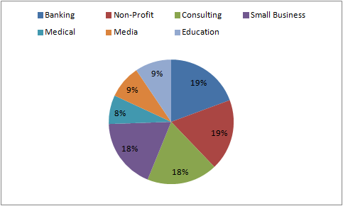
Source: Mailer, 2012
Marketers encounter many barriers for individual content optimisation while using marketing automation tools. They find it difficult to set up the dynamic content in marketing automation. Version controlling is one of the toughest tasks for marketers to implement dynamic content optimisation (Marketo, 2012).

Campaign Testing and Analysis
Marketing Automation campaign requires regular analysis and testing for yielding best result. The marketing automation tool implementation is always based on a list of closed-loop success metrics and metrics to which sales have agreed to track.
Most of the marketers create this metrics before starting serious marketing campaign. Most companies that have implemented defined marketing funnel are always successful in marketing automation (Econsultancy, 2011). These companies implement marketing as a business process. The successful implementation leads to the measurement of incremental improvement. It naturally produces improved business because marketers identify qualified sales leads and whole team focused on improving the result.

Marketing Metrics

“Marketing Metrics is a framework that is used by the marketers in order to evaluate their marketing performance. This is used by the brand managers to design and justify marketing programs. It is also by the senior management to decide on financial allocations” (Wikipedia, 2012).
Defining marketing metrics before a campaign start accelerate the Marketing automation capability.
Table 3: Key metrics and its difficulty level
No. | Key Metrics | Difficulty Level
1 | Marketing contribution to sales funnel (in %) | Medium
2 | Marketing contribution to sales revenue (in %) | Medium
3 | Quantity of sales qualified leads delivered to sales | Medium
4 | Quality sales qualified leads-SQL- (in%) | Medium
5 | Cost per inquiry | Medium
6 | Cost per inquiry that became a SQL | Medium
7 | Cost per Lead -Variable Costs | Medium
8 | Cost per Lead -fully loaded | Medium
9 | Conversion from Inquiry to MCL (in %) | Medium
10 | Conversion from Inquiry to MCL to MQL (in %) | Medium
11 | Conversion from Inquiry to MQL to SQL (in %) | Medium
12 | Conversion from SQL to Opportunity (in %) | Medium
13 | Customer Lifetime Value | High
14 | Discount Analysis | High
15 | Win, Loss rates by persona | Medium
Source: Brown, 2013
Marketing metrics is used in marketing automation for supporting content strategy and marketing plan. Marketers use many numeric data to evaluate and form a practical marketing metrics for their campaign thereby ensures the company progress. Some of the facts considered for creating marketing metrics are number of products, billed sales; brand awareness programs such as surveys, ROI, and web page visit statics.
Marketing automation tools track all predefined metrics. It starts reporting the campaign progress and these reports help the marketers to identify the ‘areas’ of campaign that need improvement instead of abandoning complete campaign process. However, it is not an easy task.

Key Metrics and Difficulty Level
Figure 4: CEOs grade marketing
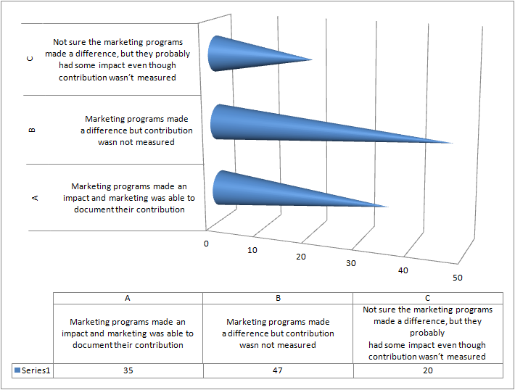
Source: Miller, 2011
Jocelyn Brown of Eloqua says that marketing metrics is tough. She says “Marketing metrics are hard. I mean the real ones, the ones that make significant business impact…” (Brown, 2013). She further identifies key metrics and its difficulty level.
Jon Miller, Vice President, Marketo says there are six prominent reason for a metrics go wrong (Miller, 2011). They are:
- Vanity Metrics: Marketers tend to present ‘feel good’ factors, that impress people, in order to justify their marketing campaign spending. They do not care about end result or performance improvement.
- Measuring what is easy: Marketers substitute the relevant revenue and profit figures when it is really difficult to measure.
- Focusing on quantity, not quality: Marketers tend to focus on lead quantity rather than lead quality. They generate considerable number of lead through marketing campaign but not sales. The end result of the marketing campaign does not produce profit.
- Measures activity, not end result: It is very easy to measure the effort of marketing activities. However, the ROI calculation is very hard. On the contrary, in sales, result is easy to measure whereas the sales activity is very hard to measure.
- Efficiency is measured, but not effectiveness: Efficiency of marketing campaign through marketing automation is measured but not the effectiveness of the same campaign. Effectiveness of the campaign actually produces result, not efficiency.
- Cost metrics: There is a wrong perception among ‘C’ level officials that the marketing is always ‘cost centre’ and sales is ‘revenue centre’.
- Most ‘C’ level officials consider marketing as a cost centre. A report from Marketo says 67% of CEOs either not measured or not documented the role of marketers in the revenue generation.

Impact of Duration of Purchase Cycle and Workflow
The marketing automation of B2B and B2C are almost similar when marketers look at technology, analytics, and reporting. However the content strategies and marketing campaign differs. The metrics use for measuring the campaign success rate differs in B2B and B2C.
The size of B2C is a stumbling block for marketers.
Marketers provide predominant consideration for B2B content tactics features such as CRM integration and scoring the leads based on their sales funnel position whereas in B2C, the campaign should comply with the large size of the campaign.
The business buyers take prolonged time for decision whereas B2C buyers take minimum time to get into a decision (Econsultancy, 2011). B2B sales may take up to 18 months whereas B2C sales occur within few days. The return on investment (ROI) of B2B sales lacks definite form or limit.
Integrated database and data structuring is not the real focus of marketing automation. However, the data sharing marketing automation work flow increases the possibility of sales. This strategy enables all resources to use single interface for completing their task. It saves not only time but also effort redundancy.
Using same interface by all resources helps client side marketers to see and evaluate the performance of their campaign. This method enabled the marketers to have continuous evaluation of predefined marketing metrics.

Automated Customer Focused Sales Process
Marketing automation tools automate marketing activities thereby increase sales. Aron Aders of Inc.5000 says that the businesses always invest lots of effort for providing best customer experience. However, many companies fail to continue that effort in providing brand experience for the prospects.
“Marketing automation software can help create a consistent brand experience with prospects and brand community members without needing to scale up your workforce” he continues in his article (Aders, 2013).
Marketing automation helps marketers to develop adequate marketing strategies and carve content that comply with the strategies and trigger events. Implementation of marketing automation tools help companies plan their marketing budget because they obtain more control over the money spend for nurturing a prospect to client. The companies which adopted the marketing automation in their marketing process have shown more structured and consistent capability in the prospect management.

Figure 5: Productivity of marketers based on automation level
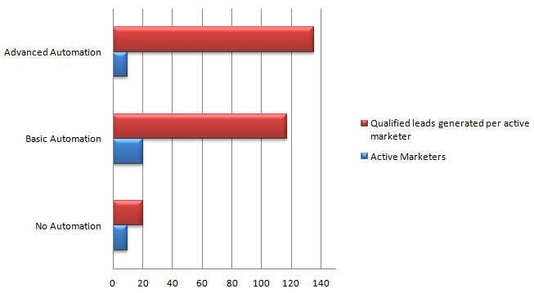
Source: Noyes, 2012
This capability enabled them to sell their products to existing clientele as well as helped them to convert more and more leads into potential clients (Nucleus Research Inc., 2012). Marketing automation also helps them to quantify the return from different marketing campaigns.

The Marketing Funnel
The marketing automation tools help the companies to provide accurate content for the prospects based on their marketing funnel position.
The top of the funnel prospects (TOFU) requires whitepapers and reports for understanding the company’s products and services because their knowledge about the product and service is little. The middle of the funnel prospects (MOFU) expects more from the company.
The automation tools help the marketers to send out case studies and other content with more personalised manner to the MOFU prospect. The bottom of the funnel prospects (BOFU) requires very specific content of company’s products and service. They are ready for sales calls.

The Vitality of Marketing Automation in the Sales Process
Potential clients actually drive the purchase process. It reiterates the importance of co-ordination between marketing and sales team. In this case, marketing automation plays a pivotal role for marketers to manage proper prospect communication.
Marketing automation tools help marketers in identifying the digital footprint of the prospect and effectively address their expectations. The tools also collect possible intelligent from the prospect data thereby marketers can score each prospect.
The lead generation capability of a good marketing automation solution is always superior to static prospect data collection or lead capture form. It is vital to have a marketing automation tool for any organisation which has substantial prospect data. According to Walmsley
“Marketing automation systems also can help identify the visitors to the website even if they haven’t filled out a capture form” (Walmsley, 2012).
It helps the marketers to identify potential leads and provides following benefits during campaign:
- Effective and efficient marketing campaign inception.
- Minimum resource and time required for campaign management.
- Marketing automation tools provide quality analytics.
- Improved cooperation between marketers and sales team.
- Marketers can provide more sales-ready leads, with adequate data, to the sales team.
- Generate more leads with less expense for each lead.

Marketing Automation Helps the CRM ROI
Marketing automation tool implementation helps companies to increase their Return on Investment (ROI) on CRM solution.
CRM stores all leads and contacts in a central location. However, CRM is developed for managing individual leads whereas marketing automation addresses the requirement of managing a segment of leads. Marketing automation tools are capable of prioritises, nurture, automate, and convert leads to sales.

Result from Marketing Automation
A study report published by Econsultancy states that marketing automation tools take an average of three to four months for showing result (Econsultancy, 2011). There are five stages in marketing automation implementation.
Table 4: Marketing automation implementation time requirement (in months)
Implementation stage | Fastest time | Average Time | Longest Time
Integration of databases | 1 | 1.4 | 4
Getting the first campaign in market | 1 | 1.6 | 3
Complete migration from old system to new system | 1 | 1.7 | 5
Learning the system | 1 | 2.5 | 8
Seeing improvement over pre-automation success metrics | 1 | 3.3 | 6
Source: Econsultancy, 2011
The first stage is database integration. This stage takes an average of 1.4 months for completion. Releasing first marketing campaign to the market is the second stage and in requires at least one month of time to implement. Complete migration from old system to new system requires on an average 1.7 months to complete. System learning requires an average 2.5 months. The overall result takes an average 3.3 months to visible.

The Importance of Adhering to Marketing Automation Best Practices
To get the fullest result from marketing automations, the marketers should invest their full capability. The result is not only depending up on investing money for tools but also for the adherence of best practises by the marketers. There are instances when resources fail to adhere to marketing automation best practises thereby generate no leads.

The product market share
Raab Associates estimates that the B2B marketing automation industry is $525 million in 2012 (Raab Associates, 2012). The total sale is estimated based on the sales of marketing automation specialists of B2B and other B2B marketers.
The specialists lead the market with a share of $365 million (70% of the total market). Oracle Eloqua, Infusionsoft, HubSpot, and Marketo hold the lion share of the specialist market. They together hold $270Million.
Table 5: Estimated Revenue of B2B Marketing Automation Specialists in 2012
Estimated 2012 Revenue - B2B Marketing Automation Specialist Vendors
Sector | installations | Revenue per  installation | Revenue | % installs | % revenue
Micro | 17,476 | $3,600 | $63 million | 62% | 17%
Small | 4,595 | $12,000 | $55 million | 16% | 15%
Mid-size | 4,796 | $30,000 | $144 million | 17% | 40%
Large | 1,426 | $70,000 | $100 million | 5% | 28%
Total | 28,292 |  | $362 million | 100% | 100%
Source: Raab Associates , 2012

The revenue of the industry is expected to be of $750 million in 2013. The latest report of Raab Associates estimates 50% growth in revenue in 2013 when compared with 2012. However, the growth rate is slightly lower when compared with 2012. In 2012, the growth rate was 54%.

Reference
Aberdeen Group. (n.d.). Marketing Automation 101: Ensuring Early Success with the Basics; Maturing Your Deployment for long-term ROI”,. Aberdeen Group. Retrieved February 16, 2013
Ariel, I. (2010, January 17). Optimization, segmentation and dynamic targeting. Retrieved February 23, 2013, from Barilliance eCommerce Personalization Blog: http://www.barilliance.com/blog/2010/01/optimization-segmentation-and-dynamic-targeting/
Brown, J. (2013, January 27). Marketing Metrics are Hard. Retrieved February 25, 2013, from Eloqua: http://topliners.eloqua.com/thread/6296
Econsultancy. (2011). Marketing Automation Best Practices: Opportunity and Operational Reality. Londan: Econsultancy. Retrieved February 16, 2013
Eloqua. (2012). Modern Marketing Insights. Eloqua. Retrieved February 21, 2013, from http://www.eloqua.com/resources/marketing-insights/fewer-measuring-revenue-impact.html
Henao, E. (Ed.). (2012). How To Select The Right Marketing Automation Software. Retrieved February 16, 2013, from CRM Search: http://crmsearch.com/marketing-automation-selection.php
Mailer. (2012). Email Marketing Metrics Report. MailerMailer. Retrieved February 13, 2013, from http://www.mailermailer.com/resources/metrics/2012/open-rates.rwp
Management Study Guide. (2012). Market Segmentation - Meaning, Basis and Types of Segmentation. Retrieved February 23, 2013, from managementstudyguide: http://www.managementstudyguide.com/market-segmentation.htm
MarketingSherpa. (2010). MarketingSherpa Email Marketing Benchmark Survey. MarketingSherpa. Retrieved February 23, 2013, from http://www.marketingsherpa.com/article.php?ident=31847
Marketo. (2012). From Creation to Conversion: Promoting Content to the Right Audience. Marketo.
Martin, M. (2010, April 21). Finding Beauty in “Ugly” Results. (Eloqua) Retrieved February 22, 2013, from Marketing Measurement: http://blog.eloqua.com/finding-beauty-in-ugly-results/
Miller, J. (2011). Marketing metrics & Anlytics. Marketo. Retrieved February 25, 2013
Miller, J., Rothman, D., & Roberson, C. (2013). The definitive guide to marketing automation. Marketo, Marketing. Marketo. Retrieved February 22, 2013
Oracle Eloqua. (2012). Best practice Toolkit. Retrieved February 16, 2013, from Eloqua: http://www.eloqua.com/topics/marketing-automation.html
Raab Associates . (2012, August 07). Raab Report: B2B Marketing Automation Now $525 Million Industry. Retrieved February 16, 2013, from Raab Associates Inc: http://raabassociatesinc.com/2012/08/07/raab-report-b2b-marketing-automation-now-525-million-industry/
Shattuck, R. (2012, January). Marketing Automation in 2012. Retrieved February 16, 2013, from Professional Services Journal: http://www.internetviz.com/psjblog/2012/01/marketing-automation-in-2012/
Strongmail. (2012). The right time email marketing playbook. Strongmal. Retrieved February 22, 2013, from Strongmail.
Wikipedia. (2012, February 1). Marketing metrics. Retrieved February 24, 2013, from Wikipedia: http://en.wikipedia.org/wiki/Marketing_metrics

