- Which equation below represents the quadratic formula?

*a. $\frac{-b±\sqrt{b^{2}-4ac}}{2a}$ = x

b. $a^{2}+b^{2}=c^{2}$

c. $f\left(x\right)=a_{0}+\sum_{n=1}^{∞}{\left(a_{n}\cos{\frac{nπx}{L}}+b_{n}\sin{\frac{nπx}{L}}\right)}$

- Which of the following represents a set of parallel lines?

a. Option one

b. Option two

*c. Option three

- What is the definition of an obtuse angle?
*a. an angle greater than 90°
b. an angle equal to 90°
c. an angle less than 90°

- Which formula below represents the area of a circle?

a. $A=2πr$
*b. $A=πr^{2}$
c. $A=π^{2}r$
d. $A= √π$
- What geometric term is represented by the image below?
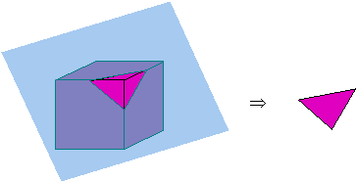
a. a corner
*b. a cross-section
c. the circumference
d. the perimeter

11. Using the data in the table below, calculate the mean, or average, number of points scored by Player B.

 | Game 1 | Game 2 | Game 3 | Game 4 | Game 5
Player A | 13 | 12 | 9 | 11 | 13
Player B | 12 | 11 | 15 | 20 | 12

*a. 14
b. 11.5
c. 13
d. 13.67

- This instrument is commonly used by surveyors. It measures horizontal and vertical angles to determine the location of a point from other known points at either end of a fixed baseline, rather than measuring distances to the point directly. What is it called?

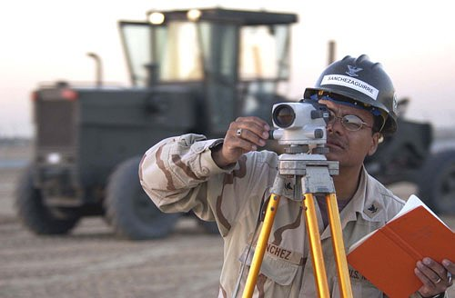

a. triangulator
b. binocular
c. tripod
*d. theodolite

- What is the name of the missing shape in the flowchart below?

a. Acute
b. Obtuse
*c. Isosceles
d. Right

- What category includes all of the items on the list below?

- Square
- Rectangle
- Rhombus
- Parallelogram
- Trapezoid
- Pentagon

a. Quadrilaterals
b. Triangles
c. Ellipses
*d. Polygons

- Determine the area of the shaded portion in the diagram below.

A B

C D

- ABCD is a square
- ABCD touches the circle at 4 points
- The length of one side of the square ABCD is 2 cm

a. $π$– 4
*b. 2$π$ – 4
c. 3$π$ ² – 4
d. 4$π$ ³ – 4
e. 5$π$ – 4

