Three were selected to show bla comparing blabla:
 | other
Region B | 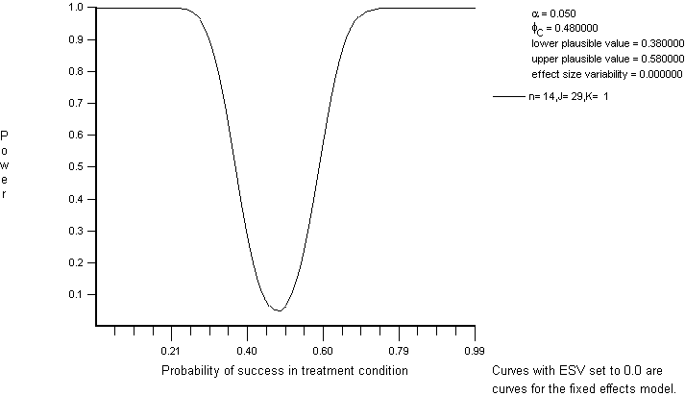
Regions | 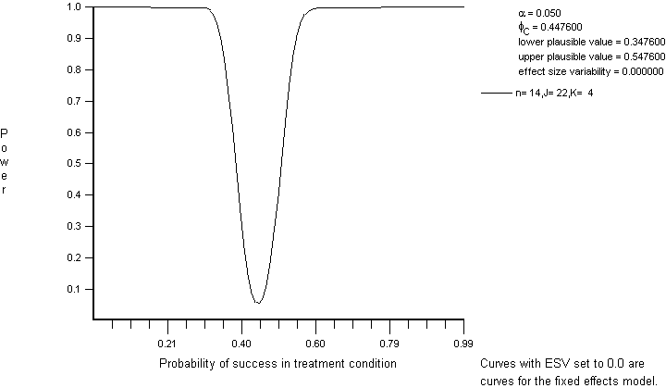
Figure 1. Another graph

