Buoyancy Name: ____________________________________
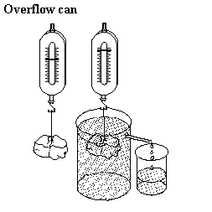
When an object is immersed in water, the water doesn’t simply get displaced; the water provides an upwards force on the object. This upwards force is called buoyancy. (The normal downwards force is called gravity.) All objects therefore seem lighter when immersed in water. How much buoyancy does the water provide? Why do some things float while others sink?
Aim: To determine the buoyancy on various objects when immersed into water.
Equipment: spring balances, cotton thread, metal cubes, overflow beaker, measuring cylinder.
Method: Find the mass of a metal cube using a spring balance.
Lower the metal cube into the water. Record the new weight.
Measure the amount of water that has been displaced.
Fill in the table. Repeat for the cylindrical prism.

