[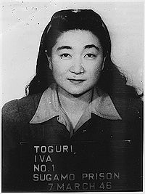](https://en.wikipedia.org/wiki/File:Iva_Toguri_mug_shot.jpg)

Ratio not locked

[](https://en.wikipedia.org/wiki/File:Iva_Toguri_mug_shot.jpg)

Ratio locked